
Volume 41 Issue 33 March 14, 18

LONDON NORTH ROTARY CLUB

WELCOME ALL

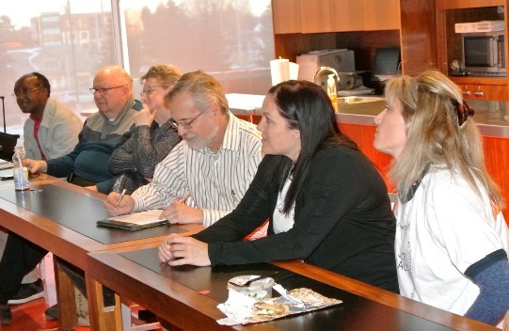
President Doug welcome us all. Our meeting took place at Loblaws Richmond .

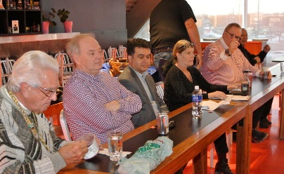

President Doug invited Don to briefly introduce our guests: Michelle, Sara. Pat is our loyal guest.

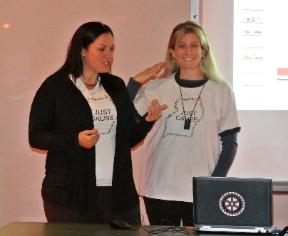
Doug informed us that our meetings will be taking place in this venue in March, April and May. He reminded us that two meetings a month will be held starting in April.
He mentioned inscriptions to LRA next month and the East Coast Party.
REGRETS
received from Bill, Mary Margaret and Ken
HAPPY BUCKS:
Margaret: $4 for her 4th grandchild who is a boy.
Colin: $ 3
Dr Vic: $20 with Rotoractors, they had 3 places cleaned.
Pat: $ 4 they will enjoy the company of a friend from India who will attend Rotary Convention in Toronto.
Don: $ 10 following birth of a grand-child .
Peter: $4 he listed a trailer for sale.
Doug: $2 his grand child is proceeding to the playoff of his favourite sport.

Arun introduced today’s speakers: Sara Hansen teaches in Kitchener, Ontario and Michelle Massaro teaches in London, Ontario. They are strongly committed to relevant and modern educational opportunities to propel growth and create change.

TALK BY MICHELLE & SARA
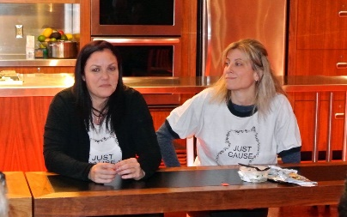
The two guests are glad to be back to speak of their initiative: JUST CAUSE EDUCATION OUTREACH.
They operate from Kitchener and London, Ontario. Their project aims at education in Uganda, Africa. They are happy that their organization is a registered Charity. They work with volunteers; in close cooperation with local people in Uganda. It started with a man who felt the need to launch home schooling: he started with 10 children; now the initiative has served some 500.
A remote area, Nanso, saw the construction of an elementary school some five years ago: 8 classrooms, 1 office, available water and a garden.
A second school is under construction: it houses a STEAM CENTER where emphasis is put on Science, Technology, Engineering, Art and Math.
They face real challenges though: remoteness, equipment & other supplies, teacher training, access to social media.
They have however been able to establish 2 MAKERSPACES where activities are centred around Robotics, Technology, Computer Programming.
Support from mentors and the link with St Joes school in ST Thomas, Ontario is appreciated. Financial and material assistance from Hacker For Charity has been instrumental.
Learning opportunities are tremendous: competitions with other schools, various workshops tackling such topics as wind power, motion, design, programming, building (legos).
Our two speakers ended their presentation by thanking us for our continued support and by answering questions from us. More information can be found at their site JUSTCAUSECANADA.ORG
President Doug presented them with a Polio Certificate emphasizing the role of Rotary in the eradication of that disease.
Dennis won the wine draw, donated to our speakers.
More information can be found at their site JUSTCAUSECANADA.ORG
President Doug presented them with a Polio Certificate emphasizing the role of Rotary in the eradication of that disease.
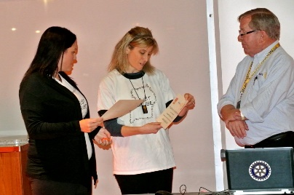

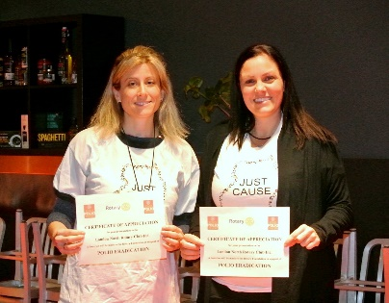
Dennis won the wine draw, donated to our speakers.

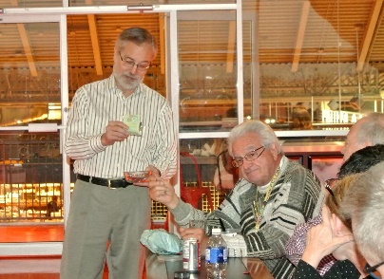

SMILES!

An Engineer or a Doctor?
An Engineer was unemployed for long time. He could not find a job so he opened a medical clinic and puts a sign up outside: "Get your treatment for $500, if not successful get back $1,000."
One Doctor thinks this is a good opportunity to earn $1,000 and goes to his clinic.
Doctor: "I have lost taste in my mouth."
Engineer: "Nurse, please bring medicine from box 22 and put 3 drops in the patient's mouth."
Doctor: "This is Gasoline!"
Engineer: "Congratulations! You've got your taste back. That will be $500."
The Doctor gets annoyed and goes back after a couple of days later to recover his money.
Doctor: "I have lost my memory, I cannot remember anything."
Engineer: "Nurse, please bring medicine from box 22 and put 3 drops in the patient's mouth."
Doctor: "But that is Gasoline!"
Engineer: "Congratulations! You've got your memory back. That will be $500."
The Doctor leaves angrily and comes back after several more days.
Doctor: "My eyesight has become weak."
Engineer: "Well, I don't have any medicine for this. Take this $1,000."
Doctor: "But this is $500..."
Engineer: "Congratulations! You got your vision back!
That will be $500.
MARK YOUR CALENDAR
- Mar 21: Lea Wilson Heart & Stroke
- Mar 22: Shaya Dhinsa: MLHU London’s Opiod crisis
2017-2018 CLUB OFFICERS
President Doug Burnard...471-7789
Past President
. .Margaret Cook 762-6984
President.-Elect
Don Langford…432-9841
Treasurer ..Gary Plomske 660-1463
Secretary
in Ndayifukamiye....709-2912
Director Foundation .
Vic Vigna ….. 660-0940
Director Club Administration
Kevin Suzuki .858-2327
Director Service Projects
Peter Hes 657-7525
Chair Community.Service
Colin Steele .. .472-5716
Chair Vocational Service
Tom Telfer.. .851-5421
Chair International Service
Lin Ndayifukamiye….685-2696
Director Public Relations
Yvette Thornton ......... .649-0558

2018 RI Officers

RI President…... Ian Riseley

DG District 6330
Martin Ward

AG Area 4.………..…Sue Storie

