Please reach out to us through our website, Facebook page or any of us if there are Rotary events that you are interested in participating in or you are considering becoming part of our team. Note: We have changed our e-mail address. It is now: meafordrotaryclub@gmail.com

October 5th - Rotarian Liz enjoying the Scarecrow Parade!

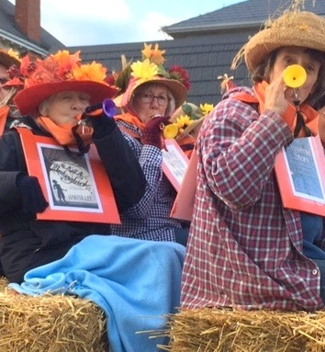

Thank you to “Friend of Rotary” Dave MacDougall for driving the 2019 Fall Fair Ambassador Brian Lepard in his 1929 Model A Ford. Driving in style!

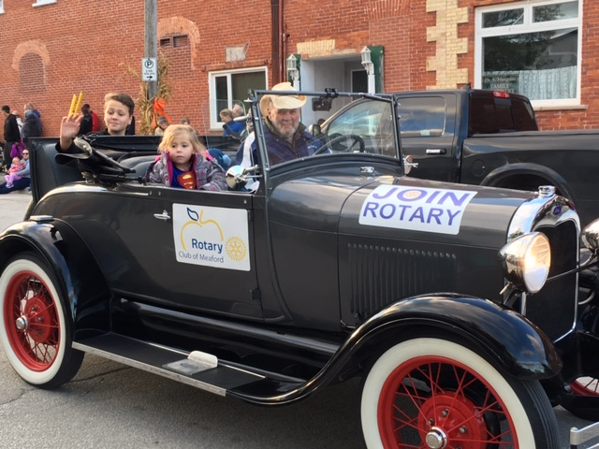

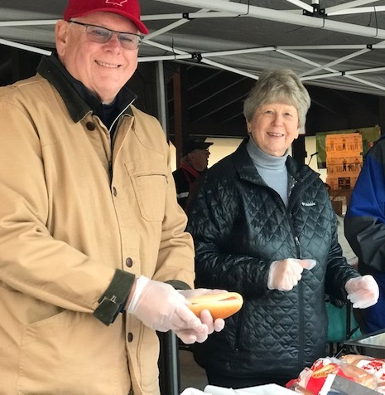

Rotarians Bill and Carol getting hot dogs prepared to give away at the Scarecrow Family Festival. What a great community turn out this year.

Highlights of October 7th Meeting

At our meeting this week, we were very pleased to induct a new member to our club. Cheryl Geonanga has already jumped into action with the club, handing out many, many hot dogs at the family festival and was seen sporting the 20/20 glasses given to us by District Governor Tony Sheard. Welcome to Rotary Cheryl!

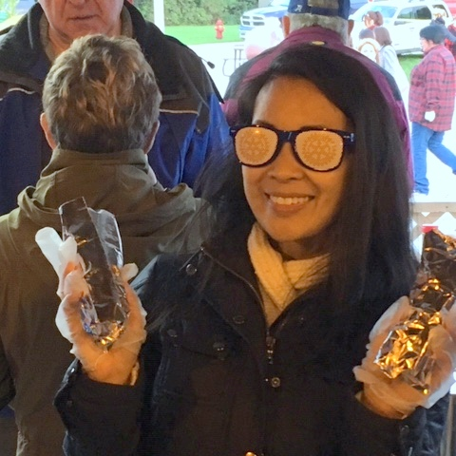

The club voted to give financial support to the Kids in the Hall. We also enjoyed the picture in the Meaford Independent of two skaters posing with us as we gave a cheque to the Meaford Figure Skating Club.

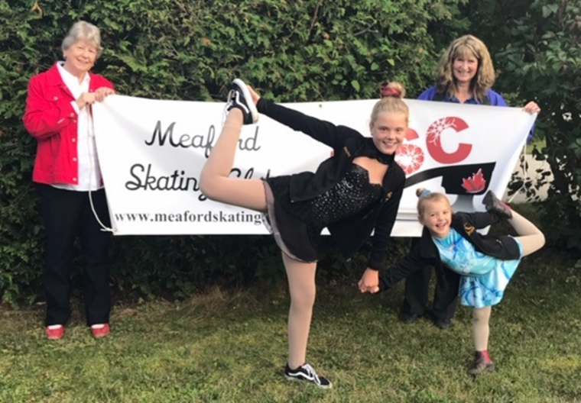
The club received a presentation from Nellie Greb, chair of the Golden Town Outreach, who gave us a summary of the work that this organization does to support those in our community who struggle to meet their needs. This deeply committee organization provides service to approximately 230 community members each month and as they receive no funding from the province, are constantly in fund-raising mode. Our hats off to the individuals who give of their time and resources to do this important work.

Highlights of October 21st meeting

Our Trivia Night was a fabulous evening that raised $2502 plus Bar to support the youth program at the new library. Our “Mulligan Cards” raised $550 which went directly to the Friends of the Library. The club also decided to provide financial support to the “Marvel Trivia Night” held by youth to again, support the library.

At this meeting, several members of the club provided dinner – soups and homemade bread and dinner funds went to the Rotary International PolioPlus program focussed on eradicating polio from our world. Thank you to our chefs for a delicious meal supporting such a worthy cause.

We were very happy to meet Jan Phelan, a Rotarian from Squamish BC who has moved to Meaford and wishes to transfer her membership to our club. Welcome to Jan!

Highlights of October 28th meeting

Our guest speaker this evening, Councillor Shirley Keaveney spoke to the club about the Economic Development initiative that is being undertaken by the Meaford Council and involves several members of our club. Shirley also clarified several aspects of joint initiatives between the municipality and the club such as the Harbour Master Plan, the harbour gardens, bar proceeds and others.

District and International News:

Rotarians Dave and Sonja are now in Tanzania. The club looks forward to hearing about our well project upon their return.

