WINE PAIRING SUGGESTIONS FOR CHOCOLATE TRUFFLES
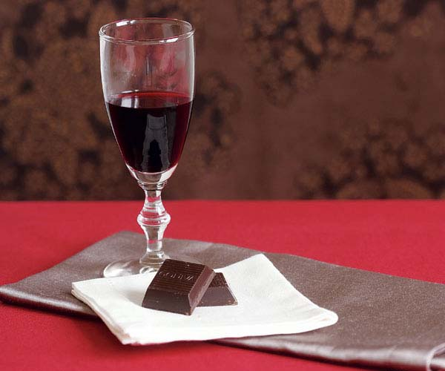
Semisweet chocolate:
With its higher cacao content (at least 35%) and more intense cocoa flavor, semisweet chocolate pairs well with slightly more intense wines, like rich, fruity Zinfandels and Shirazes. Fine, aged tawny ports and simple ruby ports will also match the levels of sweetness and tannins in the chocolate.
Bottles to try and which are available at LCBO in St. Marys:

- Taylor Fladgate Late Bottled Vintage Port $18.90 or
the 10-year-old Tawny $35.95
- Graham’s Late Bottled Vintage Port $18.55
- Sandeman Ruby Port $15.95
- Kilikanoon Killerman’s Run Shiraz $19.95 (Australia)
- Porcupine Ridge Syrah ($15.95), on sale $12.95 (South Africa)

