Jessica Lawson Is Enjoying Her Rotary Exchange in Czechia
Feb212019
Community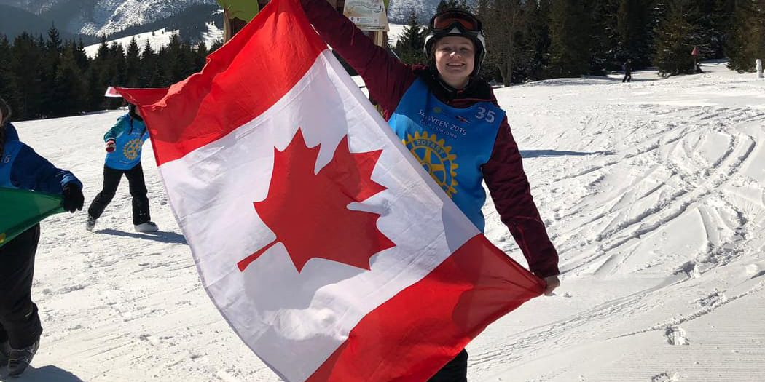
Hello! My name is Jessica Lawson. I am a recent graduate from St. Marys DCVI and I am currently living in the Czech Republic on a Rotary Youth Exchange until July. I am sponsored by the Rotary Club of St. Marys and I am being hosted by the Prague International Rotary Club.
I would like to tell you all a little about my exchange and experiences so far in Czechia. To begin, I was first supposed to arrive to Czechia in August 2018. However, due to visa issues I was not able to leave until October. I flew out of Toronto on October 22 taking a 7:00 pm flight to Munich, Germany. As I was trying to get through security in Germany, the guard was not going to let me through as he did not believe my visa was real nor was I an actual real exchange student. Finally, after some discussion and pulling out my laptop for official documents, I was allowed through. I had a 5-hour layover in Munich before boarding the plane to Prague. The flight was only 35 minutes long and it was honestly the best flight of my life. Upon arrival at Prague Airport I went to grab my luggage before going to meet my host family. Let me tell you, this part did not feel real, nothing in the first few days felt real. I went through the arrivals hall to my host family and I was happily greeted with hugs and kisses from my host sisters and host parents. They had a sign for me and everything was so exciting! The first few minutes went by and I was in so excited I actually forgot to call my Mom back home and tell her I had safely arrived (haha, sorry Mom).
From the moment, I met my host family I knew they were all very sweet and amazing. I have two host sisters, a host dad, host mom and a host dog! My host sisters are: Petra (14) and Markéta (16). My host mother’s name is Michaela and my host father’s name is Joseph. Alba is our dog. He is a beautiful golden retriever and is 3 years old. My host family is truly amazing. They were very welcoming and took me in as one of their own daughters. They are very active and have even started me into an active life. I have started Pilates and Zumba classes, joined a curling team and I hopefully plan to start beach volleyball soon with some of the other exchange students.
During my stay in Czech Republic I am living in Brandýs nad Labem-Stará Boleslav. It is an old small town with around 17,000 inhabitants. Originally, the town was separated into two smaller towns: Brandýs nad Labem and Stará Boleslav, separated only by the Elbe River. However, when the Communist authorities took over the country these two towns were merged together. The weather here is more mild than back in St. Marys. We have only had two days where it really snowed and it only stayed for a few days before disappearing. The lowest daily temperature we have had was probably around minus seven but definitely above negative ten. I believe the summers are about the same as St. Marys or a bit milder.
Within two days of my arrival I started school. My school is “Gymnázium J. S. Machara”. It is located in my town for which I am very fortunate. (I know other exchange students who travel over 1.5 hours to get to their schools!) I was put into a class called “Septima”. My fellow classmates are either the same age as me or one year younger. Students are usually in “high school” here for one more year than in Ontario as everyone graduates when they are 19 or 20 years old. Everyday I have 6-8 different classes and one lunch period. All my classes are spent with the the same people (Septima) and they are each 45 minutes long. School starts at 8 in the morning and usually finishes around 3 in the afternoon. The subjects I am currently taking are: History, Math, Geography, Geology, Social Studies, Gym, Physics, Biology, Chemistry, Czech, English, French and Computers. I hope to join the German class soon! For lunch I go to the school canteen with my friends where we get soup and a meal (usually meat and noodles with a sauce). This food is very inexpensive as it only costs 35 korunas which is about $2 CDN!
Czech food is amazing and not only for the taste. The most-Czech meal you can order is roast pork, cooked cabbage and dumplings with sauce. This was actually the first meal my host Mom cooked for me and it was amazing. Other common Czech dishes are: Guláš ( a stew made from beef with onions and spices), Smažený sýr (fried cheese), and Chlebíčky ( garnished breads with spreads, eggs, meat and/or vegetables). Czech people eat A LOT of bread, soups, potatoes and cheeses. The main meal of the day is actually lunch and for dinner, they usually just eat cheese and bread.
The Czech language, in my opinion, is very hard to learn. Czech is actually the 4th hardest language in the world. For instance, when forming a sentences the word order does not mean as much and they have 7 different cases. Depending on what you want to say, one word can be spelled at least 7 different ways. However, I am practicing and improving my Czech everyday. I also have Czech lessons in Prague twice a week and my friends and family are very supportive. (The words for Mrs. and Mr. in Czech are Paní and Pane. I accidentally ended up going into the men’s bathroom once instead of the women’s.)
As I mentioned before, I am hosted by the Rotary Club of Prague International. This club is the only English speaking club in Czechia and consists of about 30 people. They are all so inviting and welcoming. I love my club as many of the members come from different parts of the world such as India, Russia and the United States. I attend most of the Rotary meetings alongside the two other exchange students being hosted in my club. They are, Sheila from the USA and Paulina from Mexico. Some of the fundraisers my club does are mistletoe sales in the wintertime, hosting gala auctions as well as their annual dragon boat races. I am very excited, as all the Rotary exchange students in Prague have decided to make a team and compete in the dragon boat races in May!
I would definitely recommend students to consider being a Rotary Youth Exchange student. I think it is a great experience and you will learn a lot. I honestly did not know much about Rotary or even this program before leaving. But I have learned so much about what Rotary does and how amazing an organization it is. You get to experience so many new things and learn a lot not only about the world but about yourself as well. If you have any questions about the program you can talk to the Rotary Club of St. Marys or you can message me on Facebook. I would be happy to answer any questions! You can also follow my blog: Canadianexchangetoczechia.blogspot.com
Lastly, I would like to give a shoutout to my family! I want to say thank you to my Mom (Vicki Lawson) for allowing me to take this opportunity as I honestly thought she was not going to allow me to go. Also, a shoutout to my sisters for finally realizing I am Mom’s “favourite” for the amount she let me travel during my teen years compared to both of you! (haha)
That is all for now! I return to Canada in July! Can’t wait to see you all again!
(If you are interested in learning more about Rotary Youth Exchange or possibly hosting a Rotary Youth Exchange student please email Mark Oliver at mark_oliver@mac.com)
Category: CommunityBy IndyFebruary 21, 2019

