
 | 33rd Annual Southampton Rotary Charity Golf Tournament  Friday, June 19, 2026  Southampton Golf & Country Club

The Southampton Rotary Club is holding our 33rd Annual Golf Tournament to raise funds for Rotary projects in our community as well as international initiatives. We would like to thank you for your past support and if you are interested, we would very much appreciate your support this year in the following ways:

SPONSORSHIP
GOLD SPONSOR $500
Your sign or banner displayed in a prominent location at the event.
Your sign will be displayed exclusively on the tee block at one of the holes.
Another sign will be displayed at the putting green.
Your logo on the poster for the event (if received in time).
Your business will be noted on social media as a MAJOR SPONSOR as well as listed in the program and the “Thank You” acknowledgement.



SILVER SPONSOR $300
Your sign will be displayed exclusively on the tee block at one of the holes. Another sign will be displayed at the putting green.
Your business will be noted on social media as a SILVER SPONSOR as well as listed in the program and the “Thank You” acknowledgement

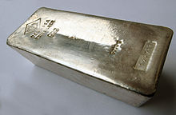
BRONZE SPONSOR $100
Your sign will be displayed at the putting green.
Your business will be noted on social media as a BRONZE SPONSOR.
Your business will be noted in the program and the “Thank You” acknowledgement.

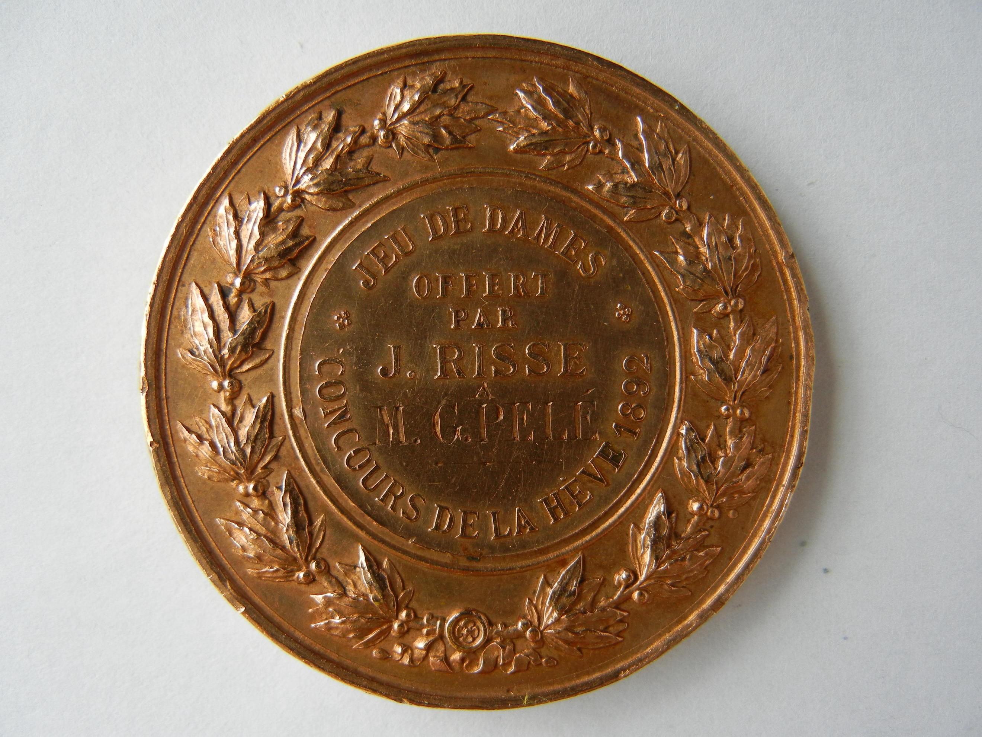

PROVIDE ITEM(S) OR A GIFT CERTIFICATE FOR:

- The Silent Auction
- The Draw Table
- Prizes for Golf Contests (Golfer, Proximity, etc.)

Your business will be noted in the program and “Thank You” acknowledgement.

Kindly make your cheque payable to the “Rotary Club of Southampton” and mail to 39 Grey St. S, Southampton ON, N0H 2L0 or contact me to arrange collection of your cheque or donated items. You can also e-transfer funds (southamptonrotary@bmts.com) if that is more convenient. If you have any questions or wish to discuss your sponsorship or donation, please contact me at your convenience.

Thank you very much for your consideration…..with your help, we look forward to having a fun and successful fundraising event.

Yours sincerely,

2026 Golf Tournament Committee on behalf of the Southampton Rotary Club

