27th Running of the Stratford Rotary Dragon Boat Festival
September 14th, 2024

This 27th year we will
“Paddle for a Million”
since together we have the potential to push the total funds raised from this event to over $1,000,000!


The Rotary Club of Stratford Charitable Foundation has invested all of these proceeds into projects that include:

- AquaBox | - Stratford General Hospital
- Respite House | - United Way
- Rotary Hospice Stratford Perth | - Avon River Enhancement
- The Local Community Food Centre  - Commit  - Academic Scholarships | - Rotary Complex  - Master Gardener’s Pollinator Garden

For more information about Rotary scan this code

For more information about sponsorship opportunities scan this code

Event Sponsor: $6,000
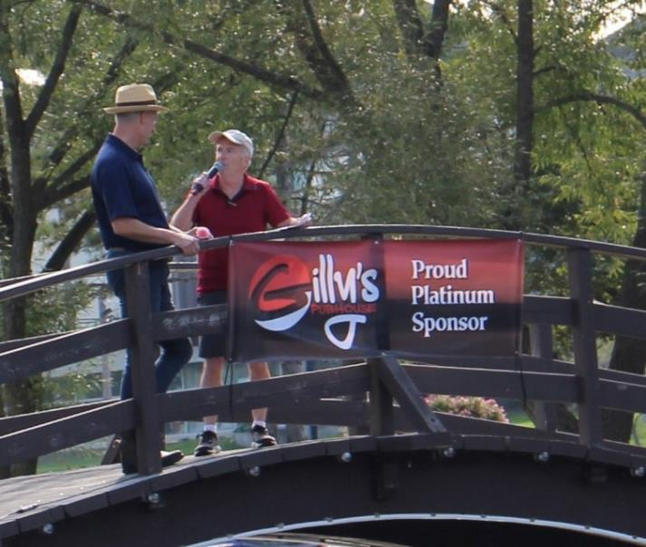

There is just one opportunity to sponsor at this level.
Before the event, we will place:

- Your logo on the Dragon Boat Festival website.
- Your logo and bio on Rotary Dragon Boat social media.
- Your logo on all Rotary Dragon Boat Festival print material.
- Your logo on Dragon Boat posters displayed in local businesses.
- Your name in a draw for Stratford Festival tickets.

Event day exposure includes:
- Event day signage.
- Event day call-out as sponsor and your bio announced over the P.A. many times.
- Your logo on the bow of all dragon boats.

Platinum Entertainment Sponsor: $4,000
One opportunity to sponsor.
Before the event, we will place:
- Your logo and bio on Rotary Dragon Boat social media.
- Your logo on Dragon Boat posters is displayed in local businesses.
- Your name in a draw for Stratford Festival tickets.
Event day exposure includes:
- Event day signage at the beer tent used all day for entertainment and beverages.
- Event Day call-out as sponsor over the P.A.

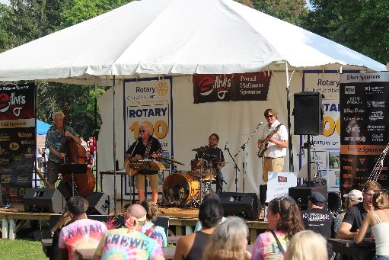

Beverage Sponsor: $3,000
One opportunity to sponsor
Before the event, we will place:
- Your logo and bio on Rotary Dragon Boat social media.
- Your logo on Dragon Boat posters is displayed in local businesses.
- Your name in a draw for Stratford Festival tickets.
Event day exposure includes:
- Event day signage.
- Event day call-out as sponsor over the P.A.

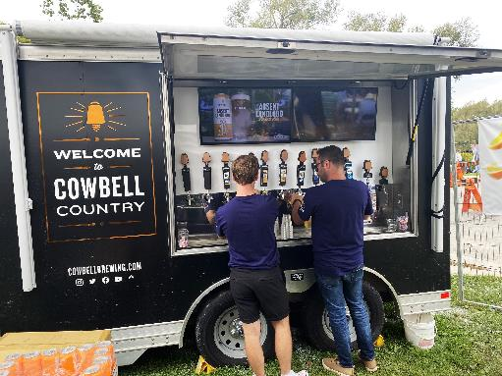

Referee Boat Sponsor: $2,000
One opportunity to sponsor.
Before the event, we will place:
- Your logo and bio on Rotary Dragon Boat social media.
- Your logo on Dragon Boat posters is displayed in local businesses.
- Your name in a draw for Stratford Festival
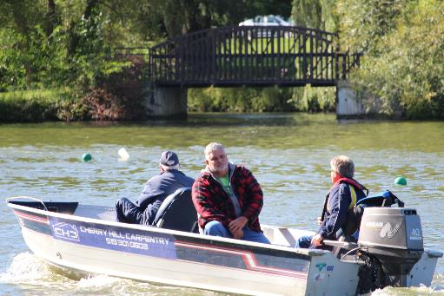

Event day exposure includes:
- Event day your sign on the referee boat going up and down the river all day.
- Event day call-out as sponsor over the P.A.

Transportation Sponsor: $1,500
One opportunity to sponsor.
Before the event, we will place:
- Your logo and bio on Rotary Dragon Boat social media.
- Your logo on Dragon Boat posters is displayed in local businesses.
- Your name in a draw for Stratford Festival

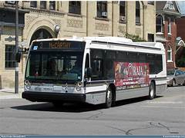

Event day exposure includes:
- Event day signage on the buses carrying participants and fans to and from the parking lots for the event.
- Event day call-out as sponsor and your bio announced over the P.A.

Gold Divisional Sponsor: $1,800
Eight opportunities to sponsor.
Before the event, we will place:
- Your logo and bio on Rotary Dragon Boat social media.
- Your logo on Dragon Boat posters is displayed in local businesses.
- Your name in a draw for Stratford Festival tickets.
- Your logo is on the seats of the Dragon Boat in the square.
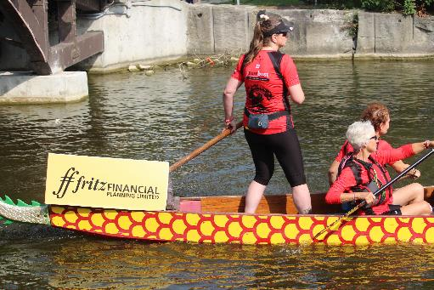

Event day exposure includes:
- Event day signage.
- Event day call-out as sponsor announced over the P.A. many times.
- Your logo on the stern of one of the eight Dragon Boats.
- Event day call-out as sponsor announced over the P.A. several times.
Silver Boat Sponsor: $1,000
Sixteen opportunities to sponsor.
Before the event, we will place:
- Your logo on Rotary Dragon Boat social media.
- Your logo on Dragon Boat posters is displayed in local businesses.
- Your name in a draw for Stratford Festival ticket
- Your logo is on the seats of the Dragon Boat in the square.
Event day exposure includes:
- Event day signage.
- Your Logo on the stern of one of the Dragon Boats.
- Event day call-out announced over the P.A. several times.

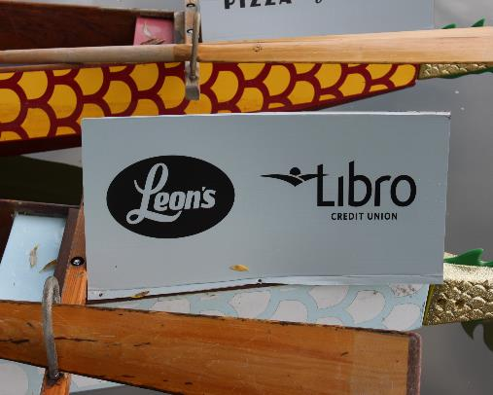

Bronze Lane Sponsor: $700
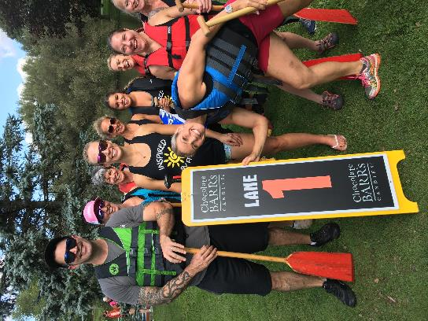
12 opportunities to sponsor.

Before the event, we will place:

- Your logo on Rotary Dragon Boat social media.
- Your logo on Dragon Boat posters is displayed in local businesses.
- Your name in a draw for Stratford Festival tickets.
- Your logo is on the seats of the Dragon Boat in the square.

Event day exposure includes:
- Event day signage.
- Your logo on the Lane Sign on Tom Patterson Island.
- Event day call-out as sponsor and your bio announced over the P.A.

Race Sponsor: $250
40 opportunities to sponsor.
Event day exposure includes:
- Event day call-out as sponsor.
- Your name on the bottom of finish-line photos for your race posted to our social media accounts.

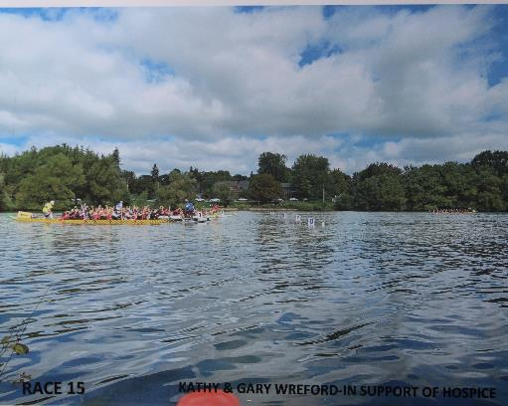

STRATFORD ROTARY DRAGON BOAT FESTIVAL
September 14th, 2024
Sponsorship Level Initial
Platinum Title Sponsor $6,000 ________
Gold Divisional Sponsor $1,800 ________
Silver Boat Sponsor $1,000 ________
Bronze Lane Sponsor $ 700 ________
Race Sponsor $ 250 ________
Name of Business: ____________________________________________________________________________
Address:_____________________________________________________________________________________
City________________________________________________________Postal Code_______________________
Name of Representative: ___________________________________________Title________________________
Email:_______________________________________________________________________________________
Phone:_____________________________________ Cell:_____________________________________________

Signature of Sponsor: _______________________________________________Date: _____________________

Signature of Rotarian: ______________________________________________Date:______________________
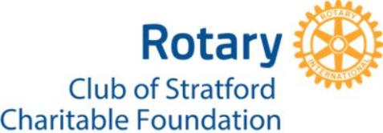
You will be invoiced for your sponsorship and payment will be to The Rotary Club of Stratford Charitable Foundation. Thank you for generous support!
Any questions or concerns, please email:

Gary Wreford Payment can be e-Transfer to:
Chair, Sponsorship & Publicity Committee foundation@rotarystratford.com
Rotary Dragon Boat Festival 2024 with “Message to Contact” of DB Sponsor
wrefords@rogers.com

STRATFORD ROTARY DRAGON BOAT FESTIVAL
September 14th, 2024
Sponsorship Level Initial
Platinum Title Sponsor $6,000 ________
Gold Divisional Sponsor $1,800 ________
Silver Boat Sponsor $1,000 ________
Bronze Lane Sponsor $ 700 ________
Race Sponsor $ 250 ________
Name of Business: ____________________________________________________________________________
Address:_____________________________________________________________________________________
City________________________________________________________Postal Code_______________________
Name of Representative: ___________________________________________Title________________________
Email:_______________________________________________________________________________________
Phone:_____________________________________ Cell:_____________________________________________

Signature of Sponsor: _______________________________________________Date: _____________________

Signature of Rotarian: ______________________________________________Date:______________________
You will be invoiced for your sponsorship and payment will be to The Rotary Club of Stratford Charitable Foundation. Thank you for generous support!
Any questions or concerns, please email:

Gary Wreford Payment can be e-Transfer to:
Chair, Sponsorship & Publicity Committee foundation@rotarystratford.com
Rotary Dragon Boat Festival 2024 with “Message to Contact” of DB Sponsor
wrefords@rogers.com

