The Rotominder

“Service Above Self”

Rotary Club of Chatham www.chathamrotary.com
St. Clair College Capitol Theatre, Rotary Lounge rotaryc@ciaccess.com
238 King St W. Phone 519-354-8300
Wednesdays at 12:15 P.M. Fax 519-354-5535

ORIGINAL CHARTER # 1011 issued - November 1st, 1921

August 5, 2015

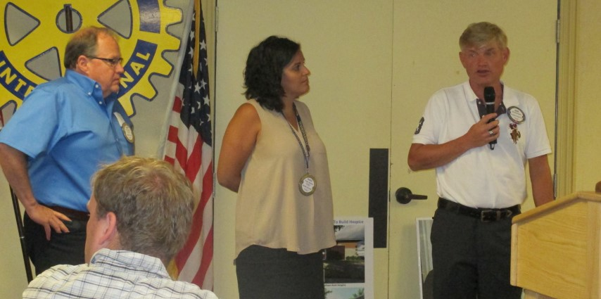

The Club held a question and answer meeting this week. Beach Boys committee members Don “Sparky” Leonard, Rob Bloomfield and President Fannie Vavoulis gave final announcements and instructions to put the finishing touches on the concert. The committee has put in countless hours in preparation for the concert this Saturday in Tecumseh Park.
Tickets are still available but are selling fast. Get your ticket from cktickets.com, calling the box office at 519-354-8338 and attending the box office at 75 William St in Chatham.
A few notes from the committee: The Park will be divided into 3 sections, the VIP area, reserved seating area and the General admission family friendly lawn section. You may be required to show proof of age at the entrances to the Park in order to be served an alcoholic beverage at the Concert. The gates open at 5:30 on Saturday. Patrons are not permitted to bring food, beverages or umbrellas into the park. There are several food vendors on sight in the park as well as a Beer Garden. General admission patrons are encouraged to bring their lawn chair or a blanket.
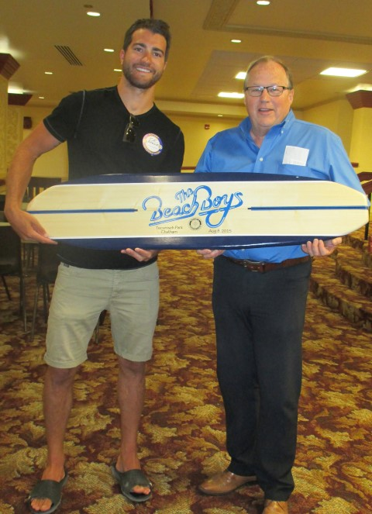
In the reserved seating area patrons may bring alcoholic beverag es back to their seat however the General admission area patrons must consume alcoholic beverages in the Beer Garden as this is a family friendly area.
The VIP area will have Hors D’ouvres available from Casa Bella and will be allotted 4 alcoholic drinks tickets. The entrance to this area will be located on William Street across from the Band Shell. There will be 2 jumbo-tron screens to ensure everyone has a great view of the Beach Boys. The local band Superfly will start playing around 6:15 with an intermission before the Beach Boys take the stage at around 8:15. There will be 2 separate raffles for patrons to purchase tickets on. One will be a 50/50 draw and the other will be for a surfboard (pictured here) that will be autographed by the Beach Boys.
Many thanks to all those that have volunteered in any capacity to assist the Rotary Club in preparation for the concert. The Club also thanks our sponsors for their financial support.
Have a fantastic evening and let’s make this concert one of the best events Chatham has ever seen.

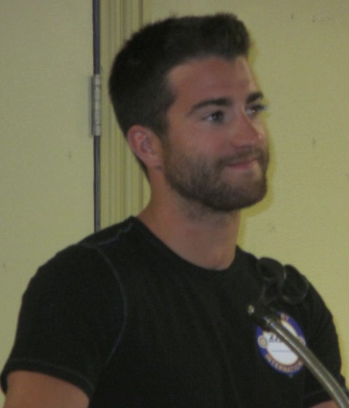
The Club also had a question and answer period with our honoured guests NHL player T.J. Brodie of the Calgary Flames and 10 year old Declan Waddick who played on the Warrior Elite European Cup tournament in the Czech Republic. These two home town heroes were brought to the Club all thanks to our President Fannie Vavoulis. Fannie is a friend of TJ’s sister and asked if he would consider attending the Club while he is home during the off season. He was only too happy to come and graciously answered question after question from the membership.
Declan and his friend Rorey Elson both played for the Draftday Canada Team. Declan proudly displayed the gold medal he won in the final game where both boys scored goals beating out Slovakia. Declan thought “it was pretty cool” to playing against players from other countries. As Declan presented TJ with a gift, he told TJ that “I am going to be here in 10 years to take your place when I make it to the NHL. Both Declan and Rorey will be playing again for Major Atom ‘AAA” Cyclones.
The Club wishes TJ and Declan great success in their future endeavors. Chatham-Kent can indeed be proud of these two “hockey stars”.
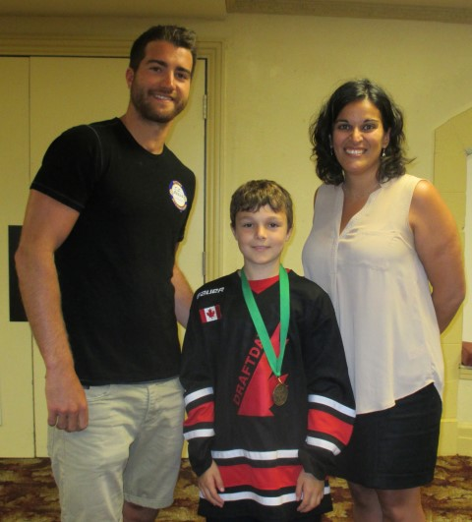

T.J. Brodie, Declan Waddick and President Fannie Vavoulis

Guest Speaker | Beach Boys Meeting/ T.J. Brodie Q &A (Hockey)
Visiting Rotarians | Michele Cryan (Chatham Sunrise)
Guests of Rotarians | Chris Prince (Sparky Leonard), Declan Waddick, Denise Waddick, Rebecca Ross & Laura Brodie (Fannie Vavoulis),  Eduard Navara (Brian Reid & Keith Dawson)
Club Guests | Julia Smith (Pianist), Chris Taylor (TV Cogeco),  Blair Andrews (Chatham This Week),

MONTH | GREETERS | 50/50 TICKETS
August | Peter Tanner  Tania Sharpe | Rob Watson
September | Moira Kerr  Rika Edwards | Keith Dawson
October | Mary Anne Udvari  Wayne Schnabel | Colin McGregor
August Birthdays & Anniversaries
BIRTHDAYS | Rika Edwards Aug 4, Augie Sunnen Aug 6, Rob Watson Aug 6, Karen Kirkwood-Whyte Aug 31
Club Anniversaries | Donna Litwin-Makey 4 years, Mike Bondy, Don Shropshire,  Brett Smith, Sarah Wagenaar 5 years, Don ‘Sparky” Leonard 17 years, Colin McGregor 18 years, Colin Patey 25 years, Rob Watson 29 years

Upcoming Speakers
Wednesday Aug 12/15 | Eileen Heasley - Low Cost Water and Sanitation Solutions
Wednesday Aug 19/15 | District Governor Henry Dotson official visit
Wednesday Aug 26/15 | Stephen and Stephanie Keating and Michael Fry - Preserving Our Local Heritage - The Story of The Kent 1874
Wednesday Sep 2/15 | Greg Heatherington – How to succeed in small market radio/business
Wednesday Sep 9/15 | Todd Warriner - Professional Hockey-Ice Dancer-Broadcaster. Still from Blenheim
Wednesday Sep 16/15 | Chris McLeod
Wednesday Sep 23/15 | Scott Collier - Youth Exchange how it changed my life
Wednesday Sep 30/15 | Lynn Henning – Detroit News

E-BINGO SCHEDULE Jul 01-Sep 30 /15

DATE PREP TIME WORK TIME WORKERS
FRI AUG 21 7:30 PM 7:45 PM TO 9:45 PM Tanya Sharpe 1 volunteer
519-365-6419
MON SEP 7 5:30 PM 5:45 PM TO 7:45 PM Donna Litwin-Makey 1 volunteer
519-999-9878
THU SEP 10 5:30 PM 5:45 PM TO 7:45 PM Donna Litwin-Makey 1 volunteer
519-999-9878

ANNOUNCEMENTS

Beach Boys Links

Sabrina our event planner for the Beach Boys would like everyone to view the following links to the Beach Boys. Please pass on these links to family, friends and co-workers to assist with tickets sales. A flyer is attached with the Rotominder.

Here is the link to the website for the concert: www.rotarypresents.com
Here is the link to Rotary's website: www.chathamrotary.com
Here is the link to the Beach Boy event's Facebook page: https://www.facebook.com/beachboyschathamkent
Please encourage the Rotary members to like, invite friends to like, and share the Facebook page.

Bus leaves from Victory Ford at 5:30 pm for the 7 pm game.
Sign-up sheets will be available at Rotary meetings or email Fannie to confirm your spot. Once you sent your RSVP you will be billed for the tickets.
Please feel free to invite family, friends and non-Tiger fans. All are welcome!

Any questions contact Fannie
Fanniev@gmail.com
519.359.3172

Former Inbound Exchange Student Returns to Chatham

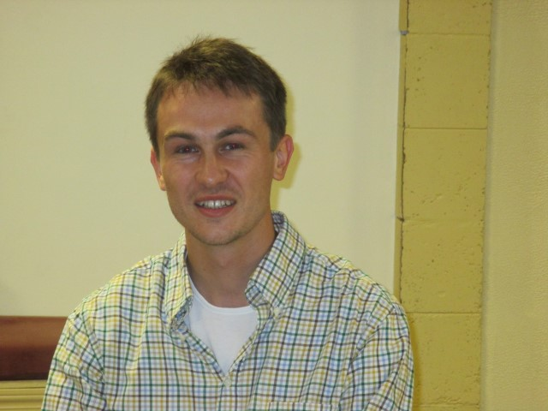
Eduard Navara from Czech Republic here in has once again returned to Chatham. He was here as an exchange student in 2008-2009. His host families were Brian & Cindy Reid and Keith & Joanne Dawson. Eduard is now a 4th year Med Student. He chose Chatham to do a placement as a med Student for 4 weeks instead of going to Germany like most of his classmates do. The membership is very proud of Eduard’s accomplishments. Pres. Fannie assisted Eduard in securing his placement at the Chatham-Kent Health Alliance.

Makeups can be done at the following Clubs

MONDAY
DRESDEN – St. Andrew’s Presbyterian Church – 6:00 p.m.
RIDGETOWN – Anglican Parish Hall – 6:30 p.m.
TUESDAY
BLENHEIM – Legion Hall – 6:30 p.m.
CHATHAM – SUNRISE – Smitty’s Pancake House – 7:30 a.m.
TILBURY – Knights of Columbus Hall – 12:15 p.m.
WEDNESDAY
CHATHAM – St. Clair College Capitol Theatre, Rotary Lounge – 12:15 p.m.
THURSDAY
WALLACEBURG – Happy Craft Building – 6:15 p.m.

Rotary Club of Chatham Officers and Directors
President: Fannie Vavoulis Treasurer: Linda Campbell
Vice President: General Fund Secretary: Tania Sharpe
President Elect: Alysson Storey Service Fund Secretary: Doug Sulman
Past President: Don “Sparky” Leonard Sergeant at Arms: Paul McDonell
Directors: Brett Smith, Jenn Jacobson, Tania Sharpe, Les Herman, Paul Watson

Club President | R.I. President | District 6380 Gov | Secretary | Editor
Fannie Vavoulis | K.R. “Ravi” Ravindran | Henry Dotson | Tania Sharpe | Sandee Frederick
2015/2016 | 2015/2016 | 2015/2016 | 2015/2016 | Executive Secretary
Chatham | Shri Lanka | Auburn Hills | Chatham | Rotary Club of
… |  | USA |  | Chatham

