 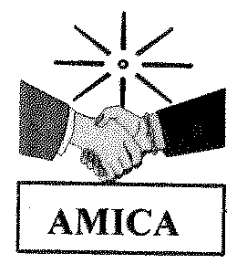

**Final Report:**

**Educating women and girls in Nicaragua’s Indigenous region to defend their rights and address violence against women**

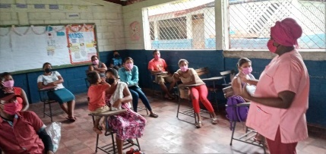

Youth participating in a workshop on COVID-19 safety.

**Final Report**

**Presented to the Rotary Club of Brighton**

**By Horizons of Friendship**

**June 1, 2021**

# Organization Background

**Name of Charitable Organization:** Horizons of Friendship

**Address of Charitable Organization*:*** 50 Covert Street, P.O. Box 402, Cobourg, Ontario K9A 4L1

**Charitable Registration Number:** 11896 3461 RR0001

**Executive Director**: Patricia Rebolledo, 1.905.372.5483 ext. 11 or [prebolledo@horizons.ca](mailto:prebolledo@horizons.ca)

**Key Contact**: Ellen Meadd, Resource Development Officer, 1.905.372.5483 Ext. 13 or [e.meadd@horizons.ca](mailto:e.meadd@horizons.ca)

**Horizons of Friendship (Horizons)** is a non-profit international development organization founded in 1973 and based in the town of Cobourg, Ontario. With 48 years of continuous operation, **Horizons** has evolved from providing humanitarian aid to long-term community-based development addressing the root causes of poverty in Mesoamerica (Central America and Mexico). Horizons' consistent presence has been made possible with strong and enduring local partnerships and has enabled sustained impacts at community, provincial, national, and regional levels.

Horizons works by developing medium- and long‐term partnerships with Central American and Mexican partner organizations and providing education, training, and resources to support local initiatives that further this goal. In Canada, we raise awareness of global issues and work with Canadian organizations at the local and national levels to bring about positive and lasting change. To date, we have implemented 1,400 projects with more than 130 organizations in Mesoamerica, including several multi-year programs funded by Global Affairs Canada. Currently our international program supports the work of 9 partners focused on 11 projects in Mesoamerica.

Horizons believes that true progress in eradicating poverty and fostering equitable development depends upon good governance, democratic process, and a strong and engaged civil society. Since the mid-1980s, Horizons has taken a systematic approach to building horizontal relationships with civil society organizations in Mesoamerica. Our frequent field visits to the region, and our convening of regional meetings, have built trust and mutual respect and expanded opportunities for ongoing dialogue and collaboration so that people can drive the development of their own communities.

**Horizons works with partners who share the basic tenets of its development approach: that programs should empower communities and grassroots organizations to become agents of social change: in meeting concrete short-term needs, but also in articulating long-term aspirations.** Horizons supports partner-defined strategies that include (1) an integral approach to development based on community organization and meeting basic needs in one or more of health, education, production, and human rights; (2) production of knowledge, and (3) citizen participation in local, district and national processes.

# Partner Organization

**The Asociación de Mujeres Indígenas de la Costa Atlántica de Nicaragua** **(AMICA)** is an Indigenous organization headed by Indigenous women. It was established in the 1980s to improve the social and economic conditions of women living in remote communities on the North Atlantic Coast of Nicaragua. One of the first civil-society organizations to emerge in this area and to focus on women, AMICA's vision is of a future in which marginalized Indigenous Miskitu women are empowered to assume leading roles in the development of their families and communities. Towards these ends, one of their primary objectives is to address the high levels of gender-based violence experienced by Indigenous women on the North Atlantic Coast. Horizons has partnered with AMICA since 2008 to support Indigenous women through education on health, violence, and gender equality. Improving agricultural livelihoods has been a complementary focus.

AMICA works to increase awareness of violence against women and of sexual reproduction and health rights (SRHR) among the Indigenous communities of Nicaragua's North Atlantic Coast, responding to a needs assessment conducted in the community, which indicated there was a need for reliable information on SRHR and increased efforts to protect women from gender-based violence. AMICA has scaled-up its educational efforts to compensate for the inadequate support currently available for young people from educational institutions, community leaders, and government authorities.

# Recap of Community Need

Nicaragua is one of the poorest countries in Latin America and the Caribbean, has had a long history of civil war, and is currently experiencing an ongoing human rights crisis that erupted in 2018. With a high poverty rate (i.e., 30% in 2014), an extreme poverty rate of 8%, and a GDP second only to Haiti’s, the country struggles with low and unequally distributed access to basic services such as electricity, water, and sanitation, and issues such as access to education, low secondary school completion rates, and rates of teenage pregnancy which are particularly high amongst Indigenous women on the Caribbean coast (World Bank, 2017).

Being female in Nicaragua means living in a constant situation of violence, discrimination, and poverty. This is especially the case for Indigenous women living in the autonomous regions of the Caribbean Coast where this project is being implemented. Gender-based violence against women has risen country-wide in recent years to become one of the main security problems for this sector of the population in which 9 of every 10 women has experienced some type of violence before the age of 15 (IEEPP,[1] 2017). Femicide, the worst form of violence against women, is also high country-wide and highest along the Caribbean Coast. Although Nicaragua has a legal framework favourable to women's rights, there is a gap between what is established in law and what is enforced. This gap is visible in the absence of access to loans, justice institutions that refuse to recognize women and the civil society organizations that defend them, and a local citizenry that prioritizes economic problems over tackling systemic institutional problems which enable discrimination, poverty, and other factors.

Studies have established a strong link between gender-based violence and women’s poverty rates and the inability to exercise their rights. Nicaraguan women are almost twice as likely than men to be underemployed, and this gap is more pronounced in rural areas. Land, even marital property, still tends to be registered to men. Women who want to start businesses have few opportunities to access credit, particularly on the Caribbean Coast. A woman’s chances for economic security are further limited by early and frequent childbirth. On the Caribbean Coast, 22% of women have their first pregnancy before the age of 15 and Indigenous women have an average of 5 to 8 children.

The response to COVID-19 in the country has left the autonomous regions of the Caribbean coast in a difficult situation. Early on, the national government chose not to establish any type of quarantine measures, even in response to the World Health Organization Director General’s urgings to governments around the world on March 11, 2020 to take aggressive action to stop the virus from spreading. Instead, there has been continued promotion during the pandemic of tourism and mass gatherings such as sports events and church services as well as political messaging that claimed the virus is nothing more than a hoax, while people are dying without access to testing or medical aid. Reliable information about COVID-19 and its spread was not provided to communities and this has been linked by some to a delay in the adoption of protective behaviours by the population and increased infection. The Nicaraguan Ministry of Health (MINSA) has reported a modest number of confirmed infections and deaths related to COVID-19, i.e., 5,833 and 186 respectively on May 25th; however, the COVID-19 Citizen Observatory, a watchdog group of medical professionals and others in the country, has consistently challenged the nation’s official numbers and claimed that actual infections are twice as high and deaths nearly 20 times higher. Claims from Nicaraguan physicians on the dire conditions in the country’s hospitals have been reported widely by media, i.e., no preventative, containment or mitigation actions being used to stop the spread, covering-up of suspected COVID-19 deaths, categorizing them as pneumonia and ordering express burials out of the public eye, and firing medical personnel for speaking out. The government has not released many details on their national vaccination program, but Reuters reported that 167,500 doses had been administered in the country as of May 25th, enough to provide 1.3% of the population with a single dose of AstraZeneca vaccines donated by the COVAX initiative, Russia’s Sputnik V or India’s Covaxin.

It is challenging to get aid to the remote communities of the North Atlantic Autonomous Region on the Caribbean coast where our project is being implemented because of the lack of road infrastructure. Without support to provide advice about managing COVID-19 to communities in this region of the country, our local partner, the **Asociación de Mujeres Indígenas de la Costa Atlántica de Nicaragua** (**AMICA)** stepped in to help and project activities were altered to reflect this. AMICA has provided information about voluntary quarantine and social distancing measures to ensure that the most vulnerable in these communities have the support they need. They set up a plan to help communities recover lost crops, procured and distributed hygiene items to families, and stepped-up their work with traditional authorities to support survivors of sexual and domestic violence. Gender-based violence has spiked in Central American countries during the pandemic; in fact, many refer to this as a ‘shadow pandemic’. We continue to watch this situation. While we do not have reliable statistics on it for Nicaragua just yet, we do know that the incidence has increased by 70% in neighbouring El Salvador, and we expect it is also severe in Nicaragua.

In addition to COVID-19, the communities being supported by this project were hit with two back-to-back hurricanes in November 2020. They were just starting to assess damages and launch the recovery process after hurricane Eta (Category 4) hit, when Iota (Category 5) came two weeks later and devastated much the same Nicaraguan communities along the Atlantic coast and the banks of the Rio Coco which forms the northern border of the country with Honduras. Reports indicate that 16 people were killed and 60,000 evacuated in Nicaragua, in what the country’s Vice-President (Rosario Morillo) called the most powerful and catastrophic storm to ever hit the country. The storm was described as causing the ground to shake like an earthquake, as it tore metal roofs from houses, irreparably damaged medical facilities and other buildings, brought down trees, and left behind high floodwaters. Many hundreds of families were displaced and are still living in shelters. The Nicaraguan military supported rescue efforts and the international community provided food relief aid to the most hard-hit areas and vulnerable populations, as determined in collaboration with local disaster response organizations, e.g., pregnant and nursing mothers, families with young children, elderly, and farmers who lost their crops.

The project aims to improve, strengthen, and continue the advocacy work of AMICA on the Caribbean coast of Nicaragua to address the situation of violence and discrimination against women, contribute to the fulfillment of women’s human rights, and improve the capacity of women, especially Indigenous women, to promote their right to live free of violence and with access to justice.

# Review of Project Summary

**Title:** *“Educating women and girls in Nicaragua’s Indigenous region to defend their rights and address violence against women”*

**Partner:** Asociación de Mujeres Indígenas de la Costa Atlántica de Nicaragua (AMICA)

**Location:** The project will be implemented in the Autonomous Region of the North Atlantic Coast (RACCN), within the Municipalities of Puerto Cabezas and Waspam

**Beneficiaries:** Direct beneficiaries include **1,544** women and youth in 12 Indigenous communities, and **300** more who will be provided with hygiene items to respond to COVID-19. Indirect beneficiaries include **11,064** community members in the two municipalities.

**Project Duration:** December 2019 to May 2021

**Project Budget: $76,992 CDN** over 18 months of which **$250 was received from the Rotary Club of Brighton.**

The *“Educating women and girls in Nicaragua’s Indigenous region to defend their rights and address violence against women”* project was implemented by **Horizons of Friendship (Horizons)** in partnership with Nicaraguan executing agency the **Association of Indigenous Women of the Atlantic Coast of Nicaragua (AMICA)**. **The project’s long-term goal was to contribute to the fulfillment of women’s human rights by addressing violence against women and working to eliminate all forms of violence and discrimination against them. It built on the previous work of AMICA to support women to take on leadership roles in their families and communities and strengthen the local organizations that defend women. This project was designed in collaboration with women in the beneficiary communities of Waspam and Puerto Cabezas and responds to identified community needs. To meet these needs, AMICA scaled-up its educational efforts to compensate for the inadequate support currently available for young people from local educational institutions, community leaders, and government authorities.**

**One of the key goals of this project was to protect the women who voluntarily defend victims of violence. Another was to support women by helping to improve their access to resources and property, by implementing business ventures to build economic independence for women and their children. A third was to provide outreach to adolescents and youth from Indigenous communities to address the issue of early pregnancy and raise awareness to reduce it, in coordination with local health, community and territorial authorities, and religious leaders. A final goal of the project was to build strong, collaborative relationships with public justice institutions to ensure that justice is available when needed for all victims of violence.**

**In addition, as noted earlier, this project responded to the recent COVID-19 pandemic and the lack of support and reliable information made available to participating communities by official agencies. AMICA amended the project budget to allow for the modest provision to these communities of hygiene materials, information sheets, and workshops dedicated to the prevention and mitigation of the disease.**

# Summary of Interim Project Activities and Key Achievements (and in each key component of the project)

With yourgenerous support, **AMICA** built upon past work that was supported by **Horizons** and implemented this project on the Caribbean coast of Nicaragua; that is, with 1,844 women, men, youth, and children in the Municipalities of Puerto Cabezas and Waspam, including 300 additional individuals who were provided with COVID-19-related training and supplies. An additional 11,064 people in these communities benefitted indirectly because of the project’s strengthened advocacy capacities for women, especially Indigenous women, to address the situation of violence and discrimination in which they live and support them in developing skills to access their rights and build economic independence.

A quick summary of program achievements to date is presented below, along with a few photos:

Project activities focused on educating Indigenous youth on sexual health and reproductive rights; training women to act as volunteer defenders for victims of violence; improving access to legal, psycho-social, and medical consultations for victims; and building strong relationships between community organizations and public justice institutions to ensure that justice is available for victims of violence. In addition, the project geared up to support Indigenous women to establish businesses and gain economic independence, but these activities had to be delayed due to COVID-19.

**Women and Youth Supported:**

* 30 Indigenous women received training to serve as volunteer defenders for victims of violence.
* 50 victims of violence were accompanied to court to state their 68 cases before government authorities, resulting in 58 successful rulings and 10 currently unresolved.
* 68 victims received personalized legal consultations.
* 526 people received counselling on sexual and reproductive health.

**Education and Promotion Delivered:**

* 740 young people received training on family planning.
* 540 young people received training on sexual and reproductive health.
* 300 people received COVID-19 training and hygiene supplies. The project reached both urban and rural families living in temporary shelters due to recent hurricanes (Iota and Eta).
* COVID-19 information was distributed in Spanish and Miskitu (local Indigenous language).

**Networking and Advocacy Gains:**

* A guide for volunteer women’s rights defenders was produced.
* 2,376 public authorities and members of the public have been reached through efforts to raise awareness on violence against women in Nicaragua.
* Networking meetings were held with local and international NGOs and organizations to discuss the work and strategies of the Network of Violence Against Women.
* A conference with community leaders was held for International Women’s Day 2020.

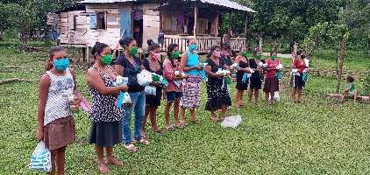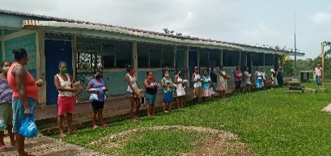

***Distributing COVID-19 Supplies to Locals Displaced into Temporary Shelters by Hurricanes***

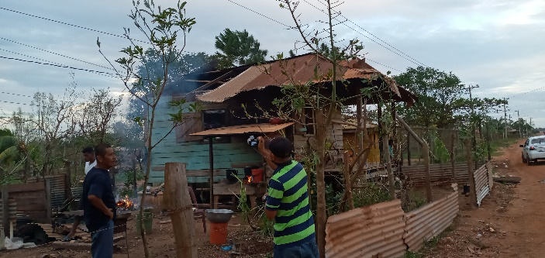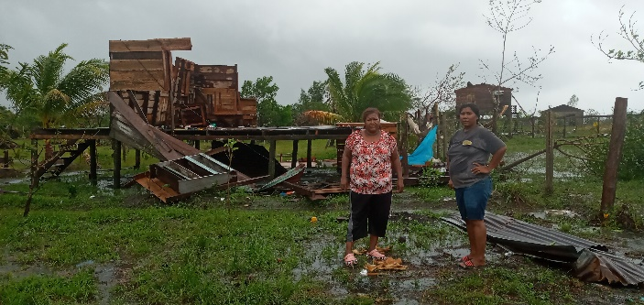

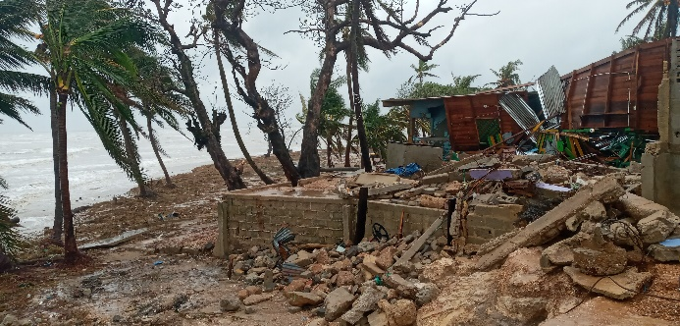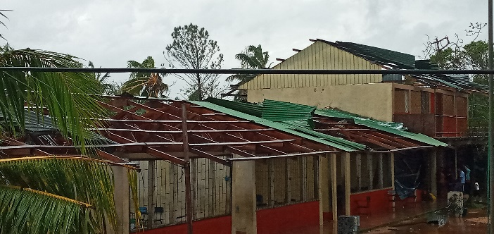

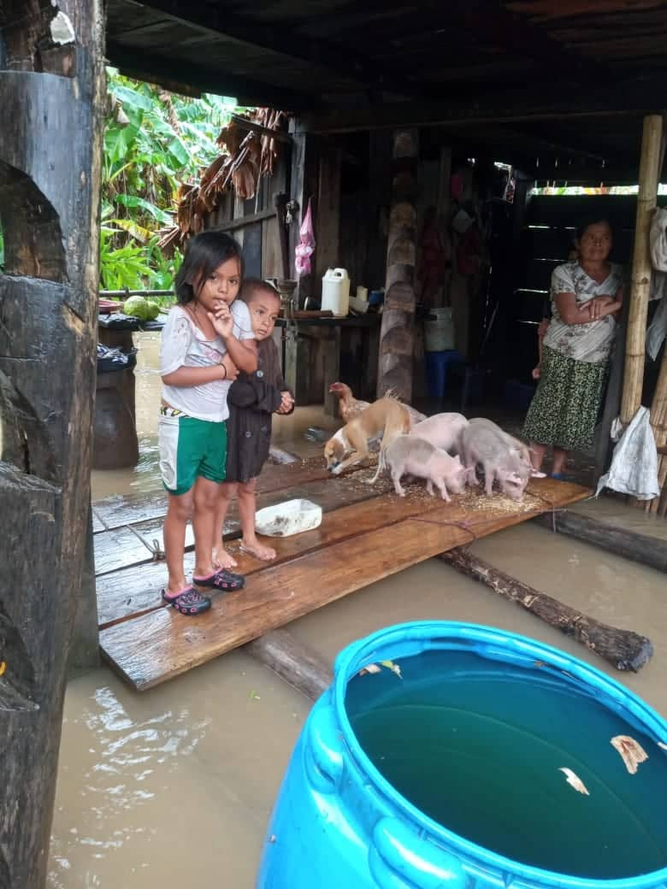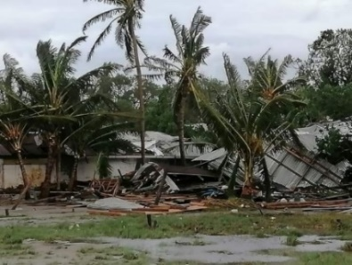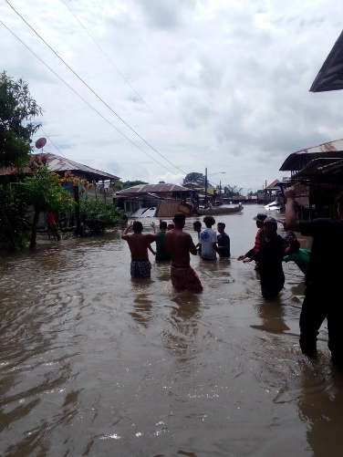

***November 2020 Hurricane Damages***

Specific progress against the expected project results is detailed below.

**Result #1: Strengthen the organizational, technical, and methodological capacities of voluntary defenders to manage compliance with the legal framework for their rights, especially to live violence-free and to have access to productive assets.**

* This goal was achieved. Indigenous women were selected and trained as planned and methodological capacities were developed.
* AMICA selected and trained 30 Indigenous women to serve as volunteer defenders for victims of violence. All the communities in the Municipalities of Puerto Cabezas and Waspam are represented in this selection. These defenders help to strengthen management capacities in the area for the promotion of women's rights.
* A protocol document on Action in the case of Violence Cases was prepared and is available for distribution. This document includes sections on four protocols, e.g., how to provide basic psycho-social care to victims of violence, the use and implementation of self-support mechanisms and procedures, and the use and implementation of The Defender Protection Strategy for volunteer defenders.
* Two reports were produced to track progress towards project goals: (1) a quantification of legal advice provided to victims and (2) a database of case records attended by the community ombudsman.
* AMICA provided economic support to 45 people with limited resources in rural areas to cover their transportation costs, allowing them to seek legal representation and health support.
* AMICA is promoting collaboration with other social organizations working on behalf of women, to strengthen coordination to improve their collective capacity to address gender-based violence and women’s empowerment. Some meetings were attended with partner organizations as below before the pandemic became established. During the pandemic, work continued in small groups and over the telephone, taking the appropriate measures to prevent the spread of COVID-19:

1. Commemoration of International Day of Rights in December 2020.
2. Commemoration of International Non-Violence Day in November 2020, with other member organizations of the Gender Bureau and the Women’s Network.
3. Meeting to commemorate International Girls’ Day in October 2020.
4. A conference to commemorate International Women’s Day in March 2020—topics included themes of violence towards women and repudiation against the death of women in the autonomous region as well as nationally. Partners at this event included territorial civil society organizations.
5. A meeting held in February 2020 with AMICA, Nidia White, and World Vision organizations to discuss the work of the Network of Violence Against Women.
6. A meeting held in March 2020 with the Gender Bureau (MEG) member organizations to discuss a variety of topics related to the work of the Gender Bureau.

**Result #2: Women - adults, adolescents, and youth - of the municipalities of Waspam and Puerto Cabezas will be enabled to work towards the effective implementation of laws, national regulations, and international conventions in favour of women's rights and especially the elimination of all forms of violence and discrimination before institutional and community authorities.**

* Due to the spread of COVID-19 and the two hurricanes, the progress of this activity was slowed slightly; however, this goal is expected to be fully met during the first quarter of 2021.
* 50 women victims of violence were accompanied to court to promote their rights before government authorities, especially their right to live without violence and with open access to justice. This action supported the presentation before court of 68 cases and achieved a total of 58 successful rulings (85% success rate). AMICA accomplished this through partnering with a legal advisory services organization. Cases included intimidation and threat, psychological and physical violence, attempted murder, and child abuse.
* In total, legal advisory services fielded 68 inquiries and provided legal consultations related to 29 civil cases (e.g., distribution of marital property on dissolution of marriage) and 39 criminal cases (e.g., threats and sexual assault), all perpetrated against women.
* 526 people were provided with sexual and reproductive health support and counselling services.
* Work is underway to update information on the work of guarantor institutions in the implementation of justice in the 12 communities being served.
* Work is underway to improve the awareness of public authorities and the public about the situation of violence against women in Nicaragua. To date, 2,376 people in the 12 communities out of a target of 6,468 have developed knowledge of gender-based violence.
* 740 adolescents and young people were provided with workshop training on family planning, including 577 girls and young women and 163 boys and young men.
* 540 young people and adolescents have been trained in sexual and reproductive health; however, these workshops have now stopped because of COVID-19, slowing further advancement towards project training goals during this reporting period. When it is safe to do so, workshops are expected to resume.

**Result #3: Improved access to productive assets and resources for women on the Caribbean coast – especially Indigenous –in the municipalities of Waspam and Puerto Cabezas.**

* The implementation and support of new women-led economic ventures was delayed due to the local emergency response to COVID-19 and the hurricanes that was necessary to support public health over the last few months. Nevertheless, seven joint economic ventures were supported over the reporting period, reaching 24 women. These ventures included economic entrepreneurship in manufacturing masks and the sale of traditional medicinal plants. AMICA estimates that this goal is likely to be fully met by the project conclusion.

**Result #4: Support indigenous communities in prevention and mitigation of COVID-19.**

* This goal was fully met during the reporting period.
* Hygiene products (soap, bleach, and masks) were provided to 12 Indigenous communities in two municipalities and three Indigenous territories (Twi Waupasa-Llano sur, Twi Yahbra-Llano norte, and Municipalities of Puerto Cabezas and Wangki Twi Tasba Raya of Waspam River Coco, directly benefiting 300 Indigenous people.
* Informative materials about COVID-19 were produced and disseminated in Miskitu (the Indigenous language in the municipalities) and Spanish.
* Two informative talks on observing social distancing principles and best practices were prepared and were rolled-out to each participating community and ward.
* Visits to deliver hygiene products and information on COVID-19 safety were made by AMICA to shelters housing those displaced by the hurricanes and remote and difficult to reach communities. For this, AMICA deserves special recognition.

**Testimonial**

*“We greatly thank Horizons of Friendship for accompanying us at this critical moment, allowing us to provide many with information of the utmost importance to deal with the COVID-19 pandemic. There are almost no projects working in the area on community care.”*

***--AMICA***

# Monitoring, Evaluation and Reporting

Horizons has strong monitoring and evaluation practices and policies, regularly collaborating with partners and beneficiaries to ensure accountability. Results Based Management (RBM) methodology and environmental and gender assessments are used to approve and oversee all projects. Independent external evaluations complement this process, as well as administrative and accounting reviews and periodic external audits. Horizons has strong institutional policies on gender equality, environmental sustainability, and anti-corruption. Quarterly financial and semi-annual narrative reports that track progress and achievements at various stages of the project, based on the outcomes listed above, are submitted by our partner **Asociación de Mujeres Indígenas de la Costa Atlántica de Nicaragua** **(AMICA)** and are reviewed by our program team. Regular contact via email, phone, and Skype ensures that Horizons can respond rapidly to issues and needs as they arise. Our Program Financial Officer performs additional monitoring to ensure that project funds are used solely for stated purposes and that partners get the support they need to maintain satisfactory financial and administrative systems and procedures. This entails annual visits to partners, where possible, to conduct audits, reviews, and special training sessions.

Horizons’ Executive Director has 35 years of experience overseeing development programs in Central America and Mexico and is well-versed in identifying and responding to programming opportunities and risks in the region. The Program Financial Officer is a trained accountant with 16 years of experience as an administrator in Costa Rica and 18 years with Horizons overseeing partner financial systems and reporting. Program staff members are trained and experienced in RBM. All Meso-American programming staff at Horizons are fluent in Spanish and English, facilitating understanding with partners.

# Financial Report

Despite the slowing in progress caused by the COVID-19 pandemic and both hurricanes, the project has advanced towards its goals over the reporting period and overall spending is only slightly less than originally expected. Social distancing continues to force lower than expected expenditures in some categories, i.e., contracting local consultants, producing publications to support SRHR workshops, the delivery of these workshops, and transportation. Expenditures are on track for many tasks, however, e.g., those related to project coordination, office and communications, and providing reliable COVID-19 safety information and hygiene products to communities.

# DETAILED BUDGET BREAKDOWN FOR AMICA PROJECT

|  |  |  |  |
| --- | --- | --- | --- |
| **PROJECT EXPENSES – December 2019 to May 2021** | **Total Expenses Budgeted $CDN\*** | **\*\*Expenses Dec. 1, 2019 to December 31, 2020** | **Balance Remaining** |
| **Project Coordination & Staff Costs** | **$27,588** | **$21,924** | **$5,664** |
| Project Coordinator | 10,724 | 9,254 | 1,470 |
| Administrator | 8,151 | 7,033 | 1,118 |
| Resources to support 18-months for care in cases of violence | 8,713 | 5,637 | 3,076 |
| **Contracting Local Consultants** | **$9,170** | **$5,459** | **$3,711** |
| Two meetings to design Self-help Manual for Women Defenders | 2,126 | 537 | 1,589 |
| Two meetings to develop the Strategy for the Protection of Women Defenders | 1,063 | 1,073 | -10 |
| Training for women defenders on relevant topics (Action Protocol / psychosocial) | 1,329 | 1,341 | -12 |
| Diagnostic support, e.g., challenges with government institutions, justice officials’ response towards victims, and so on. | 1,594 | 1,574 | 20 |
| Communication and awareness campaign on gender-based violence | 930 | 134 | 796 |
| Celebration of commemorative dates for women’s rights and against violence | 1,064 | 402 | 662 |
| Producing and disseminating material on COVID-19 | 400 | 398 | 2 |
| Project Auditing | 664 | 0 | 664 |
| **Hygiene Materials for the prevention of COVID-19** | **$1,933** | **$1,993** | **$0** |
| Purchase of Masks, soap, and other cleaning products to be distributed to 300 Indigenous peoples | 1,933 | 1,993 | 0 |
| **Materials for workshops and publications** | **$10,041** | **$4,927** | **$5,114** |
| Producing self-help manual for volunteer advocates | 1,063 | 800 | 263 |
| Workshop for development of strategy for protection of defenders | 1,329 | 0 | 1,329 |
| Workshop for training women defenders on use and application of self-help procedures | 1,329 | 1,342 | -13 |
| Workshop for building alliances and establishing network of volunteer defenders | 1,196 | 537 | 659 |
| Promotion of early pregnancy training / processes for 1,000 adolescents / youth (both sexes) | 1,200 | 0 | 1,200 |
| Promotion of age / circumstance-appropriate contraceptive methods | 1,063 | 800 | 263 |
| Technical assistance for new and established economic ventures (accounting / presentation) | 2,462 | 1,097 | 1,365 |
| Information sessions on COVID-19: Prevention and Mitigation | 399 | 351 | 48 |
| **Transportation and Travel Expenses and Other** | **$11,929** | **$6,122** | **$5,807** |
| Travel expenses for presenting project to communal and territorial authorities | 930 | 939 | -9 |
| Transportation for strategy development workshop | 797 | 268 | 529 |
| Travel for training women defenders | 1,329 | 537 | 792 |
| Transportation to bring together local organizations to build alliances and establish networks | 531 | 268 | 263 |
| Support and accompaniment of victims of violence | 1,594 | 1,073 | 521 |
| Transportation to bring together 1,000 adolescents and youth of both sexes to address early pregnancy | 1,594 | 805 | 789 |
| Travel to various sites to help Indigenous women gain access to economic ventures | 2,591 | 580 | 2,011 |
| Travel to 12 communities to provide hygiene kits, and disseminate information on COVID-19 | 531 | 587 | -56 |
| Field visit to monitor and follow-up of intervention communities | 571 | 134 | 437 |
| Transportation rental (2 trips 1st year / 1 trip 2nd year) | 1,461 | 931 | 530 |
| **Office and Communications** | **$11,935** | **$11,493** | **$442** |
| Office supplies, stationery | 1,107 | 738 | 369 |
| Telephone, power, and internet payment | 1,262 | 1,098 | 164 |
| Contribution for the venue (infrastructure and furniture) | 9,566 | 9,657 | -91 |
| **Monitoring and Evaluation** | **$4,396** | **2,500** | **1,896** |
| **TOTAL PROJECT EXPENSES** | **$76,992** | **$54,418** | **$22,574** |

|  |  |  |  |
| --- | --- | --- | --- |
| **PROJECT REVENUES – 18-Month Project** | **Requested** | **Received** | **Variance** |
| Partner Contribution from AMICA *\*\** | $26,572 | $26,572 | 0 |
| Horizons of Friendship*\*\*\** | $1,396 | $1,396 | 0 |
| **Rotary Club of Brighton** | **$250** | **$250** | **0** |
| Horizons of Friendship and Institutional Donors | $48,774 | $48,774 | 0 |
| **Total Projects Revenue** | **$76,992** | **$76,992** | **0** |

*This budget is in Canadian dollars and was converted from US dollars at an exchange rate of 1.3286 (Nov. 21, 2019). **The contribution from our partner includes both in-kind and financial support to help with project coordination, transportation, and communication services and was converted at 1.3413.

***This represents an in-kind contribution of Horizons staff time and other resources to monitor and support the implementation of the project, build the institutional capacity of AMICA, and ensure the sustainability of their work.

1. IEEPP stands for the Institute of Strategic Studies and Public Policies.