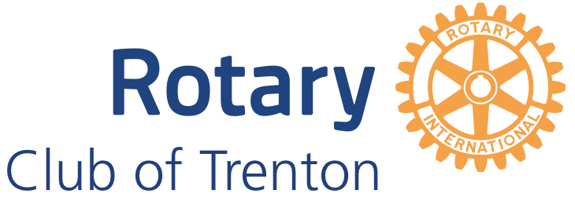

Christmas Party
November 29, 2021 **semi formal**
6:00 pm – 9:00 pm
@ Batawa Ski Hill

Tickets: 70.00 pp ( ages 2 -11: 32.00)
Tickets are on CLUB RUNNER, purchase before November 19
Welcome Cocktail & Wine on the Table (20 Bees Chardonnay or Cabernet Sauvignon)
Delicious Traditional Turkey dinner with all the fixings, soup, salads, desserts
5 piece local band (String Mashup), Christmas Carols and more…

**dietary restriction can be observed (vegan/vegetarian, etc..please advise upon ordering ticket)
**detailed meal information will be online

