THE SERVICE WHEEL NEWSLETTER
January 8 2016
ROTARY CLUB OF BRIGHTON
PO Box 1603, Brighton, ON K0K 1H0
Club Number 26508 Chartered June 14, 1989
www.brightonrotary.ca

President: Patty Parmentier
President Elect: Victoria Parker
Vice President: Ted Harp
Past President: Mark Walas
International: Ted Harp
C Community Service: Larry Dufty
V Vocational: Victoria Parker
C Club Service: Murray Workman
New Generations: Ricardo Melendro
Treasurer: Chris Reed
S Secretary: Tricia Boehme
S SAA: Bob Burke/ Jeff Brace
N Foundation Chair: Ted Harp

Guests: Taylor Navi, past outbound exchange student (Sweden)

Member Attendance: 19 members
Birthdays: R.Ted, January 12th Many Happy Returns!
Our Partners: Brenda, (R. Ted) January 10th
Wedding Anniversaries: none
Rotary Membership Anniversaries: none
__________________________________________________________________________
Happy Bucks:

Questioning protocol…our flag was smaller than the others today. American happy buck for great food on cruise over Christmas. Happy Christmas is over and routine is back. Knee surgery next week . Able to get up a bit earlier with new schedule. The New Year. Great Christmas. Enjoyed Lea’s company and playing Yahtzee. Prepping for back packing, knees are holding out with training. Lots of kids are interested in Early Act, off to a good start. Thank you for presents and sleep over, Parents in Sweden say hello. Going to Spain and always happy. Good Christmas and business is off to a good start, thankful for good people with loan of a car during repairs to own. Great weather. Learned interac machine today. Got sick over Christmas. Good to be back

Breakfast: The Morning Doves prepared scrambled eggs, sausage, hash browns and fruit. They also prepared a Dutch treat for us called Oliebollen…read on as to the new-year tradition and why you should eat them.
Oliebollen, the Dutch version of doughnuts, is literally translated as "oily balls". Not the most appetizing name, to be sure, but there is a history to these delectable pieces of fried dough. They are said to have been first eaten by Germanic tribes in the Netherlands during the Yule, the period between December 26 and January 6. The Germanic goddess Perchta, together with evil spirits, would fly through the mid-winter sky. To appease these spirits, food was offered, much of which contained deep-fried dough. It was said Perchta would try to cut open the bellies of all she came across, but because of the fat in the oliebollen, her sword would slide off the body of whoever ate them.

Correspondence received:
- None

Announcements:
- R. Tricia reminded all to work with their new teams regarding weekly meeting duties.
- R. Ruth updated us on the Refugee committee. Early March a family of 5 will arrive, Mum, Dad and 3 daughters. Fundraising will start now for a second family.
- R. Ruth updated us on the Christmas Hampers. She thanked all who helped which was R. John, Tricia, Nancy Bob B and his wife Pat on day 1 and R Bob B, Mark, and Bob R. 119 families were helped.
- R. Ruth suggested that if you are unable to make a commitment of volunteer time, to let the organizer know in advance. This gives time to seek others out. “
- SAA. Bob delivered an important message on protocol. When we have a guest speaker, please stand and ask your questions so all can hear.
- SAA. Bob reminded all that we should walk about before the meeting starts and shake hands with EVERYONE. This will be an infraction worthy of fines if not executed…warning. Let’s be friendly to all!

Speaker: Outbound exchange student Taylor Navi
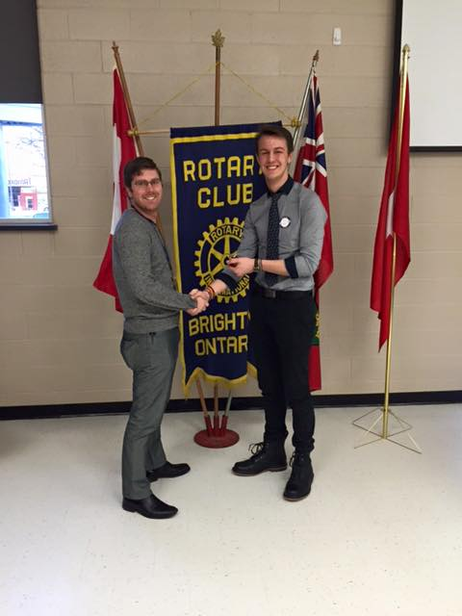Thanked by R. Kyle
Taylor developed a strong sense of family (including friends). He talks regularly with one. In the beginning he struggle to adjust and wanted to change families. He was asked to give it one more try and by the end a strong bond was developed. Taylor picked Sweden because he knew nothing about it. He was surprised it looked a lot like Canada when he got off the plane. His image was skiing, mountains and snow. Taylor met lots of people on his trips and has a strong global network. His trips were Skiing, Arctic Circle and Euro tour. Taylor learned how to deal with conflict and he built strong leadership skills. There are no dress codes at school and washrooms are unisex. You have 12 lessons per week. Taylor passed as proficient in German, although today he is a bit rusty. Taylor will be attending University in Amsterdam.
Taylor was unable to show us his digital presentation due to technical difficulties however handled the situation very well and had us all keenly interested.

Song: I’ve Been Working On the Railroad
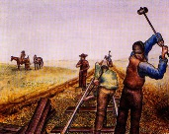

50/50: $21.50. Was won today by R. Dan K and was given to exchange student Lea. She was very happy!

Rotary Minute:
R. Rudy shared with us his beginnings as a Rotarian. He built a marina in Penetanguishene way back when. He had lunch one day with the building inspector who told him about Rotary. It was at that luncheon that he realized he had been a Rotarian all his life. We are thankful he officially joined!

