  - Vol.100/Issue 03
20 January 2020

Scribe: Tess
Quote | “Weeds are flowers too, once you get to know them.”  ~Winnie-the-Pooh  Guests Today  Shaliene Panylo – Prospective member  Larry Stevens – RC of Princeton BC (District 5060)  Cindy Jacobs – RC Uxbridge & our speaker today  President’s Announcements  - Next week’s meeting is at the Jubilee Pavilion. $20 cash only. Mayor Dan Carter will be the speaker.  - 100th Anniversary gala will be April 3rd. Tickets $100, invitations to go out this week via email. Please help promote the event and sell tickets.  Banner Exchange  Larry Stevens from the Rotary Club of Princeton BC presented President Jay with a banner from his Club.
Only about 2 months  until our birthday! | MIC Time  Kevin Harding Sr: please contact him to sign up for a noon hour draw shift. He will be away during January and February  John Hudson: 2016 Global Grants Scholar, Ivana McIntyre wrote a letter to our Club saying that she has completed both of her Masters degrees at the University of London School of Economics and Columbia University. She is now working in India working in two of Rotary’s areas of focus (Maternal/Child health and Economic/Community Development.)  Donna Doherty: received a letter from one of our High School Scholarship recipients thanking our Club and telling us that she will continue volunteering through her post-secondary education.  Tom Hodgson: please pick up your mail. New members now have a mailbox. Tell Tom if you do not have a directory.  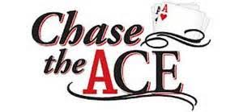  The Noon Hour Draw was worth $160.00. Geoff Lloyd had the ticket  but drew the 5 of Spades.  Final End Polio fundraising prizes  Bottle of wine donated by Arthur Lovell: Ian Young  Canvas bag: John Henry  Painting: Ian Young
Scribe for January Kevin Harding Jr.  Rotary Wheel: Tess | Happy Bucks  - Emmy Iheme: wants members to find people we’ve helped over the years and invite them to our 100th gala  - Kim Tan: we raised $2280 during End Polio silent auction, $6840 after matching grants from the Bill and Melinda Gates Foundation. Wants to invite children and grandchildren to the next Christmas Party  - Donna Doherty: been away awhile, nice to be back  - Geoff Lloyd: guests should not be allowed to sit with Bob Alexander and Bob Armstrong. The English cricket team won.  - Tom Maxwell: Geoff has a big ego because of his new position  - Kevin Harding Sr: played with his grandson Max who talks on his play phone and says he is going to a Rotary meeting  - Kevin Harding Jr: didn’t work this weekend, went tobogganing with his son who taught him that “snow is good”  - Larry Stevens: thanks for a warm welcome. He might be back in February  - Rhonda Gorham: participating in the Coldest Night of the Year fundraiser again. Might do 10km if she gets enough pledges  - Dale Duke: showed off Rotary curling jacket. Al Densham is joining the team who will be competing at world championship Feb 22nd in Madison Wisconsin.  - Al Densham: appreciates opportunity to go to world championship. Thank you Dale.  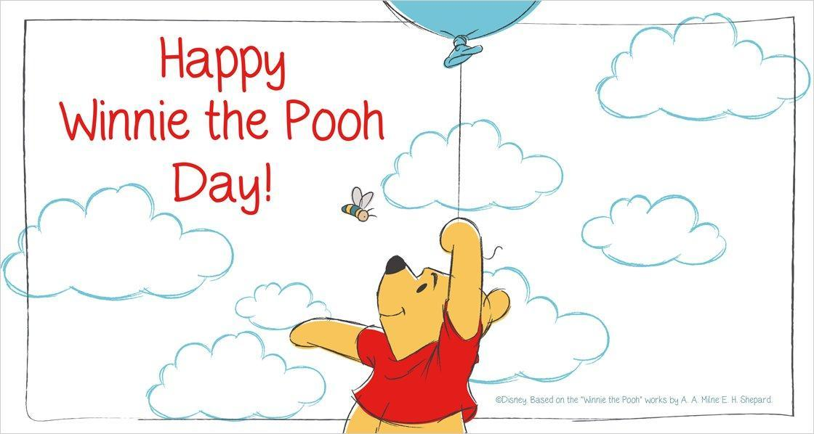

Introduction of Speaker: Donna Doherty
Cindy Jacobs is a member of the Rotary Club of Uxbridge. She grew up as part of a musical family in Toronto. Graduated from the University of Waterloo and was a teacher for 23 years before joining the Teacher’s Federation. She now spends much of her time volunteering.

Harry Colebourn Buys a Bear: Cindy Jacobs
Harry Colebourn was born in England 1887 and died in Winnipeg 1947. He graduated from the University of Guelph and became a veterinarian. In 1914 he became a mounted militia officer and headed east with his men to be shipped to England during WWI.
Cindy is a relative of Harry Colebourn and her cousin has his diaries. During a stop in White River ON, he came across a man with a bear cub whose mother was killed by a hunter. He wrote in his diary that he purchased the bear for $20, named her Winni after his hometown of Winnipeg and brought her to England. Winni was very popular around the base and became their unofficial mascot. By Dec 1914 she was getting quite large and he was ordered to get rid of her so he loaned her to the London Zoo where he visited her during every leave. In 1919 Harry permanently donated Winni to the zoo where she received excellent care.
By 1919 she was one of the biggest attractions at the zoo and in the 1920’s she was visited often by Alan Alexander Milne and his son, Christopher Robin. In 1925, Milne bought a farm near London which became the setting for all of his books. His first book, Winnie the Pooh was published in 1926. The original Winnie the Pooh didn’t wear a sweater, the sweater was added by Disney in the 1930’s. All of the characters in the book were named after Christopher Robin’s stuffed animals (Tigger, Eeyore, Piglet etc).The real Winni died at the London Zoo in 1934 at the age of 20.
In the 1960’s all merchandising rights went to Disney. In 1992 the city of Winnipeg erected a statue of Winnie and in 2014 opened an exhibit about the history of Winnie the Pooh. There is also a statue in White River ON. The original stuffed animals owned by Christopher Robin are on display at the Ney York Library. In recent years a decendant of Harry Colebourn, Lindsay Mallick has written two books titled “Finding Winnie” and “Winnie’s Great War.”
Cindy ended her presentation by reminding us that Winnie the Pooh is not a creation of Disney and has roots here in Canada.

Thanker, Marguerite O’Neal
Marguerite grew up reading Winnie the Pooh and later used the stories to teach children about how to treat people.

Most meetings held on Mondays at Oshawa Golf & Curling Club
Lunch 12:10 pm

