  - Vol.100/Issue 1
06 January 2020

Scribe: Tess
Quote | “Nothing burns like the cold.” ~ Games of Thrones, George R.R. Martin.  President’s Announcements Jan 6  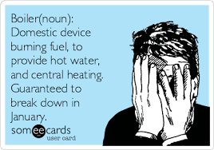  No meeting today due to boiler issues at Golf Club. We will have our regular meeting at Golf Club on Jan 13.  Upcoming Lunch Meetings  Jan 13: Randy Nickerson presents “Year in Review”  Jan 20: Cyndie Jacobs (Uxbridge Club) The history of Winnie-the-Pooh  Jan 27: Civic Day (rescheduled) Mayor Dan Carter  Save The Dates  February 24 - No lunch meeting- Join us for PUB night @ Riley’s Oshawa  April 3-100th year Gala The Jube  April 4-Rotary Leadership Institute
Scribe for January is Kevin Jr.
Rotary Wheel: Tess

Most meetings held on Mondays at Oshawa Golf & Curling Club
Lunch 12:10 pm

