**Rotary Online Auction - Steps to registering, viewing & bidding**

1. Open Internet Explorer and type or click on this link [www.sascoltd.com](http://www.sascoltd.com). Maybe easiest to register from a PC computer.

1. This screen will appear. Click on ‘Register to bid’.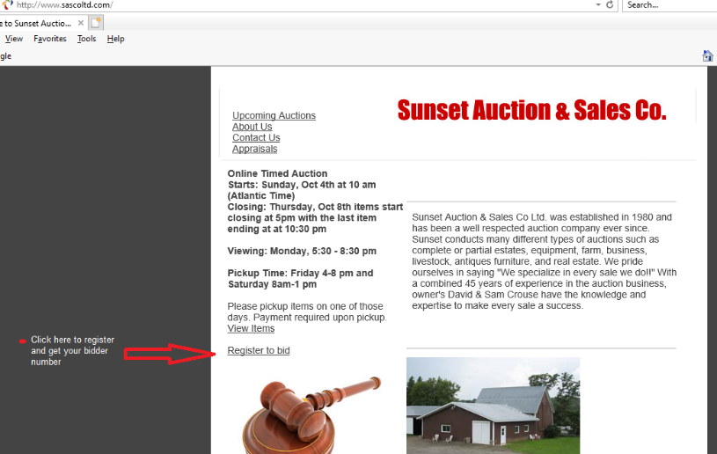

1. The following screen appears. Fill in the required information. Click ‘Create Account’.

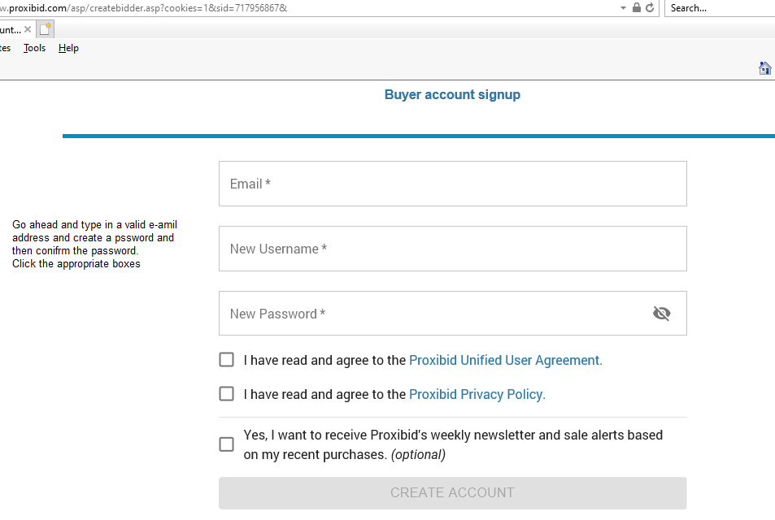

It is necessary to enter credit card information if you want to bid. Your credit card will not be charged for any items in the Rotary Auction. If you are the successful bidder, payments are made to the Florenceville Rotary Club on day of pick-up. Cash, cheques and e-transfers will be accepted, and items must be paid in full at time of pick up.

1. Continue to the next screen and fill in the required information. Note: select Country before trying to enter Province.

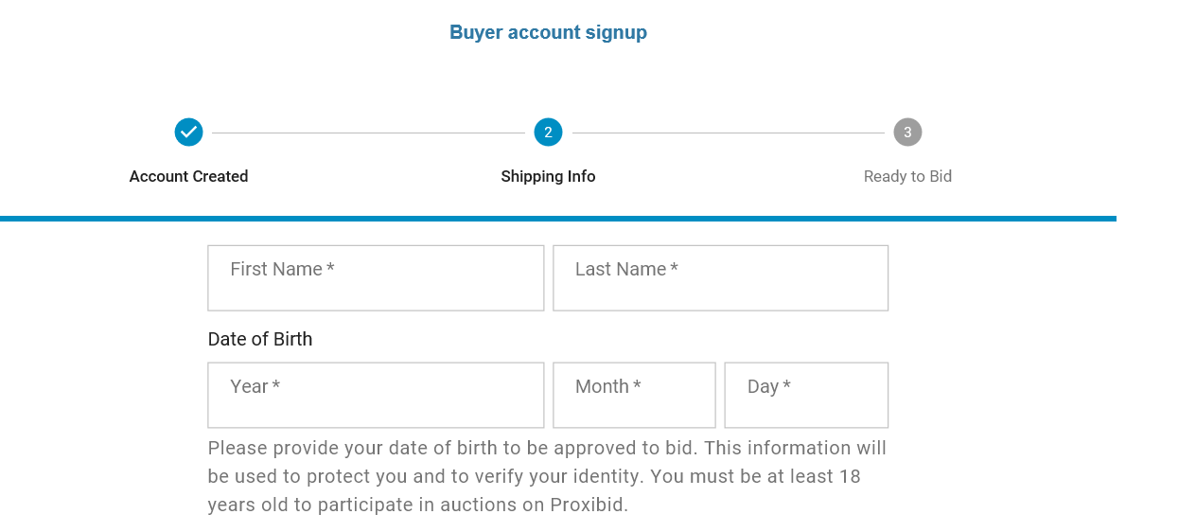

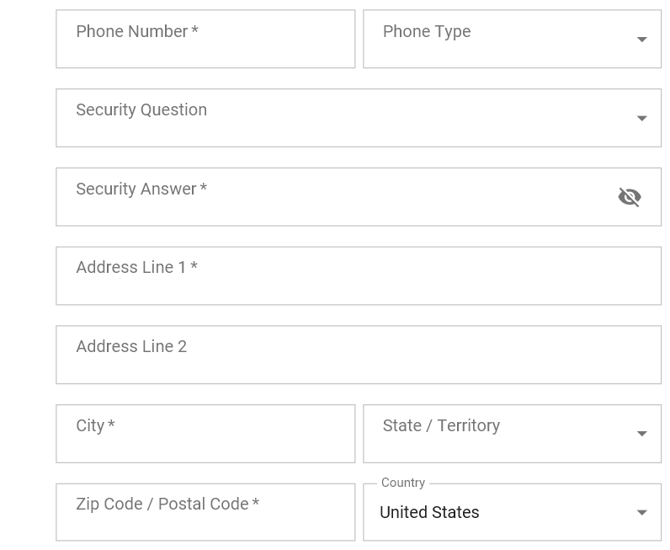

1. Continue to next screen to enter credit card information. Your name and address will automatically populate and the credit card you use must match this name.

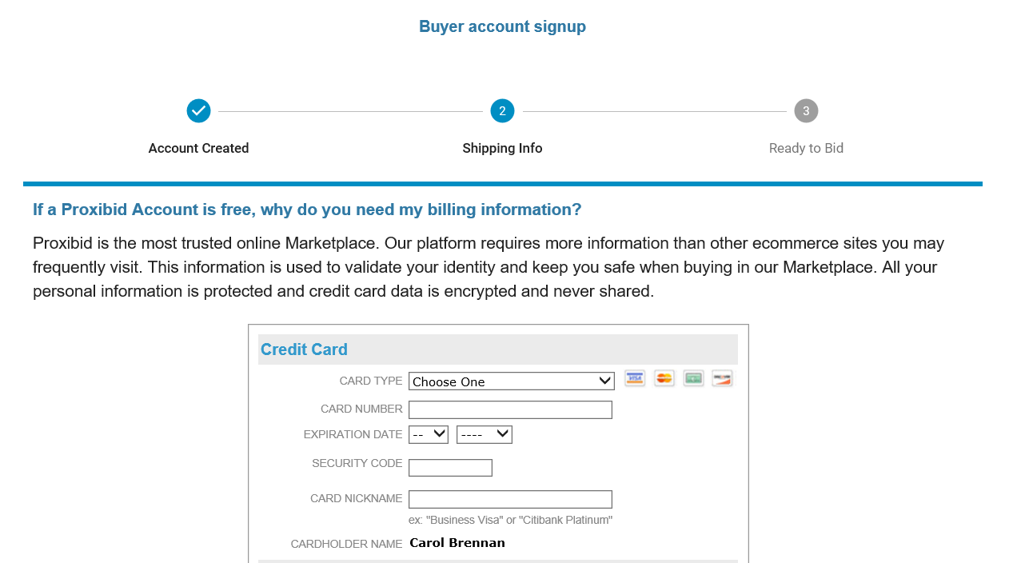

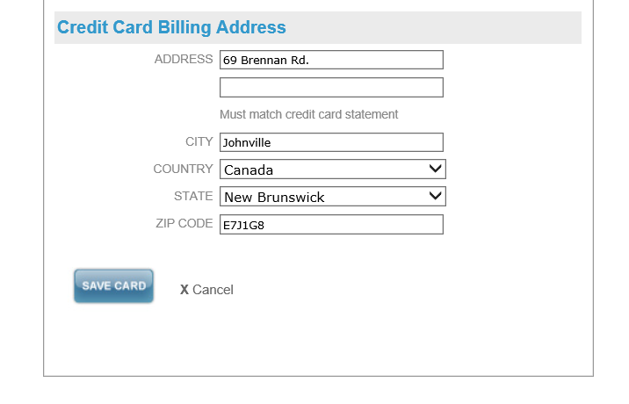

1. Click on SAVE CARD. A message appears saying, “your card was successfully added’. Click ‘Okay’. This screen appears:

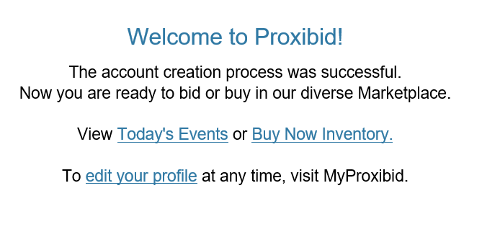

1. You will be sent a confirmation e-mail. Click on the link in the email to activate your account.

You are ready to go to back to [www.sascoltd.com](http://www.sascoltd.com) and view the auctions available. The Rotary Auction will be available for online viewing starting on November 7. The bidding is open from November 9 - 12.

1. Click on View Items



1. Click on ‘Start Bidding’ to view the items available.

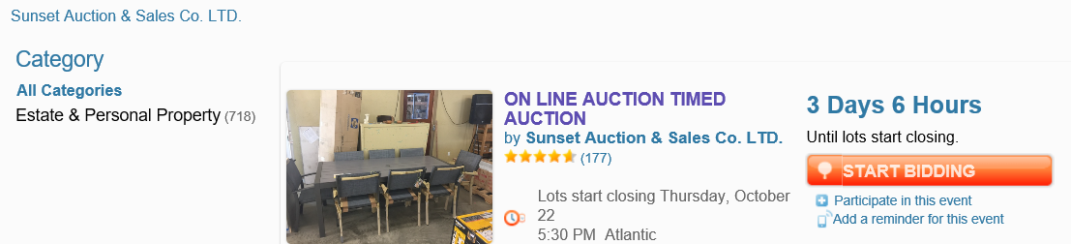

1. Click on ‘Bid Now’ when you see an item you want to bid on.

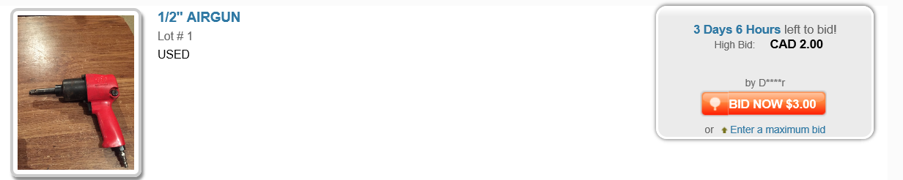

1. If you need assistance, call 1-877-505-7770.

All items are to be picked up on Saturday November 13th at the Florenceville Legion, 219 Greenfiled Rd, between 10:00 AM and 4:00 PM. Cash, cheques and e-transfers will be accepted and items must be paid in full at time of pick up. There will be no charges to your credit card.