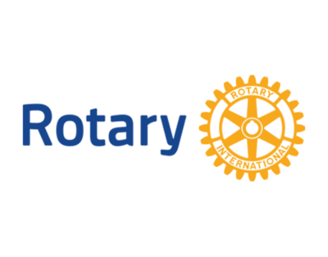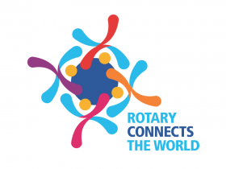
“Service Above Self”
FMAM Rotary Club: Our Mission is to improve the lives of children locally, regionally and glovally.
Committee Chairs
Secretary- Jennifer Miller Treasurer-Gene LaDoucer
Membership-Lucas Reuter Community Service-Dane Skow
International Service-Tom Newberger New Generations-Trudy Latozke
Public Relations-Scott Van Dam Website-Trent Gerads
Fundraising Sylvia Lunski & David Artz Rotary Foundation-Jamie Kronbeck
Club Administrator-Dan Peterson FM Rotary Foundation-David Dietz
Sergeant at Arms – Tom Thompson
President Elect – David Artz
Vice President – Dane Skow
Member at large of the board-Tom Riley & Herb Schmidt

