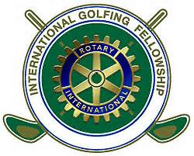
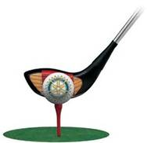

The FM Rotary Foundation Golf Outing at the Moorhead Country Club
Tuesday August 11, 2015.
Shotgun start at 1 pm (includes dinner at 5:30 and door-prizes)
Cost is $100/golfer including green fees & cart fee. The cost to sponsor a hole is $150 OR Sponsors can also provide a golf foursome for $500
Funds raised will be used to pay administrative fees associated with the FM Rotary Foundation.
This is designed to be a fun outing, no handicaps will apply!
If your company would like to sponsor a hole at $150, please fill in below:
____________________________________
____________________________________
____________________________________
____________________________________
____________________________________
____________________________________
Please email your sponsorship logo to kbrokke@borderstatespaving.com for signage.

If your company would like to sponsor a hole and provide a foursome at $500, please fill in below:
____________________________________
____________________________________
____________________________________
____________________________________
____________________________________
____________________________________

If you would like to golf and you know who you’d like to golf with (at $100 each), please fill in below:
Your name___________________________________
Golfer #2____________________________________
Golfer #3____________________________________
Golfer #4____________________________________
OR … if you wish us to place you on a team sign below:

Your name___________________________________

