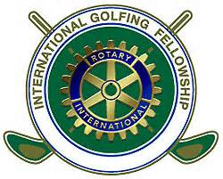
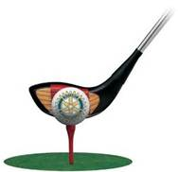

The FM Rotary Foundation Golf Outing at the Moorhead Country Club
Tuesday August 16, 2016.
Shotgun start at 1 pm (includes dinner at 5:30 and door-prizes)
Cost is $125/golfer including green fees & cart fee. The cost to sponsor a hole is $150 OR Sponsors can also provide a golf foursome for $600. This year we are offering a “sponsor a veteran” feature for $200.
Funds raised will be used to pay administrative fees associated with the FM Rotary Foundation.
This is designed to be a fun outing, no handicaps will apply!
If your company would like to sponsor a hole at $150, please fill in below:
____________________________________
____________________________________
____________________________________
____________________________________
Please email your sponsorship logo to kbrokke@borderstatespaving.com for signage.

If your company would like to sponsor a hole and provide a foursome at $600, please fill in below:
____________________________________
____________________________________
____________________________________
____________________________________

If you would like to golf and you know who you’d like to golf with (at $125 each), please fill in below:
Your name___________________________________
Golfer #2____________________________________
Golfer #3____________________________________
Golfer #4____________________________________
OR … if you wish us to place you on a team sign below:

Your name_____________________________

OR … if you’d like to “sponsor a veteran” sign below:

Veteran’s name_________________________ (if name not shown, we will assign)

