601971361
ARTICLES OF INCORPORATION
(Non-Profit Corporation)

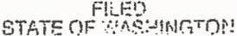

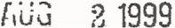

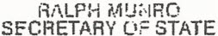

OF
ROTARY SCHOLARSHIP FOUNDATION
I, the undersigned, being over the age of twenty-one (21) years and acting
as the incorporator of a corporation under the provisions of the Washington Non-Profit
Corporation Act (Revised Code of Washington § 24.03) adopt the following Articles of
Incorporation for such corporation:
ARTICLE I
NAME
The name of this Corporation shall be: Rotary Scholarship Foundation.
ARTICLE II
INTENT
The Foundation is intended to be an organization which is exempt from
Federal Income Tax under Section 501(c){3) of the Internal Revenue Code of 1954 (or
the corresponding provision of any future United States Internal Revenue Law) and which
is an organization described in Section 509(a)(3) (or corresponding provision of any future
United States Internal Revenue law). All terms and provisions of these Articles and all
operations of the Foundation shall be construed, applied, and carried out in accordance
with such intent.
ARTICLE III
PURPOSE
The purposes for which the Corporation is organized are:

'J'
.. ~." .

1. The Corporation is organized exclusively for charitable, religious, literary,
scientific and educational purposes as set forth in Section 501 (c)(3) of the Internal
Revenue Code including, for such purposes, the making of distributions to organizations
that qualify as exempt organizations und, Section 501 (c)(3) of such Code.

ARTICLES OF INCORPORATION

1

".,

2. No part of the net earnings of the Corporation shall inure to the benefit
of, or be distributable to its directors, officers, or other private persons, except that the
Corporation shall be authorized and empowered to pay reasonable compensation for
services rendered and to make payments and distributions in furtherance of the purposes
set forth in these Articles of Incorporation.
3. No substantial part of the activities of the Corporation shall be the
carrying on of propaganda (no part of the activities of a private foundation may be used to
influence legislation as defined in Section 4945), or otherwise attempting to influence
legislation. and the Corporation shall not participate in, or intervene in (including the
publishing or distribution of statements) any political campaign on behalf of any candidate
for public office.
4. Notwithstanding any other provisions of these Articles, the Corporation
shall not carry on any other activities not permitted to be carried on (a) by a Corporation
exempt from federal income tax under section 501(c)(3) of the Internal Revenue Code,
(b) by a Corporation. contributions to which are deductible under section 170(c){2) ofthe
Internal Revenue Code, or (c) by a nonprofit Corporation organized under the laws of the
State of Washington pursuant to the provisions of RCW Title 24.03.
ARTICLE IV
TERMINATION
Upon the termination, dissolution or winding up of the Corporation, the
Board of Directors shall, after paying or making provision for the payment of all liabilities
of the Corporation, distribute all assets of the Corporation to The Rotary Foundation
Permanent Fund of Rotary International to be used for educational purposes. Any such
assets not so disposed of shall be transferred to an organization or organizations
organized and operated exclusively for charitable. educational or scientific purposes as
shall at the time qualify as an exempt organization or organizations under Section 501
(c)(3) of the Internal Revenue Code. Any such assets not so disposed of shalf be
disposed of by the Court in the County in which the principal office of the Corporation is
then located, exclusively for such purposes or to such organization or organizations as
said Court shall determine which are organized and operated exclusively for such
purposes.
ARTICLE V
INCOME DISTRIBUTION
The Corporation shall distribute its income for each tax year at such time
and in such manner as not to become subject to the tax on undistributed income imposed
by Section 4942 of the Internal Revenue Code. Further, the Corporation shall not engage '

ARTICLES OF INCORPORATION

2

- - - - -- --------------

in any act of self-dealing as defined in Section 4941 (d) of the Internal Revenue Code, nor
retain any excess business holdings as defined in Section 4943(c) of the Internal
Revenue Code, nor make any investments in such manner as to incur tax liability under
Section 4944 of the Internal Revenue Code, nor make any taxable expenditures as
defined in Section 4945(d) of the Internal Revenue Code.
ARTICLE VI
BOARD OF DIRECTORS
The Corporation shall be organized on a non-stock basis and shall have no
members. The authority for all affairs of the- Corporation shalt be in a Board of Directors
who shall have and may exercise all the powers of the Corporation as permitted by
federal law, state Jaw, these Articles of Incorporation, and the Bylaws of the Corporation
as from time to time in effect. The Board of Directors shall be nine (9) to fifteen (15) in
number, and their names and addresses of the initial Directors are as follows:

NAME | STREET ADDRESS
Eugene Donat | 221 Manzanita
 | Moses Lake, WA 98837
Bill B. Bailey | 234 Crestview Drive
 | Moses Lake, \filA 98837
 | -, .
Peter T. Erickson | 684 Edgewater
 | Moses Lake, WA 98837
David F. Bonato | 1053 W. Broadway
 | Moses Lake, WA 98837
Clay Crook | 431 W. Northshore
 | Moses Lake, WA 98837
Regan D. Bonato | 1053 W. Broadway | - ~ ..
 | Moses Lake, WA 98837 | --J'
 | Moses Lake, WA 98837 | -
Don Unland | 148 Pelican Drive S.E.
 | Moses Lake, WA 98837
Gary Pedersen | 915 Edgewater Lane
 | Moses Lake, WA 98837
Harold Tracy | 538 N. Crestview Dr.
 | Moses Lake, WA 98837
ARTICLES OF INCORPORATION 3

-:
..

ARTICLE VII
INCORPORATOR
The name and address of the incorporator of the corporation is David F.
Bonato, 1053 W. Broadway, Moses Lake, Washington 98837.
ARTICLE VIII
TERM OF EXISTENCE
The Corporation shall exist perpetually unless dissolved according to law.
ARTICLE· IX
REGISTERED AGENT AND OFFICE
The name and address of the initial registered agent and registered office
are:

Registered Agent:
Registered Office:

David F. Bonato
1053 W. Broad~§y
Moses Lake, Washington 98837
ARTICLE X
AMENDMENTS

Any amendments to these Articles of Incorporation shall be made in
accordance with the provisions of the laws of the State of Washington.
ARTICLE XI
DEFINITIONS
All general or specific references herein made to the Internal Revenue
Code shall be deemed to refer to the Internal Revenue Code of 1986 as now in force or
later amended; or the corresponding provision of any future United States Internal
Revenue law. Similarly. any genera! or specific references to the laws of the State of
Washington shall be deemed to refer to the laws of the State of Washington as now in
force or hereafter amended.

ARTICLES OF INCORPORATION 4

' .. ~
~ .
.. '-"---

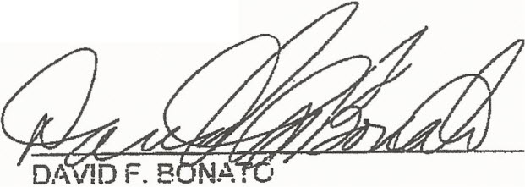
I, the Incorporator, declare that I have examined the foregoing Articles of
Incorporation and that the statements contained therein are, to the best of my knowledge
and belief, true, correct and complete.

Executed this 22nd day of July, 1999.

STATE OF WASHINGTON)
) ss.
COUNTY OF GRANT )

I CERTIFY that I know or have satisfactory evidence that David F. Bonato
signed this instrument and acknowledged it to be his free and voluntary act for the uses
and purposes mentioned in the instrument.
DATED this 22nd day of July, 1999.

7L~~~'-,

Printed or typed Name: Nancy G. Bailey
NOTARY PUBLIC. State of Washington. .
My appointment expires 11-5-02

'.-r('
....
. ' .

ARTICLES OF INCORPORATION 5

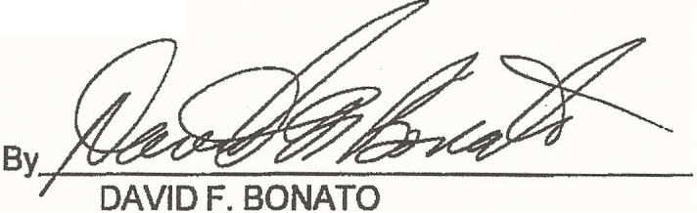
.J
... !: \

CONSENT TO APPOINTMENT AS REGISTERED AGENT

DAVID F. BONATO, hereby consents to serve as registered agent, in the
State of Washington for the following corporation: Rotary Scholarship Foundation. The
undersigned understands that as agent for the Corporation, it will be his responsibility to
accept service of process in the name of the Corporation; and to immediately notify the
Office of the Secretary of State. of its resignation or of any changes in the address or the
registered office of the Corporation for which it is agent.
DATEDthis 2~~YOfJUIY' 1999 ..

1053 W. Broadway
Moses Lake, WA 98837

ARTICLES OF INCORPORATION 6
171002ldoc1

-,-".
-,."
,;"',

