Vol. 1, No. 1 District 6290 Rotaract Newsletter Jan, 2015

Sault Ste. Marie, ON Cadillac Muskegon Baker Muskegon Community College
Grand Valley State University

This is the first of what will be a quarterly newsletter that shares information about the Rotaract clubs of District 6290. The Rotaract motto is ‘Service Through Fellowship’ and members of Rotaract clubs come together on a regular basis to do good in the world, while growing in leadership and professional development. What follows is a snap shot into the lives of these clubs.
DISTRICT 6290 ROTARACT
District Governor-Al Bonney
District Governor Elect-Thomas Schmidt
Rotaract District Chair-Steve Osborn
Rotaract Club of Cadillac-Cadillac Rotary club sponsor
Rotaract President-Danielle Mahan
Sault Rotaract-Sault Ste Marie, ON Rotary club sponsor
Rotaract Advisor-Hilda Odom
Rotaract President-Megan Wigmore
Rotaract Club of Muskegon Community College-Muskegon &Montague-Whitehall Rotary club sponsors
Rotaract Advisor-Mike Alstrom
Rotaract President-Morgan Schwing
Rotaract Club of Grand Valley State University-Allendale Rotary club sponsor
Rotaract Advisor-Aaron Haight
Rotaract President-Abbey Ballard
Rotaract Club of Muskegon Baker College-Muskegon & Montague-Whitehall Rotary club sponsors
Rotaract Advisor-Linda Meyers
Rotaract Co-President-Danielle Woodring
Rotaract Co-President-Stephanie Stewart
First Annual Multi-District Rotaract Conference
The first multi-district conference was held in Cadillac, Michigan hosted by the Rotaract Club of Cadillac and the sponsoring Cadillac Rotary Club. The current District 6290 Governor (Al Bonney), immediate past District 6290 Governor (Jim White), and District 6290 Governor-Elect (Tom Schmidt) were were in attendance with approximately 40 other participants from: Sault Ste. Marie, Windsor, Cadillac, Muskegon, Rochester, and Houghton.
Danielle Mahan, Cadillac Rotaract President opened the conference and this was followed by welcoming remarks from Steve Osborn. Al Bonney motivated the group with his focus on the importance of Rotaract contributions.
Linda Meyers, Muskegon Rotarian serving as Rotaract Chair for the Muskegon Baker Rotaract club, did a presentation on leadership and the qualities of a healthy, well-functioning Rotaract club.
Club presidents presented information about their respective clubs and Steve Fowler, past president for the Cadillac Rotaract club, energized the group with a team building activity. Jim White facilitated discussion on club projects.
Barb Darrigan presented board officer training on the role of Treasurer. Steve Osborn conducted board officer training on the roles of the president, secretary, and board.
The day ended with Rotaract presidents agreeing to partner for a multi-district international service project.

Multi-District International Service Project: Partnering For A Cause
At the multi-district conference, all attending Rotaract Club Presidents agreed to partner with the Rochester Rotary/Oakland University Rotaract clubs to support literacy at the international level, focusing on Guatemala. What follows is the actual project proposal agreed to, as presented by Oakland University Rotaract Advisor, Linda Eastman.
Proposed District 6380 Literacy Project 2014-15 Guatemala Village School Reading Workshop for Teachers
The objective of this project is to promote literacy by offering a hands-on workshop that will give schoolteachers the tools they need to make reading fun for children in their communities.
Outline of Project
Target of 90 participants
Three one-day workshops for 30 primary-school teachers (at a time)
Each workshop will have six modules, three in the a.m. and three in the p.m. There will be a one-hour break for lunch, which will be provided. Refreshments will be served at mid- morning and mid-afternoon breaks.

Example of Modules
How to promote reading in the community (taught by reading promoters from Reading Village - http://readingvillage.org/)
Reading aloud to your students
The importance of rhyming and wordplay in reading development
Helping children choose books
Setting up an inviting classroom library
Fun reading activities for the classroom
The home-school connection – reading at home as a family
Literacy centers in the classroom
Creating a literacy-rich environment
Building vocabulary skills at home and in school
The highlight of this workshop is the Book Fair at the end of each day’s session. Each teacher will receive a quantity of tokens (play money, vouchers, coupons), and he/she will be able to exchange tokens for books. A variety of high-quality children’s books will be offered. Storybooks, non-fiction, informational, poetry, picture books, songbooks, and books of high interest for primary-school children will be available. Teachers will return to their communities with books to start classroom libraries. I would hope that each teacher could receive at least 50 books. In addition, materials will be provided for starting a classroom or school-wide lending library (book cards, pockets, index-card file, dividers, incentive stickers, written instructions).
The school year in Guatemala runs from January to October. I propose that the workshop take place in May 2015.
Budget
Books $19,500
Library Materials 1,000
Food & Beverage for 100 2,000
Shipping (in-country) 2,000
Transportation, lodging, and food 500
for Reading Village reading promoters
Total $25,000
Special Features
The teachers have been in contact with me and have eagerly anticipated this workshop. I have asked them for their input on topics for the modules. Artemis Edinter Booksellers in Guatemala City has already donated a large quantity of new books. They have offered to support the workshop by sending a representative/ teacher.
Books and library materials can be purchased in country. This means that shipping from the USA may not be necessary, allowing us to spend more money on books.
I would like to get several clubs from our district to contribute to this project with funds and expertise. Rochester Rotary Club would be the flagship club. We would then seek a District Simplified Grant. I believe this project would be a good candidate for a TRF Global Grant, but I do not think the Barillas Rotary Club has any open grant slots at present. We would need a host club in Guatemala. There are no other clubs in that general area of Guatemala.
Since I have agreed to serve as the Literacy representative for Rotary Clubs in Oakland County, I am seeking support from clubs in my area (20). We may want to expand it to all the clubs in the District.
Special Note: To honor the memory of DG George Hedgespeth, I propose that we put memorial labels in each of the books, as Literacy was near and dear to his heart, and it was to be a top priority for this Rotary year.

Dear Friends,
I was completely bowled over by your enthusiasm for the Literacy Project I presented to the group at the Rotaract Conference on Saturday! Thank You--Thank You--Thank You for the warm reception you gave to the idea! Please find a written proposal of the project attached.
I did not include a funding scheme with the proposal, but I will give you an idea of how I plan to raise the money for this endeavor. I hope you will agree with me that it has the potential to make an enormous impact on the schoolchildren of northwest Guatemala.
My home club, Rotary Club of Rochester, Michigan, will be the flagship club and will contribute $3,000. I plan to ask every club in Oakland and Macomb Counties for a contribution of $500 to $1,000 each. I don't expect that every club will contribute, but I'm hoping for half the clubs to respond positively. Based on the contributions of each club in our District, I have already applied for a District Matching Grant. Our District 6380 matches 1:2, or 50%. (This is somewhat premature, but the due date for applications was October 1st. The District Grant Committee advised me to submit the proposal and hand in the final tally at a later date.)
Considering your energetic and enthusiastic response to the proposal, I believe I can count on Rotaractors for $5000 total. Do you think this is a realistic estimate? Please let me know. As I mentioned, the amount raised will determine the number of books we will be able to purchase. No donation is too small! Every donation will make a difference!
Please don't hesitate to write or call if you have any questions, suggestions, or comments. As I'm sure you figured out, I am totally committed to Literacy and to this project. I have seen the need with my own eyes and feel very strongly that we have what it takes to make a meaningful change in the lives of some very needy and deserving Guatemalan children. I have a little sign that hangs next to my desk which reads: "If you have knowledge, let others light their candles by it." How similar that is to this year's Rotary theme, "Light Up Rotary!" We have the opportunity to light up the minds of children who were born into poverty but are not doomed to continue its cycle.
THANK YOU FOR JOINING HANDS WITH ME TO MAKE THIS HAPPEN!
Sincerely,
Linda Eastman
(248) 909-5951

Dear Rotaractors,
I am writing to give you an update on the literacy project we are working on together. I am thrilled that you are helping with this project! Thank you!
Someone asked me if there was a deadline for submitting funds. The project will take place in May 2015, so if you think you will have more success in raising funds by taking it into the next semester, by all means, do it! Like I mentioned before, the more money we raise, the more books we can buy.
Would it be possible to talk to your sponsoring Rotary Club about this project? It is a natural for a District Matching Grant, if they want to become involved. It definitely qualifies for the Presidential Citation, for both an international project and a literacy project. If you need me to send anything, please let me know. Or you can forward the attachment I sent initially which describes the project in detail. If you need it again, please ask!
Two weeks ago, I met with Ms. Betzy Castro in Guatemala City. She is the general manager and children's literature expert at Artemis Edinter, a bookstore on the order of Barnes & Noble in Guatemala. I came away more excited than ever about this endeavor. It turns out that Betzy has almost 50 years of experience at all levels of education, from preschool to university. She has written several books, now considered classics in Guatemala, on teaching reading! We discussed the different topics that we will cover at the workshop, and she is eager to be one of the presenters at the workshop. She feels that it will make a huge impact on the students when their teachers learn new and innovative ways of making reading fun in the classroom.
It is our hope that we will be able to invite each teacher to choose 50 books to take home from the workshop to start a classroom library. Remember that most of these classrooms have no books (zero) at present. I have visited many of the village schools and can attest to the lack of any educational materials. As a former teacher, I can't imagine teaching without books of any kind.
I have shipped several boxes of children's books down to Guatemala already, and I gave Ms. Castro a list of titles I would like to see at the "book fair." I have also received word that Guatemalan teenage reading promoters from the non-profit organization Reading Village will attend the workshop and discuss how they are making reading an important part of community life in another area within Guatemala.
Our goal is to raise $23,000 USD for this project. Right now we have raised just shy of $10,000.
The project is taking shape! I am so happy you decided to join hands with your Rotaract counterparts to help with this!
Please don't hesitate to write if you have any questions. Your youthful enthusiasm, can-do spirit, and great ideas are an inspiration to me!
Sincerely,
Linda Eastman
Rotary Club of Rochester, Michigan

Meet the Rotaract Club Presidents and Board Members of Grand Valley State University, Sault Ste. Marie, ON, and Cadillac

The Grand Valley State University Rotaract Club is sponsored by the Allendale Rotary Club and the Rotaract Advisor is Aaron Haight. There are currently 55 active members. Rotaract Club President is Abbey Ballard and this is her second year in Rotaract. She is majoring in Human Resources and Finance. She works as a Team Member at Target in Holland, MI and completed an internship with Edward Jones. She said the following when asked about why she is in Rotaract, “I am in Rotaract because I love networking with the community and helping others. I love that it allows people on campus to meet new people and have fun while helping people in the community.”

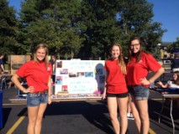
Abbey Ballard (GVSU Rotaract President),
Emily Ringquist, and Taylor Cieslak

The Rotaract Club of Sault Ste. Marie, Ontario (Sault Rotaract) was certified by Rotary International June, 2014. The sponsoring Rotary club is Sault Ste. Marie, ON and the Rotaract Club Advisor is Hilda Odom. There are currently 12 active members. The Rotaract Club president is Megan Wigmore. Megan attended the University of Western Ontario (2007-2010) earning a Bachelor of Arts degree in Media Information and Technoculture, and a certificate in Creative Writing, She then attended Humber College (2010-2011) and achieved a Post-Graduate certificate in Advertising Copywriting. She has worked as an Advertising Copywriter in Toronto on major brands, including General Motors and MasterCard and as the Communications Coordinator for Group Health Centre, Sault Ste. Marie Ontario. When asked, “Why are you in Rotaract, what does it means to you, and what you like best about being a part of this group?” she said, “I was a Rotary Youth Exchange Student in 2004/2005 (Denmark) and always knew I wanted to get involved with Rotary again. When I moved back home to Sault Ste. Marie, I started volunteering with my local Rotary club, and caught wind that they were trying to start a Rotaract club - so I jumped on board. I like Rotaract because it gives me a way to connect with other people who want to give back to our community and the world, and together we can do so much more than we can do individually. There's also a great sense of camaraderie - I've made some great friends already, and look forward to making even more!”
Our very first club meeting - June 2014

Club President Megan Wigmore, Treasurer Kylie Wigmore, and members Jamie MacDonald, Nick Willett and Paul Moore
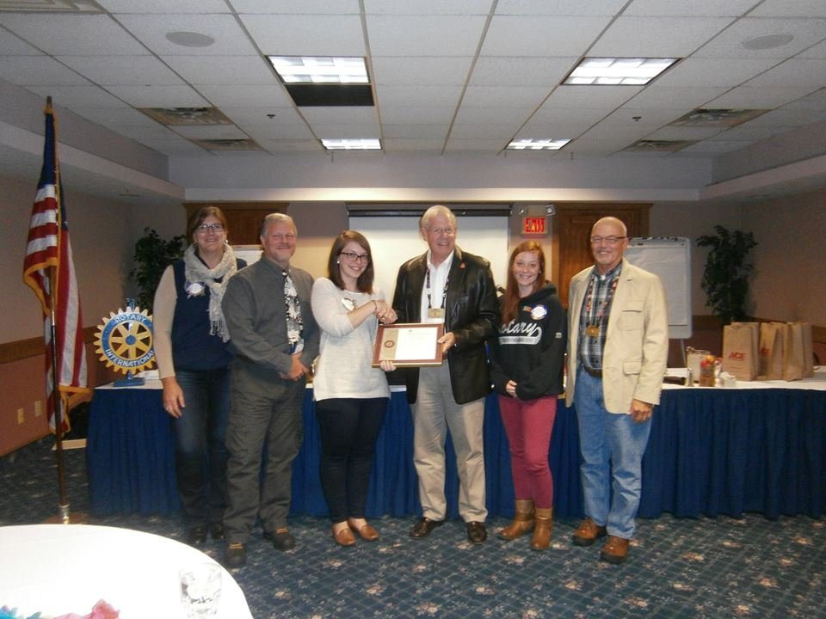Rotaract Multi-District Conference: (L-R) Sault Rotaract Club Advisor Hilda Odom, Rotaract District Chair Steve Osborn, Sault Rotaract Club President Megan Wigmore, District Governor Al Bonney, Sault Rotaract Club Treasurer Kylie Wigmore, and Past District Governor Jim White with the Sault Rotaract Charter Certificate.
The Rotaract Club of Cadillac was certified by Rotary International on November 12, 2013. The sponsor is the Cadillac Rotary Club. Danielle Mahan is the club president. She is a mother of four and working on her Bachelor of Business Administration degree with a concentration in Human Resource Management and a double minor in Accounting and Psychology. When asked why she joined Rotaract, Danielle said, “I joined Rotaract because I feel that it is my job to make myself desirable for my future employer. So when Rotary members came to my class and said that this club provided opportunities for professional development I was sold. Then I learned that they also have a strong focus on community service and networking and thought, that is me!”
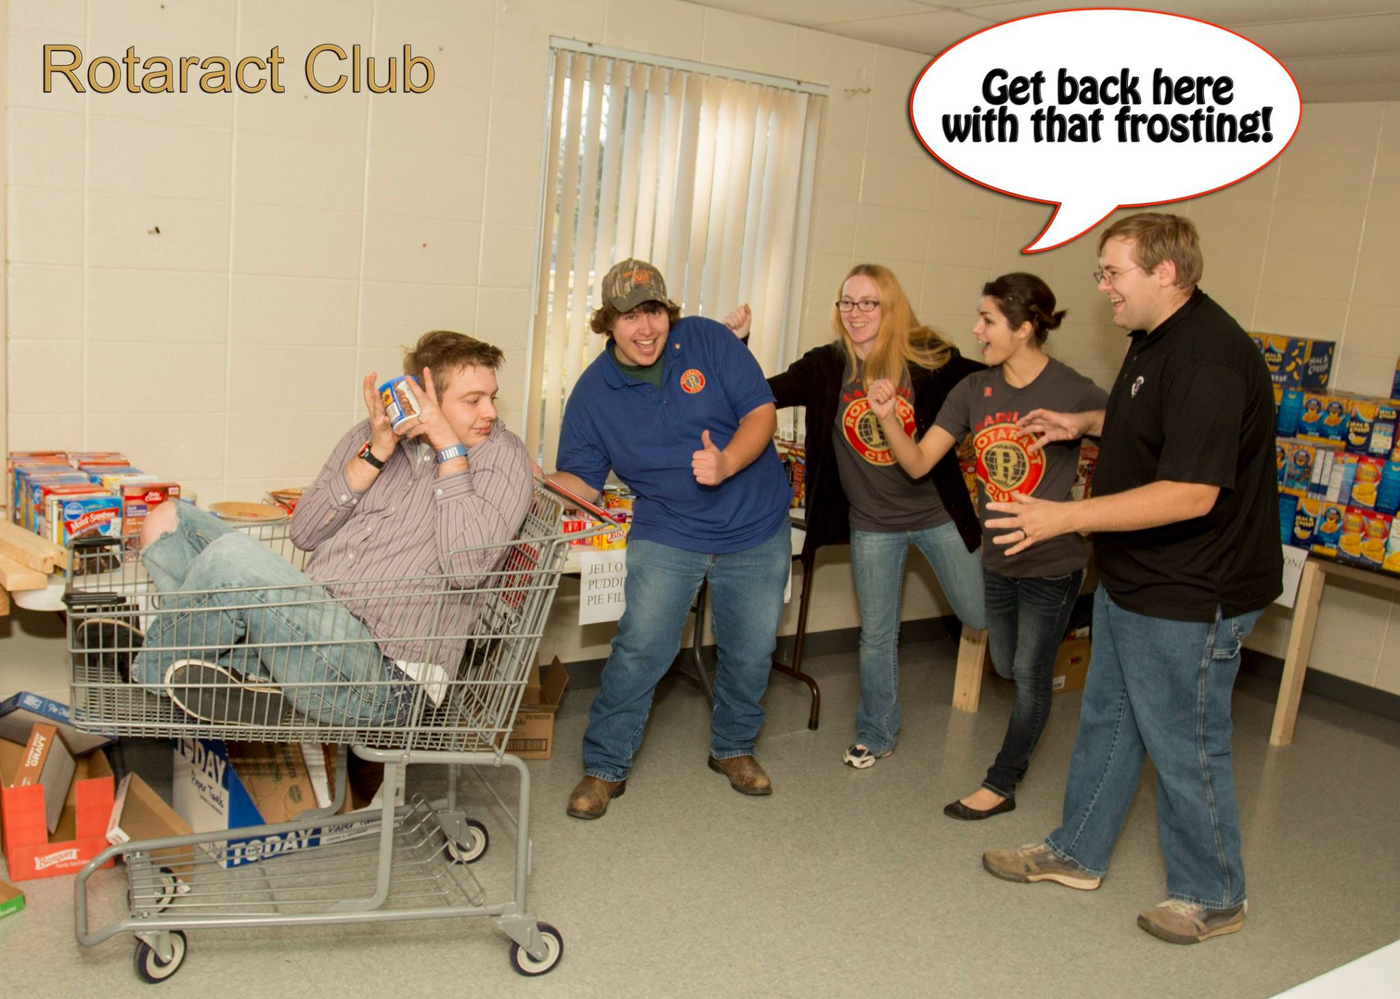

Club Projects and Activities
Here are some of the projects and activities of the Sault Rotaract Club:
May 2014- "Speed Networking" - an event to encourage conversation between people who might not have otherwise met in a format similar to "Speed Dating" (Professional Development)
June 2014 - "Flower Bomb" - an event to help clean up and beautify a rough neighbourhood in our city. Involved planting flowers, painting the outsides of buildings, picking up garbage, sweeping sidewalks, etc. (Community Service - Volunteering)
July 2014 - Miracle Mile Colour Blast - a mile long walk/run/ride that raised money for challenged children in our community and involved "blasts" of coloured cornstarch. Rotaract coordinated the race and organized volunteers for the day-of (Community Service - Fundraising/Volunteering)
October 2014 - Municipal Election Forum: an event that encouraged young people to meet candidates for a city-wide election, and provide opportunities for them to discuss important issues. (Professional Development/Community Service)October 2014 - Personality Dimensions Workshop (Professional Development)
CURRENTLY: Holiday Care Packs - collecting donations of money and hygiene items to make
care packs for homeless men in a local shelter for the holidays. (Community Service - Fundraising)
In the new year: International Project - Books for Guatamala (details TBD)

Here are some Cadillac Rotaract Club projects and activities. The club has been involved in many activities over the past year, including:
The Ed Kellogg Food Drive at the Salvation Army, where we truly expressed the motto of Fellowship Through Service; Project Christmas, where families all over Wexford County come during the holidays and receive food, clothing and gifts for their families; Make over Magic that was an auction raising proceeds for Habitat for Humanity; the Diamonds and Rubies Luncheon that raised both awareness and proceeds for the Precious Gems Home for Women; Stride 4 STRIVE which was a marathon raising awareness and proceeds for STRIDE; the Relay 4 Life helping the American Cancer Society; and Kids Crate where we participated with the Wexford Library to help children work on crafts.
This year the Rotaract Club of Cadillac is working follow up with all of our past activities, but we will also be working with Love INC to connect with and help the elderly in the community. We have offered to do everything from raking leaves to playing board games. Then on an International level we are currently working with Heart Cry International to purchase Shoes for Uganda. For this project every $10 we earn will purchase a pair of shoes for the street boys in Uganda who otherwise would be suffering with issues like foot rot. Finally we are also working with the other Rotaract Clubs to have a combined effort in raising funds for the Guatemala Literacy Project. We have not yet put on a fund raising effort for this; however we have already started to receive donations from local businesses.

District 6290 Rotaract Committee
Our district has the opportunity to establish a District Rotaract Committee composed of the following:
Current District Governor: Provides oversight to the committee; non-member/non-voting
Co-Chair: Current District 6290 Rotaract Chair (appointed by current District Gov); voting member
Co-Chair: Also known as the District Rotaract Representative and is elected by the District Rotaract members; voting member; prefer a member of Rotaract for at least one year
Other Committee Members: An equal number of Rotaractors and Rotarians
appointed by the Co-Chairs; voting members
The committee responsibilities, duties, and expectations are realistic with respect to limited time demand and intended to be a supportive resource to district Rotaract clubs. The expectation is that committee members provide whatever level of involvement they can given the circumstances of their lives at the time. The amount of time a committee member has available to serve the mission will vary from person to person, and any contribution will be greatly appreciated. The mission of the committee is to support District 6290 Rotaract and its ‘Fellowship Through Service’ motto. This will be accomplished by:
*Putting together a quarterly newsletter that informs readership of district Rotaract activities, promotes Rotaract and its cause, and whatever else the newsletter committee determines
*Organizing a Rotaract (Multi-)District Conference that considers offering such content as: Rotaract officer training, leadership opportunities, networking, socializing, fundraising, use of social media, club promotion, member recruitment/retention, professional development, partnering for a cause, team building, or whatever content the conference committee determines
*Communicating with and being a supportive resource to Rotaract clubs in whatever way needed
*Communicating with and being a supportive resource to sponsoring Rotary clubs in whatever way needed
*Growing Rotaract by communicating with identified Rotary clubs as a potential sponsor of a new club
*Ensuring that Rotaract Presidents communicate required information to Rotary International according to the established time frames
*Establishing criteria and certificate for the District Governor’s Rotaract Excellence Award
*Other methods or strategies as determined by the committee
-committee members might want to assist clubs with: fundraising, club promotion, recruitment/retention, use of social media, leadership, and/or professional development, in whatever way the members decide
Give What You Can. The District Rotaract Representative and other committee members will not be required nor expected to commit to committee activities that result in an unwanted degree of pressure due to competing time demands from life circumstances. Committee members will be able to select from a menu of options what they would like to do and how much time they are able to devote. The efficient, well-organized one hour a year will accomplish more than zero hours. One dollar at a time, one step at a time, and one hour at a time…it is all of important value. There are no dues. There is no in-person attendance at meetings requirement. Inter-club committee member communication will be primarily through e-mail.
If you would like to serve on the committee, making whatever contribution you choose, please let me know. If you would like to be a District Representative, please let me know.
Steve Osborn, Ph.D.
District 6290 Rotaract Chair

