Vol. 1, No. 3 District 6290 Rotaract Newsletter July, 2015
Sault Ste. Marie, ON Cadillac Muskegon Baker
Muskegon Community College Grand Valley State University

This is the third installment of the Rotaract District quarterly newsletter that shares information about the Rotaract clubs of District 6290. The Rotaract motto is ‘Service Through Fellowship’ and members of Rotaract clubs come together on a regular basis to do good in the world, while growing in leadership and professional development.

DISTRICT 6290 Rotaract Leadership
District Governor: Thomas Schmidt
District Governor Elect: Gernot A. Runschke
Rotaract District Chair: Steve Osborn
Rotaract Club of Cadillac - Cadillac Rotary club sponsor
Rotaract Advisor: Randy Hill
Rotaract President: Danielle Mahan
Sault Rotaract - Sault Ste Marie, ON Rotary club sponsor
Rotaract Advisor: Hilda Odom
Rotaract President: Megan Wigmore
Rotaract Club of Muskegon Community College-Muskegon &Montague-Whitehall Rotary club sponsors
Rotaract Advisor: Mike Alstrom
Rotaract President: Morgan Schwing
Rotaract Club of Grand Valley State University-Allendale Rotary club sponsor
Rotaract Advisor: Aaron Haight
Rotaract President: Waiting for the information
Rotaract Club of Muskegon Baker College-Muskegon & Montague-Whitehall Rotary club sponsors
Rotaract Advisor: Linda Meyers
Rotaract Co-President: Danielle Woodring
Rotaract Co-President: Stephanie Stewart
Passing of the Baton
Rotaract in District 6290 had an outstanding year under the steady guidance of Al Bonney, now the Immediate Past District Governor. Al was a strong supporter of Rotaract and now that foundation will remain solid under the wise counsel of Tom Schmidt. We give Tom a very warm Rotaract welcome and look forward to a year of integrating Service Above Self with Service Through Fellowship. Thank you Al and welcome Tom!

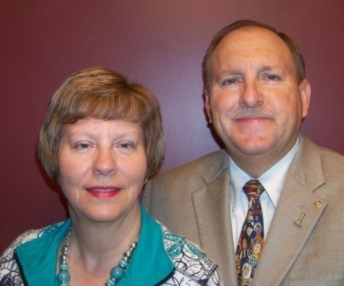
District Governor Tom Schmidt and Denise
2015 - 2016
Rotary Club of Fremont

Presidential Citation Award
Congratulations to the Rotaract Club of Muskegon Baker College for its outstanding achievement of the Presidential Citation Award. The group received the certificate at the District Conference held in Traverse City for its awesome accomplishment. It is highly recommended that all our Rotaract Clubs strive toward this worthwhile award.

Save the Date for the Second Annual Multi-District Rotaract Conference
The Rotary clubs of Muskegon & Montague-Whitehall and the Rotaract Club of Muskegon Baker College will sponsor and host the second annual multi-district conference. The conference will be held at Baker College of Muskegon on October 17, 2015. The event will run from 10:00 a.m. - 5:00 p.m. Please put this on your calendar.

Welcome
A big Rotaract welcome to the new Cadillac Rotaract Club Advisor, Randy Hill. Randy works at Baker College and will bring enthusiasm and focused support to the outstanding Rotaract group.

Rotaract Officer Elections
Congratulations to all those elected to Rotaract Board Officer roles for the upcoming Rotaract year!! Voting results from three clubs were received.

The Muskegon Baker Rotaract Club held its annual election of officers. There are 21 active members of the club and voting results are as follows:
Stephanie Stewart – Co-President
Danielle Woodring – Co-President
Kaytie Ely – Vice President
Brittney Johnson – Secretary
LaQuesha Dixon – Treasurer

Sault Rotaract held its annual election of officers. There are 10 active members and voting results are as follows:
Megan Wigmore-President
Nick Willet-Vice President
Lyndsay Avery-Secretary
Paul Moore-Treasurer

The Rotaract Club of Cadillac has 8 active members and held its election of Board Officers in May. Results are as follows:
Danielle Mahan-President
Tyler Chamberlin-Vice President
Michaela Chamberlain-Lead Secretary
Caitlyn Shead-Assistant Secretary
Steve Fleetwood-Treasurer

Multi-District Literacy Project
At the first multi-district Rotaract conference, the attendees agreed to a joint service project that targets literacy needs of some children living in remote areas in Guatemala. Linda Eastman heads this project and here is her update.

Teachers' Workshops – Motivating Children to Love Reading
Reading opens new worlds. It opens minds to new information and ideas. It stimulates imagination and creativity. Reading establishes a sense of competence and paves the way to academic success. Besides, it’s just plain fun. But how can teachers in remote villages in Guatemala foster reading skills when their classrooms have very few books and when many of their students’ parents cannot read?
Casa Colibrí developed a teachers' workshop to address these challenges. With the collaboration of the local education authorities, we invited 90 teachers from the villages surrounding Barillas and the Casa Colibrí Clinic to attend one of three workshops held May 13th, 14th and 15th in Barillas, Huehuetenango.
The workshops were highly interactive and focused on developing new approaches for encouraging reading through a wide variety of word games and fun reading activities. Teachers learned how to develop group reading activities such as "Drop Everything and Read," setting a time each day for everyone in the school to stop what they are doing and read for 20 minutes. Readers' Theater was a particular favorite—students take turns reading and acting out parts of a story.
The groups discussed ways to encourage reading at home. Reading a book to a pet or making up a story to go along with a wordless book are ways to build confidence and improve fluency.
Reading Village, another organization working in Guatemala to change lives through literacy, shared its model and best practices with the teachers. By reading aloud to children, they foster a love of reading and promote literacy in the communities where they work.
The workshops also dealt with how to set up a classroom lending library and included materials for checking out books. Teaching children to care for books was a lively theme. These topics had never been relevant since there were so few books available. Through the generous support of Rotary District 6380, Librería Artemis Edinter, and Rotaract Clubs from Michigan and Canada, each teacher was able to select 35-50 books to establish a classroom library.
The teachers were enthusiastically discussing their plans for incorporating new reading activities into their classrooms as they filled their arms with books. The success of the project was evident as teachers requested additional workshops so that their colleagues might attend. There was keen interest in a workshop for preschool and kindergarten teachers.
Being able to place a book in a child’s hands is priceless. But being able to support teachers with new approaches and resources to use in their classrooms enables them to multiply their impact across many children and families, class after class. Just think of the new worlds that will open up to the indigenous people of these remote villages as they begin to learn and love to read.
$20,262.06 was raised for the project.
$20,262.52 was spent.
Trainers paid their own expenses.
All participants were fed lunch and two snacks. Lodging was provided for any participant who needed it.
Rotaractors from Houghton Hancock, Baker College, Sault Ste. Marie, Cadillac, and Oakland University raised a total of $1703.00.
Linda Eastman
Literacy Chair, District 6380

Rotaract Club Activities
The past three months have found Rotaract clubs around the district to be quite busy with service to others, professional development and leadership training, and fellowship.

The Rotaract Club of Cadillac is excited for all of the wonderful community service opportunities coming up for summer, like Rely for Life! For Professional Development we have had a couple speakers come in at talk with the group. First we had Amy Gibbs who owns Hagstrom’s Flowers here in Cadillac speak with us about the accounting side of owning a business. Then we had Tom Armstrong who works for the Wexford-Missaukee ISD speak with us about work-path goals and how to reevaluate them. The Rotaract Club of Cadillac is excited for summer and is currently planning a social canoe/kayak trip and a campout. Cross your fingers for great weather. One fun thing that the Rotaract Club of Cadillac did different this year was help more with the Rotary Club of Cadillac’s Auction. Last year we helped them with set up, day of and clean up, this year we donated a Rotaract Club Tee and 4 hours of service. Our club earned the Rotary $200 and we had a wonderful time with Rotary member Mark Lagerwey fixing up his new house. We would also like to say a special Thank You! to Linda Meyers who helped us acquire Rotaract Sashes for our graduates to wear at graduation. It is wonderful to know that if we have questions there is always someone to reach out to.

Muskegon Baker Rotaract reports the following.
Here are some things we have been involved with since April:

*WIC – Project Fresh Day of Caring – Students will be working with WIC families doing arts and crafts and playing games
*Party in the Park – Will be working with the Muskegon Rotary club at this annual
fundraiser. This is an entertainment event for the entire family with local
bands, food, and beverages.
*Kids’ Food Basket – volunteered every Friday and helped pack over 13,600 sack
suppers for elementary children in need
*Read Early Read Often – hosted this reading opportunity at Baker College every
month for parents with children ages 0-36 months
*Youth Day of Caring – Helped clean up Camp Pendalouan
*Pheasants Forever Habitat – Planted 113 trees at the Muskegon County
Wastewater site
*Will be working the annual Seaway Run held in Muskegon handing out water to
participants and giving them encouragement
*Will be working at the Taste of Muskegon event helping Kids’ Food Basket
decorate paper bags for sack suppers.
*Fundraising – Organized three dine-to-donate events with Brann’s, Buffalo Wild
Wings, and the Station Grill
*Had an empty pop can collection contest
*Had a fundraiser table on campus selling crafts, books and baked goods
*Professional Development and Leadership skill training:
*Co-hosted a media marketing insight series. This was a TED like talk. The event
was open to the public. The speakers were from our local hospital group and discussed the use of technology in the medical field and marketing.
*Stephanie Stewart was one of the key note speakers at the annual United Way
of the Lakeshore’s Volunteer luncheon
*Attended the Rotary District Conference in Traverse City where our club was
awarded a Presidential Citation for 2014-2015
*Stephanie Stewart will be one of the leaders at the Rotary Youth Leadership
Camp in Tustin, Michigan where 150 high school students will be attending.
*Attended United Way’s Annual meeting
*Attended local Rotary Business Connection meetings
*Attended a Muskegon Rotary Lunch
*Attended a Grand Haven Rotary Lunch
*Multi-District service project (literacy project): our club donated $200 to this
literacy project by conducting a Yankee Candle sale
*Our club attended a Muskegon Rotary lunch and presented a check to the
United Way of the Lakeshore for $7,000 which is intended to go toward
literacy projects.
*At the beginning of May, we held a speakers event at a local banquet hall.
Tickets were $20 each and included dinner (soup, salad, chicken, roasted
potatoes) and 4 inspirational talks from local leaders. Thanks to a generous
corporate sponsor, almost all of our overhead costs were covered - so our
club decided to donate the full amount of the ticket price to two charities:
$1000 to the Red Cross (Maternal and Child Health program) and $500 to
create microloans for several women starting businesses via Kiva. This also
proved to be a great leadership development opportunity for our club
members, as the speakers all spoke to topics related to leadership, seizing
opportunities, and overcoming adversity.
*In response to the multi-district service project, our club collectively pitched in
and donated $150USD. Looking forward to an update from Linda on how
the trip went.
*I'd also like to add that there were 3 of us that made the trip down to Traverse
City for the district conference (6290), and we had a great time catching up
with the Baker College - Muskegon group.

**Please check out the video of the Muskegon Baker Rotaract Club at:
https://youtu.be/3ttZC0MOr_o

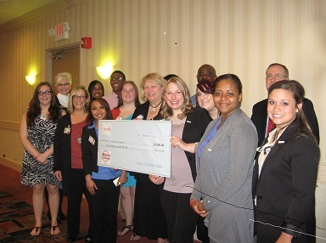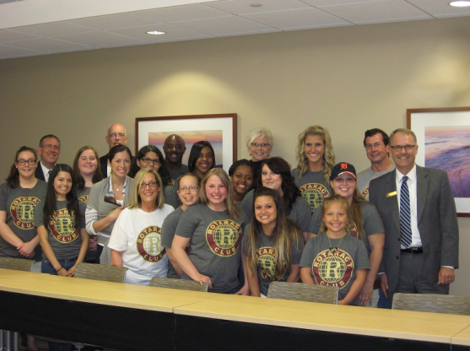

The Sault Sainte Marie Rotaract Club shared their activities over the past quarter.
At the beginning of May, we held a speakers event at a local banquet hall. Tickets were $20 each and included dinner (soup, salad, chicken, roasted potatoes) and 4 inspirational talks from local leaders. Thanks to a generous corporate sponsor, almost all of our overhead costs were covered - so our club decided to donate the full amount of the ticket price to two charities: $1000 to the Red Cross (Maternal and Child Health program) and $500 to create microloans for several women starting businesses via Kiva. This also proved to be a great leadership development opportunity for our club members, as the speakers all spoke to topics related to leadership, seizing opportunities, and overcoming adversity. In response to the multi-district service project, our club collectively pitched in and donated $150USD. Looking forward to an update from Linda on how the trip went. I'd also like to add that there were 3 of us that made the trip down to Traverse City for the district conference (6290), and we had a great time catching up with the Baker College - Muskegon group. One of the ideas we had talked about was an all-Rotaract service trip. I know my club was VERY enthusiastic about this idea - would love to find a way to make this happen on a district or multi-district level.

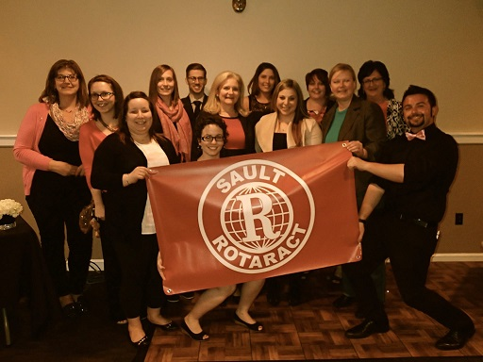

Rotaract Graduation Sash
Graduating students who were members of Rotaract have available for wear a sash that distinguishes them from those students who were not part of a world-wide service club
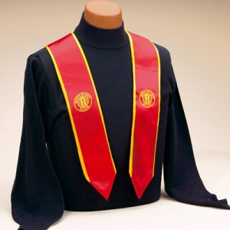

Reminder
Please remember to notify Rotary International of who the Rotaract President is for this new Rotary-Rotaract year.

