Rotary Youth Exchange Invitation
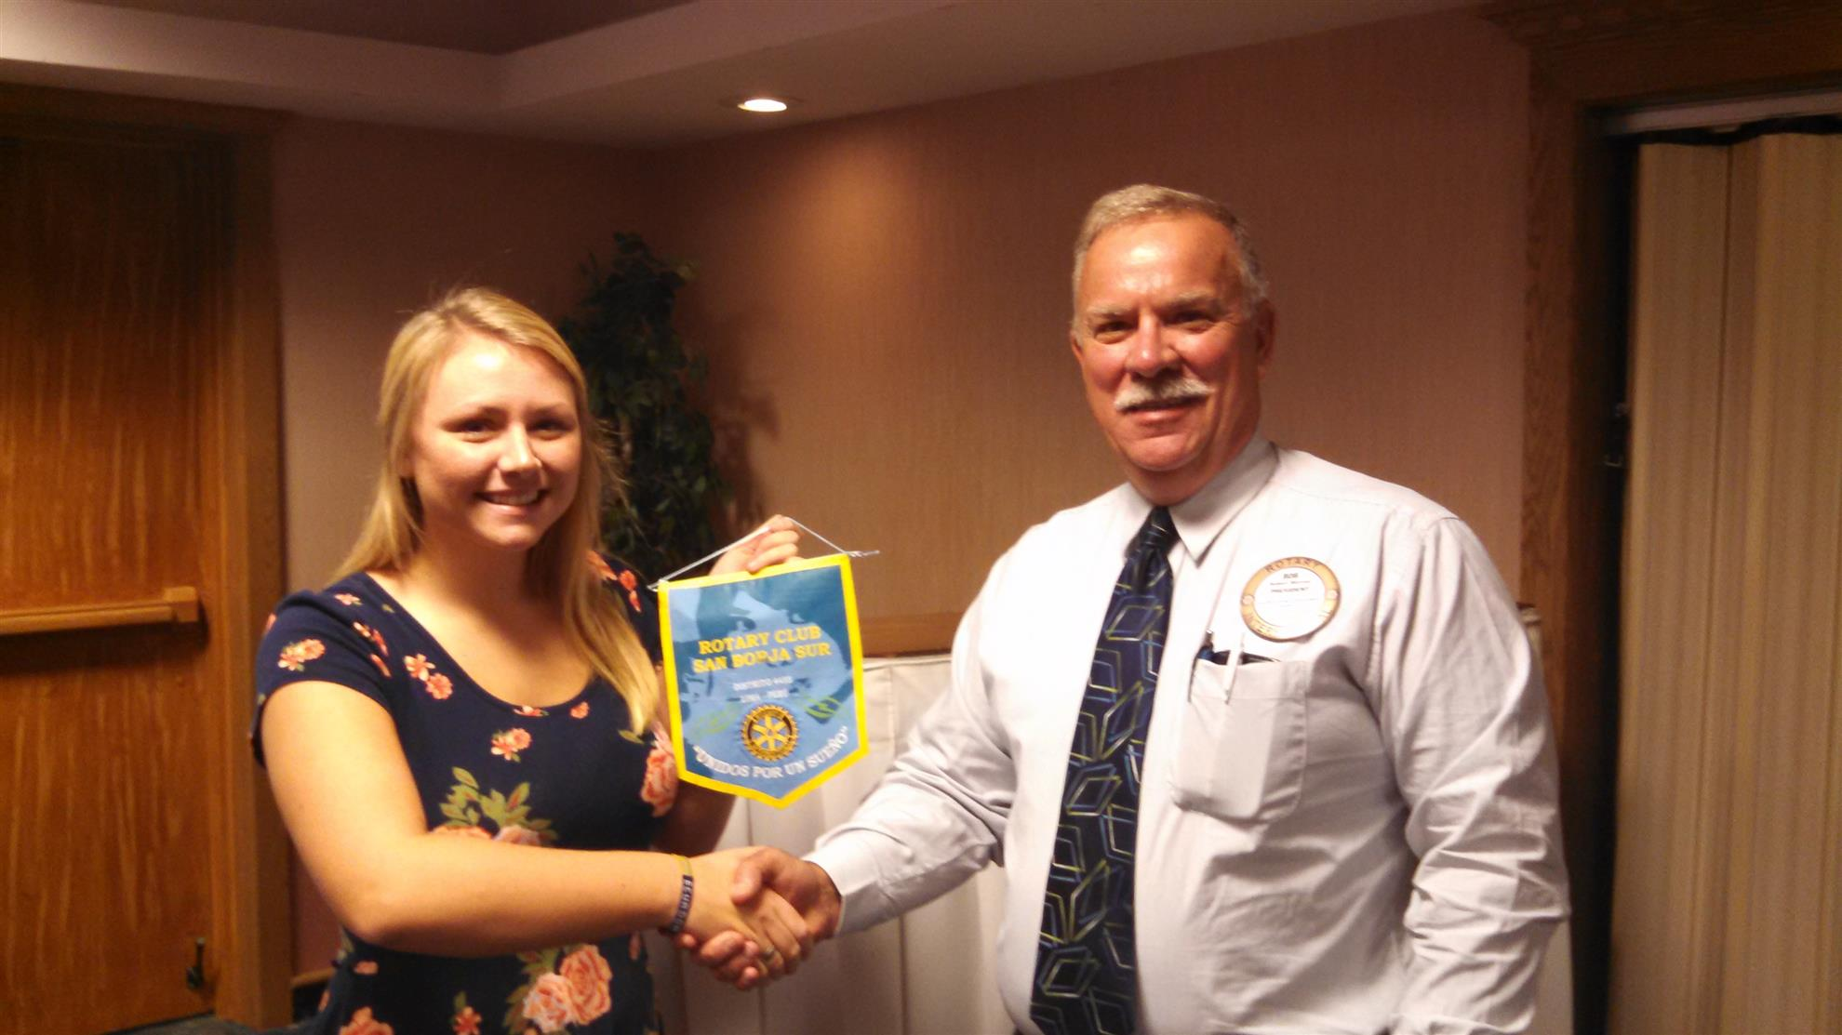
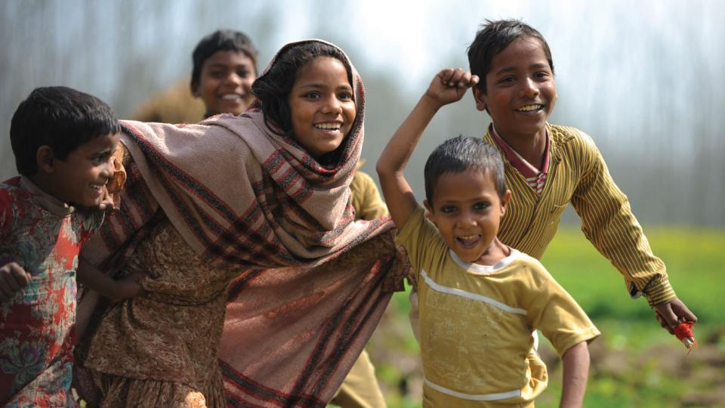

Are you interested in learning a new language or meeting new people? Rotary Youth Exchange is the opportunity of a lifetime for the more than 8,000 students who participate each year. By sharing your own culture and embracing a new one, you help foster global understanding—and learn a great deal about yourself and your home country in the process.

Live Abroad
Spend your junior or senior year of high school as a Rotary Exchange Student in another country. Or take a gap year before college.
Experience the World
Immerse yourself in another country’s culture! The Cadillac Rotary is seeking 1-4 students to sponsor as exchange student for the 2017/2018 school year.
Make New Friends
Meet new people, broaden your horizons and be a part of the International Community. Rotary will train and prepare you for a year prior to leaving for your exchange.
Qualified Students
A. Must be born between 2/1/1999 and 2/1/2002
B. Have a GPA of 2.75 or higher
C. Be a Wexford/Missaukee Intermediate School District Student
D. Should be outgoing and confident
E. Have a high interest in foreign language and international travel
F. Must be available to attend four weekend training conferences beginning with a November 6-8
District Interview conference at the Kettunen Center in Tustin
Contact Information:
Cadillac Rotary Youth Exchange Officer, Amy Gibbs, 231-468-1096 or agibbs@bcbcpa.com.
Contact your High School Counselor for a preliminary application. Application must be received by September 23, 2016. Qualified applicants will be interviewed the end of September at Baker College Cadillac and selected by October 1, 2016.

Visit: www.CSRYE.org for additional information.

Cadillac Rotary Youth Exchange Preliminary Application: 2014/2015

Name ______________________________________ Date of Birth: ______________
Name________________________________________ Date of Birth ______________
Address_______________________________________________________________

Phone #: ___________________________ Email: _____________________________

Father’s Name: _______________________Occupation: ________________________

Address: ____________________________________ Phone #: __________________

Motherʼs Name: ______________________ Occupation:________________________

Address: _____________________________________Phone #: _________________

Name of High School_____________________________________________________

Current grade in school: _______ Cumulative Grade Point Average: _______
What recreational activities or hobbies do you participate in?_____________________

______________________________________________________________________

Do you know of any medical problems that might affect you while staying in another country?
Please Explain: ______________________________________________________________________

What languages have you studied and for how long? ___________________________

Why do you want to go to another country as an exchange student? __________________

____________________________________________________________________________________

____________________________________________________________________________________

What are your plans and ambitions for the future? ____________________________________
____________________________________________________________________________________
______________________________________
Signature of Applicant / Date
Parent Statement:
A family in another country would enjoy having my child live as a member of their family
because: ___________________________________________________________________________________

____________________________________________________________________________________

______________________________________
Signature of Parent(s)/Guardian(s) / Date

