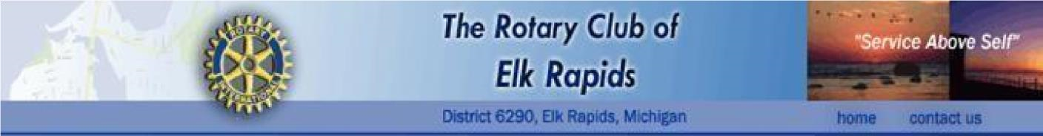

**Request for Good Works Funds**

Please complete the following Request Form and then submit the completed Form electronically, as a

Microsoft Word document (.doc or .docx) to the President of the Rotary Club of Elk Rapids, Dale Gehman at [dagehman1@yahoo.com](mailto:dagehman1@yahoo.com) , Phone: 989-370-6984; and to Jim Nothoff, the Chair of the Good Works Committee at jimnothoff@gmail.com. Phone: 231-350-1901.

You can expect to receive an acknowledgment of your Request by phone or E-mail within two weeks, which response may include follow-up questions. If you do not hear from us, please give us a call. The Good Works Committee meets once a month so please allow 30-45 days for a response to your organization’s Request. Thank you. **PLEASE MAKE CERTAIN THAT THE APPLICATION IS SIGNED**.

*Please note that grants must be from the Club’s geographic and service areas of focus. If you have a question on these parameters, please contact the Good Works Committee Chair.*

1. Name, address, and phone number of the organization making the request:

1. What is the purpose/mission of the organization making the request?

1. Is the organization a 501(c) 3?

If “yes”, please provide the number. If “no”, is the organization non-profit?



1. Describe who, and how many, the project will serve:

1. Please provide a **detailed** description of the project for which funds are requested. Use additional attachments as necessary.

1. Project Funding:
   1. What is the total project budget? $

Please attach a copy of the budget.

* 1. How much is requested from Rotary Good Works? $
  2. Source(s) of remaining funds [give detailed information.]
  3. If the grant is not awarded, how will the project be funded?

* 1. Funding History:
     1. Is this a one-time request?
     2. If “No”, Funds received from Rotary last year? $ iii. Do you anticipate requesting funds from Rotary next year?

1. When will you need access to the funds?

**Please allow 30-45 days’ lead time for the Club to consider your request.**

**Please provide the following so that we may follow up:**

Contact Person to get additional information from:

Organization: ________________

**Signed**: _____________

Title: __________________ Dated: ________

**Following to be filled in by the GWC Chair:**

**Highest Level of Action Required: [ ] GWC $500 [ ] Board >$500 – $3000 [ ] Club >3000**

**Date Received by GWC**

**Chair and Pres.: ___________________**

**Date to Club, GW Committee and Service**

**Committee Chair: _________________**

**Date of Serv. Comm. Final Action: ___________________**

**Action by Serv. Comm. ___________________**

**Date of presentation to GWC: ____________________**

**Date of Final Action GWC __________________**

**GWC Action: ___________________**

**Date Submitted to Board ____________________**

**Date of Final Board Action: ___________________**

**Board Action: ___________________**

**Date of Final Action by Club: ___________________**

**Final Disposition: ___________________**

**Source of Matching Funds: ___________________**

**Date of Communication to applicant: ___________________**

**Date Funds Requested: ___________________**

**Source of Funds: [ ] Club Check [ ] Community Foundation Request**