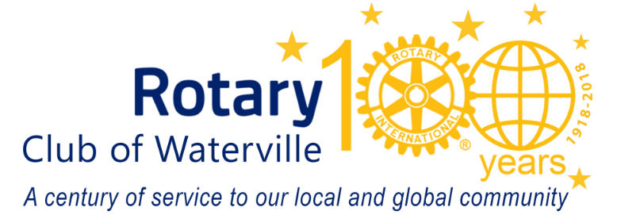
October 2019
Name
Street
City
Dear first name:
The air is changing, the leaves are turning color, the apples are ready for picking and preparations are underway for the 55th Annual Waterville Rotary Auction. For more than half a century, this important community event has raised money to meet area needs. Projects such as: the Maine Children’s Home Teen Parent Program, Operation Hope – treating opiate addiction, Waterville’s RiverWalk, the Neonatal Intensive Care Unit at MaineGeneral’s regional hospital, the Harold Alfond Center for Cancer Care, Inland Hospital, High Hopes Clubhouse, the Rotary Centennial Trail, The Muskie Center, local community food banks, the Mid-Maine Homeless Shelter, area youth scholarships, and camperships for kids are all included in Rotary’s efforts to make a difference in our community.
Proceeds from 2019 Rotary Radio Auction will again support more community programs and initiatives. Energy efficiency is our Community Focus for the year. Not only will energy efficiency save money for those who participate, it will also increase comfort and reduce emissions. Energy efficiency has been a major focus of the 2019 State Legislature, and in this project, Waterville Rotary will be working in partnership with Efficiency Maine Trust, Kennebec Valley Community Action Program, other local Rotary clubs and local contractors. Our aim will be to provide financial assistance for energy efficiency where it is needed most.
Waterville Rotary's International Focus will be to provide financial assistance for a library serving Haiti's College of Social Work and Social Justice in Port-au-prince. We will be partnering with two Waterville psychologists, Miranda and Roger Phelps, who are already very much involved with the project in Haiti, and are fluent in French and Haitian Creole.
Will you please consider donating an item or service from your business, or a local gift certificate to a local business or restaurant in your name? Your business’s name will appear in our Auction’s multi-channel marking. Cash donations are always accepted and always appreciated.
Thank you in advance for helping us improve our community. If you have any questions about the Auction or the other local and international efforts of Rotary, please contact the Waterville Rotary Club: PO Box 192 Waterville, ME 04903-0192 or visit us on-line at www.watervillerotary.com.
Sincerely,

Your name
Rotarian

