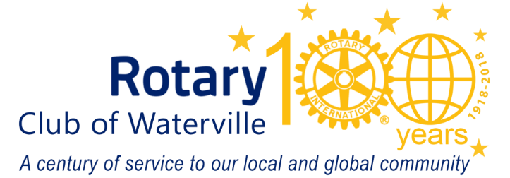
October 2022
Name
Street
City
Dear first name:
As the leaves change color and begin to fall, preparations are underway for the 59th Annual Waterville Rotary Auction. Every year, for more than half a century, this important community event has supported Rotary’s efforts to make a difference in our community.
Proceeds from our 2022 Rotary Online Auction will again go to support community programs and initiatives. Early childhood development and education help to ensure a bright future for our community’s most vulnerable and valuable asset, our children.

It is our goal to support the construction of the new Children’s Discovery Museum and the development of a second natural play area at Educare Central Maine. Together, we can make a difference for the children served by both of these amazing organizations located in Waterville.

Will you please consider donating an item or service from your business, or a local gift certificate to a local business or restaurant in your name? Your business’s name will appear in our Auction’s multi-channel marketing. Cash donations are always accepted and always appreciated.

If you would like to participate in the online auction November 27 thru December 3, 2022, please look at our webpage for details: watervillerotary.com. You may also search for the auction at Bidding Owl www.biddingowl.com/auctions.cfmon
Thank you in advance for helping us make our towns and cities better places to live and work!

Sincerely,

Waterville Rotary Club is a 501(c)(3) non-profit organization

