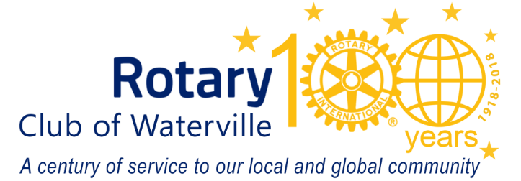
October 2023
Name
Street
City
Dear first name:
As the temperatures begin to dip and we prepare to rake the leaves, preparations are underway for the 60th Annual Waterville Rotary Auction. Every year, for over six decades, this important community event has supported Rotary’s efforts to make a difference in our community.
Proceeds from our 2023 Rotary Online Auction will again go to benefit many important community programs. This year, Waterville Rotary’s initiatives focus on our greatest asset - our children. For example, among the many service projects that we assist with, Waterville Rotary will support KVCAP’s South End Teen Center.
One of our area’s critically important needs is providing safe and secure community spaces for youth, and providing programming to draw out skills, create healthy aspirations, and combat the current mental health and substance abuse crisis. The South End Teen Center offers these types of activities and helps young people develop leadership, self-esteem, and decision-making skills.

Will you please consider donating an item or service from your business, or a local gift certificate to a local business or restaurant in your name? Your business’s name will appear in our Auction’s multi-channel marketing. Cash donations are always accepted and always appreciated.

If you would like to participate in the online auction November 25 thru December 1, 2023, please look at our webpage for details: watervillerotary.com. You may also search for the auction at Bidding Owl www.biddingowl.com/auctions.cfmon
Thank you in advance for helping us make our towns and cities better places to live and work!

Sincerely,

Waterville Rotary Club is a 501(c)(3) non-profit organization

