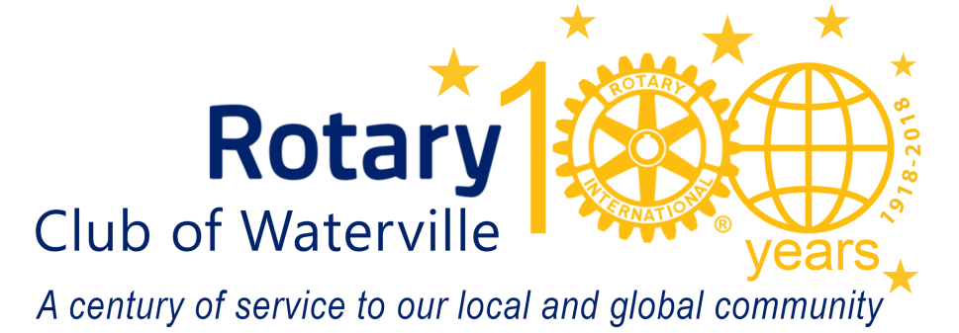
October 2018
Name
Street
City
Dear first name:
The 54th Annual Waterville Rotary Radio Auction is almost upon us. Every year, for more than half a century, this important community event has raised money to meet area needs. Projects such as: Waterville’s RiverWalk, the Neonatal Intensive Care Unit at Maine General Medical Center’s regional hospital, the Harold Alfond Center for Cancer Care, Inland Hospital, High Hopes Clubhouse, the Rotary Centennial Trail, The Muskie Center, local community food banks, the Mid-Maine Homeless Shelter, area youth scholarships, and camperships for kids are all included in Rotary’s efforts to make a difference in our community.
Proceeds from 2018 Rotary Radio Auction will go to support more community programs and initiatives as well. This year, Waterville Rotary will proudly work and collaborate with other organizations and citizens to make a significant donation to the Teen Parent Program at the Maine Children’s Home.
In addition, Rotary is also helping to fund Operation Hope – an opiate addiction treatment program run through the Waterville Police Department – and we continue to support Rhoda Reads, an early childhood literacy program developed in our club as well as many other local initiatives aimed to improve the communities in which we all live and work. The Waterville Rotary Club needs your help in making our community a better place for all of us.
Will you please consider donating an item or service from your business, or a local gift certificate to a local business or restaurant in your name? Your business’s name will appear in our auction ad and is mentioned several times during our live radio broadcast. Cash donations are always accepted and always appreciated.
Thank you in advance for helping us make our towns and cities better places to live and work. If you have any questions about the Waterville Rotary Radio Auction or the other local and international efforts of Rotary, please contact the Waterville Rotary Club: PO Box 192 Waterville, ME 04903-0192.
Sincerely,

Your name
Rotarian

