BY-LAWS OF THE
ROTARY CLUB OF LEBANON, NH CHARITIES, INC.

ARTICLE I - NAME OF CORPORATION

A New Hampshire non-profit corporation named "The Rotary Club of Lebanon, NH Charities, Inc." (Hereafter "The Corporation") has been established as evidenced by a Certificate of Incorporation issued by the New Hampshire Secretary of State and its principal office is in New Hampshire.

ARTICLE II - PURPOSES

The Corporation is organized exclusively for charitable, educational and scientific purposes as defined in the Internal Revenue Code Section 501(c)(3), including, for such purposes, the making of distributions to organizations that qualify as exempt organizations under Section 501(c)(3) of the Internal Revenue Code or corresponding section of any future Federal tax code. In furtherance of that purpose, the specific intention of The Corporation is to manage such funds and property as may be received by The Corporation for the purpose of producing income to be dispensed yearly to fund grant requests from certified tax exempt institutions as defined by the Internal Revenue Code. The intent of the Corporation is to make grants to tax exempt institutions. To further facilitate the achievement of the purposes recited above, The Corporation shall manage its business and affairs in such manner as to ensure compliance with the following provisions:

a. The Corporation shall distribute its income for each taxable year at such time and in such manner as not to become subject to the tax on undistributed net income imposed by Section 4942 of the Internal Revenue Code or corresponding provisions of any subsequent Federal tax laws.

- The Corporation shall not engage in any act of self-dealing as defined in Section 4941(d) of the Internal Revenue Code or corresponding provisions of any subsequent Federal tax laws.

- The Corporation shall not retain any excess business holdings defined in Section 4943(c) of the Internal Revenue Code or corresponding provisions of any subsequent tax laws.

- The Corporation shall not make any investments in such a manner as to subject it to tax under Section 4944 of the Internal Revenue Code or corresponding provisions in any subsequent Federal tax laws.

- The Corporation shall not make any taxable expenditures as defined in Section 4945(d) of the Internal Revenue Code or corresponding provisions of any subsequent Federal tax laws.

F. No part of the net earings of the Corporation shall inure to the benefit of, or be distributable to, its members, trustees, officers, directors, or other private persons except that the Corporation shall be authorized and empowered to pay reasonable compensation for services rendered and make payments and distributions in furtherance of the purposes set forth in this Article II. No substantial part of the activities of the Corporation shall be the carrying on of propaganda, or otherwise attempting to influence legislation, and the Corporation shall not participate in or intervene in (including the publishing or distribution of statements) any political campaign on behalf of or in opposition to any candidate for public office. Notwithstanding any other provision of these By-Laws or the Articles of Association of the Corporation, the Corporation shall not carry on any other activities not permitted to be carried on ( 1) by a corporation exempt from Federal income tax under Section 501(c)(3) of the Internal Revenue Code or corresponding section of any future Federal tax code, or (2) by a corporation, contributions to which are deductible under Section 170(c)(2) of the Internal Revenue Code or any corresponding section of
any future Federal tax code.

G. Upon dissolution of The Corporation as a New Hampshire non-profit corporation, assets shall be distributed for one or more exempt purposes within the meaning of Section 501(c)(3) of the Internal Revenue Code or corresponding section of any future Federal tax code, or shall be distributed to the Federal government or to a state or local government, for a public purpose. Any such assets not so disposed of shall be disposed of by the Superior Court of the county in which the principal office of the Corporation is then located, exclusively for such purposes or to such organization or organizations, as said court shall determine, which are organized and operated exclusively for such purposes.

ARTICLE III - MEMBERS

The Corporation will have no voting members. The members shall however, as set forth below, have the power to appoint the Board of Directors. As of the date of incorporation of the Corporation, the members thereof were and remain:

All members of the Rotary Club of Lebanon, New Hampshire, Inc.

ARTICLE IV - BOARD OF DIRECTORS

The Corporation's affairs shall be managed by its Board of Directors. The Board of Directors will be comprised of the Officers and Directors of the Rotary Club of Lebanon.

There shall be no less than five nor more than eleven Directors who will serve three year terms. The President and the Past President of the Rotary Club of Lebanon, New Hampshire, Inc. shall also serve as Directors. The Articles of Association of the Corporation as filed with the New Hampshire Secretary of State describe a Board of Directors consisting of eleven persons. The Board of Directors shall stay at that number unless and until the members shall vote to change the number of directors. Directors shall be appointed by the members. Any director may resign by giving written notice to the members. The resignation shall be effective at the next regular meeting of the Board of Directors. A director may be removed with or without cause by the other directors and replacement directors will be named by the members.
Directors shall not receive compensation for their services as directors but can receive reimbursement for expenses and can be engaged to perform other services for Corporation as long as the compensation received by such director is not excessive as that term is used in Section 4941 (d)(2)(E) of the Internal Revenue Code of 1986.

ARTICLE V - MEETINGS OF THE BOARD
The Board of Directors shall have one annual meeting. Special meetings, as needed, may be called by the President. Notice of the meeting should be given five (5) days in advance either in writing or by telephone. Attendance at the meeting shall constitute waiver of notice except where a director attends the meeting with the express purpose of objecting to the transaction of any business because the meeting is not lawfully called or convened.

A majority of the directors present at any meeting shall constitute the quorum for purposes of transacting any business of The Corporation.

A director may vote in person or by proxy executed in writing. A proxy shall be valid for eleven months from the date of execution and is irrevocable.

ARTICLE VI - OFFICERS

The officers of The Corporation shall consist of a President, a Treasurer, a Secretary, and one or more Vice-Presidents. The offices of President and Secretary must be held by separate persons, but any other two offices may be held by the same person.

The officers of the Corporation shall be elected by the Board of Directors at the annual meeting. Any officer of The Corporation may be removed by a vote of the majority of the Board of Directors then in office.

President. The President shall supervise and conduct The Corporation activities and operations. He or she shall preside at all meetings and shall keep the Board informed concerning the activities of The Corporation. He or she may sign, in the name of The Corporation, all contracts and documents authorized by the Board. He or she shall have the authority to establish committees and to appoint members to serve on such committees.

Vice-President. The Vice-President shall have such powers and duties delegated to him or her by the President. He or she will serve as President during any absence of the President and during the absence of the President shall have all powers conferred on the President by these By-Laws.

Secretary. The Secretary shall act as Secretary of all meetings of the Board of Directors and shall keep the minutes of all such meetings. He or she shall attend to the giving and serving of all notices of The Corporation. He or she shall perform all duties customarily incident to the office of Secretary.

Treasurer. The Treasurer shall have custody of all funds and securities of The Corporation. He or she shall keep or cause to be kept full and accurate accounts of receipts and disbursements of The Corporation and shall deposit all monies and other valuable effects of The Corporation in such banks or depositories as the Board of Directors may designate.

ARTICLE VII - GENERAL PROVISIONS

- Contracts. The Board of Directors may authorize any officer or officers to enter into any contract on behalf of The Corporation; such authority must be in writing.

- Checks, Drafts, Etc. All checks, drafts, and other orders for payment of money shall be signed by such officer or officers as may have been designated by the Board of Directors.

- Gifts. The Board of Directors may accept on behalf of The Corporation any contribution, gift, bequest or devise for general purposes or for any special purpose of The Corporation so long as the acceptance of any such contribution, gift, bequest or devise does not jeopardize the continuing tax exempt status of The Corporation.

- Books. There shall be kept at the office of The Corporation correct books of account of the activities and transactions of The Corporation, including a minute book which shall contain a copy of the Articles of Association, these By-Laws and all Minutes of the Meetings of the Board of Directors.

- Indemnification. The following indemnification is in addition to any indemnification afforded by the law of the State of New Hampshire. The Directors shall be indemnified by the Corporation against liabilities imposed upon them and expenses reasonably incurred by them in c01mection with any claim against them or any actions, suit or proceeding to which they may be a party by reason of their being a director. Notwithstanding the above, no director is indemnified (a) with respect to matters for which they shall be adjudged in such action, suit or proceeding to be liable for negligence or misconduct in performance of duty, (b) with respect to any matters which shall be settled by the payment of sums which independent counsel selected by the members shall not deem reasonable payment made primarily with a view to avoiding expense of litigation, or (c) with respect to matters for which such indemnification would be against public policy.

- Fiscal Year. The fiscal year of The Corporation shall end June 30.

- Amendments. The directors may amend the By-Laws at any regular or special meeting prior to which proper notice was given.

ACCEPTED AND ADOPTED BY THE DIRECTORS OF THE ROTARY CLUB OF
LEBANON, NH CHARITIES, INC. THIS 11th DAY OF MAY, 2000.

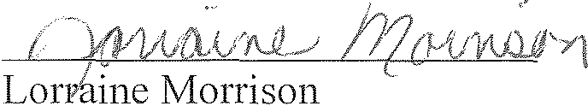

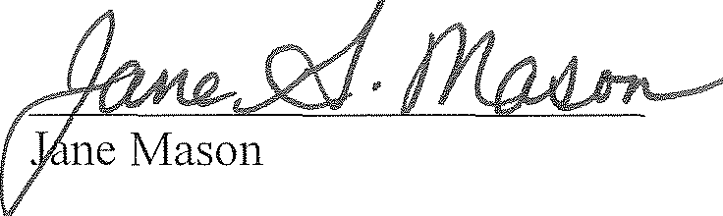

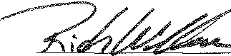
Rich Wallace

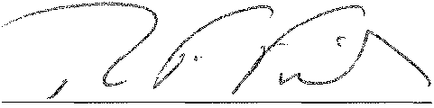

Timothy Fisher

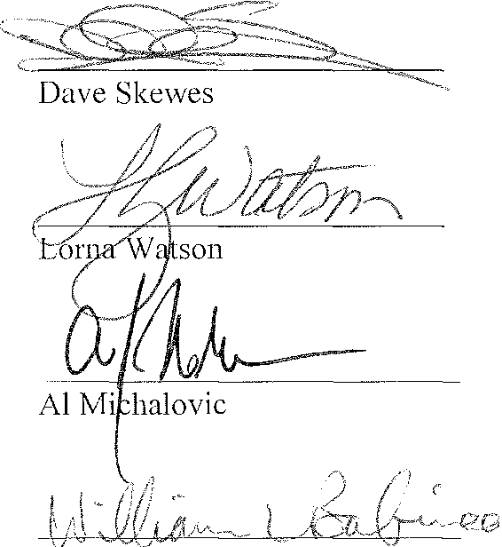
William Babineau

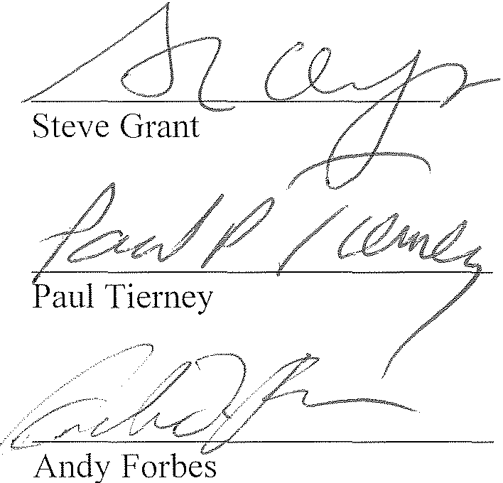

The Rotary Club of Lebanon, NH, Charities, Inc.
Attachment to NHCT-1
5. List of names, home addresses, daytime telephone numbers and titles of all directors

Lorraine Morrison, President 8 Gamet Street
Lebanon, 03766 603-448-2958

Jane Mason, Vice President 33A Bank Street
Lebanon, NH 03766 603-646-4669

Rich Wallace, Treasurer/Secretary
P.O. Box 1121
Grantham, NH 03753 603-298-8711

Timothy Fisher, Director 89 Whipple Hill Road
Lyme, NH 03768 603-643-6622

Dave Skewes, Director RR 2 Box 66H
Canaan, NH 03741 603-298-2905

Loma Watson, Director 62 Winona Circle
Lebanon, NH 03766 603-448-4553

Al Michalovic, Director 68 Foliage View
Lebanon, NH 03766 603-298-5155

William Babineau, Director 17 Dana Street
Lebanon, NH 03766 603-448-298-0442

Steve Grant, Director
4 Ridge Road
Hanover, 03755 603-646-4446

Paul Tierney, Director
P.O. Box 1192
Norwich, VT 05055 603-298-5400

Andy Forbes, Director
P.O. Box 92

Meriden, NH 03770 603-443-4124

