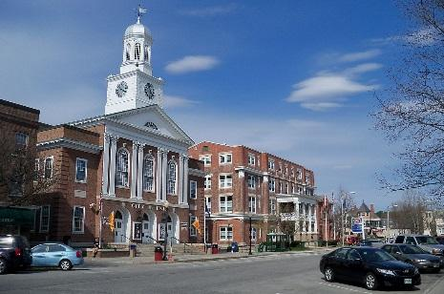 | 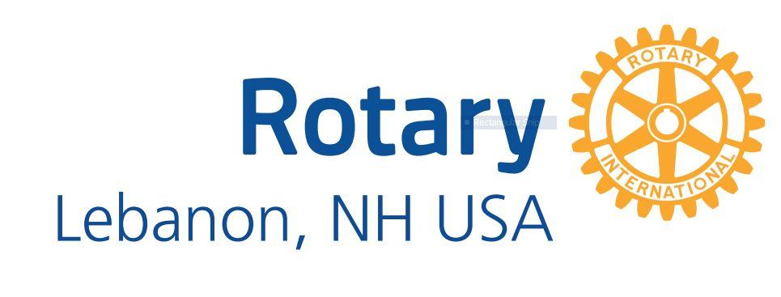  Chartered in 1923  One Profits Most Who Serves Best

What is Rotary International?  Rotary International (RI) is a worldwide network of inspired individuals who translate their passions into relevant social causes to change lives in communities.  RI is the world’s first service organization, made up of over 35,000 clubs and 1.2 million members worldwide.  RI is essentially a grassroots group, with most of its service efforts carried out at the club level. Rotary Clubs are organized into districts to help guide and support the clubs regionally.  The district and international structures are designed to help clubs perform more service both locally and abroad.  Rotary International’s mission: We provide service to others, promote integrity, and advance world understanding, goodwill, and peace through our fellowship of business, professional, and community leaders.  Rotary International’s Vision statement: Together, we see a world where people unite and take action to create lasting change — across the globe, in our communities, and in ourselves. | Who is the Rotary Club of Lebanon?  Our Mission Statement – Our goal is to develop the next generation of leaders through our support of our youth programs in Lebanon and around the world.  Vision Statement – The Rotary Club of Lebanon will be a vibrant club as measured by having:  - A good mix of age and gender in membership,  - Excellent weekly programs,  - Meaningful local and international service projects,  - A strong financial base.  We will be known as the “go to” club for literacy and youth service. In addition, we will participate in international service projects in Kenya, Nepal, Ghana, Haiti and El Salvador.  Learn more about Rotary International at www.rotary.org  Explore our Club’s Web page at https://www.rotarylebanonnh.org/

The Object of Rotary
The Object of Rotary is to encourage and foster the ideal of service as a basis of worthy enterprise and, in particular, to encourage and foster
FIRST, the development of acquaintance as an opportunity for service;
SECOND, high ethical standards in business and professions, the recognition of the worthiness of all useful occupations, and the dignifying of each Rotarian's occupation as an opportunity to serve society;
THIRD, the application of the ideal of service in each Rotarian's personal, business, and community life;
FOURTH, the advancement of international understanding, goodwill, and peace through a world fellowship of business and professional persons united in the ideal of service.
Our Ethical Framework: The Four-Way Test
The Four-Way Test of the things we think, say or do:  First, is it the TRUTH?  Second, is it FAIR to all concerned?  Third, will it build GOODWILL and BETTER FRIENDSHIPS?  Fourth, will it be BENEFICIAL to all concerned? | The Four-Way Test is the guiding principle of Rotary, and members pledge to follow its ideals in both their professional and personal lives. The Test was created in 1932 by Rotarian Herbert J. Taylor as he re-built a bankrupt company during the Great Depression.

Rotary International requirements:  - All clubs to participate in service projects that align with Rotary’s 5 Avenues of Service: club, vocational, community, international, and youth.  - All members to help sustain or increase the membership base of Rotary  - All members are encouraged to support The Rotary Foundation financially and through program participation (Annual/Share, Endowment and Polio)  - All clubs to develop leaders capable of serving Rotary, both at the club level and beyond  - All members to attend 50% of weekly club meetings in each half of the calendar year. Rotarians are encouraged to expand their horizons by making up any missed meetings with any other Rotary club in the world. Make ups can also be made at club board meetings, service projects, or via online e-clubs. | Club dues cover the following:  Dues payments are $35/month or $420/year. Your dues payments include these annual costs:  - Rotary International dues, The Rotary magazine, and insurance: $92.89  - Rotary District 7850 Dues: $38.00  - District insurance $ 2.00  Our Club pays Rotary District 7850 $250 for Club Presidents-elect Training, plus $225 for District Training of all officers and committee members.  - Club: The remainder of Club dues cover Club administrative expenses.  - Meals & beverages at Harvest Hill: $10/meal. Members are not required to purchase a meal/beverage.  Lebanon Rotary encourages  100% member participation in Every Rotarian, Every Year with a suggested minimum annual contribution of $100 to The Rotary Foundation, to increase funding available to the club for local projects via District grants.

Club  Service  (Strengthening our club) | Vocational Service  (Serving through our professions) | Community Service  (Improving our community) | International Service  (Promoting world understanding and peace) | Youth  Service  (Developing the next generation of community leaders)
-Attend club meetings and social events  -Join a committee and participate in committee meetings  -Join a fundraising committee  -Lead a service project  -Find a program speaker  -Host a fellowship event  -Contribute to the weekly newsletter  -Attend a Board meeting  -Attend a District event  -Be a greeter  -Encourage fellowship  -Join a District Committee | -Attend Rotary Leadership Institute  -Give a Classification Talk  -Mentor a student  -Follow the 4-Way Test  -Involve your company  -Organize or judge our speech contest  -Attend an ethics seminar  -Determine ways we can maximize the use of our various professions  -Find new members from a variety of vocations and classifications | -Help with food drives for Listen  -Help with Holiday Basket Helpers for Listen  -Help prepare meals at Listen dinners  -Maintain Riverside & Baker’s Crossing Parks  -Help determine where we will donate funds we raise  -Identify new community service projects & participate in established community service projects  -Ask others to join our community service projects | -Support polio eradication efforts  -Donate to Shelter Box  -Join a Friendship Exchange team.  -Host a Friendship Exchange Team Member  - Support clean water projects in Ghana & Kenya  Support other projects in Nepal, Haiti and El Salvador  -Travel to another country to do a service project | -Support our Interact Clubs  -Find a Peace Scholar candidate  --Find students for & participate in the Rotary Youth Leadership Award (RYLA) Conference  -Provide career mentoring  -Organize or Judge the Speech Contest for local high school students  -Distribute our First Grade readers
Lebanon Rotary: serving the youth of Lebanon and the world.

