THANK YOU SO MUCH for volunteering for Duck sales!

Mike Curtin and Jane Macan will be heading up in-person ticket sales this year.

Below are the details for your shift. PLEASE read through this before your shift.

Do not hesitate to contact us with any questions or concerns.
Mike Curtin (781) 771-8560
Jane Macan (610) 420-1477

Key things to know for sales:
- We are not handing out paper tickets. We are doing ticket sales lists. Anyone who buys a ticket needs to give us their name, email AND phone number. Ideally, you have a tablet/device with you and type in their information into a form (excel, google sheet, word...doesn't matter). Or, you (or buyer) can fill in buyer information on a paper sheet. If you don't bring your own device, there will be paper printout lists available for you use. So far this has worked well even with ticket buyers filling in their own information. Just make sure the information is legible.
- Buying ducks:
  - We take Cash, Venmo & Square (square = credit card, apply pay, google pay)
  - QR codes are on plastic table signs that will be with supplies.
  - Venmo username is @MRVRC (also on plastic table sign just below QR code).
  - No matter what form of pay, we need the buyer’s info filled out on the ticket sales list.
  - Anyone who buys tickets will get an email receipt later in the week that will have their duck numbers on the receipt...reminder to make sure we can read their information!
- At the conclusion of shift/day you need to get back to us:
  - All ticket sale lists (digital version or take a pictures of sheets and send to us)
  - All cash (except leave $40 in change in small bills in the cash box). Please email or text us and we'll coordinate as best we can.
Mehurons Specifics
- All supplies are just inside front door of the office right next to Physical Therapy Office located on Main St (4740 Main St. Waitsfield). See pic below of location as well as what Mehurons set up should look like.
- Please return all supplies back to same location
Farmers Market Specifics
  - Daily set-up and take-down will be handled by a separate team.

Photos:
4740 Main St. Waitsfield
  - 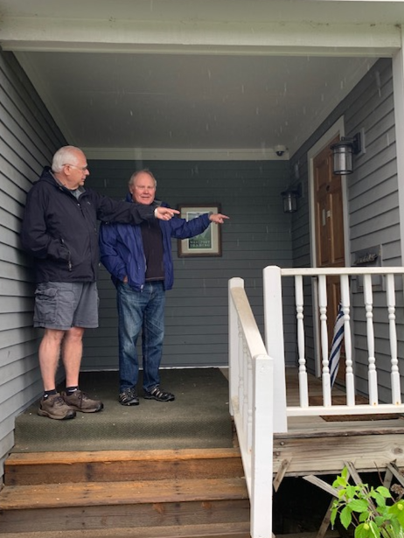

Mehuron’s Table Set up
