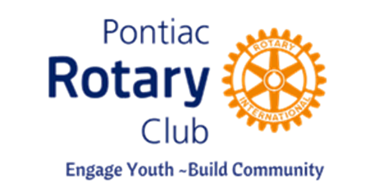
Pontiac Rotary Club
GRANT APPLICATION 2025

Date of request:
Organization Name:
Organization Address:

Organization website:
Contact Name / phone / email:

Federal Tax Exempt? Tax ID #
Pontiac Rotary Co-sponsor:
Project Name:

Provide a brief explanation of the need and project:

Are there other partners associated with this specific project? If so, please list and describe role if not otherwise presented.

What amount are you requesting? What is the total cost of the project?

Please address how this project will specifically benefit Pontiac youth and families.

Please forward this completed application to susanebeling1@gmail.com. Questions? Please feel free to contact Susan at 248.787.1619. After your grant application has been reviewed by our Charities Board, you will receive follow-up to discuss next steps. Thank you for partnering with Pontiac Rotary!

