
Attention Students of French
The Rotary Clubs of Middlebury, Vermont, and Sherbrooke, Quebec, offer high school students in Addison County and Sherbrooke an opportunity to expand your knowledge of the French language and Quebecois culture this coming summer 2019.
- 2-4 students from Addison County will spend two weeks in July as guests with a student and his/her host family in Sherbrooke and then two weeks in August as a host to that Quebecois student back in Addison County.
- There is no cost other than spending money.
- This is open to all students who are at least 15 years old and have had at least one semester of French/English.
- The purpose is to experience life in a French/English speaking household in a setting close to home at an affordable cost.
Your [exchange] program was a life-changing experience for me and I will be grateful for the opportunity for the rest of my life." - Sabi, MUHS student

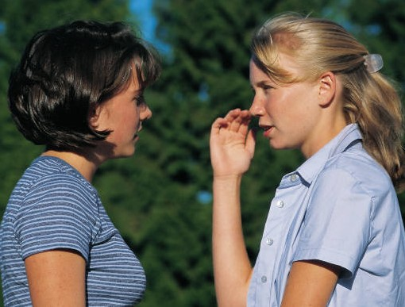
For more information, contact:
David Clark at rotaryclubofmiddlebury@gmail.com
and see our website www.middleburyrotary.org

