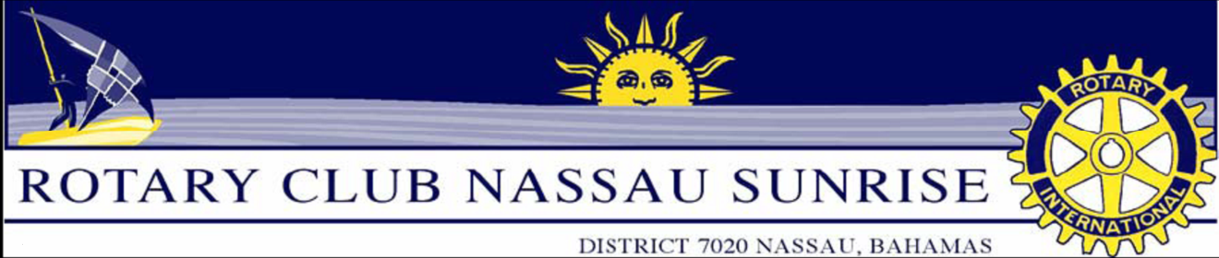

RCNS New Member Sponsor’s Guide
We are asking sponsors of new members to assist the potential member with completing the requirements for acceptance into the club and once the member is inducted, we are asking sponsors to assist with the Orientation of the new member by helping them complete the red ribbon badge removal expectations.

New Member Proposal Criteria:

New members proposed by existing club members are to meet the following criteria:
- A leading representative of a business or community organization.
- Willing to help and personally participate in projects that enhance the community. Family commitments should not impede participation.
- Willing to work on projects that help people in developing countries.
- Of good character and good reputation in his or her business, profession or community organization.
- A member of a vocation, business or profession that will not cause the club to exceed classification limits.
- Able to meet the club's weekly attendance or community project-participation requirements.
- New members are to be representative of classifications not represented within the club. If there are too many persons already within a single classification, the proposed member may not be included in the club.

The New Member Proposal Process:

It is important for existing club members to determine if the candidate will be a good fit for the club. By modifying the membership approval process as suggested below, RCNS members can to get to know potential members before voting and potential members can determine if RCNS is the right club for them. Therefore it is proposed that the undernoted expectations are to be satisfactorily completed before the proposed member can be invited to become a member and be inducted:
- Attendance of 3 RCNS Thursday morning meetings
- Attendance of 1 Club service project
- Attendance of 1 Club social
- Attendance of another Rotary Club Meeting
- Present a “My Job Talk”
- A minimum of 75% of the votes of the interview panel.
- A minimum of 75% of the votes of general membership. (It is important that the potential member try to meet as many members as possible prior to the commencement of the voting process.)

Sponsor duties:

- Invite the prospective member and accompany them to meetings and events.
- Join the prospective member at the interview.
- Join the prospective member at the induction ceremony.
- Assist the new member with selecting and joining at least one committee.
- Assist the new member with the red ribbon removal process.

Red Ribbon Badge Removal

The membership committee will support the sponsor of the new member who we propose will help the newly inducted Rotarian assimilate into the club. We want new members to feel they are part of the Rotary Family. As a result, we modified the red ribbon badge removal process so please use the checklist below starting September 1, 2010. We are targeting a maximum of two months to have red ribbons removed.

Duties | Date Completed
Weekly Meeting: Lead the Rotary Grace
Weekly Meeting: Rotary Toast
Weekly Meeting: Announce Visiting Rotarians
Weekly Meeting: Introduce Guest Speaker
Weekly Meeting: Vote of thanks for speaker
Weekly Meeting: Lead the 4 Way Test
Suggest or find a speaker
Provide a raffle prize
Supply or tell a joke
Visit at least 1 of the other 5 Nassau Rotary Club Meetings
Attend an Interact Club Meeting (GHS or Lyford Cay School)
Join at least one committee within the club and attend a committee meeting
Attend a Rotary Club of Nassau Sunrise Board Meeting (3rd Wednesday of the month)

