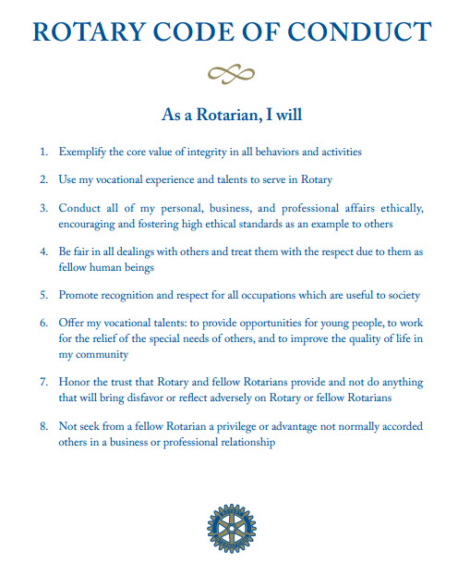

**Last Week’s Meeting**

After President Allison had called the meeting to order and the preliminaries taken care of Rotarian Wendy Birthwright presided over the introduction of visiting Rotarian and guest of Rotarians.

In his presentation Secretary Gregory reminded members with 2013-14 dues outstanding of their responsibility to the club in light of the fact that these dues were already advanced to RI by the club.

Fund raising chairman PP Richard reminded the meeting of the upcoming fund raising event – the performance of the Jamaica Folk Singers - to be held at the Little Theatre on September 13. Ticket price: $1200 Prepaid tickets & $1400 at the gate.

The President announced that the upcoming Club Assembly, to be held at the Pegasus on Saturday August 24, will be followed by a fellowship event at the Blends bar in the hotel. She encouraged members to invite acquaintances who might have an interest in Rotary.

Fellowship chairman SteveHudson advised that he was in the process of planning a beach trip to Portland for September 21st. Further details will be available soon.

Rotaract Chairperson Rosie Voordouw announced the following events being planned by the Rotaract Club of Kingston and appealed to Rotarians for their support; astationary collection drive to benefit wards at the Rio Cobre Juvenile Centre, a fun day to be held at Alpha Boy School and a fund raising raffle.

After VP Francois had introduced guest speaker PAG Andre Hylton the former District 7020 Membership Chairman reminded the meeting of the importance of members to the success of a club and the fact that good membership begins with the selection process. He indicated the qualities one should look for in a person while proposing them for membership and pointed out the importance of attendance, integrity and the need to pay ones dues. He pointed out that it is the responsibility of the proposer to ensure the development of the members they propose. He identified some of the negative trends he has witnessed in the movement and asked that every effort must be made to cauterize these tendencies.

PAG Everton Davies moved the vote of thanks after which the PAG was presented with a token by President Allison and the meeting adjourned.

***ROTARY MEMBERSHIP QUIZ:***  
*1. There are five standing committees within the Club Leadership Plan.  Which committee is responsible for recruitment and retention?*

*a) Club Administration b) Membership c) Public Relationship d) Service Projects e) Foundation*

*2. Clubs may not elect a person to active membership from a classification in which the club already has:*

*a) Five or more members of the said classification. b) One member. c) Three or more members in the classification. d) 5% of the clubs active membership is already of the proposed classification. e) None of the above*

*3. As a method of encouraging younger members into Rotary, clubs may waive club dues and admission fees for membersunder the age of 35.*

*True___ False___*

*4. What are the types of Membership that are recognized by Rotary International*

*a) Active b) Senior Activec) Additional Active d)Honorary e) Past Service*

*Answer: (Choose all that apply)*

*5. The retention portion of the Membershipplan is divided into four areas.  Name all four areas:*

*a) Mentoringb) Educationc) Involvementd) Fellowship and Recognitione) None of the abovef) All of the above g) Both “a” and “b”*

**Club Diary**

1. See the Jamaica Folk Singers in performance @ Little Theatre on September 13. Pre-purchase tickets $1200, $1400 @ the gate.
2. Fellowship trip to beach in Portland on Sept 21. Details to come.

**The funny side**

Three couples went in to see the minister to see how to become members of his church. The minister said that as a test they would have to go without sex for two weeks and then come back and tell him how it went.

The first couple was retired, the second couple was middle-aged and the final couple was newlywed.

Two weeks went by, and the couples returned to the minister. The retired couple said it was no problem at all. The middle-aged couple said it was tough for the first week, but after that, it was no problem. The newlyweds said it was fine until she dropped the can of paint.

"Can of PAINT!" exclaimed the minister.

"Yeah," said the newlywed man. "She dropped the can and when she bent over to pick it up I tried but I just couldn’t help myself .”

The minister just shook his head and said that they were not welcome in the church.

"That's okay," said the man. "We're not welcome in Home Depot either."