MID ISLE
_l!gi JY

St Croix Rotary Mid-Island
3RD QUARTER NEWSLmER

OVERVIEW: Francois Dominique
From a Rotary perspective, this period can be aptly called "New Generations." It began with the Club's support and participation In tha followlns youth events: Mathcounts ­ a local mlddle school math competition that resulted In one of the participants representing St. Croix at the natlonal level. The event, under the auspices of the V,I, Department of Education, was co•sponsored by RMI and Ocwen Mortgage Servlclns, Inc. Youth Duathlan - an event In which different age sroups competed In blklns and racing. Members supervised the events and provided prizes for winners.
Meanwhile, several youth groups made presentations at the Club's 7:15a.m. breakfast meeting, Included were: The RMI Interact Club of Country Day Good Hope School, under the Chairmanship of Rotarian Yvonne Liburd; FSLA - Future Business Leaders of America; RMI Scholarshlp Reclpl,nts -selected by Rotarian Nina York; The St Patrick
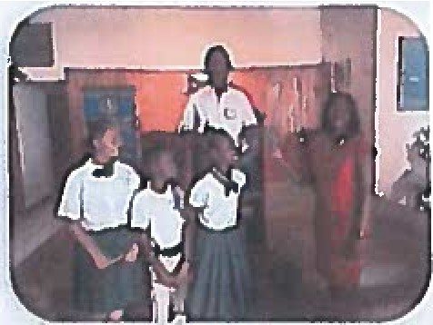
Steel Pan Orchestra played very melodic breakfast tunes. The members were so Impressed that they raised $400.00 towards the orchestra's trip to Vlrslnla and Sal Sanpere retained the band for $500.00 to play at his function.
Other activities during this period Included the planting of 9 Agave plants at the Gov. Juan Luis Hospital grounds In commemoration of the Centennial Celebration of the USVI/Danlsh Transfer Day. For "World Water Day" observation, the suest speaker, Julia Wright, Director Natural Resource Conservation Service of the USDA, save a comprehen1lve presentation on the subject, Sha has agreed to Join the Club to do a Radio Talk Show on the tubjec:t.

RMI Internet Club: Yvonne Hunt Liburd
Interact beaan Its activity on September 8, 2016, a few weeks after the raopanlns of school. Present wera RMI Past President l<lm Deline and Vvonne Hunt Liburd, chair and co-chair of New Generation, as well as Ms. WIison, teacher/advisor at the Good Hope Country Day School. The Club consisted of fifteen (15) members which Included the followlns officers: President Marshall McCormick; Vlca•Presldant Jonson Thomas; 2nd Vice-President Thalia Hendricks; Secretary Rachal Conhoff; and Treasurer Timothy Nqueyen.
The President stated the following soals for the year- asslstlns with local projects such as: Lighthouse Mission; Duathlon and Trlathlon; and clean up at Point Udhnl. The members wlll also participate In an International project,
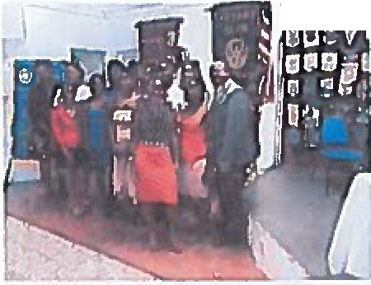By October membership Increased to twenty-five (2S). At one of the weekly Thursday meetings held from 1:00-1:15 p,m. , suest speaker Sherry Derusha showed a video on Blndlns Love and demonstrated scarf making for the purpose of fundralslng, RMI
L
.....
Prasldent Francois visited and addressed the Club . Thus far the Club has held a food sale, served breakfast and sans Christmas Carols at the Lighthouse MIHlon, They also sans and presented sifts to children In the Pediatric Ward at the Gov,
Juan Luis HospItal. The members visited the RMI at a 7:15 a.m, breakfast maetlns where they received a donation of $100.00 used to purchase materlals to make Valentine cards and obtain other goodies for winners of theDuathlon. At that event they assisted In registration and monitored tha racecourse. During the month of February 2017, the club continued with Its sponsorship of the annual Kids Ouathlon. Children between the ases of S and 1S competed In cycUns and running. Prizes for the winners ware donated by our Interact members, who also provided assistance along the race course.

Community Service: Patrie/a St11l1
At our last meeting for the month of Fmbruary, several members of the St. Patrick's School Steel pan ensemble treated us to a wonderful repertoire of sanes, The band Is currently raising funds to attend the Virginia lnternatlonal PAN fest In May at Vlrslnla Beach, Vlrslnla. As a result of our club's commitment to youth and youth activities, we were able to collect $400.00 which was donated to the band.
In the month of March, tha club co-sponsored the annual luncheon for the Center for
Independent Llvlns. The Center was established many years aso to provide assistance to members of the community who e,cperlence dally challenges resu\tlns from a wide range of dlsabllltles.
To commemorate the 1001h anniversary of the transfer of the Virgin Islands from Denmark to the United States of America, the club planted B Asave cactus plants on the grounds of the Juan Luis HospItal, The Asave plant Isnative to theIsland of St. Croix, and Is commonly called the "century plant" because It blossoms every hundred years.
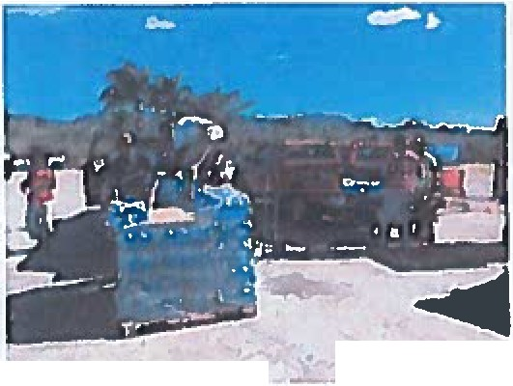In recognition of World Water Day, the club closed off the month of March by dellvarlng 100 cases of bottled water to the elderly residents of the Whim Gardens Community. The club In conjunction with the U.S. Department of Agrlculture•Natlonal Resources Conservation Service will also do
a radio presentation on the Importance of water conservation.
In early April, President and Member Sweany appeared as guests on the Community Digest talk show. This provided the Club with an opportunity tospread the news about Rotary and Its mission. The community was 1110 brought up to date on the Club's accomplishmentsthus far for the 2016-17 Rotary Vear.
The club continues to make lt1 community a better place to llve by maintaining Its
Peace Garden at the Golden Rock Triangle, and providing breakfast three (3) Saturdays per month for the homeless at the Lighthouse Mi ssion.

St. Croix Rotary Mid-Isle 3rd Quarter Photos

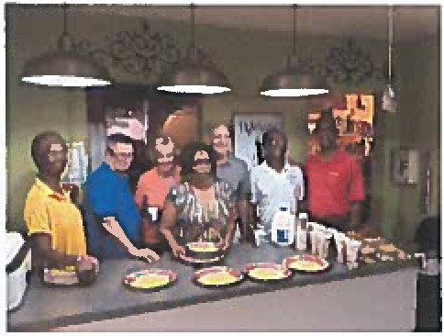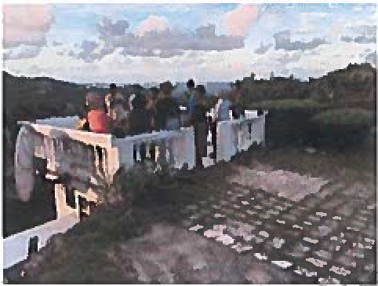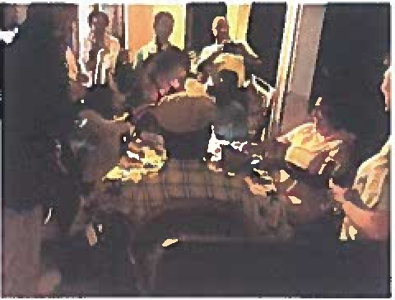

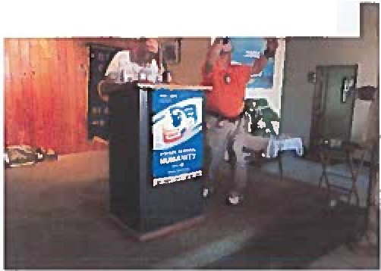
RMI Team serves breakfast to the needy at the Lighthouse Mission

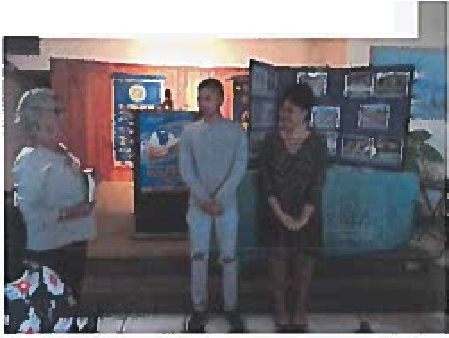
Ralph receives his 4th Paul Harris Fellow. He beckons others to give to Rotary

Nina presents scholarship winners - Julian Bishop & lmani Evans - of the World Affairs Seminar at Carroll U. in Wis.

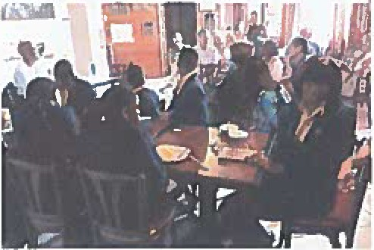
Future Business Leaders (FBLA) attended RMI Breakfast Meeting
Social gathering at the Dominique's

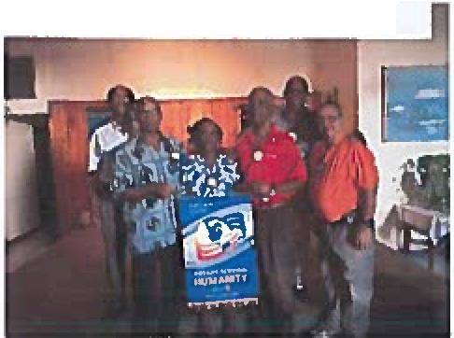
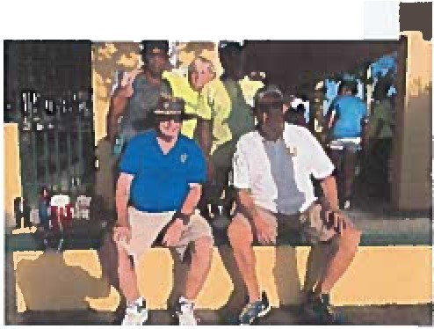
Paul Harris recipient s: Willard, Yvonne, Sweeny & Ralph

RMI Duathlon helpers: Ralph, Joe, Willard, Mary, Edel, Claudia & others

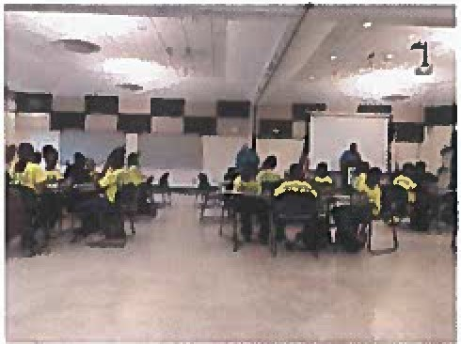
Middle school students compete ln Mathcounts
Edel celebrates birth at the gathering

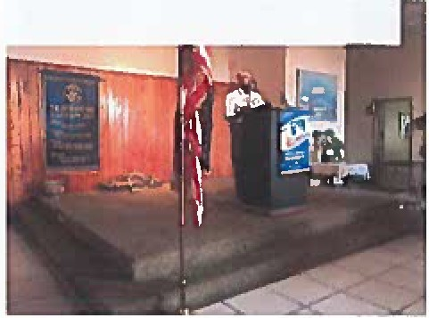
Member Lambert tells his life story
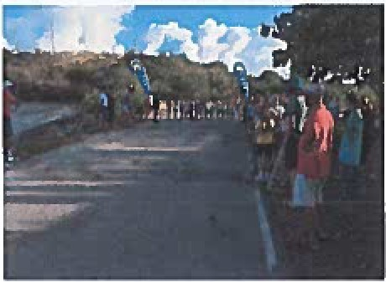
Photographer Richard and Director Sweeny look on at Duathlon race line up

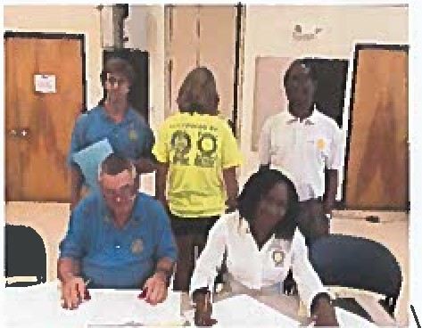
Club members along with Mathcounts student displays T-shirt showing RMI & Ocwen's Logos

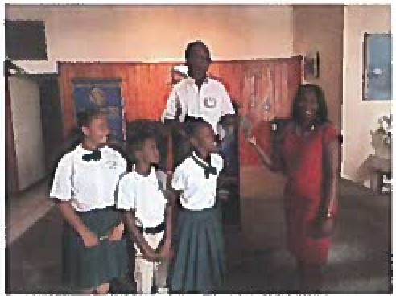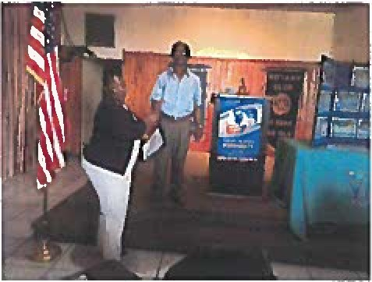

St. Patrick Steel Pan Orchestra received
$400.00 to attend PAN Fest in Virginia

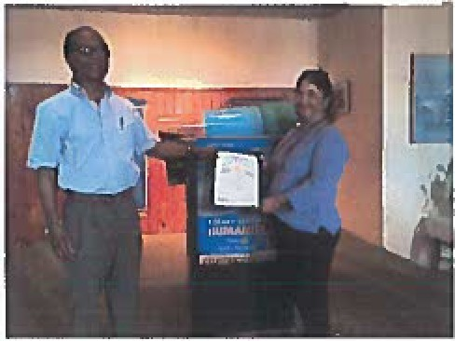
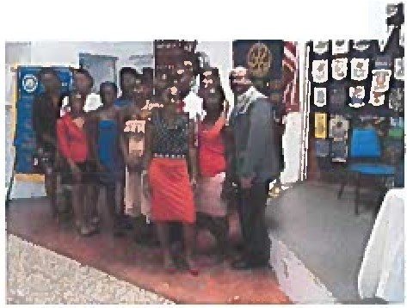
President thanks Julie Wright from Natural Resources Conservation Service (USDA) for presentation on nworld Water Day"

ADG Marcel with YRLA participants on St.
Croix
Jennifer & PP Jackie at RMI Iron bar Comcetition Fundraiser soonsored bv Diae:eo.

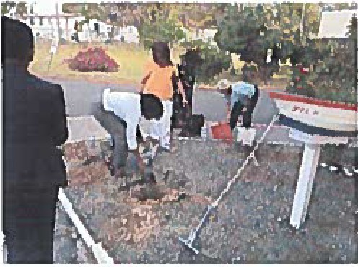Planting Agave at the Gov. J. L. Hospital grounds to commemorate USV/Denmark Centennial Celebration
f

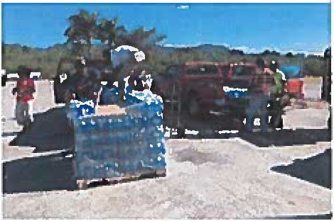
Team Loads cases of water to distribute at the Whim Home for Seniors
Pres. Francois thanks Director Ann Hanley for Presentation on Waste Management

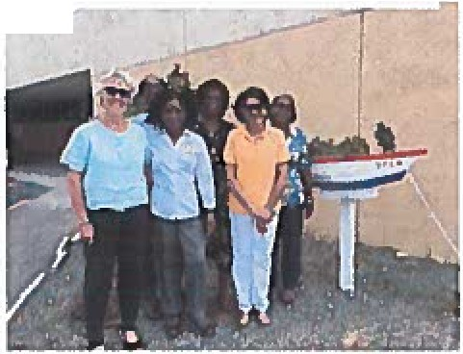Agave planting part icipant s: Nina, Anestine, Pat, Francois, Vincenta & Carmen
r

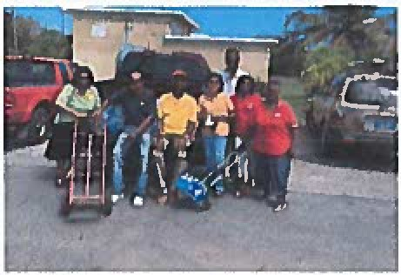
Water Distribution Team Celia, Anestine, Richard, Chester, Pat, Angie, Pastor Etienne & Conrad

