ROTARY CLUB OF

ST. MARTIN SUNRISE



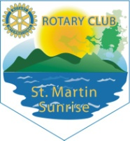

Table of Contents

Our Organization………………………………... 4

The Board…………………………………...5

The Breakfast Program……………………..…….6

Readers Are Leaders…………………………..….8

Peace & Conflict Resolution Rotary Peace Monument………………………..........................12

The Vision Project……………………………….14

Emilio Wilson Park Recreational Playground…...15

Over the Years in Pictures………………...……..18

Foreword

t

*he Rotary Club of St. Martin Sunrise has, over the years, worked towards encompassing the vision and mission of Rotary International, and that is, to provide service to others; promote integrity; and advance world understanding, goodwill, peace through fellowship of business professionals and community leaders.*

*As such, this booklet attempts to explain some of the work the club has been promoting on this beautiful island of Sint Maarten. All these projects were undertaken with much zeal by a group of hardworking volunteers who sought to better the standards of our small island-nation.*

*There is so much more that can be included in this booklet to underscore the work of the Rotary Club of St. Martin Sunrise. Nonetheless, I am sure that by the end of this journey, you will be able to answer the question, “Why join the Rotary Club of St. Martin Sunrise?”*

*The club provides a forum for professionals to meet, and make decisions that influence policy. But most importantly, it provides an opportunity to serve our community – whether through its Breakfast Program, Reading Program, or a myriad of other community service projects that benefit the young and not so young of Sint Maarten.*

*Each Tuesday morning, as the sun rises above the Great Salt Pond, mild waves pf the Caribbean sea gently flapping over the shore and the cruise-ships prepare to anchor in Great Bay, friendships are formed over a sumptuous breakfast, as volunteers from diverse cultural backgrounds and professions meet at the Ginger Bread Café Restaurant, Belair Beach Hotel in Little Bay to help build a nation.*

*This is what the Rotary Club of St. Martin Sunrise is all about and as the club grows from strength to strength, so will Sint Maarten. Do enjoy this booklet which gives but a glimpse our work.*

*We thank you for your support and look forward to our strengthened cooperation.*

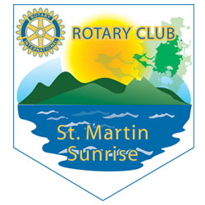Our Organization

*ROTARY CLUB OF ST. MARTIN was chartered June 17th, 2004, on Sint Maarten and registered at the Chamber of Commerce with registration #19499. The Rotary Club of St. Martin Sunrise is an association of members governed by a board. There are four Rotary Clubs on the island of Sint Maarten/St. Martin, which all are part of District 7020.*

Rotary’s main objective is service to the community in the workplace, and around the globe through fellowship. “Service above self” is what the 1.2 million Rotarians united in 34,000 Rotary Clubs around the world put to practice every day.

Rotary Clubs are open to people of all cultures, colors and creeds, and are not affiliated with any political or religious organizations. But, there is something that all Rotary club members have in common: we take action. As a community of volunteers, we reach out to neighbors in need. We build, we organize and carry out a remarkable variety of humanitarian, educational and cultural exchange programs that touch peoples’ lives in our local community and worldwide.

The 1.2 million men and women of Rotary work locally, regionally, and internationally to combat hunger, improve health and sanitation, provide education, job training, promote peace, provide access to clean water to areas that need it the most around the world, and eradicate polio, all, under the motto service above self.

As our Rotary mission says, we provide service to others; promote integrity, and advance world understanding, goodwill, peace through fellowship of business professional and community leaders.

***We Support***

** 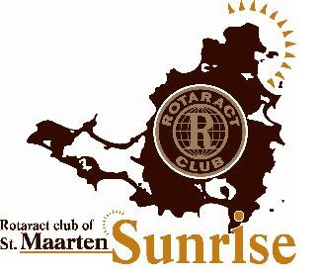  [](https://www.google.com/imgres?imgurl=http://sch.sumnerschools.org/clubs/Interact%20Club/interact%20logo%202.gif&imgrefurl=http://sch.sumnerschools.org/clubs/Interact%20Club/Interact%20club%20index.htm&docid=QYxxN3GRjw3PJM&tbnid=J-BP5dm33j9ujM:&w=539&h=539&ei=WW24U9_JMPOssQTG_4CoAQ&ved=0CAIQxiAwAA&iact)**

***The Board***

The Governing body of the Rotary Club of St. Martin Sunrise shall be a Board of Directors consisting of at least seven members, whom must be eighteen (18) years of age or older among whom a President, Secretary, and a Treasurer.

***2016***

* President: Okama Ekpe Brook
* VICE-PRESIDENT: Prakash Peter Dialani
* Secretary / President Elect: Damali Bryson
* TREASURER: Siddarth Cookie Bijlani
* Sergeant At Arms: Monique Alberts
* CLUB ADMINISTRATION DIRECTOR: Valda Woodley- Hazel
* ASSISTANT MEMBERSHIP DIRECTOR: Debbie Karani
* PUBLIC RELATIONS DIRECTOR: Dolly Sadarangani- Ahuja
* ROTARY FOUNDATION Director: Ahmed Bell
* NEW GENERATION DIRECTOR: Ruminni Rogers
* FUNDRAISING DIRECTOR: Meredith Boekhoudt
* DISASTER MANAGEMENT CHAIR: Virginia Asin Oostburg
* IMMEDIATE PAST PRESIDENT: Marcellia Henry
* INTERNATIONAL SERVICE DIRECTOR Bernadette Davis

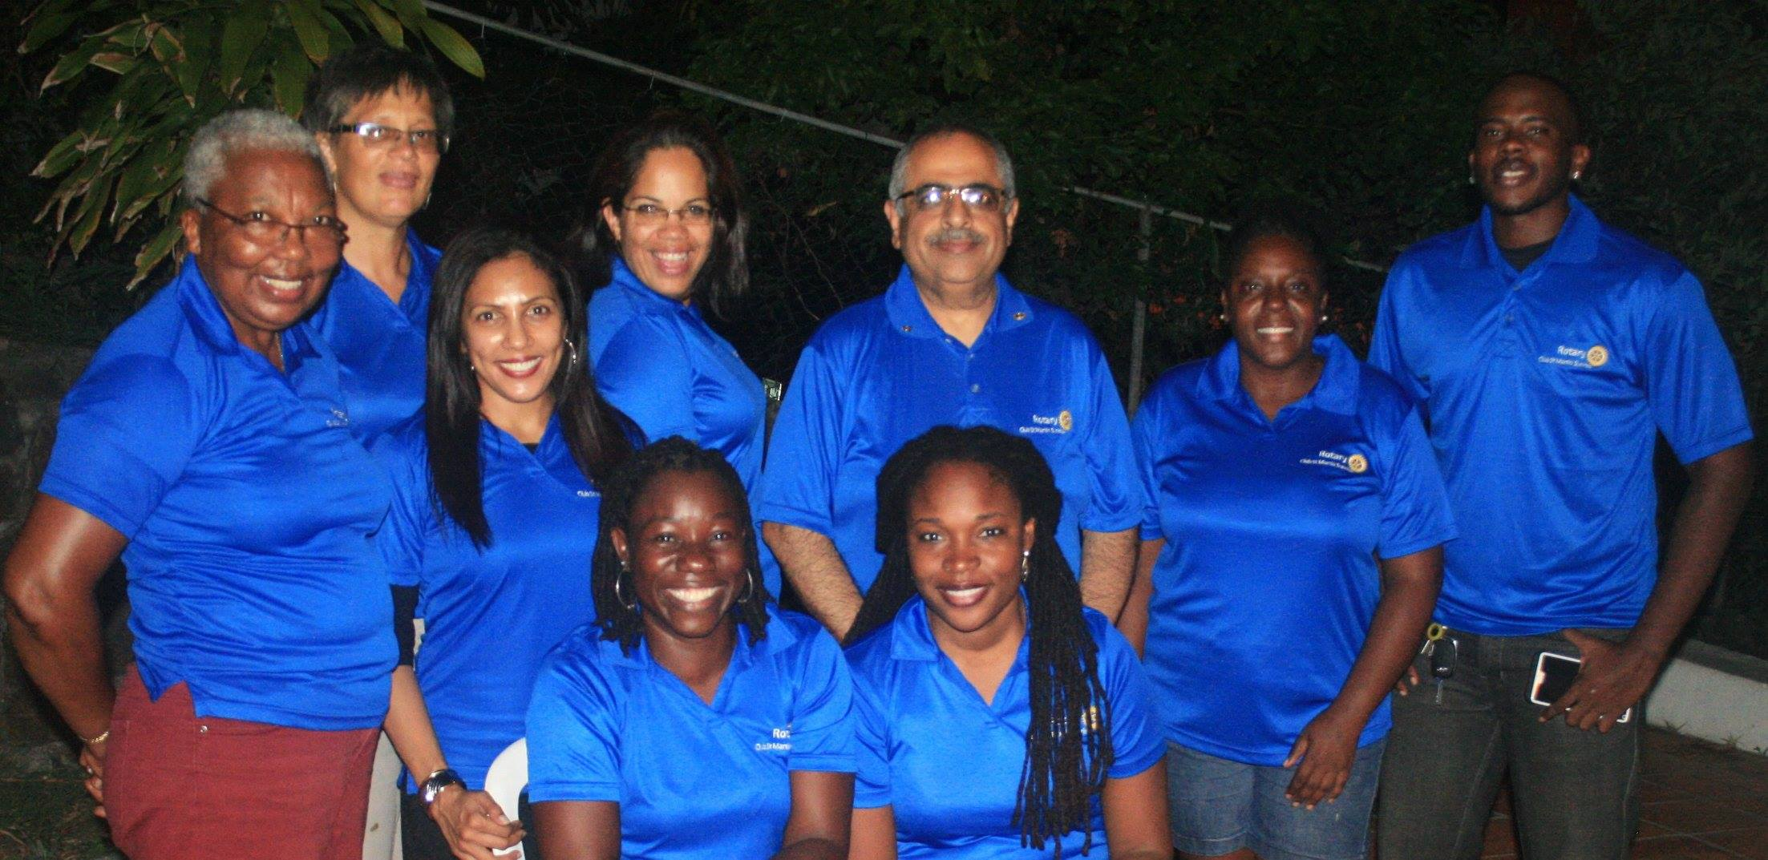

The Breakfast Program

*The purpose of the breakfast program is not to replace parents' / guardians' role as a provider, but to assist schools with promoting healthy nutritional habits, and to increase the academic performance of students.*

t

he objective of this program is to increase the probability of students eating a nutritious breakfast in the morning and, in turn, improve their learning, the Rotary Club of St. Martin Sunrise decided to pilot a school breakfast program.

BACKGROUND

Children often attend school without having a proper breakfast which can impact their academic performance. Some parents let their children choose what they want to eat. As a result, the children’s diet is not as varied as it should be.

Some parents do not have the financial resources to purchase more nutritional foods products as they are usually the most expensive. Sometimes parents are unable to manage their time to prepare nutritious, home-cooked meals, and therefore resort to the choice of purchasing convenient, unhealthy fast food, as was discovered by a local research.

Since eating breakfast increases a child’s ability to learn, improves behavior, and decreases the risk of being overweight, the Rotary Club of St. Martin Sunrise launched the Breakfast Program in August 2012. The pilot schools – Ruby Labega and Dr. Martin Luther King Jr. School underscored that eating breakfast benefits children’s ability to learn and concentrate. One year later, in 2013, Prins Willem Alexander School and St. Maarten Vocational Training School were added to the program.To date, more than 160 children attending four of the island’s public schools continue to benefit from a nutritious meal in the mornings.

Children who come to school on a regular basis (three or more days a week) without breakfast, as well as those who come from families with known financial difficulties (low income) were selected for the program. Children who have challenges with learning and short concentration span (poor academic performance), or who lack time and/or skills to prepare their own breakfast were not excluded from the breakfast program.

Through partnership with several business organizations, including telecommunications magnate UTS, the Rotary Club of St. Martin Sunrise was able to serve nutritious meals that included oats, Cream of Wheat and other cereals, bread and cold cuts, eggs, and fruit. Children were given choices of peanut butter, jams, and butter; as well as hot drinks such as Ovaltine, Milo, milk and teas. Over the years, the club has spent an average of $20,000 per month bringing breakfast to the schools.



Shopping with partner UTS for the Breakfast Program

Over the years, the club has kept close check on the breakfast program. Schools have the responsibility of coordinating the distribution of breakfast to the students on daily basis. The school submits a monthly report, which will include: the number of children who received breakfast, the number of days each child received breakfast; the menu for each day / week, students’ academic and behavior progress, bottlenecks / challenges they experienced, and measures taken to overcome challenging situations.

The Rotary Club of St. Martin Sunrise ensures that the items are purchased and delivered or collected by school coordinator, communicates with the coordinator of the breakfast program ever month, visits the school to observe the breakfast program at hand, ensures that the monthly expenses are paid, reviews the monthly reports, and assists with challenges.

Readers Are Leaders

*Raising our readers to be leaders! Our youngsters need to become strong readers to succeed in life! These are the slogans under which the Rotary Club of St. Martin Sunrise and the Philipsburg Jubilee Library launched the ‘Readers Are Leaders’ reading program aimed at all high school students on our island. Our goal is to turn St. Maarten’s teenagers into avid readers.*

t

he Readers Are Leaders (RAL) program was launched on March 19, 2010 at the premises of the Philipsburg Jubilee Library. The campaign culminates with a closing party to celebrate the achievements of all participating students in March which used to be Rotary’s Literacy Month. It is then re-launched at the beginning of the school year in August, since the program is an annual event.

###### http://a2.sphotos.ak.fbcdn.net/hphotos-ak-ash4/s720x720/417036_2945333112733_1243412449_32492400_620682553_n.jpg

**About the campaign**

High school students are challenged to read at least two books per month. As extra incentives to encourage participants to continue reading, prizes are awarded to the first three participants to finish reading seven books.

Each year, students are wowed by the prizes, which include Kindles, IPods, USB sticks, and free internet hours at the library.

RAL is also visible on the World Wide Web. There is a RAL Facebook account and participating teens are encouraged by their classroom teachers to post comments and book reviews the RAL Facebook page.

The participants are free to select books of their choice. However, they are also encouraged to read non-fiction books about leaders from Sint Maarten, the Caribbean and the rest of the world.

***School Curriculum***

Since the initial launch of the campaign in 2010, several schools, including St. Maarten Academy’s academic and vocational campuses, Sundial, and St. Maarten Vocational Training School have made the RAL Program part of the Language Arts curriculum.

The students read books that are part of the school’s English language curriculum, or books from the RAL book list. They then write book reports that are corrected by their English language teachers, and/ or participate in the school’s Reading or Book Club, where they discuss the books they read.

In the month of March, the English Language teachers at the various schools, nominate and submit the names of at least two (2) students who met the criteria listed below:



###### ***Criteria for selecting RAL winners***

* Read a minimum of seven (7) books before the month of March *(which are part of the school’s English Language curriculum, or books from the Readers are Leaders’ Book list).*
* Participate in discussions on the ‘Readers Are Leaders Facebook page’.
* Participate in at least one (1) of these extra curricula reading activities:
  + Being a member of the Readers Are Leaders (RAL) Board
  + Participating in the Reading or Book Club at the school
  + Reading or assisting children with reading at an afterschool program
  + Tutoring fellow classmates or others for the subject of English
  + Participating in the Poetry Evening or Black History Month Program (development of original poems, stories, skits)

***Readers Are Leaders Board and Activities***

Participants are also invited to join the RAL Board, which was established in October 2010. The Board of the RAL program, which comprises of students from the various high schools, advised by a representative from the Philipsburg Jubilee Library and a representative from the Rotary Club of St. Martin Sunrise, also organize annual programs for high school students. These activities also help to promote literacy and awareness in the community. The annual programs that are organized are the Black History Month program in February and a Poetry Evening in March.

**Joining Readers Are Leaders**

Interested students can sign up for the “Readers Are Leaders” program at the Philipsburg Jubilee Library or via their English Language teacher at school. To date there are more than a hundred (100) students participating in the “Reader Are Leaders” program.

Changing Lives through Reading

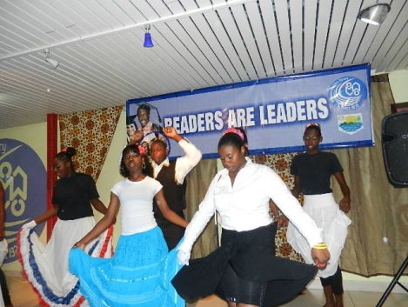

***Celebrating Black History Month - February 2012***

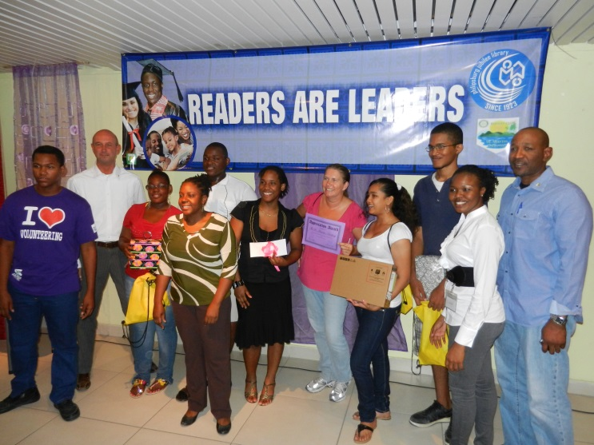

***The Readers Are Leaders ‘Award Ceremony’ On March 28,2012***

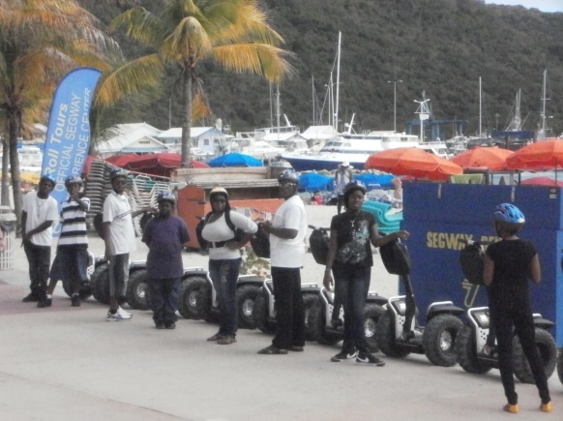

***The Segway Experience on March 24, 2012: (Award for Reading Excellence)***

**Readers are Leaders celebrate St. Maarten’s Day with Poetry Evening – *St. Maarten Island Time.com***

PHILIPSBURG, St. Maarten – Tuesday November 13, 2012 The Philipsburg Jubilee Library (PJL) in collaboration with the Rotary Club St. Martin Sunrise hosted RAL post St. Maarten's Day Poetry Evening entitled "An Expression of Love for St. Maarten's Past, Present and Future", geared specifically for high school students.

The RAL poetry evenings are organized to promote literacy by encouraging high school students to not only read but express their thoughts, feelings and ideas through the written word.

Monique Alberts, Director of PJL and Marcellia Henry, Past President of the Rotary Club St. Martin Sunrise each gave word of welcome. Host Lenworth Wilson introduced poets Brilliana Hodge of the Sundial school and Andrew Peterson of the St. Dominic High School, who bravely expressed their pride, frustration and love for St. Maarten through their spoken words.

St. Maarten student, Merlina Aventurin, currently studying at the Tallahassee Community College, was invited to share her poetry, to the delight of the audience, via a Skype video call. Audience members were also treated with a mix of jazz and reggae music by the MPC Band.



Peace and Conflict Resolution

Rotary Peace Monument

*The Rotary Peace monument was created as a dedication of the Rotary Clubs on Sint Maarten /Saint Martin to community peace extended to world peace.*

***The Mission:***

*To convey our commitment to promoting world peace, it is our sincere belief that the Rotary Peace Monument will foster insight into the meaning and root of peace, and empower members of the community to overcome violence and injustice.*

A

s a result of our demanding societies, we often disregard the importance of taking time out to meet each other in a relaxed and positive environment. Our school buildings, workplaces, and public buildings all cater towards “don’t hang around” mentality. As a consequence, we deprive ourselves from some of our basic needs such as sharing our thoughts, talents, happiness and sadness with others who care.

In these troubled times, with an absolute lack of moral ethics and principles, the Rotary Peace Monument will form an “important component of our peace movement…” and stand for reformation and restoration of peace within our community.

The Rotary Peace Monument will be a symbolic piece of art representing peace, dignity and prosperity in our community.

***Objectives***

The objectives of the Rotary Peace Monument are:

* To promote a healthy and peaceful environment among the people of St. Maarten/Saint- Martin in general, and the youth in particular, without any distinction of color, race, gender, social background or religious beliefs.
* To promote the quality of life of the community at large by providing healthy, productive and meaningful opportunities for interaction based on moral ethics and principles.
* To improve the social welfare of the youth with special emphasis through history, educational lectures, social activities and the likes.
* To promote community development and partnership and mobilize the youth towards community building.

***Purpose***



The monument is based on the ideology that peace begins in the family, in the home, and in the community. In Rotary, we believe that peace belongs in the hearts and minds of each individual. Through awareness, goodwill, and rejection of conflict, we can stimulate change in attitudes within both our local and global communities.

It will be the effort of Rotarians to visualize the promise of Rotary International Founder Paul P. Harris to convey the worth of promoting peace in our communities that will be extended to world peace.

**“The ultimate goal is to be able to declare St. Maarten a peace community”**

The Rotary Peace Monument will truly be a worthy exercise to breathe new life into our community. It will foster an opportunity for us to meet and have discussion with among others community councils, Police community leaders, school managers, and other Peace Organizations.

International Peace Day was held on Sunday September 21, 2014. People around the world participated in activities to celebrate. It was no different on Sint Maarten/ Saint Martin. Peace Day, established by the United Nations General Assembly in 1981, gave us an opportunity to create a practical act of Peace on a shared day.

With the unveiling of our own Peace Monument on the International Day of Peace, the UNDP and UNESCO joined forces with the Rotary Clubs on Sint Maarten/ St. Martin, the Government of St. Maarten, schools, and cultural organizations to execute various Peace related activities.

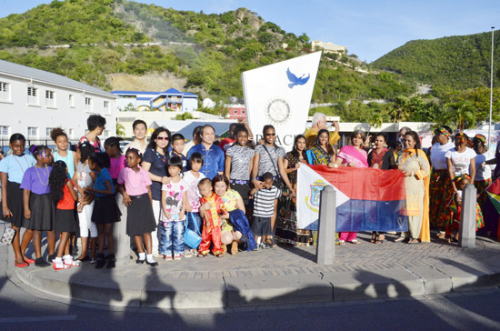

The Vision Project

*The Rotary Club of St. Martin Sunrise has, over the years, reached out to many in the community, especially school children, to provide eye glasses. This was accomplished through partnership with companies such as St. Maarten Optical and Coralie Vision.*

**Rotary Club of St. Martin Sunrise assists in purchase of glasses to students**

PHILIPSBURG, July 18, 2014 -- The Rotary Club of St. Martin Sunrise was able to assist two young students the St. Maarten Academy with the purchase of eye glasses.

Part of the funds to purchase the eyeglasses was made available through the Bert Miller Funds, a fund created in the name of the late Dr. Bert Miller from Nova Scotia. The remainder was secured by Rotary Sunrise Fundraising Director at that time, Mr. Peter Dialani, through a donation from Coralie Vision.

Dr. Miller, an eye doctor by profession, was a regular visitor of Sint Maarten as a timeshare owner at Belair Hotel. Sadly, Dr. Miller passed away during his last visit on St. Maarten in March of 2008. At his memorial held on Sint Maarten, his family, Belair Beach Hotel timeshare owners, and guests donated funds towards eye glasses for children in need as they knew Dr. Miller would have wanted.

Rotary Club of St. Martin Sunrise is very much honored to have been chosen to identify these children in need and to, therefore, make the funds available to purchase the required eye glasses.

The club had donated more than fifteen eyeglasses over the years and it is the wish of the Rotary Club of St. Martin Sunrise to raise funds every year to replenish the Bert Miller Fund and be able to donate more glasses to students in need.

On behalf of the children, Rotary Club of St. Martin Sunrise wishes to thank all who made these donations possible.

Over the Years

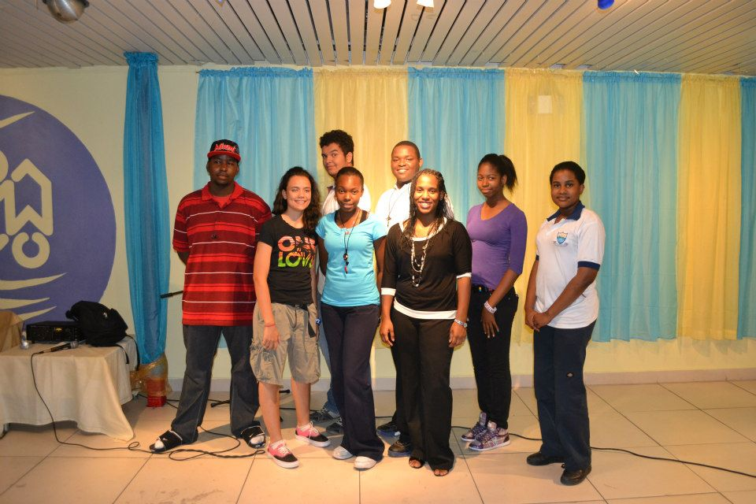

***The Readers Are Leaders (RAL) Board 2012-2013.***

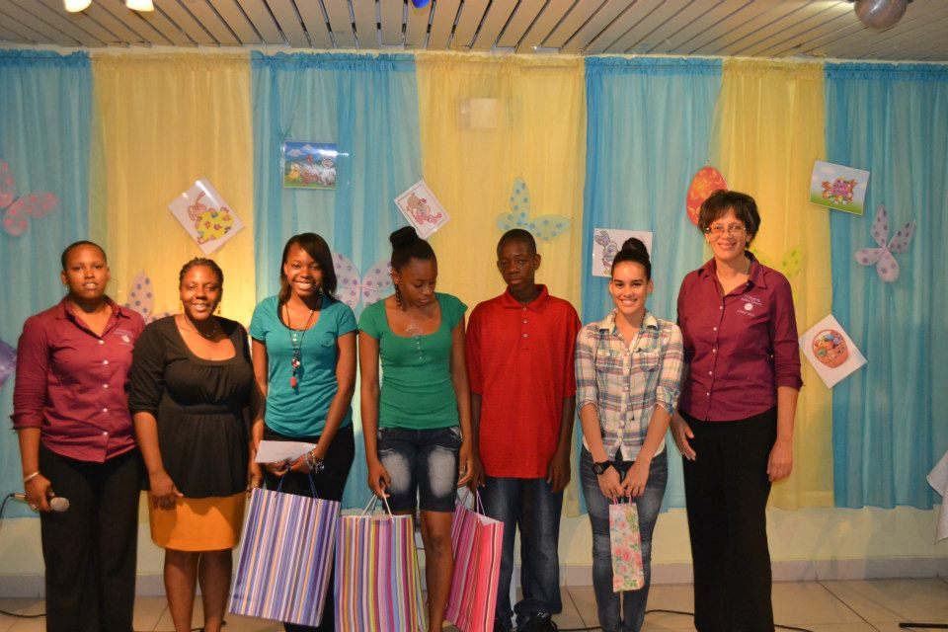

***The Readers Are Leaders ‘Award Ceremony’ in March2013.***

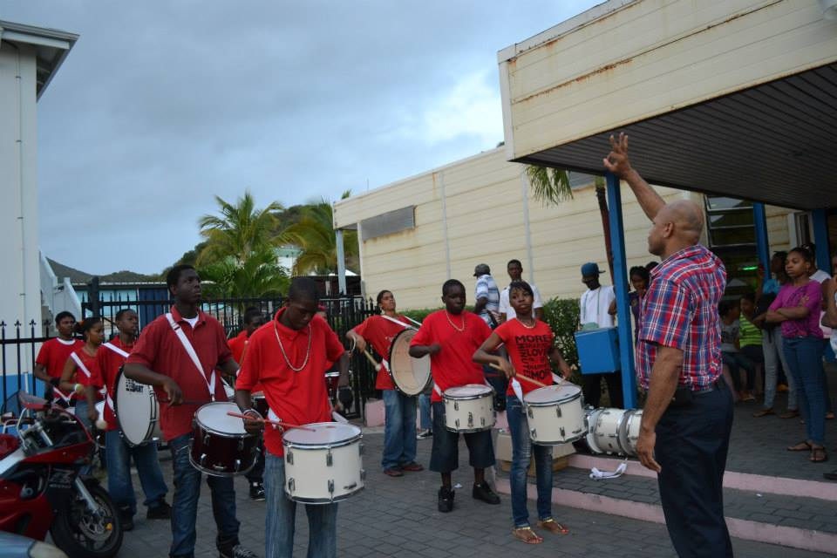

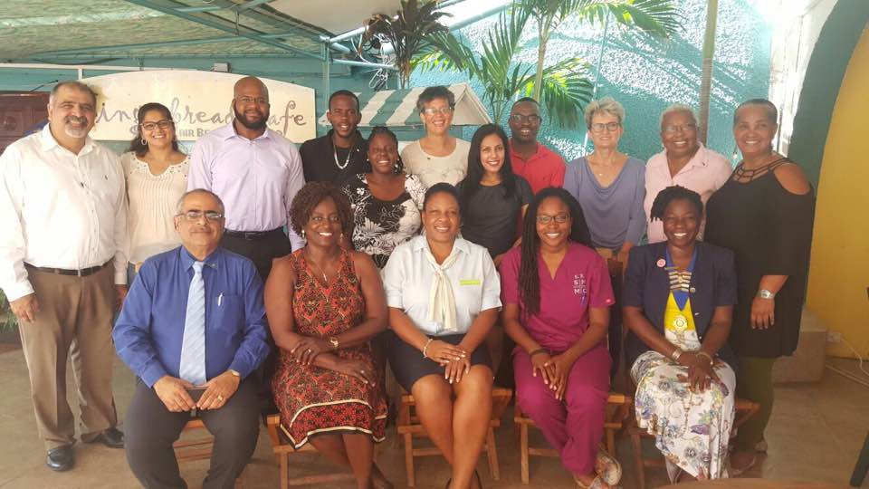

Election Day, October 25th, 2016. Incoming Board 2017-2018

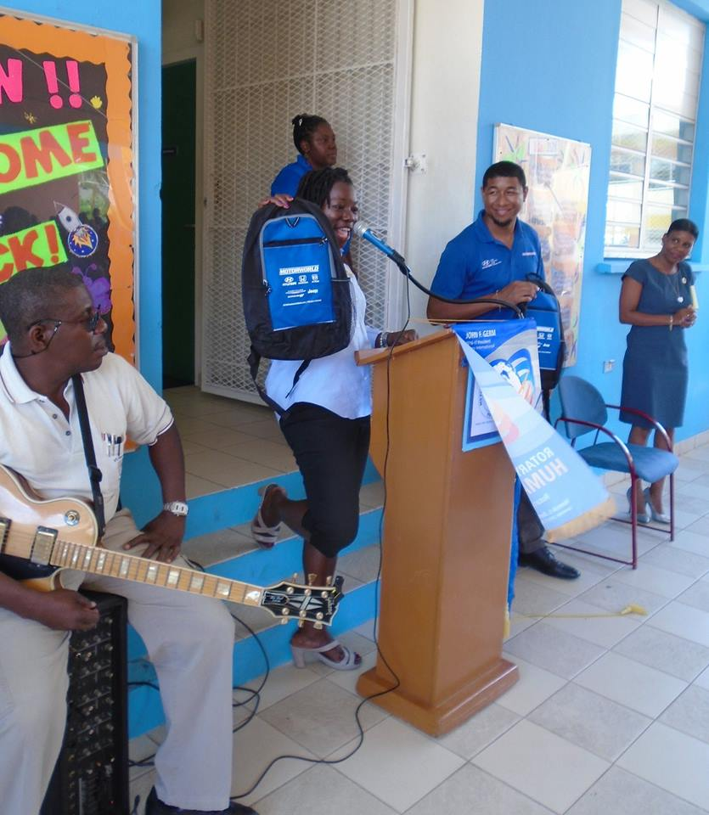

Distributing book bags among the students of the Methodist Agogic Center. August 2015.

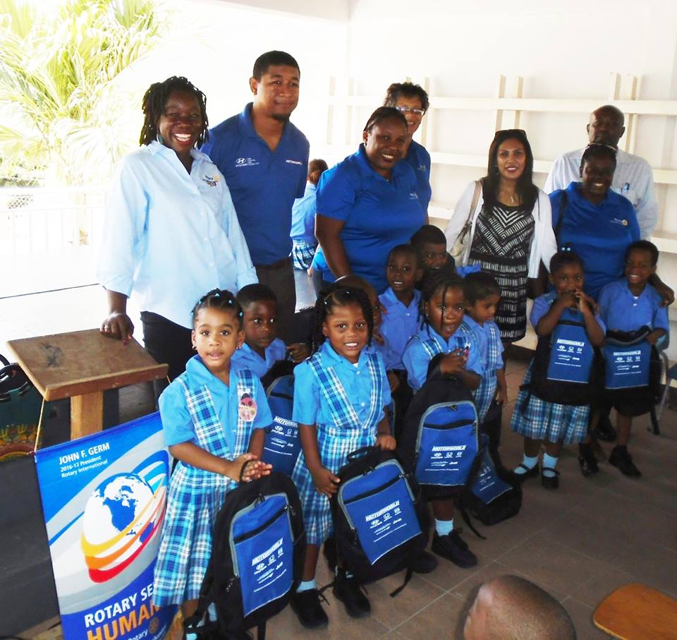

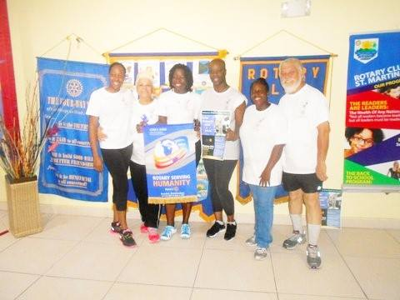

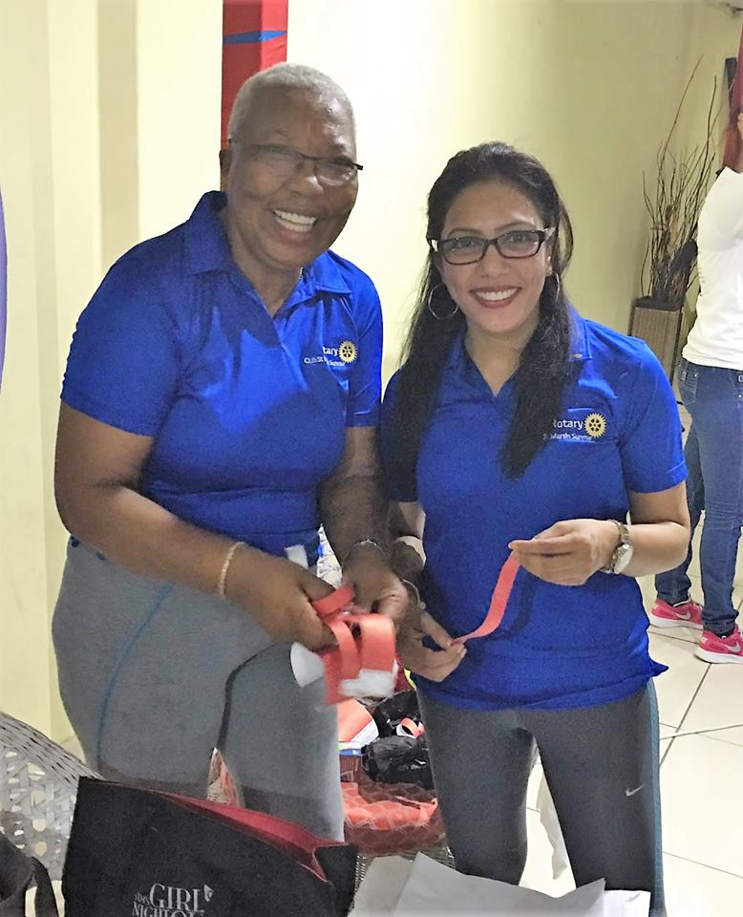

Rotarians at work for the International Peace Day Memory walk and Bike-a-thon on September 17th, 2016.

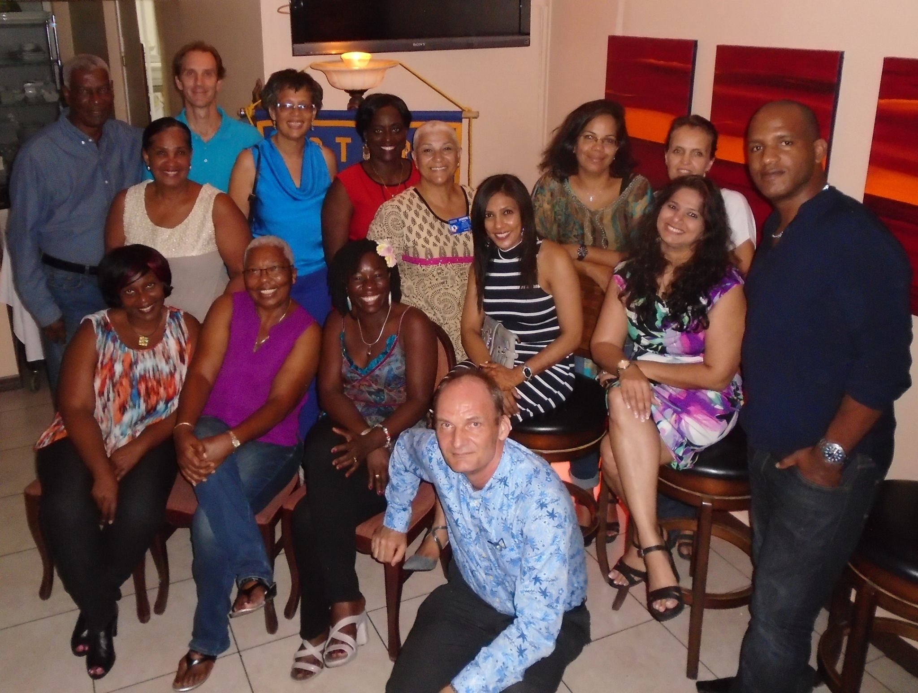

Enjoying each other’s company during a fellowship. August 2016.

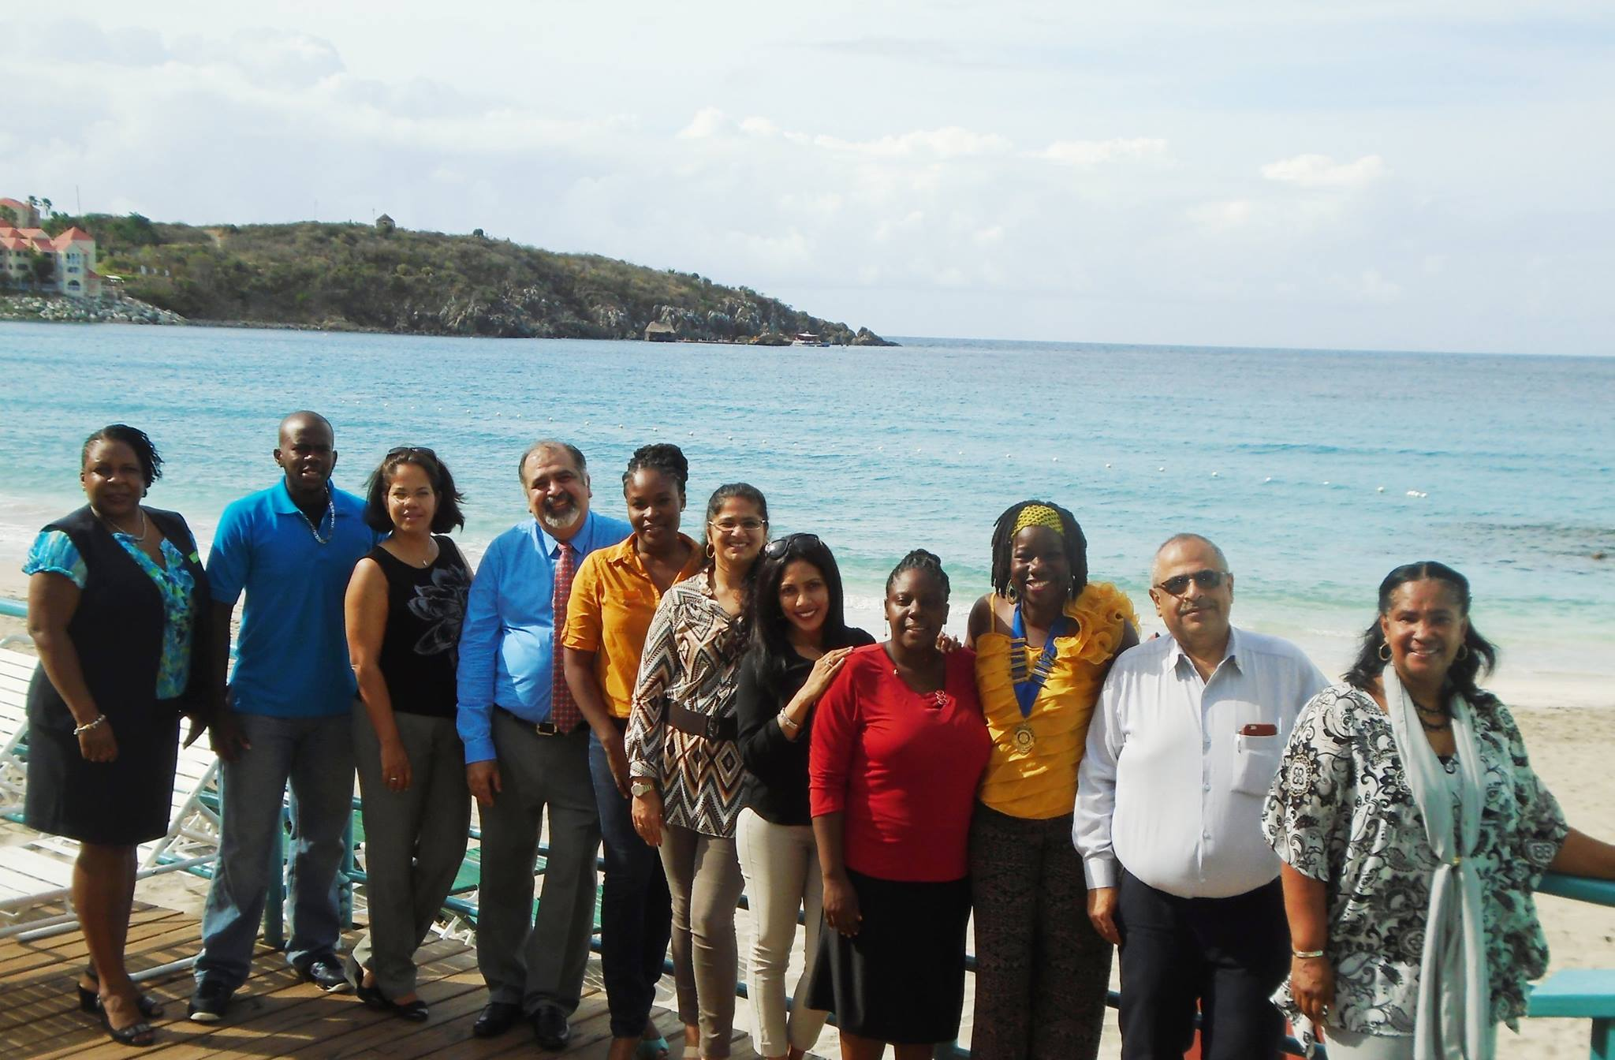

Our amazing new location at the Gingerbread Café at Belair Beach Hotel.

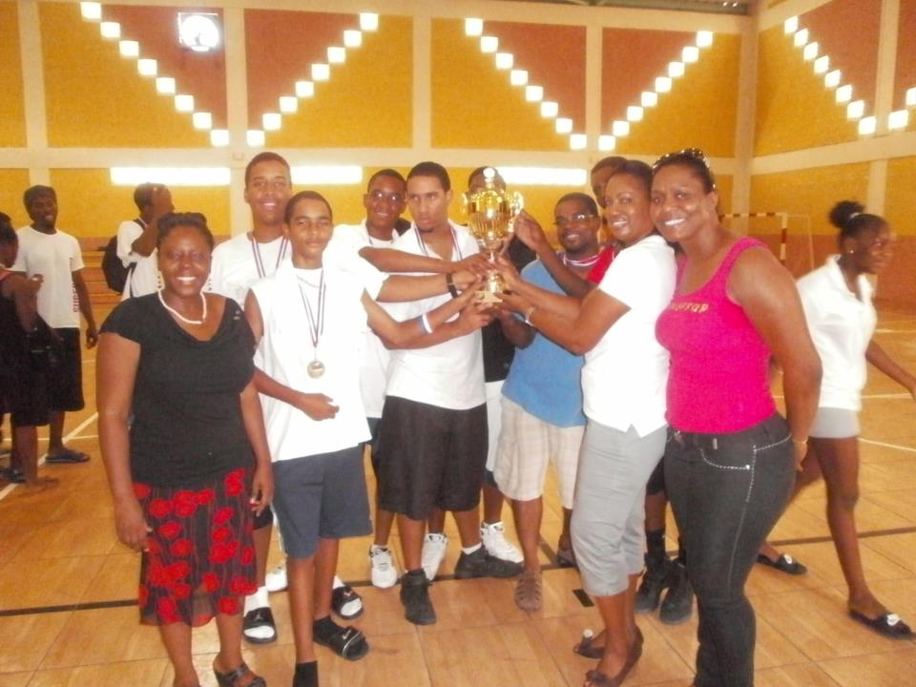

Rotary Club of St. Martin Sunrise held its first annual High School Volleyball Tournament with the assistance of the St. Maarten Volleyball Association on September 29 and October 6, 2012. The finals were on October 6, 2012 at the Melford Hazel Sports Complex. The participating Schools included: Milton Peters College, St. Maarten Academy PSVE, and the Sundial School.  Each school had male and female teams. In lieu of September being Rotary’s International New Generations Month, the Rotary Club of St. Martin Sunrise organized the volleyball tournament, which was coordinated by the New Generation Director, Ms. Paula Gordon.

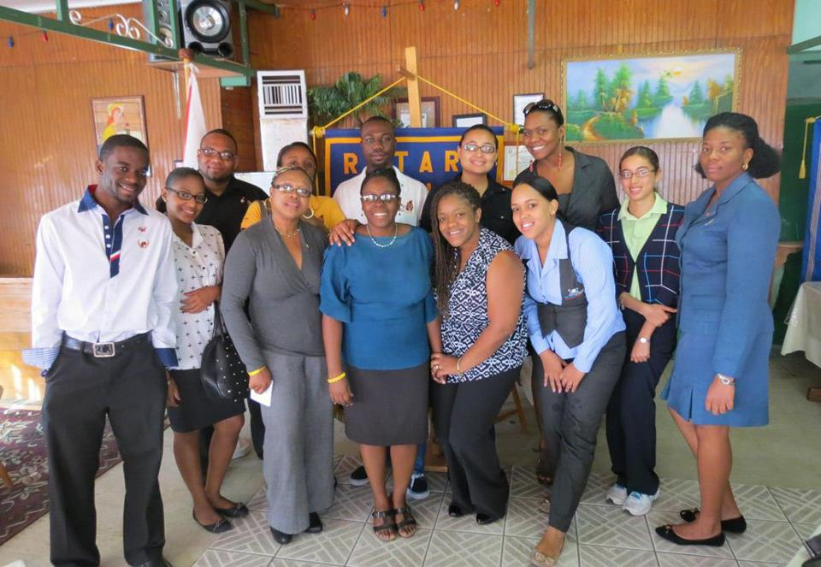

***Rotaract Club of St. Martin Sunrise celebrated ROTARACT WEEK in March 2013.***

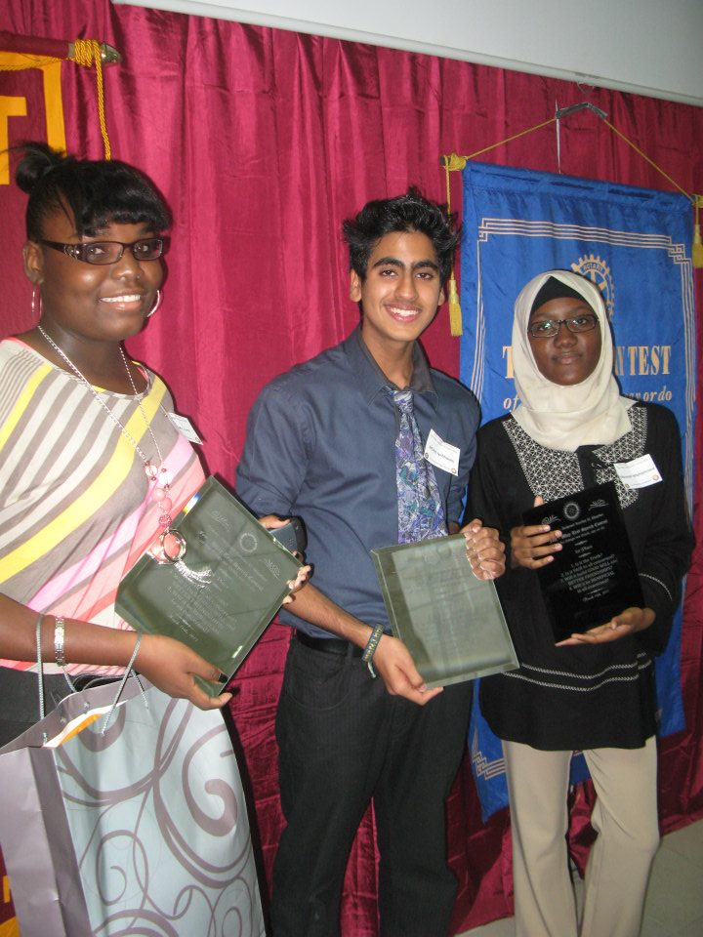

***March 16, 2013, Rotary Club of St. Martin Sunrise and Rotaract Sunrise collaborated in hosting a 4-way speech competition for high school students.***

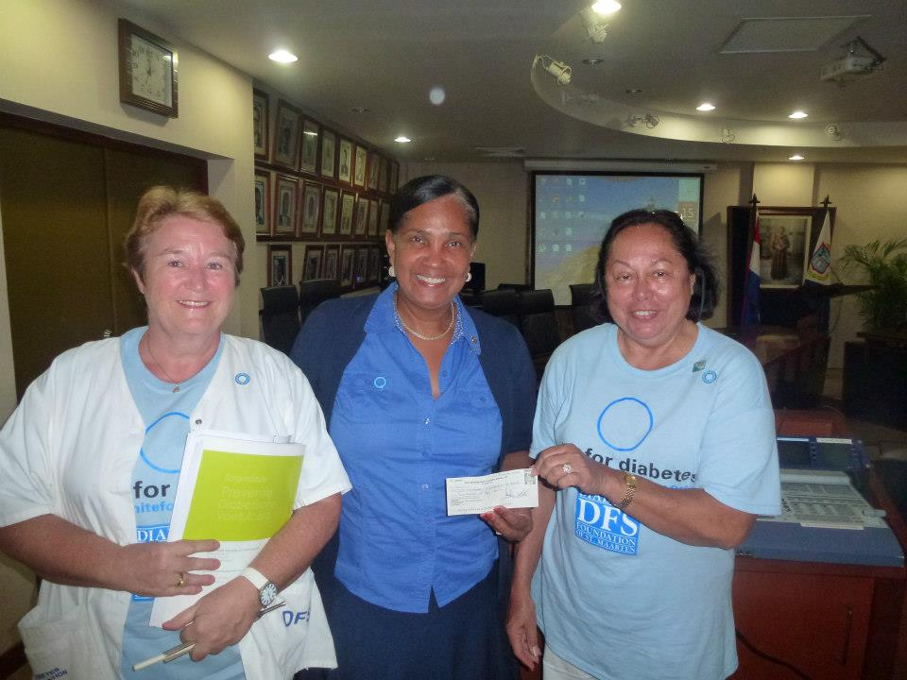

***November 19, 2012:   A donation of USD$ 350 was presented to Diabetes Foundations of St. Maarten at their presentation of the diabetes foot investigation results 2012 in the A.C.Wathey Hall, Government Administration Building.***

***In picture (from left): DF Foundation member Thea Habermehl-Pauw, Rotary Sunrise Vice President Virginia Asin-Oostburg, receiving check DF Foundation Chair Lotty Peterson.***

**ROTARY 4 –WAY TEST**

**Of the things we think, say or do**

* IS IT THE TRUTH?
* IS IT FAIR TO All CONCERNED?
* WILL IT BUILD GOOD WILL AND BETTER FRIENDSHIPS?
* WILL IT BE BENEFICIAL TO ALL CONCERNED?

***"Rotary Serving Humanity"***

CONTACT US

**BELAIR BEACH HOTEL, Gingerbread Café Restaurant**

**Little Bay, Philipsburg, St. Maarten**

**Meeting day: Tuesdays, 7:00 am – 8:00 am**

**Website: sxmsunrise.org**

**District: 7020**

**Visit us on Facebook: Saint Martin Sunrise Rotary**



***“Be The Change"***

