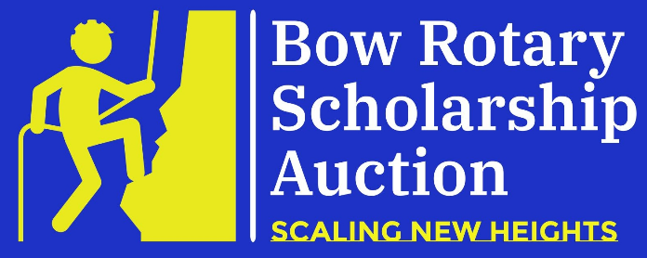
Sponsorship Levels
Wednesday, November 1, 2023 – Saturday, November 4, 2023
Online at www.bowrotary.org
(Please check your level of participation below)

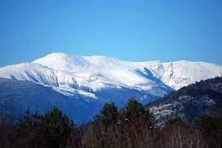 Mount Washington $1,500 (limited to two sponsors)
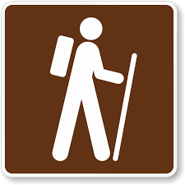 Through Hiker: $1,000
Park Ranger: $500

Tender Foot: $250

Benefits of sponsorship
- Company logo and sponsorship level displayed on “Sponsors” page of auction website, visible for the 4 days of the auction and the weeks leading up to the event.

- Inclusion in homepage window highlighting a different sponsor every few seconds (beginning with higher levels).

- All sponsors will be recognized with a full-page ad in the December edition of the Bow Times with company logos and support levels.

- The satisfaction of giving back to the community by supporting local education!

To confirm your sponsorship, please send this form and your check for the appropriate amount made payable to The Bow Rotary Club Foundation, and mail to: Bow Rotary Club, P.O. Box 1935, Bow, NH 03304. TO ENSURE MAXIMUM EXPOSURE FOR YOUR COMPANY, PLEASE SUBMIT YOUR FORM AND CHECK NO LATER THAN OCTOBER 1st, 2023.
Company: ________________________________________Contact: _____________________________________
Mailing Address: _______________________________________________________________________________
Phone:_______________________________________ Email:___________________________________________

