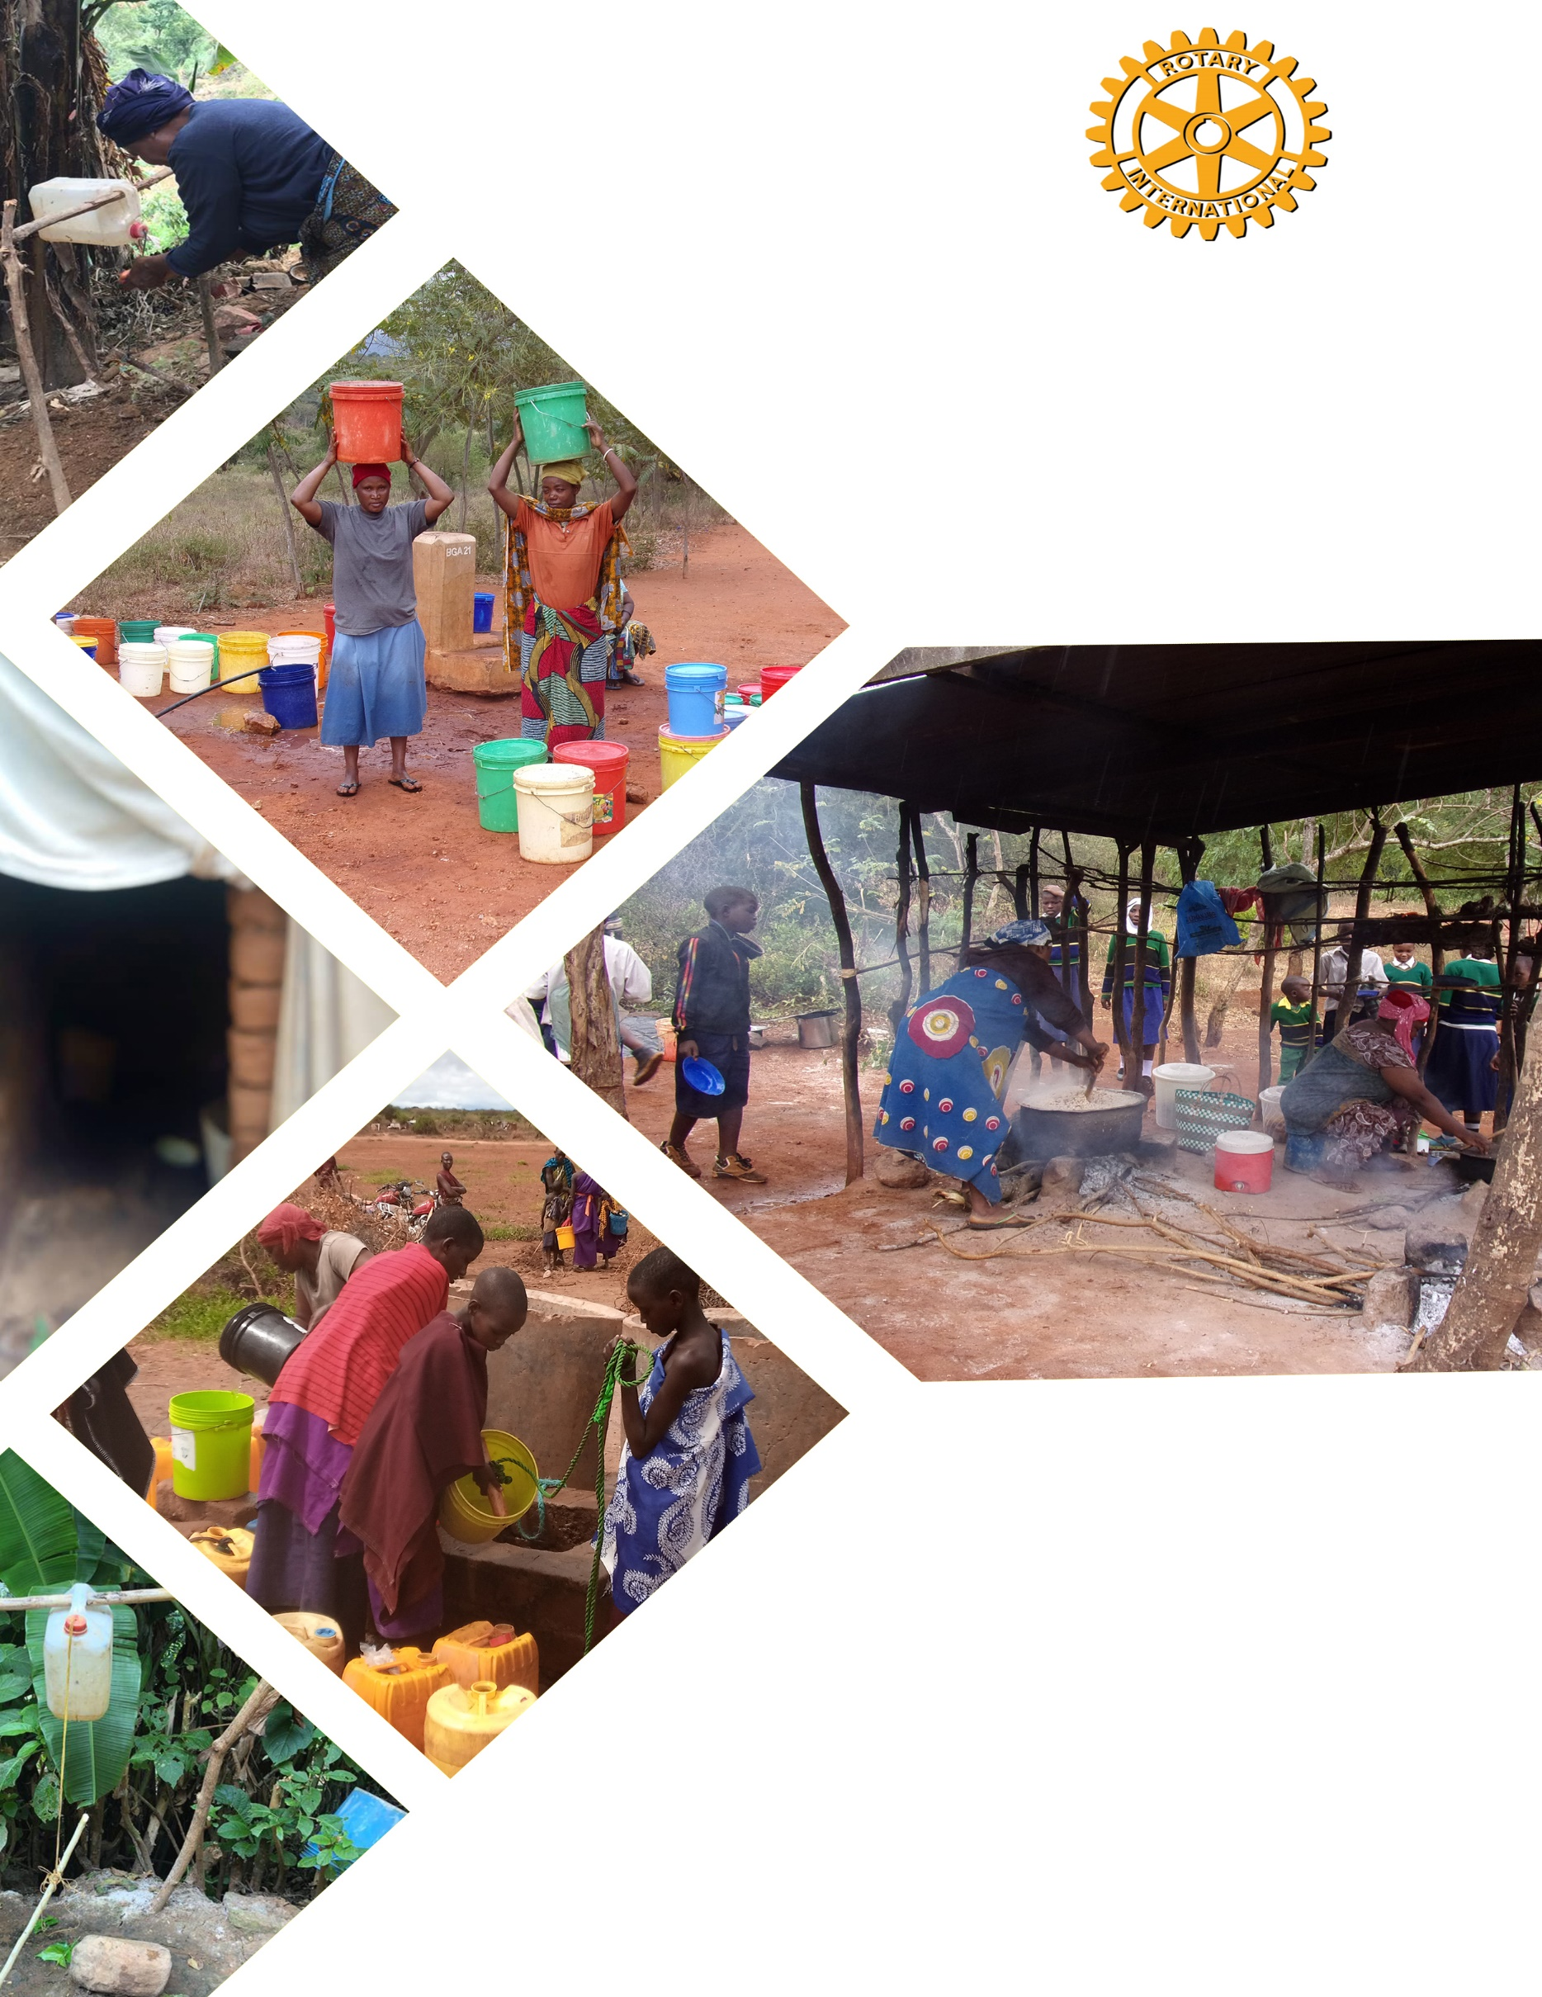
ROTARY CLUB OF SAME

COMMUNITY NEEDS ASSESSMENT REPORT IN SAME DISTRICT

33333333

333

Conducted in seven villages of Same district, Kilimanjaro, Tanzania

Completed in 11th September, 2020

Table of Contents
Background 1
General overview 2
Assessment Objectives 2
1.0.1 Scope of the Study 3
1.0.2 Significance of the study 3
1.0.3 TECHNICAL APPROACH AND METHODOLOY 3
1.0.3.1 Same district Profile 3
1.0.3.2 Sampling 4
1.0.3.3 Sampling technique 4
1.0.3.4 Data Collection 5
1.0.3.5 Technique of data collection 5
1.0.3.5.1 Interview 5
1.0.3.5.2 Focus Group Discussion 5
1.0.4 Observation 5
1.0.5 Documentary 6
1.0.6 Data Analysis and Presentation 6
1.0.6.1 Quantitative Data analysis 6
1.0.6.2 Qualitative Data Analysis 6
1.0.7 Study design 6
3.0 KWIZU VILLAGE 8
1.0.1 Introduction. 8
1.0.2 Community Assessment. 9
1.1.0 Community leaders focus group discussion 9
1.1.2 What job or role do you play to protect or improve water sources? (Explain fully) 10
1.1.3 How do you manage water supply system in the village? What problems are there now? What are your goals for the water system? 10
1.1.4 Hygiene and sanitation 11
1.1.5 Water conflict 11
1.1.6 Water costs 12
1.2.0 Social services to the population in the village 12
1.2.1 Educational institutions 12
1.2.2 Health care facility 13
1.2.3 Sanitation 14
1.2.4 Waste disposal 14
1.2.5 General Comments: 14
1.3.0 Focus group discussion with pupils and teachers at Primary and Secondary schools 15
1.3.1 FGD at Kafingiro primary school 15
1.3.2 Hygiene and sanitation 16
1.4.0 Focus group discussion with pupils at Kwizu primary school 17
1.4.1 Water sources 18
1.4.2 Hygiene and sanitation 18
1.5.0 Focus Group discussion with pupils at Kwizu Secondary School 20
1.5.1 Water sources 20
1.5.2 Hygiene and sanitation 21
1.6.0 Focus Group Discussion with teachers at Kafingiro Primary school. 22
1.6.1 Water source 22
1.6.2 Water sources 24
1.6.3 Water charges 25
1.6.4 School Hand washing 26
1.6.5 Hygiene 26
1.6.6 Hygiene and sanitation 27
1.7.0 Focus Group Discussion with Teachers at Kwizu Primary School 29
1.8.0 Focus group discussion with teachers at Kwizu secondary school 30
1.8.1 Water sources 31
1.8.2 Water charges 32
1.8.3 Hand washing at school 32
1.8.4 Hygiene practices 32
1.9.5 General comments from the above discussion 33
1.10.0 Focus discussion with selected households 33
1.10.1 Economic activities of the house holds 35
1.10.2 The main drinking water in the village. 37
1.10.3 The location of water source in the village (where is the water source) 38
1.10.4 How far is the distance from the household to the water point? 38
1.10.5 How long does it take to go there, get water, and come back? 39
1.10.6 The preferred water source in the community, what is its condition? 41
1.10.7 Challenges faced by households in accessing water from their main source of water. 41
1.10.8 Efforts which have been taken by the community, government and stakeholders to mitigate the problems; 42
1.10.9 General recommendations of Kwizu Village 43
3.0 VILLAGE VUDEE 44
3.1 Introduction. 44
1.0.1 Community needs assessment. 44
2.0.1 Social services to the population 45
2.0.1 Education institution 45
2.0.1 Health care facility 48
2.0.2 Religious institutions 49
3.2 Households interviews 49
3.0.1 Economic activities 52
3.0.2 How may acres of land does your family own, and how many are used for production of agriculture products; if water was more available, what percent would this increase? 53
3.0.3. What kind of domestic animals and birds do your family own? How many of each? If water was more available, what percent would this increase? 53
3.0.4 The biggest problems or needs of any kind in daily living or achieving goals in the village. 54
3.0.5 If you or a family member could work or have a job to make money for your family, what would you wish to do? 54
3.0.6 What is the main water source for members in the households? 55
3.0.7 Where is the main water source located? 56
3.0.8 How far is the distance from the household to the water source? 56
3.0.9 In the last month has been any significant period of time when households did not have sufficient quantities of drinking water? 57
3.0.10 How is the condition of your preferred water source? 57
3.0.11 The challenges you face in accessing water from your main water source based on time spent, method, quantity, quality and other challenge. 58
3.0.12 Efforts have been taken by the community, government and other development partners to mitigate the problems 59
3.0.13 The other factors which could make the water system sustainable. 59
3.0.14 Has the water quality been tested for bacteriological contamination 60
3.0.15 Conflicts that happen in households, or with other people in the community because of water scarcity. 60
3.0.16 Is the water supply managed well by the village? Explain 60
3.0.17 Observation on the place where the household members often wash their hands. 61
3.0.18 Observation to the presence of water at the hand washing station for the households. 62
3.0.19 Is soap or detergent present at the place for hand washing? 62
3.0.20 Do households currently have water and soap for washing hands near the toilets near the kitchen? 62
3.0.21 How do households make water safe to drink? 63
3.0.22 How often the community members conduct hygiene practices of their houses, toilets and clothes? 63
3.0.23 Households experience on diarrhea or other waterborne diseases, what kind of diseases and how often do they happen? 64
3.0.24 Trainings on water, hygiene and sanitation for household’s members in the village. 64
3.0.25 Do households in the village chlorinate or boil water 65
3.0.26 Methods of treatment to drinking water by the households. 65
3.0.27 Type of latrine used in the village 66
3.0.27 Do household’s empty their pit latrine or septic tanks when are filled 67
3.0.28 Do households in the villages share the toilets with other people who are not members? 67
3.0.29 What can be done to improve water and sanitation issues? 68
3.3 Community leaders 68
A. Water sources 68
B. Hygiene and sanitation 69
C. Water conflict 69
3.4 Community Focus Group Discussion 70
4.0 MENAM VILLAGE 71
6.0.1 Introduction. 71
6.0.2 Community Assessment. 71
5.0 Community leaders focus group discussion 72
6.0 Hygiene and sanitation, 73
7.0 Social services to the population in the village 75
9.0.1 Educational institutions 75
9.0.2 Hygiene and sanitation condition 76
9.0.3 Health care facility 77
9.0.4 Religious institutions 77
9.0.5 Households interviews 77
9.0.6 Household’s economic activities 79
9.0.7 Land ownership in the village; 80
9.0.8 What kind of domestic animal and birds do your family own? How many of each? If water was more available, what % would this increase? 81
9.0.9 If you or a family member could work or have a job to make money for your family, what would you wish to do? 82
9.0.10 The main source of drinking water for members of your household 83
9.0.11 The location of water source in the village 84
9.0.12 How far is the distance from the household to the water point? 85
9.0.13 How long does it take to go there, get water, and come back? 85
9.0.14 The preferred water source in the community, what is its condition? 86
9.0.15 Please explain the biggest problems or needs, of any kind, for your family in daily living or achieving goals. (Any topic, not only WaSH) 87
9.0.16 The challenges faced in accessing water from main source? (Time spent, method, quantity, quality or any other challenge) 87
9.0.17 The efforts have been taken by community, government and other development partners to mitigate the problems (list names of development partners?) 89
9.0.18 Efforts that have been taken so far to help the community. 89
9.0.19 Factors which would make the water source more sustainable? 90
9.0.20 Water quality test for bacteriological contamination 91
9.0.21 The place water quality tested 91
9.0.22 Factors which would make the source more sustainable 92
9.0.23 Explanation on the conflicts that happen in the households, or with other people in the community, because of water scarcity or water problems. 92
9.0.24 How do households make water safe to drink and cook? 93
9.0.25 How often do households conduct cleaning of houses? Their toilets? And washing clothes? 93
9.0.26 Anyone in your families experienced diarrhea or other water borne diseases? What are the diseases? How often do they happen? 94
9.0.27 Have the households received any training on water, sanitation and hygiene? Who provided it? When did it happen? And describe the training. 95
9.0.28 What can be done to improve water and sanitation issues? 96
8.0 Focus group discussion with community members 97
10.1 The main source of drinking water to community 97
10.2 Location of the water source in the community 97
10.3 What is the condition of the water source? 97
10.4 What are challenges you face in accessing water from the source? 97
10.5 What efforts have been taken by community or government to mitigate the challenge? 98
10.6 What are the factors which would make water source more sustainable? 98
10.7 Has the water quality been tested for bacteriological contamination? 98
10.8 Water related conflicts 98
10.9 Water management 98
10.10 Hygiene and sanitation 98
10.11 General comments 99
9.0 Needs identification through the Global Grants’ community assessment results 99
10.0 Factors for the project Sustainability 99
11.0 Marwa village 101
4.0.1 Water Supply, Sanitation and Hygiene challenges 103
4.0.2 Opportunities available for improving water supply, hygiene and sanitation 106
4.0.3 Efforts, Strategies and Plans of improving Water Supply, Hygiene and Sanitation 106
4.0.4 Focus Group discussion 107
4.0.5 Gaps, weakness and strength identified 108
4.0.6 Project Sustainability 109
5.0 Emuguri village 109
5.1.1 Water Supply, Sanitation and Hygiene challenges 110
5.1.2 Opportunities available for improving water supply, hygiene and sanitation 113
5.1.3 Efforts, Strategies and Plans of improving Water Supply, Hygiene and Sanitation 114
5.1.4 Focus Group discussion 114
5.1.5 Gaps, Weakness and Strength identified 115
5.1.6 Project sustainability 115
6.0 Bangalala village 116
6.1.1 Water Supply, Sanitation and Hygiene challenges 117
6.1.2 Opportunities available for improving water supply, hygiene and sanitation 119
6.0.3 Efforts, Strategies and Plans of improving Water Supply, Hygiene and Sanitation 119
6.0.4 Focus Group Discussion 120
6.0.5 Gaps, Weakness and Strength identified. 120
6.0.6 Project Sustainability 121
7.0 Mabilioni village 122
7.1.1 Water Supply, Sanitation and Hygiene challenges 123
7.1.2 Efforts, Strategies and Plans of improving Water Supply, Hygiene and Sanitation. 126
7.1.3 Focus Group Discussion 126
7.1.4 Gaps, Weakness and Strength identified 126
7.1.5 Project’s Sustainability 127
8.0. Selection of priority villages in the district 127
8.1. Table of priority villages determined by rural water supply and sanitation authority and Rotary club of Same 129
9.0. General comments from the above table 131
10.0. Success/Achievement 131
11.0. Conclusion 131

List of Tables
Table 1: Number of puplis at Kwizu Village 12
Table 2: Respondents Gender 33
Table 3: Respondents Age 33
Table 4: Respondents Sex 34
Table 5: Marital Status 34
Table 6: Respondents Education level 35
Table 7: main drinking water in Kwizu village 37
Table 8: The total number of pupils at Vudee Village 45
Table 9: Total number of respondents by age 49
Table 10: The sex status for respondents 50
Table 11: Marital status of the households assessed 51
Table 12: Respondent’s education level 52
Table 13: The main water source for members in the households 55
Table 14: The main water source located 56
Table 15: Distance from the household to the water source 57
Table 16: Sufficient quantities of drinking water 57
Table 17: The condition of water source 58
Table 18: Water quality tested for bacteriological 60
Table 19: Water supply management 61
Table 20: Hand wash facilities status 61
Table 21: Availabilities of water in Hand wash facilities 62
Table 22: Reality of hand washing 62
Table 23: Water& soap near kitchen and toilets 63
Table 24: Water treatment at household’s level 65
Table 25: Number of Pupils 75
Table 26: respondents Sex Distribution 77
Table 27: Respondent’s distribution by age 78
Table 28: Respondents Education status 79
Table 29: The main source of drinking water 83
Table 30: Location of the main water source 84
Table 31: Source: Respondent’s age, Field data 2020. 102
Table 32: Respondent’s sex, Source: Field data, 2020 102
Table 33: Diseases 113
Table 34: Bangalala respondent’s age (n=52) 116
Table 35: Mabilioni village respondent’s age 122
Table 36: Water borne diseases 124

List of Figures
Figure 1: Total Population in Kwizu Village 8
Figure 2: Community FGD at Kwizu Village-Source was from field visit 10
Figure 3: Respondents Gender 33
Figure 4: Respondents Age 34
Figure 5: Income Activities at Kwizu Village 35
Figure 6: main drinking water in Kwizu village 38
Figure 7: Distance from the household to the water point 39
Figure 8: Time used to obtain water 40
Figure 9: Sufficient quantities of drinking water 40
Figure 10: Water source condition 41
Figure 11: The total population in Vudee village 44
Figure 12: The total number of pupils in Vudee Village 46
Figure 13: Temporally Toilets at Hembua Pimary School 46
Figure 14: The Second water source at Vudee Primary School 47
Figure 15: Total number of respondents by age 50
Figure 16: The sex status for respondents 51
Figure 17: The main water source for members in the households 56
Figure 18: The condition of water source 58
Figure 19: Water supply management 61
Figure 20: Water treatment at household’s level 65
Figure 21: Methods of treatment to drinking water 66
Figure 22: Type of latrine used in the village 66
Figure 23: Number of Household Shared toilets 68
Figure 24: Kitchen status at Vudee Secondary School 69
Figure 25: Total population in Menam Village 71
Figure 26: Number of participant in FGD 73
Figure 27: Type of latrine used 75
Figure 28: Shared Pits 75
Figure 29: Number of Respondents 78
Figure 30: Respondent’s distribution by age 78
Figure 31: Respondents Education Status 79
Figure 32: Drinking Water source at Menam Village 83
Figure 33: The main source of drinking water 84
Figure 34: Location of the main water source 85
Figure 35: The location of water source 85
Figure 36: Time used to obtain water from the main source 86
Figure 37: The Preferred water source condition 86
Figure 38: Water quality test for bacteriological contamination 91
Figure 39: land size owned by households. 101
Figure 40: Source: Field data 2020 101
Figure 41: Marital status 102
Figure 42: Toilet Status at Marwa Primary School 103
Figure 43: Distance to the water source 104
Figure 44: Water borne diseases 105
Figure 45: Major problems raised in the village 108
Figure 46: Emuguri Respondent’s age 109
Figure 47: Marital status 110
Figure 48: Water Sources 110
Figure 49: Emuguri Community’s problems. 111
Figure 50: Water costs 112
Figure 51: Water Point at Betel Sub Village 116
Figure 52: Water Point at Emuguri Village 116
Figure 53: Bangalala major problems 117
Figure 54: Tape in the Health Facilities 118
Figure 55: Common diseases in Bangalala village. 119
Figure 56: Kitchen Status at Bangalala Primary School 121
Figure 57: Toilet Status at Bangalala Primary School 122
Figure 58: Mabilioni Major problems 124
Figure 59: Mabilioni water borne diseases 125
Figure 60: Water Source at Mabilioni 127
Figure 61: Mabilion Primary School Water Point 127

Background
Access to clean and safe water has been a major challenge especially in developing countries where resources are limited to handle the challenge. This situation caused challenges to hygiene and sanitation cause health and economic challenges. Full realization of the SDG targets, which aim to ‘end’ open defection and achieve ‘universal access to WASH ‘for all’ will be a challenge for all countries, World health Organization (WHO) report, 2019. The outbreak of waterborne diseases like typhoid, amoeba and cholera have been experienced and endanger people’s life. At domestic point, people especially women and girls spend much time in searching for water which affect other income generating activities and speed up gender gap. However, the water challenges reported to be the as source of family and community conflicts.
Several efforts have been made by governments and other development partners to address the challenges but empirical evidence shows, that plan achieved more in towns and left rural areas with major water challenge. According to Water Supply and Sanitation in Tanzania report of 2015, the water supply coverage in Tanzania is estimated at 84 % for urban areas and 58 % for rural areas and sustained sanitation coverage is estimated at around 50 %. However Tanzania the National Water Policy (Nawapo) launched in 2002 established “community participation” as one of the main principles for the management of rural water supply. The Water Supply and Sanitation Act (Wssa) No. 12 of 2009 presents Community Owner Water Supply Organizations (Cowso) as the only legal management entity entitled to implement Nawapo’s principle. The Wssa introduces Cowso in order to improve local water management systems by ensuring communities participation, ownership and independence in the management.
Same District is one among several districts in Tanzania which face water challenge. Although in Same Township center there is water availability although the service provision is in turn, but some of its villages face serious shortage of water, the fact which led the district authority and other development partners to intervene the challenge to some villages. However, because of insufficient resources, the efforts made by district designated authority and other development partners doesn’t solve the problem to all villages. The Rotary Club of Same and ETI played a vital role in addressing water challenges in Same district. Among the potential development partners the Rotary club of Same supported the communities in three villages of Ishinde (Kigogo), Masandare, Mhezi phase one and the underway Mhezi phase two. Likewise the ETI was potential to implement water projects the villages of Muheza (Nadururu), Hedaru (Katahe), Ruvu Muungano and the underway project at Ndolwa village. Those villages were among the ones which identified to be with serious water challenges and there people were at risk of water borne diseases, poor hygiene and sanitation.

General overview
The Rotary Club of Same (RC Same) has been working with the Manager for the Rural Water Supply and Sanitation Authority (Ruwasa) for a couple past years. The Ruwasa began to identify 14 villages in the District with critical water needs and explore opportunities to help them with this priority need. Rotary club of Same and ETI chipped in by soliciting funds through the District 5100 to support the community needs assessment for situational analysis. The community needs assessment was proposed to respond for the interests for Rotary club of same and ETI to assist several villages through a scale up model. The study aimed to collect and review primary data, to assess all kinds of water sources including surface water, springs, rivers, rain harvests and underground water data. Likewise, the study focused to establish the conditions and usage of toilets and kitchen at households, health care centers and schools. The assessment team had chance for discussion with village leaders, men, women, primary/secondary school’s pupils/students and community through meetings to obtain their opinions and feelings about the issues related to water supply, hygiene and sanitation in the villages. The activity hardly started on 3rd May up to 2nd July 2020 whereby the team has been doing the initial preparations to questionnaires and deployment of questions to the mWater surveyor tool. In 4th July 2020 the mWater surveyor tool was rolled out to the enumerators to equip them on the utilization skills. In 6th July 2020 the team of 10 enumerators conducted a field visit for pretesting of the questionnaires and the mWater surveyor tool at Mabilioni village. However, due to the situation in this village the team is convinced to include the village in the plan for intervention. Likewise, in 7th July 2020 team visited Vudee village for data collection whereby team members were divided into two persons assisted by local leaders of each sub-village. Few of them were sited to conduct interviews and focus group discussion with specified respondents in schools and other social institutions. Similarly, from 8th-12th July 2020 the team visited Menumu, Bangalala, Kwizu, Marwa and Emuguri villages for data collection. In 13th July 2020 the data collection team had a meeting and discussion to finalize the activity. Some of participants were yet completed the task of data submission as many questionnaires were drafts in the mWater tool. The assessment team was advised to have more few days to finalize the exercise of data validation in the mWater surveyor tool and submission for analysis and report writing.

Assessment Objectives
The objectives of the study were; to establish the situation based on water supply, sanitation and hygiene situation and challenges in seven villages of Same District, Assess opportunities available to improve water supply, hygiene and sanitation and Examine efforts, strategies and plans of improving water supply, hygiene and sanitation.

Scope of the Study
This study focused on water, hygiene and sanitation related challenges in specific villages. Therefore the study doesn’t work on scientific issues like water quality testing because it needs time and financial resources.

Significance of the study
The Community Needs Assessment (CNA) is very useful in identifying actual community situation and understanding water related challenges facing the communities. Also the exercise helped to understand water sources and their situations and challenges facing them. However the CNA provided awareness to the researchers and other development stakeholders on efforts done by communities, government and other development practitioners on challenges mitigation and future plan as well. It widened knowledge on how community handled the challenges of water, hygiene and sanitation and resilience and coping strategies.
The findings provided important information and knowledge to development organizations which are dealing with water sector. Some of the information will be useful in planning and budgeting processes since some hygiene and sanitation challenges were addressed. Also the study adds knowledge to community on the existing water, hygiene and sanitation challenges and provides new ways of thinking to address those challenges. It further provided adequate information to policy makers about the existing water challenges which gives a chance for intervention to minimize its effects. However, the study will act as reference for other researchers on related studies.

TECHNICAL APPROACH AND METHODOLOY

Same district Profile
The study was conducted in Same District, Kilimanjaro Region. The district was selected purposely due to the fact that Rotary Club of Same and ETI took initiatives in addressing water challenges by identifying villages with critical water needs. The district has identified fourteen villages with water challenges but Rotary Club of Same and ETI the cooperating partner selected seven villages with more critical water related challenges. The selected villages included Vudee, Menamu, Bangalala, Emuguri, Mabilioni, Marwa and Kwizu villages. The main economic activities of these villages is agriculture, livestock keeping and small scale businesses.
Geographically, Same District is located in the Northern part of Tanzania, about 105 km from Moshi town. It covers an area of 5186 km2 which is equivalent to 39% of the total area of the region (13 309 km2). Administratively, the district is divided into 6 divisions, 34 wards, 100 villages and 506 registered sub village in which 12 sub villages form Same Township Authority. The district also has two parliamentary constituencies Same East which has 14 wards, 52 villages and 266 sub village and Same West which has one Township Authority, 20 wards, 48 villages and 240 sub villages. The council has established the provisional Same Township Authority and it is in operation.
According to National Population Census of 2012, Same District has 269 807 people, of whom men were 131 515 and 138 292 women. However population projection of 2019 shows that, Vudee village has 2316 people of whom 1168 were women and 1149 men, Menamu 2381 (women 1214 men 1168), Kwizu 2257 (women 1144, men 1113), Emuguri 1876 (women 998, men 878), Marwa 3569 (women 1703, men 1866), Bangalala 2929 (women 1588, men 1441) and Mabilioni 1757 women 881 and 876 men.

Sampling
The sampling unit involved households, community, institutions (schools, health care facilities). Additional information was obtained from leaders. The researcher’s preferred a sample of 50 respondents from each village. The sample size was justified on the fact that too large a sample implies a waste of resources, and too small a sample diminishes the utility of the results (Bartlett et al., 2001). The selected sample was adequate to establish cross-tabulation in water challenge in area for this study.
The sample size established was reliable at 90% because the residents in those villages experienced water, hygiene and sanitation situations. The unit of analysis was individuals, and groups who were residents of specified villages. Random sampling was applied to obtain and people who were involved in focus group discussion (FGD).

Sampling technique
Multistage sampling was employed to select households whose members had experienced life in the village. The technique was preferred because it allowed the use of both probability and non-probability sampling techniques. Purposive sampling was used to select leaders and teachers in the villages.
Since the population of the study was not homogenous, stratified sampling design was applied to create strata which obtained from the study area. Then simple random sampling was used to select households and individuals. This technique was applied in order to eliminate bias and create equal chance for each unit to be included. In selecting leaders, teachers and health facility staff, purposive sampling was applied because the researcher specifically required official data from them. The data from leaders was useful as it enabled the researchers to have knowledge on constrains facing water sector.

Data Collection
There were two types of data collected which included primary and secondary data. The primary data involved data which collected by the researchers for the first time from the respondents. During obtaining primary data, structured questionnaires were applied. The second type of data was secondary data. These were type of data which have been collected by someone else and passed through statistical process. It was collected through web based materials and other documentation from different places government offices in Same District. Secondary data was provided supplementary information to the primary data and make findings more detailed and comprehensive.

Technique of data collection

Interview
The respondents were interviewed in order to get required data which were relevant to the study. Check list was applied to guide the researcher on issues relating to the topic. However, the researcher spent about 15 to 20 minutes for interviewing one person where for one day a minimum number of 50 respondents were interviewed. This technique was applied for the purpose of saving time and provided flexibility during interview. The researcher encountered some challenges when applying this technique. Among challenge experienced included difficulty in obtaining respondents for interview in some villages as most of them were busy with farming activities. However the application of polite language helped to overcome the challenge.

Focus Group Discussion
The focus group discussion technique was applied for the purpose of obtaining relevant information. The check list tool in software was applied to guide the researcher on specific areas which were discussed. It was experienced that, some group members wanted to dominate the discussion. In ensuring all participants got equal chance to provide their ideas, the researcher invited them to contribute what he/she knew as everyone has got valuable contribution. The discussion covered about 1 hour minutes in order to avoid long discussion which might constrain member’s personal activities.

Observation
This method was used during data collection whereby researchers observed and captured pictures on various parts such as water sources, hygiene and sanitation. Issues relating to hygiene and sanitation were also observed in the field. At some point, the researchers sought clarification on some complicated observation.

Documentary
The information was gathered by using documentary source. Programs from different official publication, files, books, journals, and pamphlets were applied. The document supplemented the data obtained from the respondents. Documentary materials also provided supportive evidence and references about the study.

Data Analysis and Presentation

Quantitative Data analysis
Quantitative data were collected and checked for correctness, coded and improved, including recording variables in IS Units, e.g. litters etc. before being entered into SPSS. After entry, the data were checked again for accuracy, and any irregularities that were found were corrected. Then the data were analyzed by using multiple response analysis.

Qualitative Data Analysis
The multiple response analysis was applied during qualitative data analysis process. The questionnaire was reviewed to identify answers in relation with respective objective. The relating answers were put into the same group for coding and assessing them for differences and similarities. Then results were interpreted in comparison with the results obtained from questionnaires. Also qualitative data analysis was applied in order to show the relationship which exists between variables. The results were interpreted in comparison with the results obtained from the respondents. The SPSS tool was applied in qualitative data analysis.

Study design
The study applied a cross-sectional survey which allowed data to be collected at a single point in time. The design was chosen because it entails collection of data on more than one case at a single point in time in order to collect a body of quantitative and/or qualitative data about two or more variables, which were then examined to detect patterns of association. The design provided a chance for the researcher to make comparison among different groups of respondents to determine how dependent variables relate to independent variables. The collected data were used for simple description and establish relationship among variables. The study was supplemented by personal observation on field during data collection. Focus group discussion was conducted to get in-depth information whereby community representatives were involved in focus group discussion in each village. Therefore, the study was descriptive because it contained greater degree of occurrence and precision in findings. The following are the villages visited and the interview, FDGs and observation conducted.
In 6th July 2020 the assessment team conducted a field visit for pretesting the questionnaires and the mWater surveyor tool at Mabilioni village. Due to the critical water situation at Mabilioni village, the team is convinced that the village should be included on the list of selected villages with critical water needs in the district. In 7th July 2020, the team visited Vudee village at Vudee ward for data collection. In 8th July On 7th July 2020, the team visited Menum village at Vudee ward for data collection. In 9th July 2020, the team visited Bangalala village in Bangalala ward for data collection. In 10th July 2020, the team visited Kwizu village in Mshewa ward for data collection. In 11st July 2020, the team visited Marwa village at Ruvu ward for data collection. In 12th July 2020, the team visited Emuguri village at Njoro ward for data collection. In 13th July 2020, the data collection team had a meeting and discussion to finalize the activity.
The main challenges during field visits were; much time used to develop and review questionnaires and the mWater surveyor tool technology in data collection. From 3rd May to 4th July 2020 the team had intense work of developing and reviewing questionnaires before approval. Poor road access especially in highland villages. It was very difficult for the participants to walk up and down during the household's interviews. Some of the visiting points at the villages are sited very far from the village’s centers. Therefore the team spent almost a day or two days to cover the whole village. Economic and social activities in some villages, the assessment was interrupted by the central markets and other social activities in the villages. In some villages the leaders to some institutions were not available therefore the team had to wait or move forward. In some of the school timetables for pupils and teachers it was very tight to give adequate time for interviews and focus group discussions. Budget constraints, the budget was not flexible due to new arising needs like budget for the surveyor’s helping team and local transportation in villages, meals and or drinks for the helping team in villages who had to spend all the day to assist the data collection team. Achievement; Seven villages out of six in the original plan were visited and data collection was successfully done.

KWIZU VILLAGE

Introduction.
Kwizu village in one of the five (5) villages in Mshewa ward namely, Kwizu, Marindi, Mshewa, Manka and Goma. The village is located over the highlands of same District to the South-West of Same District. The Kwizu village is bordered by Mhezi ward to the West, Msindo ward to the East, Kisiwani ward to the South and Vudee ward to the North. The village is about 30 kilometers drive on the rough road away from Same District township center via Mwembe village. The village is mainly dominated by Pare tribe and few public service workers in different local government sectors. The total population in the village is 2674 dwellers of whom 1224 are male and 1450 are female. The village has approximately 382 households based on the current census in the village. The village is including of five (5) sub-villages namely, Kibengele, Dule, Kireti, Kindi and Chasheve. The Kwizu village has the following social institutions; Kafingiro primary school, Kwizu primary school, Kwizu secondary school, Evangelical Lutheran church at Kindi Dule sub-parish, Manolo parish of Roman Catholic church, Roman Catholic church of Kwizu sub-parish and Kwizu dispensary. The main economic activities in the village include farming for food/cash crops and livestock keeping. The main crops grown in the village are maize, beans, sugar cane, bananas, trees for wooden poles and timbers. Likewise, the types of livestock raised in the village are cows, sheep, chicken, goats, and pigs to mention a few. The figure below indicate the total number of population in the village.

Figure 1: Total Population in Kwizu Village
Source: Field visit

Community Assessment.
The community Needs Assessment activity was conducted at Kwizu village on Friday July 10th 2020. The team of nine (9) assessors visited the village for community needs assessment based on water supply, hygiene and sanitation. A team arrived of nine (9) participants arrived at 9:00 am in the morning at village ward office. The team leader gave a brief introduction on the purpose of the visit before the meeting and team members were introduced by their names to leaders. However, the plan and arrangements for assessment were already done based on community administrations whereby the village executive officer (VEO) played the protagonist. Afterwards, team members were divided into groups based on the number of sub-villages and each group accommodated by a local supportive leader. Yet one person remained at the village office for leader’s focus group discussion and leader community lead a meeting in the afternoon. After we were through with all logistics at the village office, the leaders for sub villages were consigned to escort enumerators to the households for interviews. The mode of selecting households for interview in a particular out of many was random sampling. Prior to household’s visit for interview with an individual members in a designated household, the interviewees were acknowledged and asked for permission to participate the interview on behalf of their household.

Community leaders focus group discussion
Kwizu village is located at the GPS Location:-4.132840, 37.897849 and the administrative region is Mshewa, Same, Kilimanjaro, Tanzania.
Later in the afternoon the leaders for the Kwizu village and its sub-villages were involved in the discussion about the situation based on water supply hygiene and sanitation. The facilitator for the focus group discussion was Charles Anatoly, the representative personnel from the district community development department (DCDO). Number of participants were eight (8) of whom five (5) were male and three (3) were female as clearly shown in the figure below;

Figure 2: Community FGD at Kwizu Village-Source was from field visit

The questions were presented to the group for discussion to assess their thoughts and feelings on the subject presented and based on the following questions;

What job or role do you play to protect or improve water sources? (Explain fully)
Leaders in the community admitted to have various committees with different roles to play in protecting water sources, such as to supervise water committee on water source protection, to enforce by laws which guide people from the following activities; grazing livestock along the water sources and if happened there is penalty of Tanzania Shillings 50,000/=, Ensure there is no water linkage along the local available water infrastructures, Trees planting at water sources for protection and improvement purposes, Regular inspection of water sources, supervise health committee which is responsible on health issues including effective use of toilets and environmental hygiene.

How do you manage water supply system in the village? What problems are there now? What are your goals for the water system?
To inspect local water infrastructure system existing and if happen damaged parts, they organize community contribution to maintain broken parts. To supervise water allocation from the source. If customer water to install water to his house, must request to government then the village discuss the application and official reply, to supervise and identify new water channels and problems, the existing poor water infrastructures due to non-constructed water sources, which is not adequate to serve the community. In addition, poor tank quality which cause linkages of little water available, shortage of storage tanks, during rainy season storage tank is contaminated and filled with mud because of poor infrastructure, the goals is to make regular maintenance of water system, to rise fund from the community to renovate the available infrastructures and solicit funds from donors to support construction of a modern water project which will address water needs to the community.

Hygiene and sanitation
How the condition of hygiene and sanitation is in the village? The washing situation in the village was explained to be poor up to the recent months, where people have changed the behavior due to the spread of corona virus pandemic, the hygiene and sanitation situation in the village is good. Now then each household and social institution is sensitized to install a washing station at different corners of the premises. Above all, the different public parts of the village centers posters are displayed to provide education on effective hand washing to prevent people from the Covid-19 infections.
What efforts have been taken to improve hygiene and sanitation in the village?
The village government in collaboration with the key stakeholders and committees in the village like water, environment, security and health committee educate people on the significance to hygiene and sanitation practices. Household’s inspection is regularly carried out to ensure hygiene and sanitation condition is improved for a healthier community. Likewise, the village government is organized to enforce the guiding by laws in the village to ensure that people adhere with health principles.

Water conflict
Have you experienced water related conflict? How did you addressed
No conflicts was reported based on conflicts related to water supply and service in the village.
Are there outcomes from water related conflict? Explain
Nothing was reported based on the aspect of social conflicts in the village

Water costs
Do you have water charges system in the village? How do you set water charges rate? How much is the charge?
Water service is for free in the village, although community members have to contribute money for maintenance of the local existing water infrastructures.
The general comments by community leaders; the village has great need for safe and clean water, interventions against water borne diseases and support to construction of the washing stations and better toilets at the existing primary and secondary schools will highly be appreciated.

Social services to the population in the village

Educational institutions
The village has two (2) primary schools namely Kafingiro and Kwizu. Similarly, there is one (1) secondary school namely Kwizu both serving boys and girls. The number of pupils at Kafingiro primary school is 178 of whom 100 are male and 78 are female. As well, number of pupils at Kwizu primary school is 101 of whom 52 are male and 49 are female. Likewise, number of pupils for Kwizu secondary school is 333 of whom 145 are male and 188 are female as clearly presented in the table below.
No | Name of School | Male | Female | Total
1 | Kafingiro primary | 100 | 78 | 178
2 | Kwizu primary | 52 | 49 | 101
3 | Kwizu secondary | 145 | 188 | 333
Table 1: Number of pupils at Kwizu Village
Field source
Two members from the assessment team Efrancia Nzota and Pilly Msuya were committed to visit Kwizu primary and secondary schools to conduct focus group discussion with teachers and pupils aimed at gaining several facts based on water supply, hygiene and sanitation condition. Amon and Athuman did the same thing at Kafingiro primary school, whereas, Giliard visited all schools to conduct study by use of the Global grants community assessment results. The Kafingiro primary school is located closer to the beginning of Kwizu village near the border from Mhezi village at about 500 meters beside the main road from Mhezi to Mbaga.

Health care facility
Focus group discussion at Kwizu dispensary.
The point visited by Charles and Giliard in 10th July 2020. Charles conducted interview with the center staff. Giliard compiled the global grants community assessment results.
Kwizu dispensary: GPS Location:-4.141790, 37.913817 and administrative Region is Mshewa ward of Same district in Kilimanjaro, Region, Tanzania.
The focus group discussion led by Charles based on the presented questions and finding were recorded through the mWater surveyor tool as clearly reported in the below section. The participants for discussion were two staff and number of patients were already attended and got back home.
The main water source for the dispensary is tape type located within the center compound. There is storage tank with 2000 liters installed for water collection. Based on discussion the condition of water access is scarce, sometimes they stay one month without water, they use to buy water one jug of 20 litter tsh.500. Although water is available at the dispensary, there is challenges in accessing water which led to stay up to two weeks without water. In this situation they have to buy water in twenty (20) liters containers. The rate of water charges is Shillings 500 per container of 20 liters and cash comes from staff pockets. The condition of water source, is seasonal and water is contaminated. They don't drink water available at the source. Every staff come with treated water from home. The patient are also facing a challenge of water to drink. During time of survey, there was no drinking water from the main source currently available at the health facility. The available water reserved for hygiene and sanitation only. Neither water quality has tested for this water point nor water quality sample taken for testing.

Sanitation
Likewise, there is no sufficient water for washing our bottom, or paper for wiping, in the toilet. At least there is one usable improved toilet designated for women and girls, which provides facilities to manage menstrual hygiene needs and women toilet also is used for menstruation purpose. In addition there is at least one usable improved toilet designated for staff. Hand washing principles and procedures are taken into account.
There is no any usable improved toilet that meets the needs of people with reduced mobility. The type of toilet used are pit latrines with water container inside and water is sufficient where there is shortage of patients but when number of patients increased is not enough. Toilet has cleaning facility water, soap and brooms. There is functional hand hygiene stations available at the selected point of care on the day of the survey. Likewise, based on observation, there was functional hand washing facilities with soap and water available at toilets on the day of the survey. Staff do hand washing regularly though normally use sanitizers to clean hands, they use tap flowing water, soap and rinse up to 15 seconds.

Waste disposal
Waste safely segregated into at least three labelled bins in the consultation area and disposed to the incinerator. The facility usually treat/dispose of infectious waste through open burning.

General Comments:
Based on discussion, participants had the following opinions regarding to services available in this HCF. They need water for health service. Also construction of incinerator is very important. The dispensary building is not enough. Construct staff house Number of staff need to be increased there only two staff. One staff is suffering from mental illness therefore there is only one staff who is working at the dispensary

Focus group discussion with pupils and teachers at Primary and Secondary schools

FGD at Kafingiro primary school
The focus group discussion activity was led by Amon and Athuman. Number of participants was 15-20 pupils. The questions were presented to pupils for discussion and the findings were tracked through the mWater surveyor tool by the helper.
Pupils were engaged in discussion through the questions raised and acquired findings as follows; based on the question about whether the main water source provide adequate water for use, they came with findings that, the water tap as a main source does not satisfy the school needs. During the dry seasons of August to October in every year the quantity of water is diminishing to the extent that affects community health. At Kafingiro primary school, there is no any storage tank which can be used as an emergency to serve water during the dry season. The school needs is 1000 liters per day to accommodate the total number of 176, among them.
On the question about how shortage of water affect your academic performance and class attendance, they responded that, shortage of safe and clean water in the village and the school affects the pupils in different aspects as follows; 1. Failure to perform cleanliness, hence the school environment is very dirty and unsafe to keep pupils. 2. Delays or failure to prepare meals for pupils during school hours. 3. The school has nod clean and safe drinking water. 4. Pupils have to walk long distance to find water at about 1 or more kilometers the fact which lead them to miss class sessions regularly. Likewise in the same section were asked on time they use to get water from the source and acknowledged that as have only one tap which is currently damaged, so they have to walk to the neighbors to obtain water at their school and homes. They normally use 1to 2 hours to get water the fact which disturbs they class attendance and performance. In addition to that, they discussed and came up with common understanding that their water source is a seasonal and during months of August to October the quantity of water is decreasing. Failure to do cleanings, so the school environment are very dirty and unsafe to study. 2. Failure to cook the school meals 3. No access to safe and clean drinking water 4. Walking long distance to find water of about 1 Kilometers so they have to miss the lessons

Hygiene and sanitation
On the question of water hygiene and sanitation the discussed how they make water safe for drink and wash and came with findings that there is no any water treatment method to make water safe. The school administration have taken initiatives to ask pupils to come with their bottles of water from home something which is also unhealthy for pupil’s life at school hours.
Likewise on the question on how often they wash hands and when they do it, the discussion established that, pupils admitted that they wash often and usually during arrival to school from home, before getting in and after class hours 2. After toilet service 3. After sports and game sessions, before and after meals and before going back to homes. However, the hand washing habits has improved due to the outbreak of the Covid-19 pandemic.
Above all, enumerators wanted to understand on the condition of toilets, and after discussion pupils responded that there are eight (8) holes in their toilet of which four (4) pits are for male and other four (4) pits are for female. However, there is no water system connected at the pupil’s toilets, so they are not very comfortable to attending a call of nature. The condition with their toilets is not conducive for the girl’s pupils especially during menstruation. The findings during discussion were that, many girls pupils miss approximately 4-7 days every month to attend classes due to lack of friendly toilets at the school to accommodate their needs during menstruation, the fact which is highly affecting their academic progress.
However, when the pupils were asked about which hygiene facilities are available in their toilet, discussed and revealed that, there is no any hygiene facility available at the school toilets, neither washing buckets filled with water nor tissues at each room. The pupils have to use papers and or water carried by individual small gallons for washing after defection in the toilets.
On the subject about how they handle the issue of menstrual hygiene at school, they responded that, their school have two teachers who are partially trained to handle the issues of menstrual hygiene management for girls in the school, to help girls during their days and counseling, to educate girls and boys how to take accommodate the days, to support them on effective utilization of the local available materials to secure them during menstrual days. Pupils are engaged how to speak and practice menstrual hygiene management for their health.
On top of that, enumerators wanted to establish knowledge about whether participants have received any training relating to menstrual hygiene management and pupils explained that they have received training during class lessons. Particularly class 6 and 7 have already trained and are obliged to support the younger girls. Base on assessment the total number of 43 pupils have already attended the training. Likewise the type of trainings have received related to water hygiene and sanitation were; hygiene practices, coping with stress and discomfort, effective use of sanitary pads including safe exchange and disposal of used pads, they added that this is done regularly as there is no specific time for training on that matter.. However, pupils requested the ETI staff and members for Rotary club of Same to provide the trainings at school when it is possible.

Focus group discussion with pupils at Kwizu primary school
At same time in the village, the second group of enumerators which involve of Pilly Msuya and Efrancia Nzota visited the next primary school namely Kwizu to lead a focus group discussion with teachers and pupils. The following were questions presented, discussion and findings;

Water sources
In this section participants discussed and identified their main water source at school. They acknowledged that they fetch water from the spring it’s near school compound it takes about 20 minutes to take a bucket of water to school. In addition to that, they also established that the water source is adequate during dry season and during rainy season the water is available but visibly dirty. However, during the dry season the water gets low and competitive among the users including farmers and households in the community.
On the question about how shortage of water affect your academic performance and class attendance, pupils responded that they fetch water sometime we fall due to steepness of the environment and it doesn’t make you feel good. Sometimes they get tired and don’t concentrate much for the classes for the rest of the day. When were asked how much time do you use to get water from the source, they responded pupils acknowledged that, it takes about 20 minutes as the point is located near the school compound. Based on the question about whether the water source is seasonal or permanent and if is seasonal what are the effects, they admitted that the source is permanent, although during rainy season the water gets low and dirty some people places it’s just water paddles. During dry season people in the village compete against little water flowing from the down streaming springs. There is a couple of households in the village who practice horticulture and irrigation farming especially in August to October yearly.

Hygiene and sanitation
In this section, participants were asked about how they make water safe for drink and wash and admitted that they don’t have a water drinking point. If we’re thirsty you go to the nearby water spring. Sometimes we come to school with small cane s of water although not safe, there is no way we can make our water safer. We used to drink raw water at school as there is no any drinking point here.
Based on the question about how often they do hand washing and when they do it, participants acknowledged that, every time we get in the class we wash your hands, break time, after using the toilets, before and after meal, after class hours. The health teachers have seriously trained pupils to wash their hands as far the outbreak of the Covid-19 pandemic is concerned. Washing points are fitted out of each classrooms and it is a rule to wash all time we are getting in and out of the toilets and classes.
When participants were asked about condition of their toilets responded that their school real have very bad toilets, and for girls it’s a direct pit with slab and for boys it’s a flush with a septic tank We don’t like our toilets are in bad condition boys toilet have only one hole and no door but also girls toilets is one room and one hole and hygiene facilities are available in found in the school girl’s toilets include buckets of water, hard brooms for cleaning, liquid soap, while in boy’s toilets there is nothing inside as of observation.
The other significant question was about how they handle the issue of menstrual hygiene at school, after discussion findings were that, there is neither special room nor anything in our school is in favor of girls during menstruation. During the focus discussion we have not experienced menstrual debate and were so shy to say anything. In the aspect of any training have received relating to menstrual hygiene management, participants admitted to have received training from their teachers about menstrual flow, menstrual hygiene management and coping with stress and pains. They actually in high need training and open discussion about this topic whereby both girls and boys should be involved. However, caregivers should also be aware of their girl’s situation so that they can support them during menstruations.
Apart from training on menstrual hygiene management, participants acknowledged that in the aspect of water hygiene and sanitation have received the trainings from their teachers about drinking safe and clean water, water treatment methods, and effective use of toilets, environmental sanitation and personal hygiene.

Focus Group discussion with pupils at Kwizu Secondary School
At same time in the village, the second group of enumerators which involve of Pilly Msuya and Efrancia Nzota visited the next primary school namely Kwizu to lead a focus group discussion with teachers and pupils. Pupils were fully engage in discussion through the presented questions. They were asked to fell free and share all what they know about the questions and situations. The following questions were presented for discussion and results recorded as follows;

Water sources
The first question was about the main water source at school. During discussion the pupils admitted that, there is water tap near school compound. The water was taped from the higher land crossing the village to school. However the source is seasonal and dries up during summer and on rainy season is contaminated by running water from the hills above the school.
Does your water source provide sufficient water for use? The question aimed to establish knowledge about the studying about the adequate of water supplied for the school use. There is adequate water at source although it’s just during dry season the water is not as much sufficient, but still pupils get water for cleaning and cooking.
The pupils were engaged to discuss and explain how shortage of water affect your academic performance and class attendance. During discussion pupils came with findings that they miss classes as have to go for water when there is shortage and disturbs school routines like, lunch time and other sessions, Delay finishing annual syllabus, the environment is not conducive some fall it’s very steep and slippery and also dangerous as there are poisonous snakes around the grasses.
Pupils were engage in discussion about how much time they use to get water from the source, and acknowledged that, it takes about 30-50 minutes to take water and go back to class, the pupils acknowledged. They feel like wasting much time to collect water for hygiene, cleanliness and meals.
Pupils were engaged in discussion on the question whether the water source for the community and school is seasonal or permanent, and if is seasonal what are the effects to their welfare in academic aspect. The findings from discussion were that, the current water source is permanent and it’s just it gets low during dry season, pupils acknowledged. During the dry season water flow rate is very low to the extent that it is not adequate to the community and institutions particularly their primary school.

Hygiene and sanitation
During assessment pupils were engaged in focus discussion on the condition of hygiene and sanitation in the school, also they make water safe for drink and washing and came with the following findings that there is a real filter but it doesn’t make enough water for all students. Most of students go for drinking unsafe water from the springs. Sometimes take with them small bottles from home or filled from the springs on the while on the way to schools.
Pupils discussed about how often do you wash your hand and when do they do it and acknowledged that they wash hands regularly before class hours, during break time, during lunch time, after visiting the toilets and after class hours. Based on the question about the condition of school toilets it was studied that there are flush toilets with a septic tank. The enumerators finally observed that toilets were there although are no adequate to satisfy the actual requirements by pupils. And on the fact about the hygiene facilities available, pupils responded that there are buckets of water but no enough water to sustain for the whole day, sometimes just before lunch there is no water for the rest of the day until tomorrow morning
The additional question in this section was about how do pupils handle the issue of menstrual hygiene at school and responded that, teachers help provide sanitary pads if one starts a period unexpectedly. No special room for exchange the sanitary pads and dressing, Sometimes the teacher give permission for girls to go back home, No disposal bins or incinerator at the school, pupils normally use surface pits and burning.
Above all pupils were questioned whether they have received any training relating to menstrual hygiene management and explained as follows; yes, “We were trained by our health teachers about menstrual cycle periods and puberty”. The health teacher is supporting girls to effectively cope with the health crisis during menstruation. Girls are trained how to handle the situations whether good or bad and adhere with health principles including hygiene practices.
The type of trainings have received related to WASH were menstrual cycle, periods, Puberty and how to handle the puberty crisis and it was in last time done in August of the year 2019. However, majority of girls are facing many health challenges during mentation including abdomen pains and discomfort. The health teacher is supporting girls and sometimes may offer permission to some of us to go back home.

Focus Group Discussion with teachers at Kafingiro Primary school.
The discussion was led by Amon and Athuman, the school site school site location was GPS Location was -4.131171, 37.896585 and the administrative Region is Mshewa Ward, Same district, Kilimanjaro region of Tanzania, the type of setting is rural and the date of assessment was July 10, 2020. The number of pupils in the school is 178 and 4 staff. The questions were presented to teachers based on categories for discussion as follows;

Water source
The main drinking water source was identified as the Kiondogolo water source which is potential to supply water for the school, Dule and Kireti sub villages. Water is flowing at the North West side of the village.
Based on the question about where the water point located at school, participants responded that the water point is located within the school grounds. It is taping from the local piping made to the village dwellings. Although, it is inadequate due to leakages and blockages uphill to the main water sources-the down streaming Kiondogolo River participants acknowledged.
On the question whether drinking water from the main source currently available at the school at the time of the survey. It was observed that, in the previous two weeks, the drinking water from the main source available at the school throughout each school day. And “yes”, participants responded, like wise water was available in the previous two week although it is not available frequently due to the poor and old piped system which is associated with regular blockages and breakdown.
Based on the question whether drinking water from the main source typically available throughout the school year, the answer was “yes”, although it is unreliable especially during the dry season and during rains the sources is contaminated and blocked by rubbishes therefore the school cannot have adequate water all time. The existing piping system is very old and was done traditionally by village themselves. There is a high need to improve the water system so can meet higher water demands for the schools and population.
The assessment aimed to study whether drinking water accessible to those with limited mobility or vision, and findings from discussion were “yes and is accessible”, the tap is just around the school when water is available all kind of pupils are able to access this point.
The discussion studied on number of drinking water points (e.g. taps) are at the school and respondents acknowledged that, the school has two (2) water points around the school. However, this number is too less to accommodate the big number of pupils at a go. The teachers reported that the school yet has a plan to fix additional drinking water for the school population.
The question aimed to study whether the school is doing anything to the water from the main source to make it safe to drink. From teachers discussion the response was “No” the school has no any mechanism to make water safer for pupils to drink. The pupils use to drink raw water as there are no any fixed infrastructures to support either water treatment or filtration.
The study aimed to study whether water was tested in past 12 months. The findings were as explained “No” Compliant and No, Arsenic Nothing, done” Based on the question, teachers said that they know nothing about water testing at the source and school. Traditionally people have been using water whichever is available. Although they admit that, it is necessary to get the water tested before used by human being for the sake of health children and community and large.
Finally after discussion participants observed on water situation in the school that, water points at school are 2, but its only one point which is functional, the other point is damaged and needs repair and reinstalling. The school should be helped to build a water filter and or treatment method to enable pupils drink safe and clean water.

Water sources
The question aimed to establish knowledge about the main water source for the school, and during discussion teachers acknowledged that, the main source of water at school is from the spring and there is an installed pipeline to the school, the school don’t have a storage tank for reserving water for emergency. Either, the school has no improved toilets connected with water and washing stations to support pupil’s hygiene all the time.
Based on the question whether the water source for school is seasonal or permanent, it was studied that, the water source to the school is permanent, although in dry season the flow drops due to competition, among the household’s users and the farmers. The village is dominated by local agribusiness for production of vegetables and food crops through irrigation. Likewise, discussion aimed to study whether the water source accessible all time, and findings were that, the available water is accessible to the school throughout the year, although the flow rate is dropping sometimes during the dry season. Likewise, in rainy season water is contaminated with muds and as long as the pipes are locally fixed the community experience pipe leaks and or washed away. Although in most cases water is accessible which is uncle and unsafe.
The discussion aimed to study on how much time pupils spend to the source of water and how it affect school performance in terms of school routine, attendance and achievements. The findings after discussion were that, school pupils do not spend much time in fetching water from the source because water tap is in the ground. Either no much time is wasted for water. The problem is that the school does not have a well fixed storage tank to reserve adequate water for emergencies.
Based on the question on the challenges that school face in accessing water, the judgments after discussion were that, the school is facing inadequate water supply during the rainy season because the pipeline received a lot rubbishes including fine and large particles plugged in pipes. Either the school does not have well developed water system to supply safe and clean water. It has no storage tank to reserve water during emergencies and support supply to different water station including toilets, kitchen and washing points.
The discussion aimed to obtain findings on the quantity of water required for daily uses at the school. It was studied that, the schools use almost 1000 liters per day for school activities, this amount is very little for the total school needs because the school is lacking facilities to hold water in toilets, drinking points and washing stations.

Water charges
Based on the study, the question aimed to establish understanding how the school managed water supply system in the village. During discussion it was found that, the village has formed various sectorial management committees’ including one for water and environmental committees, but the committee is not performing in their duties. Even though the school doesn’t have any systems or control mechanism to manage the water system. Likewise, the study aimed to establish explanation on the status whether the school pay water bills and if the response was yes, how much the school pays. The school does not contribute any amount, it was acknowledged that, water service is for free at the school as well as in the village. However, the village should have a plan to form a water oversight board which will support to develop mechanisms of water management for sustainable water supply in future.

School Hand washing
Based on the question to study whether the school currently purchases soap for hand washing? The response was “Yes” participants responded that the outbreak of Covid-19 worldwide has forced the whole community including school’s population to adopt a behavior of regular hand washing. The school is dedicated to buy as much liquid soaps as possible for effective hand washing. Photos of hand washing points with buckets and liquid soaps were taken for evidence.
Based on the question to study whether there were hand washing facilities with water and soap located at the school?, the discussion came with findings that, hand washing buckets with liquid soaps are fixed before the entrances to classrooms all where. The regulations are in place to ensure that everybody is washing hands vigorously before getting in the classes. Actually in the school there were 2 taps to facilitate washing.
On the question to establish what type of water hygiene and sanitation activities does the school health club engage in? The participants were engage in discussion and came up with findings that, the school does not have a special club to deal with WASH promotion in the school. However, the following are types of hygiene and sanitation activities in practice at school; cleaning latrines, cleaning the school compound, tending for school garden, utensils hygiene, hand washing, trees and flower garden management and cloth hygiene.

Hygiene
Based on the question whether there are hand washing facilities in the school. The findings from teacher’s discussion acknowledged that, “Yes” there are washing buckets fitted with taps, hand washing liquid soaps and bins. However, the washing point are less in number compared with the number of pupils in the school. The teacher’s opinions were to inviting stakeholders who can support the school with large containers or storage tanks to support effective washing for the school population.
The discussion aimed to determine the presence of hand washing facilities and the provision of soap and water. The participants were able to determine the presence of washing facilities all around the classroom’s entrances. Early in the morning before classes pupils ensure that the buckets are filled with water and liquid soap or its alternative are available.
The discussion aimed to study whether both soap and water was currently available at the hand washing facilities at the time of the survey. Based on the observation, during assessment only water was available, and liquid soaps were not yet distributed to the washing points. It was agreed during discussion that, the school should deliberately promote washing for pupils, staff and visitors through increasing number of washing points. To ensure that, for effective washing there should be either powder or liquid soaps place at every point. It was insisted that, pupils contaminate their hands as they interact during class, toilet and sports hours therefore should need efficient washing facilities for effective hygiene.

Hygiene and sanitation
Based on the question about facilities which are available for water hygiene and sanitation at the school. Findings were that, the school has 2 hand washing points coupled with buckets fitted with taps and placed on chairs. There were no liquid soaps for effective washing. The school need to form a special washing club which should be trained and assigned to prepare liquid soap from the powder soap to ensure that always the washing pint is possessing soaps.
According to the question about, whether the school make water safe for daily use; the school have to filtering the water but during the visit, Participants observed there was no treatment is practiced. The school teachers is seeking for support from any stakeholder would be potential to support pupils with local and simple technology to filter their drinking water for safety especially during rainy season.
Grounded on the question about number of pit at the school toilets it was observed that, the school has 8 toilets hole's for pupils of which standard 1-7 and 4 toilets holes for small children pre-school, all toilets are pit latrines. However, the existing toilets are not adequate to accommodate the big number of pupils in a day and likewise, toilets are not friendly for both boys and girls as they lack the necessary washing facilities to support effective hygiene.
Based on the question about what are the facility available in student’s toilet, participants reacted that, in the school toilets, there are nothing like wash facilities are available. The condition of the existing toilets is very poor for pupil’s health particularly girls during menstruation. In addition, when pupils attend calls of nature do not have alternative to wash and maintain hygiene rather than using papers on not at all.
On the question on how do teachers support girls on menstrual hygiene at school based on special room, equipment and incinerator? Participants responded that, school does not have a special room for menstrual hygiene but they use one room from preschool, the school does not provide the pad, the use a local burning pit. The alternative support for girl’s in crisis is sometimes to release them get back home
During discussion participants were asked whether have received any training relating to menstrual hygiene management and responded that, that actually there was no formal training offered at the school about menstrual hygiene management. The school is inviting the health promoters in the community and or stakeholders to support trainings to young school girls and boys on this matter
Based on the question of training received which is related with hygiene and sanitation, the teachers responded that they received the trainings on significance to hand washing, personal hygiene and environmental sanitation when they were at the college. Likewise, practice for hand washing was highly promoted during the recent Covid-19 outbreak.
Based on discussion the following were opinion regarding water and sanitation issues in your school, to have a storage tank, to have a sanitation equipment, to build a special room to support girls during menstruation time, to be oriented in menstrual hygiene management and to have a storage facility for storing the student’s properties. Trained on the simpler method to make the reusable sanitary pads to support girls for those who cannot afford to purchase the disposable ones.

Focus Group Discussion with Teachers at Kwizu Primary School
School site: Kwizu, Kwizu primary school and the location of the premises GPS Location:-4.131438, 37.907423. Administratively the Kwizu secondary school is located at Mshewa Ward, in Same district of Kilimanjaro region, Tanzania. The assessment was completed on 10th July 2020. The number of school population at present is 101 and 5 staff members. The water point t at the school is located within 500 meters from the school compound.
Based on the survey, it was studied that, the school had installed water drinking point from the main source, although currently the available points do not satisfy the actual requirement by pupils. Likewise it was studied that, in the previous two weeks, drinking water from the main source was available at the school and is throughout each school day although not safe for the users as there is no consistent means of making water safe. Additionally, it was studied that, the drinking water from the main source typically available throughout the school year but not accessible to those with limited mobility or vision. It was suggested that, this condition should be improved to accommodate pupils of different groups including those living with disabilities. Moreover, during discussion it was noted apart from the school having one (1) water point, drinking water is also accessible to the smallest children at the school. The teachers acknowledged that, the staff have a method to make water safer through filtration.
After discussion, the general comments on water situation in the school were that when water is collected from the springs by pupils can be contaminated either at the source or through containers used by pupils. Therefore the school is inviting potential stake holder to support in development of improved water infrastructures for the wellbeing of the school community.
Based on the assessment, the main water sources for the school was identified as surface water from the spring connected through pieces of pipes from the spring down to the village and school and the source was describe as permanent. Although it is not accessible to all pupils as some of them are too young to carry buckets over their heads or shoulder. Pupils reported that they spend up to 20 minutes, use more time, a place is mountainous pupils may fall dawn with a bucket, miss class sessions, lower attendance and performance.
During assessment, it was also studied that, pupils waste much time in long walking to the source for water and the point is shared with secondary school and civilians and above all, there is a risk of stung by scorpion, snake and the place is slippery during rainy season. The amount of water requires in a day is 1000 liters of water, Water is available for free in the village and there are no water bills in the community However, there is no water management structures in the village and school. The school is currently purchasing hand washing liquid soaps. Photo was taken to identify realities on the above issues.
Lastly, based on the findings from the assessment completed at Kwizu village, the team propose beyond reasonable doubts that this village should be among the top priority villages for Rotary club of Same to propose and accomplish an improved water system.

Focus group discussion with teachers at Kwizu secondary school
Description: the school name is Kwizu secondary school, Location of the school is GPS Location-4.132030, 37.907674 and the administrative region is Mshewa, Same, Kilimanjaro, Tanzania. The school was again visited by Pilly Msuya and Efrancia Nzota to lead focus group discussion with teachers. The date of assessment was July 10, 2020, number of pupils is 333 and 16 staff. The teachers were engaged in focus group discussion based on the questions presented next discussion and findings; the main water source for drinking in the school is located at within 500 meters from the compounds. It was observed that, the drinking water from the main source currently available at the school at the time of the survey.
Likewise, it was studied that, in the previous two weeks, drinking water from the main source was available at the school throughout the school days. During discussion it was admitted that, drinking water from the main source is typically available throughout the school year despite of variations in water levels based in seasons. And water accessible to the smallest children at the school?

Water sources
In this section, the assessment focused to establish knowledge about the water status in the school whereby the participants acknowledged that, the main water source at their school is underground natural spring water, the place is bare/open space probably water is contaminated. It is permanent although in dry season waters decreases and the source is accessible.
In the question of how much time is spent by pupils to get water from the nearby water source participants responded that, they spend up to 20 minutes to and from the source of water and it affects school time table as experience wasted time due to very long queues awaiting each other to fetch something which create risk to students. Water is carried by students by using buckets in the morning before sessions and evening after sessions.
The challenges that the school face in accessing water are risks accrued by the place is hilly and slippery during rainy season some students fall down due to plugged muds, the amount of water usage in the school is 4000 liters per day. The quantity which is not sufficient for the actual school population and environmental needs.

Water charges
Based on the question of water bills, participants responded that water is accessible for free and there is no management in the school as in the village, and no any charges involved, water is natural used for free.

Hand washing at school
The school currently purchase soap for hand washing due to the threat of covid-19. Photo was taken for a hand washing facilities. They are fixed to serve the students getting in classrooms, dinning and toilets.

Hygiene practices
During assessment it was revealed that, there are hand washing facilities in the school such as buckets and soap dispensers, Enumerators determine the presence of hand washing facilities and the provision of soap and water. Buckets, water and soap are available and observed, in the toilets there were Liter pits, brooms and buckets. We make water safe for drinking and washing for daily use by filtering only drinking water.
In the aspect of toilet the type used is pit latrines and school have 2 holes for teachers and 8 flush pit latrines for students. During discussion the participants affirmed by the school has a plan to support girls on menstrual hygiene at school by provision of a special room, equipment, and local bins for disposal for used pads while the problem is inadequate resources. However, the sanitary pads are provided for girls with emergency mensuration period at school, there is no incinerator for disposal of used pads, and no special room to girls, girls are trained on menstrual management and hygiene. Above all it was also revealed that, teachers would not receive any training relating to menstrual hygiene management they use own experience. Nonetheless, they have received a trainings related with hygiene and sanitation. The health community workers visits school and offered trainings to guiding students on school environment and self-hygiene.

General comments from the above discussion
the overall opinion after discussion regarding water and sanitation issues in the school were; needs for developed water systems at school, build an incinerator, water storage tanks, special room for girls installed protective washing stations and regular trainings on water, hygiene and sanitation in the school.

Focus discussion with selected households
The assessment team visited the identified households for interview. Each enumerator visited a sub-village accompanied by leader for the respective area. The names for assessment team were; Charles, Pilly, Giliard, Amon, Athuman, Amos, Ephra, Cathy and Asimwe and the local helping team. The number of households visited for assessment was 42 of whom male were 64% and 36% were female as illustrated in the tables and figures below;
Respondents by gender
Gender | Number | Percentage
Male | 27 | 64%
Female | 15 | 36%
Total | 42 | 100%
Table 2: Respondents Gender

Figure 3: Respondents Gender

Table 3: Respondents Age
Age | Number | Percentage
19-35 | 9 | 21.4%
36-45 | 7 | 16.7%
46 to 60 yrs. | 14 | 33.3%
61 and above years | 12 | 28.6%
Total | 42 | 100%

Figure 4: Respondents Age

Respondents’ by sex
Sex | Number | Percentage
Male | 19 | 45%
Female | 23 | 55%
Total | 42 | 100%
Table 4: Respondents Sex

Respondent’s marital status
Marital status | Number | Percentage
Married | 29 | 69.0%
Single | 4 | 9.5%
Widow/Widower | 6 | 14.3%
Separated | 3 | 7.1%
Total
Table 5: Marital Status

Respondent by education level
Education level | Number | Percentage
Primary | 29 | 69.0
Secondary | 9 | 21.4
College/university | 3 | 7.1
Illiterate | 1 | 2.5
Table 6: Respondents Education level

Economic activities of the house holds
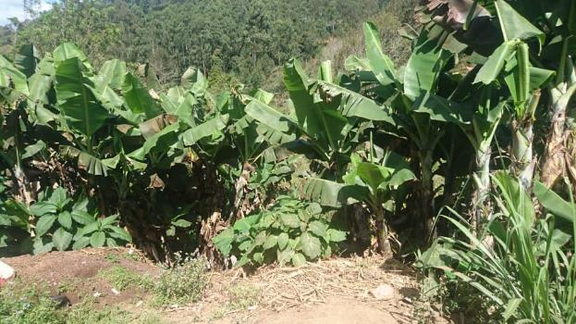
The main economic activities identified in the village are; Agriculture and Livestock Keeping. The additional activities are masonry, carpentry and riding motor cycles. The type of crops grown include maize, beans, bananas, cassava, sugarcane and coffee. While the type of animals kept include chicken, goats, cows, pigs and ducks. However, the limitations of income from the economic activities have been an obstacle to satisfy the household’s goals. The family cannot afford all costs to manage building of modern toilets, having a washing station, good system for irrigation and connection of Water to their toilets. Likewise, some of the respondents in the households admitted that no toilets or hand washing are limited due to lack of water although during rainy season water is inadequate because of sand and mud plugging in the piped infrastructures. Also, respondents informed the team that there is no water charges in the village. In addition, income of the family was said to not sustaining the daily life for 30-40% due to various challenges as follow; the agriculture production depending on the availability of rainfall, hence, income of the households doesn’t sustain the daily life and is insufficient due to lack of quality agriculture inputs such as seeds and fertilizer. Income is insufficient due to few products from agriculture activities and seasonal. For income to sustain daily life happens when there’s good rains and harvest. But when there’s inadequate rain and climate change we harvest few products and the income becomes insufficient respondents said.
Figure 5: Income Activities at Kwizu Village
On the question about size of acres owned by households, the majority of respondents acknowledged that they own from 0.5-to 3 acres of land is used for production of agriculture products and if adequate water was close to the farm field the family could have been increased production from 20%-70%. Likewise in the case of domestic animals, if adequate water was available would have increased production by 60%.
The households were interviewed on the main problems or needs in the community. The following were problems and most pressing needs in the community; lack of safe and clean water for domestic uses, poor infrastructure such as accessibility of roads to the community, lack of the nearest health care facility whereby people have to walk over 4 kilometers, lack of adequate land and capital, lack of proper use of agriculture technology, wild animals such as monkeys which destroy banana and other crops, need for agriculture extension officer, poor irrigation system, climate change which affects agriculture activities, inadequate harvest and low income to sustain daily living.
The other question to households was if they had jobs and earn adequate incomes what would they wish to tanking children to good schools, start profitable business, houses renovation and or build modern houses, invest in modern farming and livestock, power connection to households, would use money for buying food and medicines.

The main drinking water in the village.
Based to the question on what is the main drinking water for households, participants responded differently; Some of them answered that it Piped into compound, yard or plot, Piped to neighbor, Public tap / standpipe and unprotected spring and Surface water (river, stream, dam, lake, pond, canal, irrigation channel). Likewise when were asked about where the source of water located they also responded differently that; in own dwelling and in own yard / plot and or elsewhere. The purpose of this question was to establish understanding on the main source of water for household’s domestic uses in the village. Based on the assessment it was studied that out of 42 participants interviewed 20 (47.6 %) obtain surface water, participants 2 (4.8%) tape water from the unprotected springs while participants 20 (47.6%) taping water from the protected springs as clearly illustrated in the table and figures below;
Main water | # Of Respondents | %
Piped in to compound | 10 | 23.8%
Piped to neighbor | 8 | 19.0%
Protected dug well | 0 | 0.0%
Protected spring | 0 | 0.0%
Unprotected spring | 2 | 4.8%
Tanker-truck | 0 | 0.0%
Surface river water | 20 | 47.6%
Other(specify) | 2 | 4.8%
Total respondents | 42 | 100%
Table 7: main drinking water in Kwizu village

Figure 6: main drinking water in Kwizu village

The location of water source in the village (where is the water source)
The question aimed to establish knowledge about the location of the community main source of water for domestic uses. This would significantly help to make decisions during planning of any proposed water system development in future as indicated in the figure below;

How far is the distance from the household to the water point?
The study aimed at finding out the distances covered by household’s members to their main water source in the village. The following were findings; 4 (9%) participants reported to walk more than 1000 meters from the households to the water point, 10 (24%) participants said that they walk less of 10-500 meters from the households, 28 (67%) participants revealed to walk about 10-500 meters from their households to the main water source as shown in the figures below;

Figure 7: Distance from the household to the water point

How long does it take to go there, get water, and come back?
The question aimed to assess time used to obtain water from the main water source as shown in the below figure;
Figure 8: Time used to obtain water
In the last month, has there been any time/significant period of time when your household did not have sufficient quantities of drinking water as indicated in the figure below;

Figure 9: Sufficient quantities of drinking water

The preferred water source in the community, what is its condition?
The question aimed to establish understanding on the situation of the preferred water source in the village, whereby 27 participants admitted that the main water source for the households in the village is seasonal available while 4 households admitted that the preferred source is working although is contaminated as shown in the figure below;

Figure 10: Water source condition

Challenges faced by households in accessing water from their main source of water.
Based on the question about challenges faced by households in accessing water from their main source, participants responded to the question above based on experience and knowledge in the village as follows; access to unsafe water, during rainfall the quantity of water is too high and verse versa, water contamination during rains, much time spent to fetch water to another source when there is no water for over 30 to 60 minutes, inadequate water flows and a lot of people depends on the same water source, regular plugging of water infrastructures, carrying a bucket of water for all domestic purpose is difficult and incidences of water borne diseases are very high.

Efforts which have been taken by the community, government and stakeholders to mitigate the problems;
Beside the challenges above there are efforts which have been taken by community, government and other development partners to mitigate the problems. During household’s interviews, the participants responded with different feelings and opinions as follows; The Government have tried to invite other Development partners to help the community, The Government have taken effort especially conducting community meeting discussing the solution to the problems Inviting partners from Rotary Club of Same to conduct community need assessment, others said that no idea and never heard before, people are not aware that means not well informed, No idea and never heard before, they are not aware that means not well informed, the head of the family and members are not aware of any effort that have been taken by the Government or development partners. Peace Corps helped to build water tank for water storage, No government effort but joined community members support we were able to build few water infrastructure such as tapes to distribute water into people’s dwelling, Installing Tanks for water storage of water but the project was didn’t incomplete so water stills inadequate This effort was done by development partners called Peace corps, Development partners called Peace corps tried to build infrastructure but the project was incomplete, Peace corps helped to install and build water infrastructure such as water storage tanks but the project m were incomplete, Yes government has worked in building water infrastructure also there’s a water committee which helps in dealing with water related issues and others said there is no any effort that has been taken by the government or development partners.
The other question was focused to identify the factors which would make the Water source more sustainable in the village. During household’s interviews, participants responded with different thoughtful and emotions as follows; People in the village should be sensitized to stop cutting trees without replacement first, protection of water sources, stop cultivating along the sources of water, reconstruction of the water system, application of bylaws, renovate water infrastructure such as installing large tanks with good quality, building and installation of large water tanks for storage, public water points and tapes for distribution of water in the community and people’s dwelling, treatment of water to be clean and safe for human consumption, renovate public water points for distribution of water to people’s dwellings, maintenance of water source, conservation of catchment areas, Building and renovation of tanks for storage and distribution of water to people dwelling, Planting trees around water source and cleaning the bushes and the like.

General recommendations of Kwizu Village
From the above discussion, I acknowledge that the village is in higher needs for adequate clean and safe water for human being. Above all the village need adequate water for domestic animals and excess water to support improved irrigation and construction. Therefore, the assessment team recommend beyond reasonable doubts that this village should be among the top priority villages for Rotary club of Same to propose and accomplish an improved water system.

VILLAGE VUDEE

Introduction.
Vudee village in one of the four (4) villages in Vudee ward namely Vudee, Menamu, Ndolwa, and Kisesa. The village is located at the highland of same District to the North-East of Same District. The village is about 34 kilometers rough road drive away from Same District township center. The Village is mainly dominated by Pare tribe and few public service personnel. The total population in the village is 2082 inhabitants of whom male are 1029 and 1053 are female, the number of households is 417.

Figure 11: The total population in Vudee village

Community needs assessment.
The community Needs Assessment activity was conducted at Vudee village on 7 July 2020.The team of nine (9) enumerators visited the village to conduct community needs assessment based on water supply, hygiene and sanitation. The team arrived at the village and reported to the ward office early in the morning. It was the day of the farmer’s holiday therefore our hosts came very late at the government offices. The team was introduced to leaders for the Ward, village and sub-villages. The team leader gave a word of introduction and explained in brief a purpose of the visit to the village leaders.
However, the initial arrangements were already done with regards to organizing the community whereby the village executive officer played this role. Thereafter, team members were divided into groups based on the number of sub villages and each group hosted by a local leader. However one person remained at the village office for leader’s interview and conduct community focus group discussion in the afternoon. The sub village leaders were assigned to accompany enumerators to the household’s interviews. Before interview with a respective member in a specific household, the participant was briefly identified and asked for permission to interview the family member.

Social services to the population

2.0.1 Education institution
The village has two primary schools namely Hembua and Vudee, and there is one secondary school namely Vudee. The total number of pupils in those schools is 733 as indicated in the table and figure below.
SN | Name of School | Male | Female | Total
1 | Hembua Primary school | 129 | 121 | 250
2 | Vudee Primary school | 141 | 103 | 244
3 | Vudee Secondary school | 104 | 135 | 239
5 | Total number | 374 | 359 | 733
Table 8: The total number of pupils at Vudee Village

Figure 12: The total number of pupils in Vudee Village
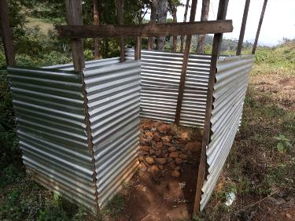
Two members from the assessment team Amon and Athuman were assigned to visit the primary schools and conduct assessment to establish various information. One of the pr imary school visited is Hembua primary school, its water point is located within the compounds at less than 5oo meters, and the school has 7 water buckets for taping drinking
Figure 13: Temporally Toilets at Hembua Pimary School

Water and washing. The taps are accessible for little children. Findings and comments were as follows; the water available is contaminated and the tap at school is damaged. Therefore the alternative source is only nearby spring whereby children have to use jerry canes. The total water requirement is 2000 liters per day and so far the school has to use only 1000 liters due to inaccessibility to adequate water. The village has no effective water management system therefore they use internal mechanism through use of local artisans. In the aspect of toilets, the school have no adequate pits and the current toilet is broken and unfriendly to pupils particularly girls menstrual management. General comments; need for construction of new friendly toilets, additional classrooms, water storage tanks, food storage and sanitary equipment. The second primary school visited is Vudee primary school. The following were findings from questions and observation by assessment team; its water point is at the compound connected from the nearby HCF, and there is a downstream river nearby the school. There are fixed 9 washing stations in the school as preventive measures from the outbreak of the Covid-19 pandemic. The daily use of water by the school is 1000-1500 liter per day. Water supply at the school is self-managed by use of capitation fund and use of local artisans. The school has created a children wash club which is responsible for issues related to water, hygiene and sanitation. The toilets are pit latrines and cleaning facilities available were of brushes, brooms and sweepers. The school has no effective solid waste management system, the pupils use open rubbish dumping pits and burning. General comments; there is high need for an adequate water storage tank, need for kitchen construction, need for additional toilet’s pits, need for renovation of the existing classrooms and staff rooms. The following is a table to indicate the schools and number of pupils registered.
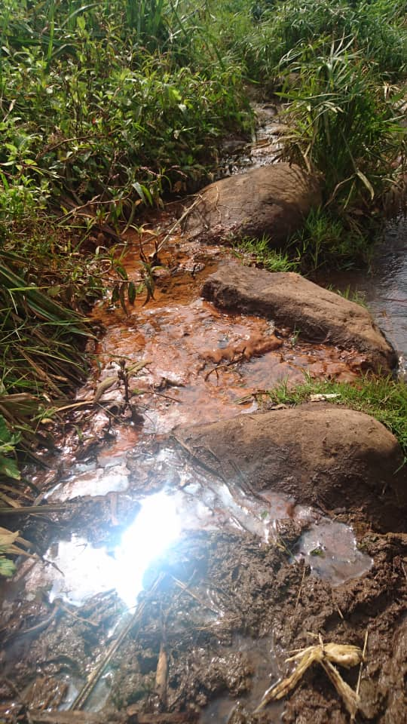
The third school visited was Vudee secondary school, the enumerators were Pilly Msuya and Efrancia Nzota. The school is located at the GPS coordinates -4.066929, 37.742329 in the village. The following were findings from questions and observations by the team; the water point is at school compound which is for free, there is single fixed water drinking point which is accessible for children of all ages. The main water source is down flowing stream be taped to school compound- when there is no water pupils have to walk down the stream and collect water for school use the fact which promote truancy and other criminal practices for some pupils. The number of hand washing facilities is 10 which are fixed at front of toilets and classrooms doors. The available cleaning facilities at school are brooms, disposal bins in girl’s toilets and the school provides free sanitary pads for girls. The school has yet formed a health club to promote issues related to water hygiene and sanitation. The main identified challenges for the school were; social conflicts between the school and community due to scarcity of water, human activities along the water sources spoil water for school use. The general comments agreed were; need for water storage tank, water treatment unit, training to pupils on issues related to water and sanitation.
Figure 14: The Second water source at Vudee Primary School

Health care facility
The village is possessing of a health facility operated in partnership between the local government authorities and pare diocese of evangelical Lutheran church of Tanzania, pare diocese. The health care facility in the village is a potential center to provide health services to the population. The groups mainly served are women (maternal care) people living with disabilities, children, visitors and the population at large. Two members from the assessment team Amon and Athuman were assigned to visit the available health facility for interview and focus group discussion with staff and patients. Based on the assessment questions, the following were findings; the HCF has two staff, one clinical officer and a nurse attendant. At the compound there are water distribution points to serve patients and staff. It was studied that, apart from connecting water to the compound, the HCF also supplied water to the nearby primary school namely Vudee primary school. The source of water for the facility is Kiweni sub village at about 3 kilometers from the center. During rainy season the source supplies much water and is contaminated. The toilet for the HCF is designed to support issues of menstruation hygiene. However, the existing toilets are not friendly for people living with disabilities. The facility has not developed a waste disposal system to dispose solid sharp waste, they use open burning. Recommendations; the team discussed with the HCF staff an agreed that there is a high need to reconstruct the efficient water supply system, renovation of buildings and staff quarters, employment to additional and skilled staff, improvement to the health services for the population as the solely one in the village.

Religious institutions
The village has various religious denomination which involved of the Lutheran church, SDA, Roman Catholic and Pentecost. All of those institutions provide holist services to the population. These institutions have great role to providing water and health services in the village. The Lutheran Church is the owner of the only health care center in the village. In some of churches there are child development programs including Sunday schools youth and women programs.

Households interviews
- The enumerators were assigned to visit five households each at a specific sub village. The sub village leaders had roles to accompany the assessment teams to individual households. The number of households selected for assessment was 33 of whom 68% were male and 31% were female as illustrated in the below table.
Category | Age | %
Below 18 years | 2 | 6
19 to 35 years | 5 | 15
36 to 45 years | 7 | 21
46 to 60 years | 8 | 24
61 and above years | 11 | 34
Total # of respondents | 33 | 100%
Table 9: Total number of respondents by age

Figure 15: Total number of respondents by age

- The sex status for respondents
The data presented on the table and figure below, indicate that majority of the respondents were Male 12 (36.4%) and female respondents were 21 (63.6%) The implication is that, men are more involved in household’s livelihood activities as bread winners than women. The study shows that, in this community women are more engaged in domestic chores including fetching water, hygiene, cooking and taking care of children.
SEX | NUMBER | %
Male | 12 | 36.4
Female | 21 | 63.6
TOTAL | 33 | 100%
Table 10: The sex status for respondents

Figure 16: The sex status for respondents

- Marital status of the households assessed.
The presented data implies that, the common marital status in the village is married as presented below. Hence, division of labor between men and women would be potential to enhance the household’s economy as well as improve health, hygiene and sanitation status of Household’s members.
Marital status | Quantity | %
Married | 22 | 67%
Single | 4 | 12%
Widow/Widower | 6 | 18%
Separated | 1 | 3%
Total respondents | 33 | 100%
Table 11: Marital status of the households assessed
- Respondent’s education level.
The information presented in the below table and figures gives a wide picture that, the majority of sub-villagers attained primary and secondary education. Few of respondents attained college/tertiary levels. This implies that the village is rich in human resources to support implementation and management of any community project.
Education level | Quantity | %
Primary Education | 22 | 66.7%
Secondary Education | 7 | 18.8%
College/University | 4 | 12.5
Total respondents | 33 | 100%
Table 12: Respondent’s education level

Economic activities
The main economic activities in the village is faming and livestock keeping. The main crops produced are maize, beans, cassava, yams, coffee, bananas, green vegetables, Irish and sweet potatoes, although water is limited to farming activities and sometimes is associated with social conflicts. The crops produced in the village are with multiple use for food and business. Moreover, some of the respondents reported to conduct small scale business like shops, food vending, milling, drinks and selling at markets. Some very few respondents in the village are public service workers and some of them engage in local handcrafts and artisans in masonry and carpentry works. However, the majority of the respondents interviewed at the household’s level reported that total income from the above mentioned activities does not sustain the family daily means of living. However, the major economic activities reported are farming and livestock keeping which produce inadequate earning to support all the costs including hand washing and sanitary practices, although can use part of the income for hygiene and sanitation activities. Likewise, all of the household’s members interviewed responded that available water in the village is unsafe, scarce and provided for free although they manage a small amount they obtain daily. It was reported that, in the village there is dam namely Namnyambwe of which in the previous time supported irrigation very much but so far it is damaged and dry that is no longer supportive to agriculture. Agriculture activities are highly affected by the factors like climate change which results to unreliable rainfall and soil erosion. The population in the village generally depends mainly on rainfall to raise food and cash crops, therefore due to factors like limited rains, scarcity of water for irrigation, exhausted land and lack of expertise, the harvest are very low to generate higher income as it was in the past. Furthermore, one of the opinion from the households interviewed was, if the village will have an effective-developed water system may help to supply water for domestic uses and compliment for improved irrigation with home gardens for generating sustainable income.

How may acres of land does your family own, and how many are used for production of agriculture products; if water was more available, what percent would this increase?
The assessment teach was divided into groups of two people with a helper each who would lead them to a specific sub village. It happened that some helpers were leaders for the particular sub-villages or an ordinary person in case a leaders was not available. Among the team members, one of them would have role to introduce the subject continue asking questions to a household head or anyone would be available at home during interview and the other one assumed the role of recording the answers from the respondent. During the field interviews, it was studied that each house hold in the village has a certain piece of land for either agriculture or other uses. Based on the assessment conducted, the study determined that at least every house has a land for agriculture and only a part of the land majority of households is under production. Therefore, the total land owned by the 32 households interviewed in the village is 63.5 acres and out this amount the total amount of land used for production is 63 However, if water was more available in the village, production would have increased by an average of 60 %

What kind of domestic animals and birds do your family own? How many of each? If water was more available, what percent would this increase?
Based on the assessment in the village, it was studied that, each of the respondents interviewed possessed at least a certain number of domestic animals, birds or chicken. It was studied that the number of domestic animals raise by 32 households interviewed is divided into the following categories; cows 37, sheep 13, goats 13 and pigs 4. Similarly, the number of domestic birds/chicken raise by the same number of households interviewed is reported in as following grouping; chicken 219 and ducks 5. However, it was studied that, due to inadequate supply of water for domestic uses, the number of domestic animals, birds and chicken is limited. The assessment established that, if the village had sufficient supply of clean and safe water for domestic uses and surplus for animals or bird’s uses, and likewise the number of domestic animals, birds/chicken would have increased to a considerable amount by average of 60%

The biggest problems or needs of any kind in daily living or achieving goals in the village.
The households assessed were asked to identify the most pressing needs of any kind around their village. The following is a list of problems and needs identified by 32 households interviewed in different location and time in the village; lack of clean and safe water, disease, walking distance to the health care facility up to 2.5 miles, the high costs of medication as the available center is private owned, lack of equipped public health care center, low income, elderly health challenges, need for health insurance cards for elders, loneliness for elders due to rural urban influx for youth after school, insufficient food harvests, high incidents of water and vector borne diseases, need for sustainable agriculture, poor roads access within the village, need for animal and agroindustry experts, high dependency ration with some households, need for youth employment opportunities, need for secondary school’s girls hostel, poor irrigation systems, need for improved services at the only available health care facility in the village.

If you or a family member could work or have a job to make money for your family, what would you wish to do?
Based on the study, the respondents in 32 households interviewed had sufficient income as follows; starting a new business, improving chicken project, sustainable agriculture, large scale farming, vegetable production in large scale, renovation of the house, construction of better house, pay school fees for children, improve household’s living standards, improve livestock project, connect water to households, start vegetable project, be grocer, improve the food security, power connection to households and purchase additional land for family projects, though one respondent reported to be too old enough to work.

What is the main water source for members in the households?
During assessment, 32 households were visited in the village and any of the members in each household had equal chance for interview. Majority of respondents by 68.8 % established that their main source of water for household members is surface river water and 9.4& of respondents admitted that their main source of water is unprotected spring and 6.3% of respondents had piped water to their compound as presented in the table and figure below.

Main water | # Of Respondents | %
Piped in to compound | 3 | 9%
Piped to neighbor | 1 | 3%
Protected dug well | 1 | 3%
Protected spring | 2 | 3%
Unprotected spring | 3 | 9%
Tanker-truck | 1 | 3%
Surface river water | 22 | 97%
Other(specify) | 1 | 3%
Total respondents | 33 | 100%
Table 13: The main water source for members in the households

Figure 17: The main water source for members in the households

Where is the main water source located?
Location of the main water source | # of respondents | %
In own dwelling | 3 | 10%
In own yard | 5 | 15%
Elsewhere | 25 | 75%
Total respondents | 33 | 100%
Table 14: The main water source located

How far is the distance from the household to the water source?
During assessment, it was studied that, in the village no toilets and hand washing has been limited due to lack of water adequate water in families, they always manage to use available unclean water for their activities. It was studied that, water available in the village is obtained for free of charge and not well managed. There is no efficient developed water system to supply clean and safe water for domestic uses. Although the water situation varies from one sub-village to another, some of the household’s interview admitted that water is scarce to satisfy both domestic uses and agriculture uses, sometimes can just obtain few bucket for a day therefore have to manage it well for basic uses such as cooking and washing. Also, some of the households interviewed claimed to be walking long distances down the springs and rivers up to 500 and 700 meters to take water for domestic uses as presented in the below table.
Walking distance to the water point | # of Respondents | %
Less than 10 meters | 5 | 15.5
10-500 meters | 15 | 45.0
500-1000 meters | 5 | 15.5
More than 1000 meters | 8 | 24.0
Table 15: Distance from the household to the water source

The data presented above aimed to establish the distances covered by household’s members to their nearby water sources. The implication is that, women and children in some households who are mostly responsible for water collection walk up to 1km for water, which means the remote the water sources means waste more time which could be used for economic activities for women to improve their livelihood.

In the last month has been any significant period of time when households did not have sufficient quantities of drinking water?
Response | # of respondents | %
Yes at least once | 25 | 75.8%
No always sufficient | 7 | 21.2%
Not answered | 1 | 3%
Total respondents | 33 | 100%
Table 16: Sufficient quantities of drinking water

How is the condition of your preferred water source?
Response | # of respondents | %
It is working but the water is contaminated | 11 | 33%
It is seasonal, available only some months | 14 | 43%
It is working and the water is good | 2 | 6%
It is working but the water is contaminated, It is seasonal, available only some months | 3 | 9%
It is seasonal, available only some months, It is working but the water is contaminated | 2 | 6%
It is seasonal, available only some months, It is working and the water is good | 1 | 3%
Total respondents | 33 | 100%
Table 17: The condition of water source

Figure 18: The condition of water source

The challenges you face in accessing water from your main water source based on time spent, method, quantity, quality and other challenge.
The aim of the study was to list challenges related to obtaining water from the main water source which were identified as; time waste and replace to production activities,, too contaminated water, unsafe to drink, locally collected without developed system, unprotected water source, some sources are owned by neighbor not accessible at all, available and sufficient only during rainy season, temper with the available local system, water is not easily accessible, traditional means of treatment, too much contamination during rainy season, water is insufficient during dry season and the likelihood of waterborne diseases.

Efforts have been taken by the community, government and other development partners to mitigate the problems
The local government has a plan to develop water system from Kiririgwi water source although the challenge is limited resources.
Individual households have taken efforts to establish local water sources by their own,
The schools and health care facility have built local storage tanks to collect spring water for the pupils and patients, The politicians have regularly pledged to support building a water system unsuccessfully, The Lutherans tried to build water infrastructure although the plan could not work out. SIPRO organization tried to build a water source to distribute water although could not work as no prior was carried out. World vision Tanzania, tried to build a water infrastructure to support people obtain water service at the near point and meanwhile the project failed, ELCT tried to establish a water system but not functioning due to poor design, the government has not taken deliberate initiatives to address the challenge, some community members claimed to have not heard any updates on what is going on with the problem, the village called a meeting to discuss and obtain solution on how to address the problem, the development partners were involved to support addressing the water challenge, the report is already submitted to the district government for possibility of support, the Lutheran church had initiatives to install a pipe line from source to the health care facility which gave relief to the nearby households.

The other factors which could make the water system sustainable.
Conservation of the water sources, formation of guiding bylaws to protect water sources, using pipeline rather than down streams, training to the water use groups on sustainable use of water, fight deforestation, construction of the public water points, afforestation along the water sources, renovation to the existing water infrastructures, construction of a main storage tank and establish supply systems to the public, growing trees alongside the down springs and water sources, community sensitization, formation of water management systems, prohibit human activities beside the water sources and enforcement to the existing laws.
    - Has the water quality been tested for bacteriological contamination?
Water test | Response
Tested | 0
Not tested | 19
Not answered | 13
Don’t know | 1
Total respondents | 33
Table 18: Water quality tested for bacteriological

Conflicts that happen in households, or with other people in the community because of water scarcity.
Respondents reported minor fights between people taping water from the same source, insignificant competitions between farmers and domestic users, in other words no serious conflicts reported on water users, fights experienced during dry season when people competed for irrigation, some communities in the same village do not experience fights due to water scarcity.

Is the water supply managed well by the village? Explain
The aim of the question was to establish whether in the village there is a well-organized water management system to oversee the water supply and distribution in the village. The participants interviewed responded based on their view s and opinions as presented in the below table.
Prominence | # of respondents | %
Very good | 1 | 3%
Good | 4 | 12%
Not good | 5 | 15%
Poor or no management | 20 | 61%
Not answered | 3 | 9%
Total respondent | 33 | 100%
Table 19: Water supply management

Figure 19: Water supply management

Observation on the place where the household members often wash their hands.
Apart from asking questions on various aspects at the households, the enumerators were able to observe the place for hand washing at the household’s level. The presented data in the below table indicate the actual condition on hand washing for household’s members.
Hand washing status at households | Respondents
Observed fixed facility in the dwelling | 0
Observed fixed facility in yard/plot | 8
Observed-mobile object(bucket/jug/kettle) | 25
Not observed-no hand washing facility in the dwelling/yard/plot | 0
Table 20: Hand wash facilities status

Observation to the presence of water at the hand washing station for the households.
The purpose of this question was to see the existence of water to support hand washing for the members in a particular household. To prove if water is available at the washing site as shown in the below table below.
Water status at a washing sites | Percentage
Water is available | 84%
Water is not available | 15.4%
Table 21: Availabilities of water in Hand wash facilities

The data presented in the above table implies that, the community is trained and motivated to use flowing water on hand washing especially due to the outbreak of the Covid-19 global pandemic.

Is soap or detergent present at the place for hand washing?
The respondents were interviewed whether their home stations had soap or detergents. The purpose of this question was to establish understanding whether the community adhere with washing principles as directed by health workers in the village. Particularly as part of community strategic/protective measures against the Covid-19 pandemic. The presented data in below illustrate the reality of hand washing in the households.
Soap/detergent | Percentage
Soap detergent available | 46.2%
Soap/detergent not present | 53.8%
Table 22: Reality of hand washing

Do households currently have water and soap for washing hands near the toilets near the kitchen?
The participants were assessed to establish if they adhere with health washing principles, which guides the community to install washing facility near the kitchen and toilets for their member’s health. The following table with presented data demonstrate the reality of hand washing condition in the community.
Water& soap near kitchen and toilets | Percentage
Yes | 13%
No | 87%
Table 23: Water& soap near kitchen and toilets

How do households make water safe to drink?
The purpose of this question was to assess whether water treatment is done at the households and how is it done. The findings are that, among 32 households assessed in the village, some of them use to make water safer while others do not. Boiling and filtering are major methods identified to make water safer by participants interviewed. However, there is a considerable number of participants responded that they use raw water and there is nothing done to make water safer. This fact implies that, the community in in high need of health education based on water hygiene and sanitation.

How often the community members conduct hygiene practices of their houses, toilets and clothes?
The aim of this question was to find out the frequency of hygiene among the household members in the village, in relation to water accessibility. The 32 participants involved in the assessment from different context in the village responded differently as follows; the families conduct hygiene every day, three times a week, twice in a week, once in a week, helped by neighbors once have time and three times a day. However, various participants interviewed reported that there are factors which determine the frequency of hygiene activities in the households such as; water availability, water accessibility, long walking for water, helplessness, and time used to obtain water, nature of substances for hygiene such as a toilet’s hygiene is more frequent than houses and the like. From the data presented in this section, it is true that majority of the respondents would afford hygiene practices every day, once and twice in a week. However, the household’s members would do better if the community would have adequate supply of safe and clean water to the village. Therefore, it is assumed that hygiene and sanitation would have improved if the village had access to sufficient source of water for domestic uses.

Households experience on diarrhea or other waterborne diseases, what kind of diseases and how often do they happen?
The question aimed to establish the case that due to lack of adequate clean and safe water in the village, it might be a cause factor for various water borne diseases in the community. Among the 32 participants from the households visited responded differently to the question as presented here under, the majority of participants admitted to have no experience of the water borne diseases and while two out of 32 participants reported that the diarrhea and typhoid and amoeba cases.

Trainings on water, hygiene and sanitation for household’s members in the village.
The purpose of this question was to establish knowledge whether participants assessed in the village have obtained any training on water hygiene and sanitation. Out of 32 participants interviewed, 15 of them admitted that have received trainings on the mentioned topic, and the rest 17 have not received any training. The training involved of the listed subjects; use of clean and safe water for healthier life, hand washing and availability of local materials, body and cloth hygiene, environmental hygiene, significance of improved toilets, environmental conservation, trees planting, menstrual hygiene and management, prevention measures to the Covid-19 pandemic, dental hygiene management. Who provided the trainings, health workers, village assembly, ETI, government officials, community meetings, media radio, television, newspapers, and the non-governmental organizations of FORESTA, SEMICAO and Christian churches in the village.
These trainings may be potential in creating awareness on issues related to hygiene and sanitation such as; reproductive health, menstrual hygiene to female youth and adults, body hygiene, utensils hygiene, proper use of toilets, water hygiene, disposal or re-use of waste water, solid waste management technology and establishment of kitchen racks.

Do households in the village chlorinate or boil water
The purpose of this question was to assess on water treatment at household’s level. The findings were that (34.4%) participants admitted that the treatment is done through boiling at their households. However, the participants reported to have not chlorinated drinking water although had information on the significance to water treatment as shown in the table and figures below.
Household interviews | Respondents | %
Always | 12 | 36%
Mostly | 5 | 15%
Sometimes | 1 | 3%
Never | 15 | 46%
Total respondents | 33 | 100%
Table 24: Water treatment at household’s level

Figure 20: Water treatment at household’s level

Methods of treatment to drinking water by the households.
The question aimed to establish understanding on water treatment method in the villages. Based on the study the findings were that, 6.3% of respondents admitted that they do not treat water for domestic uses.

Figure 21: Methods of treatment to drinking water

3.0.27 Type of latrine used in the village
The purpose of this question was to establish knowledge on the common type of toilets used in the seven villages in Same District. The assessment team was able to visit and see the type of toilets for each household visited in the village. It was studied that 34.4 of respondents use pit latrine, 28.1% of respondents have toilets with flush system to septic, 21.9% respondents use pit latrines tank and 12.5% use flush toilets to pit latrines.

Figure 22: Type of latrine used in the village

Do household’s empty their pit latrine or septic tanks when are filled.
The purpose of this question was to study the condition of household’s pit latrines in the villages. The assessment team was able to observe the toilets for households to determine their statuses. The majority of participants by 97% admitted that they have never emptied as clearly illustrated in the following figure.

Do households in the villages share the toilets with other people who are not members?
The purpose of this question was to establish a situation whether the toilets for households are shared with other people who are not members of their families as presented in the figure below.

Figure 23: Number of Household Shared toilets

What can be done to improve water and sanitation issues?
The assessment team required to determine factors which are significant to improve water and sanitation issues in the village. The following were findings from the household’s interview; the government or stake holders should put more effort in improving the situation of Water System in the Village to motivate the economic activities, there is a demand of hydroelectric Power system, promote education, training and seminars on environmental conservation, propos the improved water systems with improved water source and treatment unit to serve people at the nearest points to the households, proposed project for construction of the government health care facility. People should be educated on the effective use of water as well as proper management of water sources, Create water management system from the village government and educate people about effective use of water and water system, The community must be involved in all environmental activities, To make sure the bylaws are in Place and used Education is the best ways of changing the community, The construction of Water Source and public HCF, Construction of water infrastructure, to have a committee which will manage the water issue in the villages, to restructure a water system, 2- to plant a tree to the water sources 3- to train the community on water and sanitation

Community leaders
One of the assessment team was assigned to meet the community leaders for focus group discussion through the questions presented. The number of participants was 15- 20 leaders’ representatives for the Ward, village, sub villages and potential elders. The questions were raised, discussed and came back with solution and comments as follows;

Water sources
- The roles of community leaders to protect water sources are; to enforce environment by-laws, to educate people and improving water source by planting trees at the source. The village has environment committee which is responsible in protecting water source.
- How do you manage water supply system in the village? What problems are there now? What are your goals for the water system? There is water users committee which is controlling irrigation water allocation. Also there was water committee for domestic water but is no longer exist but leaders have no idea why the committee collapse. Currently there is no organ in the village which manage water. The village is in plan to establish domestic water users committee which will be assigned water management and supervision role

Hygiene and sanitation
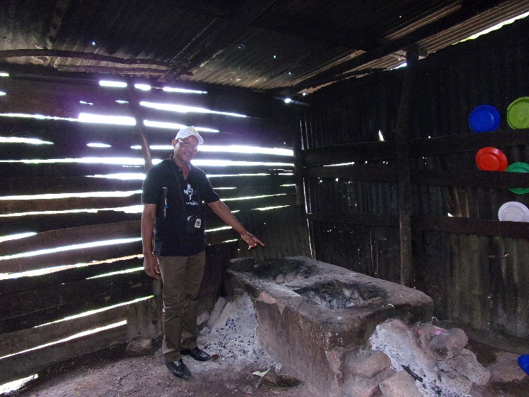
The condition of hygiene and sanitation is in the village, the currents water sources available is clean but not safe because there is no treatment service at the source even at household level. The toilets in the village are not in recognized standard. This contributed by water challenge in the village. They use pit latrine and covered it after being full, the efforts have been taken to improve hygiene and sanitation in the village by Community leaders are educate people on hygiene, sanitation, enforce environment related by-laws, and conduct trees plantation campaign.
Figure 24: Kitchen status at Vudee Secondary School

Water conflict
The Community experienced social conflict during summer seasons, the leaders were managed to solves those conflict by make sure all the famers know the timetable of water for irrigation activities and the timetable are prepared in collaboration with the community. The water for domestic use it for free, Likewise irrigation water is free. The leader declares that if there is any improvement to the infrastructure, the irrigation activities will improved and the Household income they will contribute money depending on estimated costs.

Community Focus Group Discussion
The condition of water sources is not good most of the sources are open and not protected because of that you can find animal carcasses in the water sources and other dust, occasionally water flows decreases it’s not enough for human consumption especially during summer season. Most of the people boils drinking water and few just drink water without treating it.
The social Conflicts occurred because there’s a lot of people who needs water and the water is inadequate, the long queue at the same time, Sometimes water is too dirt and is not good for human consumption the water is shared with both human and livestock
There’s water committee and the main goal of the committee is to supervise and make sure that by- laws for water are followed also to solve different water conflicts
Water related Diseases prevalence in the village; from the findings after discussion was the Diarrhea Typhoid Amoeba Skin diseases.
Training conducted to the villagers
We have received training from Empower Tanzania through Community health educator regarding clean and safe water, hand washing and other public health related topics FORESTA and SEMICAO training regarding environment conservation Health center, when people go for clinic
General comments as of discussion
- Afforestation Sponsors to improve, maintain and renovate already built infrastructure with other development partners to make the sources sustainable Build tanks, and tapes that will distribute
- Water to peoples dwelling-The community is willing to offer support and cooperation such as local materials and human labor
- Some household don’t have waste dump, but most of them use dust or waste as fertilizer or manure for their agriculture activities “We just throw our dust/ waste to our farms because it’s a source of manure
- Build and renovate water drainage and other water infrastructure for irrigation activities -Building tanks and tapes for distributing water into people dwellings - Provide education on how to keep and maintain water sources - Building of public DPs for water distribution.

MENAM VILLAGE

Introduction.
Menam village in one of the four (4) villages in Vudee ward namely, Menamu, Vudee, Ndolwa, and Kisesa. The village is located over the highlands of same District to the North-East of Same District. The village is about 37 kilometers drive on the rough road away from the center of Same District via Vudee village. The village is mainly subjugated by Pare tribe and few public service personnel. The total population in the village is 2146 inhabitants of whom male are 1063 and 1083 are female. The village has approximately 420 households based on the recent village census. The village is comprising of six (6) sub-villages namely Mpongwe B, Mpongwe A, Nzava B, Mitini and Mpinji. The Menamu village has the following social institutions; Mtunguja Primary School, Roman Catholic parish, Lutheran Parish, SDA church, International Evangelism church and Pentecost church. The main economic activities in the village are agriculture and livestock keeping.

Figure 25: Total population in Menamu Village

Community Assessment.
The community Needs Assessment activity was conducted at Menamu village on 8th July 2020. The team of nine (9) enumerators visited the village to conduct community needs assessment based on water supply, hygiene and sanitation. The team arrived of six participants arrived at the village and reported to the ward office in the morning. The rest of the team members Amon, Giliard and Athumani remained in the village of Vudee to complete the work that has remained the day before. When the enumerators arrived the village, they were introduced to Ward leaders and later to sub-villages for data collection. The team leader had a briefing word on the purpose of visit to leaders.
Conversely, the plans and procedures were already completed based on community organizations whereby the village executive officer played this role. Subsequently, team members were divided into groups based on the number of sub villages and each group hosted by a local supporting leader. Though one person remained at the village office for leader’s interview and leader community focus group discussion in the afternoon. The sub village leaders were assigned to escort enumerators to the household’s interviews. Prior to discussion with an individual member in a specific household, the participant was briefly identified and asked for a permission to conduct interview with a family member.

Community leaders focus group discussion
Menamu village is located at the GPS -4.212858, 37.888226 and the administrative region is Vudee, Same, Kilimanjaro, Tanzania. The village and sub villages leaders were involved in the discussion about the situation based on water supply hygiene and sanitation. Number of participants were eight (8) of whom seven (7) were male one (1) was female. The discussion was facilitated by Charles Anatoly the personnel from the District community development department committed to lead a focus discussion for leaders.

Figure 26: Number of participant in FGD

The questions for discussion were presented to obtain their knowledge and feelings about the community needs and solution. The roles played by leaders to protect or improve water sources were identified as; to educate people on water sources protection, monitoring of water and hygiene issues, take legal action against those who went contrary to law, conduct participatory security and protection of water infrastructure, trees plantation, the village has environment committee which play role of protection water sources and control environmental degradation, educate community on good agriculture practices to avoid erosion such as terraces.
Similarly leaders were asked about how they manage the water supply system in the village and what problems are there now, the replies were no water supply system in this village, but people use local ways to tape water at community point. The village government has a plan to establish domestic water supply system but the plan fail due to insufficient fund. Water used other people taped from farms which is more dangerous due to contamination of agriculture chemicals

Hygiene and sanitation,
The condition of hygiene and sanitation in the village is that leaders usually conduct toilet inspection to the household to ensure each household own toilet. This exercise is conducted after rain season each year and those who lack toilet they face penalty of Tanzania Shillings 50,000/=. At least 90% of households have toilets, though there is short of improved toilets to households. The issue of cleaning the toilets to majority of households remain a big challenge due to water scarcity.
Efforts have been taken by the community leaders to improve hygiene and sanitation in the village such as to educate people on hygiene and sanitation through general meeting, monitoring hygiene situation in the village, to insist use of tippy taps technology which is affordable at household’s level. The leaders were also asked about informed water related conflicts in the village and how they are addressed. Certainly sub villages like Mpinji, Mitini, Nzava A, Mpogwe use irrigation water for domestic purposes. However, in the village there are conflicts among farmers when irrigation activities are carried on. Some farmers damage pipes serving domestic water uses due to irrigation purposes and this result conflicts. At last there are outcomes from water related conflicts such as destruction of water infrastructures and poor relationship between two parties. The last question to leaders demanded water charges system in the village and the response was that, there is no any kind of setup of water cost rate. Water is free of charge in the village, although water is free but community suffer a lot due to insufficiency where others fail to efficiently wash clothes due to this challenge.
The general comments by community leaders; the village highly in need for safe and clean water, interventions against water borne diseases and support to build an equipped health care facility as the village has no any.

Figure 27: Type of latrine used

Figure 28: Shared Pits

Social services to the population in the village

Educational institutions
The village has only one primary school namely Mtunguja and without any secondary school, whereby those pupils complete class seven have to walk a distance of approximately ten kilometers to secondary school located at the nearby Vudee village. The number of pupils at Mtuguja primary school is 185 as presented in the table below.
SN | Name of School | Male | Female | Total
1 | Mtunguja Primary school | 104 | 81 | 185
 | Total number | 104 | 81 | 185
Table 25: Number of Pupils

Two members from the assessment team Efrancia Nzota and Pilly Msuya were committed to visit Mtunguja primary school to conduct focus group discussion with teachers and pupils aimed at gaining various facts. The primary school is located at the upper part of the village at about 7.5 kilometers from the village center and main road from Vudee to Ndolwa village.
Water sources; the school has no water point at premises hence pupils have to walk down to the nearby Mwahona river valley to draw adequate water for school use. The shortage of water is associated with pupil’s poor academic performance and class attendance in the school. Pupils said that “it’s far we get our uniform dirty every time we go to fetch water” Some fall from steeps and get hurt. “We miss classes when it’s our turn to go fetch water”. “We may fail our exams for missing classes often while fetching water”. “Also we have only 3 teachers in our school” It takes time as you may find a teacher who was in the class has done teaching (50 minutes) although water is permanent at the spring they said.

Hygiene and sanitation condition
Pupils were asked about how they make water safe for drinking and wash at school. They responded that they drink boiled water from home and at school there is no drinking water sometimes they beg water from nearby households to their school. Pupils were asked on how often they wash their hands and they responded that, from toilet entering classrooms during break time, during lunch time, after class hours while are about to get back home. Hence, they wash hands at minimum of 5 times in a day.
In the aspect of toilets, the condition is not satisfactory and there are no adequate pits to satisfy pupils particularly girls who need special handling. There are no materials available in the school toilets. When girls were asked about how they handle the issue of menstrual hygiene at school, they responded that mostly it happens at school we get permission to go home. If it starts at home we don’t go to school, we stay until we are done with menstrual flow about 4-5 days. Pupils were asked whether have received any training relating to menstrual hygiene management and explained that were trained about personal hygiene and how to handle menstrual flow and Puberty and relationships. The type of trainings received related to WASH was training about personal hygiene and how to handle menstrual flow during puberty and provided by health promoters from Empower Tanzania organization who came to their school and was done at the end of last year.
Generally Mtunguja primary school and the village at large is with higher needs for clean and safe water, need for six (6) additional pit latrine, need for special room for girl’s menstrual management, need for additional classrooms, need for school renovation and sports ground equipment.

Health care facility
Basically, the community at Menamu village does not have either a clinic or a health facility so the people are treated by a health center located at the nearby Vudee village, which is operated in partnership between the local government authorities and pare diocese of evangelical Lutheran church of Tanzania.

Religious institutions
The village has various religious groups which involved of the Lutheran church, seventh day Adventists, Roman Catholic and Pentecostal churches. These organizations mainly responsible to provide spiritual based services to their congregations. Above all, these organizations have great role and responsibility to providing both spiritual and social services to its members in the village. It was studied that, the religious institutions in the village have contributed much to improve spring water sources and connected pipes to their centers of which the nearby population can benefit.

Households interviews
The assessment team members had chance to visit the identified households for assessment. Each member was organized to visit a sub-village accompanied by the leader of the respective area. The names of members for assessment were; Charles, Pilly, Giliard, Amon, Athumani, Amos, Ephra, Cathy, Asimwe and the local helping team. The number of households visited for assessment was 31 of whom 17 (54.8%) were male and 14 (45.2%) were female as illustrated in the tables and figures below.
- Respondents distribution by sex
Sex | Number | Percentage
Male | 17 | 54.8%
Female | 14 | 45.2%
Total | 31 | 100%
Table 26: respondents Sex Distribution

Figure 29: Number of Respondents

- Respondent’s distribution by age.
Category | Number | %
Below 18 years | 0 | 0
19 to 35 years | 3 | 9.7%
36 to 45 years | 9 | 29%
46 to 60 years | 10 | 32.3%
61 and above years | 8 | 25-8%
Total # of respondents | 31 | 100%
Table 27: Respondent’s distribution by age

Figure 30: Respondent’s distribution by age

- Respondent’s education status
Level of Education | Number | Percentage
Primary Education | 28 | 90.3%
Secondary Education | 2 | 6.5%
Illiterate | 1 | 3.2%
Total | 31 | 100%
Table 28: Respondents Education status

Figure 31: Respondents Education Status

Household’s economic activities
The study established that, the main crops grown include beans, maize, bananas, sugarcane, coffee, cassava and Irish potatoes in which some of them are grown for food and others for sale to enhance their income. The other common human activity is horticultural business for improved food security and sale. The main crops grown in this aspect are green pepper, carrot, onion and amaranth. In addition, the village is productive in fruits particularly the pears, avocado, passion, annona squamosa, guava and eriobotrya species. In the village there is plenty of water for agriculture and toilet’s hands washing practices is limited due to lack of water. However, the village has serious lack of safe and clean water for domestic uses including drinking, washing and cooking, households can access 20 liters Jerry cane or more per day for free. In addition to agriculture activities, the amount of water obtained from the down streaming rivers is also complemented to domestic uses.
Based on the question whether household’s income sustains family daily life, including water charges, the household’s respondents explained that, generally the income of the households does not sustain the daily life of the family so the life became very difficult, the approximate average number of the family members is eight (8) people. Therefore, little income earned helps households buy food, clothes and pay medical bills, construction of houses, pay school fees and purchase of additional domestic animals. “Household’s income is insufficient because agriculture is the main income activity and agriculture depends on seasonal rains and also because of climate changes,” said by one of the responds. The Income of the family on average the family per month is 20,000/= to 30,000/=, Livestock keeping of which 1 cow which produce 2 - 3 liters in a day. Average income per month is 40,000/= the low income is the major obstacle of the above mentioned activities.

Land ownership in the village;
Almost all of the households interviewed possess a piece of land with different size ranging from one (1) to five (5) acres. However respondents admitted that, if adequate water was available in the village they would have increased production through irrigation. If sufficient water comes now would increase production by using terrace farming to places where water will reach, respondents declared. Another interviewee admitted that if water was available at a significant amount, would increase production by irrigation throughout the year. Another said that, he has 2acres and if water comes will be able to cultivate more than currently as will apply irrigation. “I have 5 acres” he said. Moreover, one respondent declared that, besides being an old person he doesn’t cultivate all acres as he is old, there is a probability that he could cultivate more and earn more through production by irrigation. Water is everything. So if water is available will be able to gain more income though an old age but will use any means. The following were more feelings from the respondents from the households interviewed. “3acres are all cultivated, although water for agriculture is not enough. If water was improved...I could get 30% more production”. “The land owned by family is 2 acres and all planted by the children”. “They growing maize, banana, beans and sugar cane. If the availability of water could be improved the production will I crease of about 55%.” “They owned 3 acres and all used for agriculture products. The availability of river is an opportunity to this family, the Challenge is that the water is far away to the farm field”. “In my family we own 5 acres of land and all is used for production of agriculture products. If water were available I could cultivate few acres but because of availability of water, irrigation system I could be able to get more products. Harvest could have increased for 75%”. My family owns 1.5 acres of land and 1 or 1.5 acres is used for production of agriculture products, we rent or billowing the other acres of land Yes for about 90% and I would highly engage in agriculture activities. In a modern way”. “I own 1 acre of land and it’s all used for production of agriculture products Yes, if water were more available for irrigation, I could have cultivated more acres of land and harvest more from each acre, it would have increased for 97%”. “In my family we own 5 acres of land, only three 3 acres of land is used for production of agriculture products. If water was more available this would have increased for about 85%”. “In my family we own 2 acres of land and it’s all used for production of agriculture activities Yes, if water were more available we could cultivate more acres of land, because of irrigation system and it’s possible to get more products, the production could have increased for 65%”

What kind of domestic animal and birds do your family own? How many of each? If water was more available, what % would this increase?
The participants responded to the question based on different experience and feelings as follows; Chicken-10, Cow-2, chicken-5. If water come I will be able to increase animal keeping at least by not less than 50% of current animals keeping, Cow-3, chicken 7, Sheep 4 and chicken 5. If water was here I could have increased animal keeping, Cow 6, chicken 12. Yes it's true that if water comes I will be able to increase animal keeping because I will have water to feed them and money from agriculture will help me buy more animals, Sheep 4, chicken 5. Yes if I have more water I will increase animal keeping but not much as I am old now, Chicken 20, cows 2, sheep 6. Yes if water availability increases I would increase animal husbandry by even 20%, Domestic Animals: 1. Cows - 2 which produce 3 - 5 liters per day which the family using it as a food 2. Cat 1 for Leisure and guide Birds 1. Indigenous Chickens: 5 + 8 chicks = 13, Domestic animals: 1. Cow 1 2. Petty 5 Birds: 1. Chicken 5, In my family we own Cow 3 Sheep 3 Chicken 10 Yes if water were available I could herd more domestic animals due to availability of water and pasture for animals, In my family we own Cow 1 Chicken 6 Yes, if water were more available 90% would have increased because I could get a lot of pasture for domestic animals, We own Cow 2 Chicken 4 Yes, if water were more available I could have herd more domestic animals of different kind such as goats and ship, In my family we own 3 chicken, if water were more available we could have on different kind of animals such as cow and goat, this would have increased for about 70%, In my family we own Chicken 5 Yes if water were more available in my family we could have herd more domestic animals of different kind such as cows, goat, In my household we own Chicken 5 Yes, if water were more available we could have herd more domestic animals of different kind such as goat, cow and ship, due to the availability of water and pasture, In my household we own Ship-5 Cow-2 Pigs -2, Yes if water were more available I could have kept more domestic animals and earned sufficient household’s income.

If you or a family member could work or have a job to make money for your family, what would you wish to do?
The participant responded based on their experience and feelings as follows; “I could use to buy food and clothes. I can't build house anymore. I don't have much strength left. But also I could buy clothes” “First I could use it to bring water at my home, buy food and bring electricity. I could use it to agriculture and increase my income, I could use them to bring water here at home” “I could use that money to buy more farms for cultivation” “I will use the money to bring water. To start my garden and increase irrigation agriculture production and house construction”. The following are the ideas of the family: 1. Laborers at her farm land 2. Clean and safe Water 3. Improvement of house and construction of a new one, 1.Building a new house 2. Improve IGA, Agriculture and livestock keeping 3. Installation of solar supply power 4. Taking children to better school 5. Practice modern agriculture using modern seeds and tools, Improve agriculture activities, introduce modern agriculture with irrigation system I would wish to do Modern agriculture, Irrigation system for agriculture activities and modern ways and improved seeds, business selling food products, this would help households to increase their capital from agriculture activities, we will be able to purchase modern and improved seeds and do practice modern agriculture for sustainable household’s income.

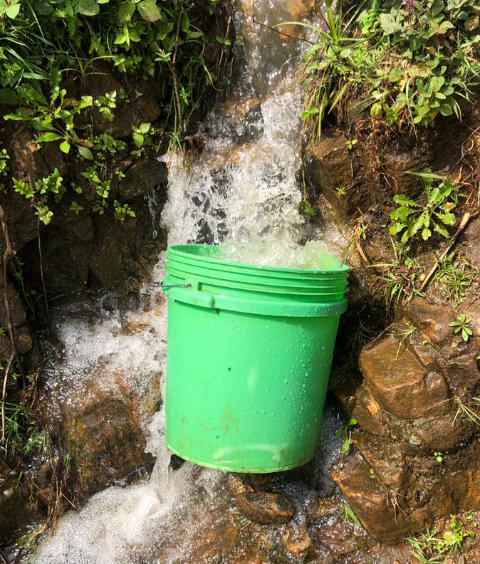
The main source of drinking water for members of your household
The purpose of this question was to establish understanding on the main source of water for household’s domestic uses in the village. Based on the assessment it was studied that out of 31 participants interviewed 27 (87.1%) obtain surface water, 2 participants (6.5%) tape water from the unprotected springs while 2 participants (5.6%) taping water from the protected springs as clearly illustrated in the table and figures below;
Figure 32: Drinking Water taping source at Menamu Village

Main water | # Of Respondents | %
Piped in to compound | 0 | 0%
Piped to neighbor | 2 | 6.5%
Protected dug well | 0 | 0%
Protected spring | 0 | 0%
Unprotected spring | 2 | 6.5%
Tanker-truck | 0 | 0%
Surface river water | 27 | 87.1%
Other(specify) | 0 | 0%
Total respondents | 31 | 100%
Table 29: The main source of drinking water

Figure 33: The main source of drinking water

The location of water source in the village
The question aimed to establish knowledge about the location of the community main source of water for domestic uses. This would significantly help to make decisions during planning of any proposed water system development in future. Based on the study 31 participants (100%) admitted that location of the main water source in the village is elsewhere as indicated in the figure below;
Location of the main water source | # of respondents | %
In own dwelling | 0 | 0%
In own yard | 0 | 0%
Elsewhere | 31 | 100%
Total respondents | 31 | 100%
Table 30: Location of the main water source

Figure 34: Location of the main water source

How far is the distance from the household to the water point?
The study aimed at finding out the distances covered by household’s members to their main water source in the village. The following were findings; 15 (48.4%) participants reported to walk more than 1000 meters from the households to the water point, 9 (29.0%) participants said that they walk about 10-500 meters from the households, 6 (19.4%) participants revealed to walk about 500-1000 meters from their households to the main water source. None of the respondents reported to walk beyond 10 meters for water as shown in the figures below;

Figure 35: The location of water source

How long does it take to go there, get water, and come back?
The question aimed to assess time used to obtain water from the main water source as shown in the below figure;

Figure 36: Time used to obtain water from the main source

The preferred water source in the community, what is its condition?
The question aimed to establish understanding on the situation of the preferred water source in the village, whereby 27 participants admitted that the main water source for the households in the village is seasonal available while 4 households admitted that the preferred source is working although is contaminated as shown in the figure below;

Figure 37: The Preferred water source condition

Please explain the biggest problems or needs, of any kind, for your family in daily living or achieving goals. (Any topic, not only WaSH)
The participants responded to the question above based on experience and knowledge as follows; the biggest problem people have in the village is water. People use stream water which is not treated and not enough for household’s use, the biggest problem here for people is water. If we have water we will have more food and money for my family, need for agricultural inputs like pesticides. As we cultivate using irrigation we can harvest throughout the year, Water is the only biggest problem in the village, the only problem we have is water of which we call it it's a mother problem to villagers, Water that is safe is the solely problem. As water has impact on personal development and personal health, Water for drinking is the main problem in the village. The other community needs identified were; Health Services, capital to improve livestock and farming projects, need for an independent heath care facility in the village, developed water source which is shared by the community rather than individuals, need for reasonable income to improve families living standards in the village, need for improved school infrastructures and better education for our children and need for better housing for villagers.

The challenges faced in accessing water from main source? (Time spent, method, quantity, quality or any other challenge)
The following were responses from households in different settings at the village; the source is far it takes time for majority to get water. Also the water taped for domestic uses is not treated. Water source is far uphill and my age is great so I feel so unhappy. I wish I could have a nearby source. The challenge I face to my water source is that during dry season it get dry and water is not enough at all times during those period so I have to walk distance to get water. As there is no enough water I have to cultivate seasonally. And also water is not clean nor enough. No any challenge. Sometime you find people fetching at the source so you have to wait. So time increases. It's long distance going uphill considering my age. And also you spend more time going to fetch water. A lot of people at one source making it take long time to fetch water especially dry season, and distance. There are lot of challenges, the water comes from springs where are the farm lands owned by individuals. Its quality is poor and full contaminated. Contaminated water (quality) 2. Lack of piping system to home 3. Time management. Long walking distance for water and is sometimes contaminated with chemicals from agriculture activities and the water is not safe for human consumption. Time spent because of long walking distance, quality water is not done, it’s contaminated with chemicals used for agriculture activities Quantity during dry season water flows decreases and sometimes the stream dries. Quality, water is contaminated with chemicals from agriculture activities Time spent, the source is very far we use a lot of time to just get one bucket of water. Inadequate water especially during dry season, the source of water dries out which makes us to go even much far for searching of water Long distance, we spent a lot of time to work for collecting water for only one bucket of water Quality, the water is not safe for human consumption, because at the source of water are contaminated with agriculture chemicals. Inadequate water especially during dry season water flow decreases and sometimes water dries out, Water is not safe because it’s contaminated with chemicals from agriculture activities. Quality, water which we get is not safe Time spent, we use a lot of time to go, fetch water and came back home Long distance, and the water source is far from dwelling. Time spent, the water flows decreases especially during dry season and sometimes the stream dries out Method, we carry water by head, which affects the quantity of water we get per day Quality, and water available is not safe for human consumption. Long distance so we use a lot of time to go fetch water and came back home Quality water is not safe for human consumption because it’s contaminated with chemicals used for agriculture activities. Water infrastructure are not good especial for the sources for drinking water. Water is contaminated as people use wash clothes and take bath at the source and time consuming for searching water. Time spending for searching water and method of carrying water he use head and water is not good for human consumption. Contaminated water and we use head for carrying 20 liters from the source. Water is contaminated with animal feces, time spending, we use head to carry water from the source and water is seasonal. Time is wasted and water is contaminated. During the summer season the water isn't enough for irrigation activities it is not safety at all. The source is far from my home and it's located downstream. So going down and coming uphill with water is a tedious job. The water is contaminated during the irrigation activities the water line were too dirt. Sharing water and animal Contaminated of water during rainy season Eruption of diseases.

The efforts have been taken by community, government and other development partners to mitigate the problems (list names of development partners?)
During household’s interviews, the participants responded with different feeling as follows; “There were plans to bring water from Kiririgwi water source to the village. But up to now no water has been taped”. “I don't know why maybe it's because scarcity of resources”. “Yes the village government has tried to start Kiririgwi project but up to now has failed to start.” “The government has plans but not yet implemented”. “Plans to bring water from Kiririgwi water source”. “The government ordered villagers to visit to a place where they wanted to bring water”. “We went and offered our labor, but up to now nothing has been done with Kiririgwi project”. “The village council wrote a letter of need of water at the village, and also there was a project called Kiririgwi water project which was stated but have never been finished”. “The village council wrote a letter of need of water at the village”. And also there was a proposed project namely Kiririgwi water project which was stated but have never been finished”.

Efforts that have been taken so far to help the community.
The following were participant’s responses based on individual understanding and feelings ; the village tried to mitigate the situation, the challenge have been remaining the same, The Same District is well informed but no action have taken due to the limited Government funds, The Village Government leaders have contacted Rotary Club of Same as a Development partner for action, The other respondent admitted that no effort from the local village government leaders and other stake holders have been taken, By laws set by village government strategies to do survey about the availability of water from the main source, this is done by the government, Yes there’s government strategies on how to bring water from the large source of water, Yes, village government supervises, manage and control the water source also the government has helped to build water infrastructure for irrigation such as drainage, Yes, the village government have set by laws which helps to manage and protect water sources, Yes, government has tried to distribute few water tapes but still water is inadequate because of high demand of water from people, No effort that has been done with the government or development partners, No any effort that has been done by the government such as to build water infrastructure but there’s only by laws to manage the water source, A member of parliament donated to improve water infrastructure but it was incomplete, Yes there some effort that government has done there’s some strategies and fund from village bucket which used to build few water infrastructure, No any efforts have been taken by either community or government, No any efforts taken by government, community and development partners, The community and government trying to clean the water source, The village government had once said they will bring water from Kiririgwi, but now nothing has come on, The community is continue report the water situations to the different development partners for the supports, The family report the problem, to the government for the further action, The community leader were once tried to make contribution to install the pipeline but the failed.

Factors which would make the water source more sustainable?
During household’s interview, participants responded with different thoughtful and emotions as follows; “May be planting trees and the village, government should be responsible to monitor the sources, for me I need water at my home as age goes on, I can't go uphill to fetching water”. “Water at this source is little we can't improve it. People have taped water at this source to their home and it's where we go to get water. May be if water coming from the source could be increased and being administered by the government.” “At my source, I would like to plant trees and construct a structure like tank, a tank will store water and people will come to fetch smoothly”. “By putting infrastructures that protect water in the source and put pipes to bring water to home”. “Planting trees at the source in order to increase water, challenge is tree seedlings are from the lower land and we are living up the hill so it's difficult to bring trees to the source.” “If trees were planted it could be better, the source is clean”. “Planting friendly trees and construct a structure and force water to come close to the people.”

Water quality test for bacteriological contamination
The question aimed at founding whether water from the main source is tested for bacteriological contamination where by 2(6.5%) of participants replied yes and 23(74.2%) participants replied no, while 6(19.4%) participants replied nothing and shown in the below figure:

Figure 38: Water quality test for bacteriological contamination

The place water quality tested
The question aimed at understand where was the water quality tested for bacteriology. The participants reported that water was tested at the source. Was the water sample taken from the source?
The question aimed at studying whether the water sample for quality testing was originally taken from the same source or otherwise. If yes it means that the quality test report would be significant during execution of the future proposed water project.

Factors which would make the source more sustainable
The following were responses from the participants; 1. Establish tree planting program, the village is working with FORESTA organization to improve environment at the water sources. 2. Reinforcement of bylaws 3. The community should be involved in making sure that the sources are protected 4.there should have a skilled personnel and water board committee. 5. Construction of Intake and piping systems. 6. Water tanks and tapes to supply water to people’s dwellings. 7. Water tanks and tapes to supply water to people’s dwellings, 8. To build good water infrastructures from the main source in the village which will help to supply water around the village for both human, agriculture and livestock. 8. To build good water infrastructures from the main source in the village which will help to supply water around the village for both human, agriculture and livestock. 9. Sponsors to build good infrastructure for water such as tanks, public water points with tapes that supplies water. 10. People must stop washing clothes in the water source they cause water contamination. 11. To continue clean the water source regularly and reforestation at the water source. 12. Provide training to the community in protection to water sources and to establish a regular visit to the water sources. 13. Sensitize people to stop construction of settlement near the water sources through established bylaws which control the water management.

Explanation on the conflicts that happen in the households, or with other people in the community, because of water scarcity or water problems.
The participants responded with different feelings as follows; “No. we are old. I remember when I was young we had one fight. My wife went to get water and arrived back late, we had a fight”. “Fighting with the neighbors, as the source is located to someone’s farm, sometimes the water is fully contaminated, so the conflict with the owner occurred.” Yes between farmers and water for human consumption because all needs water at the same time from the same source and water is inadequate.” Yes there’s conflict because water is inadequate and everyone needs water for human consumption, agriculture activities and livestock so people fights”. “Yes people fights because the only source of water is used for human consumption and agriculture activities.” “The conflict happen during irrigation activities, because the water are not enough.” “The family and the community does not experienced a conflicts that related to water.” “The conflict happen during the summer time because of insufficient of water.”

How do households make water safe to drink and cook?
The participants responded to the question above in different perspectives as follows; by boiling water, sometimes by boiling and sometime water used as raw water no boiling at all, very rare the household boils drinking water but normally drink without treatment, sometimes they treat by adding water guard.

How often do households conduct cleaning of houses? Their toilets? And washing clothes?
The following were responses from the participants interviewed;
Cleaning house and toilet is done once a day, and washing clothes is done once a week
Cleaning houses is done once per day, cleaning toilets is also done once per day and washing clothes is done thrice per week, clean house and toilet once per day and clothes Wash then once per week, Cleaning house once per day, toilet once per day, clothes cleaning is done thrice per week, Cleaning house compound is done three times a day, toilet is cleaned once a day and washing clothes is done three times a week., Cleaning house compound is done three times a day, toilet is cleaned once a day and washing clothes is done three times a week, Cleaning house compound is done three times a day, toilet is cleaned once a day and washing clothes is done three times a week, They are doing cleanliness at the house always they are doing cleanliness at the Toilet triple in a week they are washing clothes twice in a week, Sometimes it may happen triple or twice in a week, We clean house and toilet once per day, but washing clothes it depends with the availability of water sometimes once per week and sometimes three times per week.
We clean house and toilet once per day and wash clothes twice per week due to scarcity of water, Due to scarcity of water we clean the house and toilet once per day and wash clothes twice per week, Because of scarcity of water we clean house and toilet twice per day and wash our clothes four times per week, Because of inadequate water in my family we clean the house and toilet twice per week and wash clothes every day because we have children in the house, Due to inadequate of water in my household we clean the house and toilet once per two days and wash clothes twice per week, Due to scarcity of water we clean the house, toilet and wash clothes once per day, we have to manage well the water which we get in doing all this important chores, We clean house and toilet three times per day and wash clothes three times per week because of scarcity of water, We clean house and toilet once per day and wash clothes three times per week due to scarcity of water, Due to scarcity of water in my household we clean the house and toilet twice per day and wash clothes twice per week, Cleaning house and toilet is every day, but washing clothes is 3 per week, Cleaning house once per day toilet once per day washing clothes two times per week, Cleaning house made once per day and cleaning toilet once per day washing clothes twice per week, The family conduct a cleaning up to 3 time a day during meals, after toilet service and after come back home, The family conduct a cleaning up to 3 time a day during meals, after toilet service and after come back home.

Anyone in your families experienced diarrhea or other water borne diseases? What are the diseases? How often do they happen?
The following were responses from participants based on experience and feelings; Yes. Especially during rainy seasons we experience diarrhea, No have never happen because the family is usually using the boiling Water, No have never happen because the family is usually using the boiling Water, No have never happen because the family is usually using the boiling Water, Yes diarrhea this has happened once almost in six month, Yes diarrhea this has happened once almost in six month, Yes, Skin diseases and diarrhea, The diarrhea and malaria is the main diseases the family experienced, During the rainy season the family experienced the diarrhea because sometimes they drink a water from neighbors, The family experience a diarrhea, malaria and UTI and these occur during the rainy season, The family does not experienced any water borne diseases and No one has experienced water borne diseases.

Have the households received any training on water, sanitation and hygiene? Who provided it? When did it happen? And describe the training.
The following were responses from the participants based on diverse feelings and experiences. No. I haven't heard anything, No I haven't received any training, No I haven't received any training, never happened before. Yes from the local government they trained about hand washing, tippy tap clean and safe water and the importance of having and using toilets, Yes from the local government they trained about hand washing, tippy tap, clean and safe water and the importance of having and using toilets, We have received training on how to make clean and safe water, hand washing, use of tip tippy tap, having toilets from the dispensary, Yes, Empower Tanzania has provided education regarding hand washing, clean and safe water and other health related topics, Yes, Empower Tanzania has provided education regarding hand washing, clean and safe water and other health related topics, Yes, government officials has provided education on clean and safe water, hand washing and the importance of toilets, Yes government officials has provided training on clean and safe water, hand washing, Yes government officials has provided training on clean and safe water, hand washing, Yes village government officials has provided education on hand washing, use clean and safe water, the importance of having and using toilets. Yes obtained knowledge via media (radio) and village meetings, Yes from the village executive officer and chairman readers, They don't received a training on water, sanitation and hygiene from their village's but through television and radio, Yes, from Health officer gave us this year 2020, The family didn't received a training on water, sanitation and hygiene, The family received a seminar during the village meeting by Their leaders on hand wash and personal hygiene, The family didn't received any form training rather than listing and watching the television

What can be done to improve water and sanitation issues?
Responses to the question based on peoples experience and feelings as follows; I need water at my compound. I have no strength to go to the source, I wish water from Kiririgwi could come near to my home. I use a lot of time in finding water. So I water comes I will be able to do other activities, at the source I wish we could have a tank that store water. Water is what I need, I need water. Only water, we need water. If we have water at my house everything else will come, we need water me and my household. We only need water, Water should come near my house and be able to get it all time to meet my sanitation water requirements, Construction of HCF, 2. Income for the family, 3. Safe and clean Water is the best way of helping the community against water borne Diseases, The ideas from the head of family and his wife, 1.The river should be protected and construction of piping system to the community, 2. Build water infrastructure such as large tanks, distribution points and tapes, to get water from the large source of water Kiririgwi, Tapes to distribute water to the dwellings, taping water for supplying to the dwellings, Tapes to supply water to people’s dwellings, Tapes to distribute water into dwellings improve water infrastructures, To build infrastructure from the large sources which are far and build public tapes which will distribute water to the dwellings, Distribute water tapes and build drainage for irrigation, Tapes from the main source to supply water into people dwelling, To build good water infrastructure from the large source of water Kririgwi and tapes that will distribute water to the community, Readers should mobilize community in water source protection and where necessary mobilize community contribution to improve water system, construction of storage tank and distribute to the community, Improvement of water source, Water is the biggest problem so they need enough water, To installed water system around the households. The community health water must visit the households. Regular training to the farmers, I need water at my home. Even if is not at my home water should be near my home, to installed a water system, to have a storage tank in a community, to separate a uses of water (Agricultural activities and household activities), To installed water system around the households. The community health workers must visit the households for training and providing regular training to the farmers by agriculture field officers.

Focus group discussion with community members
Late in the evening the assessment team arrived at the village government office for the community meeting. After a short briefing on the subject, the community members were engaged in discussion through the questions presented whereby Giliard and Charles led the focus group discussion as presented below; the number of group participants was 18 whereas male were 10 and female were

The main source of drinking water to community
The main spring source is at Mahona which is a ground/surface water. Apart from Mahona there are other minor streams like Kwagushuru and Kwasengala.

Location of the water source in the community
Beside the primary school and below the school. It is about 6 kilometers Road access, mountainous, it is seasonal water decrease in summer and increase in rain season Shared with farmers and animals and minor landslides in rain season.

What is the condition of the water source?
There are no human activities carried out, the source is contaminated during rains

What are challenges you face in accessing water from the source?
Water conflicts/fights due to scarcity during summer Geographical layout of the area, ups and down

What efforts have been taken by community or government to mitigate the challenge?
The community has set regulations to divide water equally in the village The village has a plan for security of the water source The environment committee has set principles to protect the sources together with sub- village leaders

What are the factors which would make water source more sustainable?
Tree planting of the water friendly species 2. Protection of the water sources- the whole community be responsible to secure the sources 3. Training and awareness on land conservation 4. Promote sustainable agriculture 5. Prohibit bush fires 6. Enforcement of the laws to take care of sources

Has the water quality been tested for bacteriological contamination?
The response was “No” The sources are local and traditional serving

Water related conflicts
Have the households experienced water related conflicts in the village?
Yes; Fights between farmers and domestic users due to completion. Destruction of the water infrastructures and farmers Water division between the people living at lowland and those living at highland.

Water management
How water supply is managed in the village
There is a special committee to guide water Management-equal distribution. Guiding rules and regulations are in place
Does community pay for water service?
No water is free of charge in the village
No developed water system, the community is not sensitized to pay for water charges

Hygiene and sanitation
What are challenges relating to hygiene and sanitation in the village?
In availability of water guards lack of health education, Behavior of don't care. The community is holding traditional belief that boiled water is not sweet.
Have households experienced water borne diseases?
Yes, Amoeba, typhoid, diarrhea, worms
Have you received any training regard water, sanitation and hygiene? Who provided the training, and what was about?
Trained on washing, Boiling water, Body hygiene, Cloth hygiene and environmental hygiene

General comments
4.0.10.1. What can be done to improve water and sanitation issues?
Education on wash be provided to the community, Tree planting, Home garden establishment, Water treatment, Proper use toilets.

Needs identification through the Global Grants’ community assessment results
Need for school rehabilitation, need for adequate number of teachers at Mtunguja primary school- the current number of teachers is 3 per 250 pupils, need for roads construction to the primary school, need for economic empowerment for men, women and youth, need for electrical power supply to Mpongwe A, B, Nzava A, B, Mpinji and Mitini and need for school toilet construction and additional furniture
List of the Assets and or strengths in the village
Forests, Kiririgwi water sources, primary school, industrial area-Kwasenzai A, leadership, trusted elders, local government experts,
How will the community be involved?
Community participation at all levels, local contribution-man power
And cost sharing-water tariff
Current situation:
The village has no well-developed water system-community use water from the rivers and springs

Factors for the project Sustainability
Capture the current ideas for how the project will be sustainable for many years to come?
Effective designing of the project, consider standards during construction-ratios and genuine parts, technical & technology, quality equipment and tools-considering locally available materials-technology is important to be applied to the project for the purpose of minimizing operation costs, training to operators and water users, promote use of local experts, people must be trained on project operation and management for sustainability purpose, effective maintenance and repairs, expansion of the project, financial management, socially-community involvement, use of local experts, the community should be involved at each stage and must contribute to the project’s costs, there must be by-laws established for water users to control defaulters.
The general observation and comment from the village was that, the Kiririgwi water source was identified as a main and potential source of which once it is developed may serve three villages of Vudee and Menamu at the same level and Bangalala which is located at the lower part.

Marwa village
The community Need Assessment exercise was conducted on 11 July 2020. All Government logistics applied in organizing the community whereby Village Executive Officers played this role. The community was informed about visiting of enumerators in the village and the purpose of visit. The team reported at the village office where exercise purpose made by the team leader. Thereafter team members divided into groups according to number of sub villages and each group hosted by local leader. The sub village leaders led enumerators to the households and made an introduction to the head of households before interview. However one person remained at the village office for leader’s interview and community focus group discussion. There were 6 village leaders who interviewed and 15 peoples involved in focus group discussion. Household interview spent 15 to 25 minutes where Focus Group Discussion took about 2 hours. The village has got 4 sub-villages which are Pateli, Lesirwai, Njakitai and Marwa sub village. In this village there are two primary schools and one dispensary. Inhabitants of this village depend on irrigation cultivation from river Pangani, livestock keeping and some people depending on fishing. They own land with different size as figure No. 36 illustrated.
Figure 39: land size owned by households.
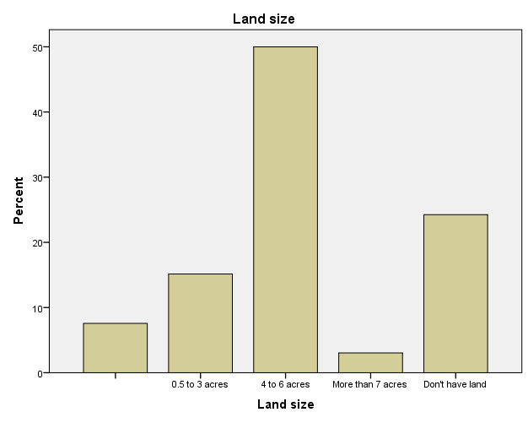

Figure 40: Source: Field data 2020
About 49 percent of the respondents in this village their age range between 46 to 60 years old, see Table No.31 below. This imply that majority of the resident of Marwa village were adults with families and income generating activities.

Respondent’s age (n=61)
Age range |  | N | Percent | Cumulative Percent
 | 19-35 | 12 | 19.7 | 19.7
 | 36-45 | 16 | 26.2 | 45.9
 | 46-60 | 30 | 49.2 | 95.1
 | 61+ | 3 | 4.9 | 100.0
 | Total | 61 | 100.0
Table 31: Source: Respondent’s age, Field data 2020.

The findings revealed that about 54 percent of the respondents were men. However 7 percent who were women were widow or divorced. It means that high percentage of the households in the village lead by men. Table No.32 shows respondent’s sex.
Respondent’s sex (n=61)
Sex |  | Frequency |  | Percent |  | Percent of cases
 | Male |  | 54 |  | 81.8 |  | 89.4
 | Female |  | 7 |  | 10.6 |  | 100.0
 | Total |  | 61 |  | 100.0
Table 32: Respondent’s sex, Source: Field data, 2020
It was noted that about 85 percent of the respondents in this village were married, 5 percent were widow and 3 percent single. The data implied that youth who were single were very few and households with families were many. It means that water demand to the household’s members was high depending to the number of family members.
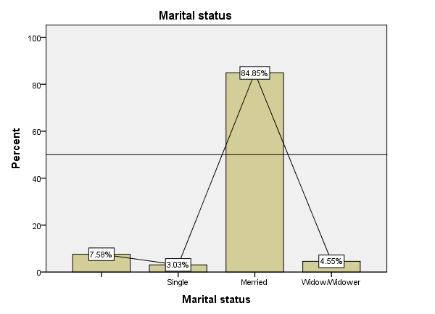
Figure 41: Marital status

Water Supply, Sanitation and Hygiene challenges
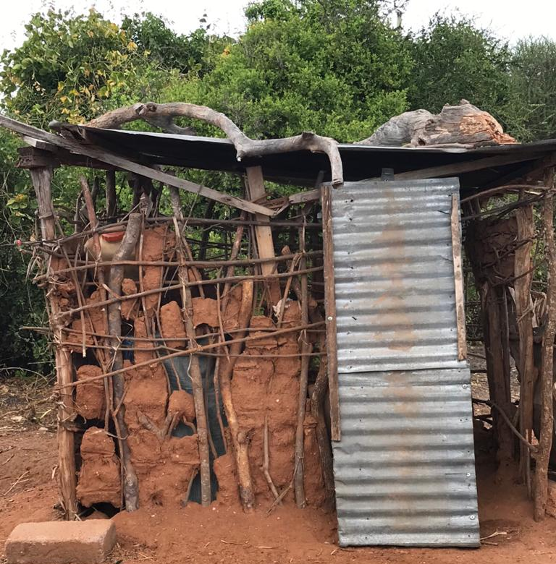
Marwa village is located about 30 km from district headquarter Same. The village situated along Pangani River which is the main source of water. It is permanent river flow throughout though there is distance of about 6 km to the village. The village doesn’t have water supply system as water source which are close to the people owned by two private people. It was revealed that the residents use to buy water for Tsh.100 per one basket of 20 litters from wells owners who drilled water for domestic and business purpose. The wells owners supplied water to some people who are close to him and charged water according to number of basket taken. Water is controlled by the owner therefore for those who have access to the source if want to fetch water, must inform the owner who send a person to count number of baskets taken and charge money according. It is possible for the owner to manage water as the control system is at his home, so even if people supplied water infrastructures, but can’t access water until the owner informed and open the main cock. However due to insufficient income of the people, few people managed to buy water and others about 80 percent use irrigation canal to access water near to their settlements and river. The water from canal normally used for agriculture activities therefore water is contaminated with agriculture chemicals like pesticides, fertilizer etc. Some people use motorbikes where others use animal like donkey and other carry water on their head more than 500 meters from the river see figure No.43. It was explained that there were other risks of fetching water at the main source as the river was settlement of animals like hippopotamus and crocodiles. Those animals are dangerous to human life especially those went close to their settlement in river.
Figure 42: Toilet Status at Marwa Primary School

Figure 43: Distance to the water source
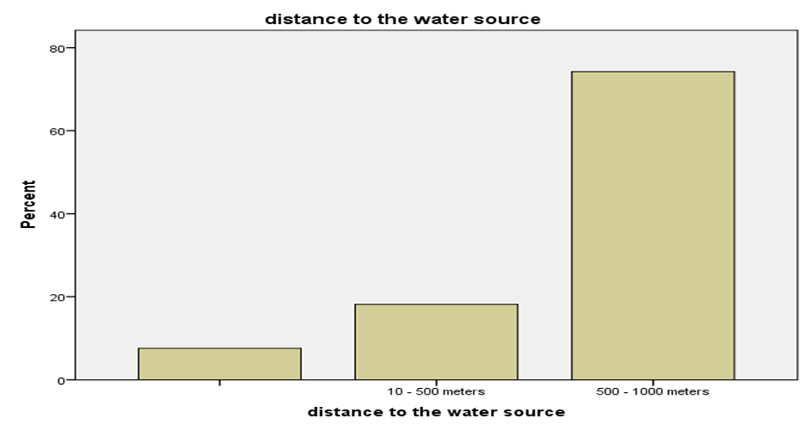

Source: Field data 2020
About 70 percentages of the respondents walk more than 500 meters to fetch water. This was due to the water challenge existed in the village. However 20 percent use to buy water in the village for tsh.100 per 20 litters.
The institutions also depends water from the river as their main source. The researcher interviewed teachers and pupils of Marwa Primary school who said, the school got support of storage tank construction from Kilimanjaro Hope organization (KIHO). The water tank helped the school during rain water season because the school has rain water harvest infrastructures. The tank can store water for only one month and thereafter students have to walk on foot 6 km to the river to fetch water. Although the pupils use break time to fetch water to avoid class session interference, still session interruption occurred as they use more than 2 hours and came tired. Fetching water from the river has been raised conflict between parents and teachers. The parents don’t like children to fetch water from the river due to risks associated (dangerous animals).
It was observed hand washing facility (tippy tap) at school compound where pupils use it to make their hand clean. The pupil’s toilets infrastructure doesn’t consider people with disability and lack menstrual support facility. Although it was noted that if pupil face menstrual situation in school, teachers provides to her emergency pads which reserved mainly for emergency purpose. The pads bought by teachers to help pupils as the school doesn’t have fund for pads.
For the dispensary it was revealed that, there was storage tank with capacity of 15,000 litters. Rain water harvesting infrastructure was observed at the dispensary buildings. It helps the facility to access enough water during rainy season though experienced challenges during dry season. Staff of the dispensary use to buy water for activities operation and they spent Tsh. 42, 000 per week during dry season. Since the health facility doesn’t have budget and fund for water, staff have to use their own money to buy water for the HCF.
The issue of hygiene and sanitation also revealed as challenges which caused other outbreak diseases. Majority of people lack toilets instead use bushes and farms for toilet services. There are several reasons of why people don’t have toilets among the reasons are water challenges and inadequate knowledge. Nevertheless the cultural factors rose as among of reasons hence pastoralist community (maasai) don’t use toilets due to negative perception. They believed that sharing of toilets with other family members is shameful to the head of the household. Furthermore, due to water challenge some people think having toilets is more challenge especially on cleaning every day therefore use alternative way which is more risk to human health. Furthermore people lack knowledge on the importance of using toilets that’s why didn’t care about their behaviors. The village experienced outbreak diseases cholera and water borne diseases in 2018 and 2014 whereby some people dead see figure No.3 below. Even though they use water from the river which is contaminated and shared with animal, still some people drink without any treatment. This situation put the residents in more risks of outbreak diseases.
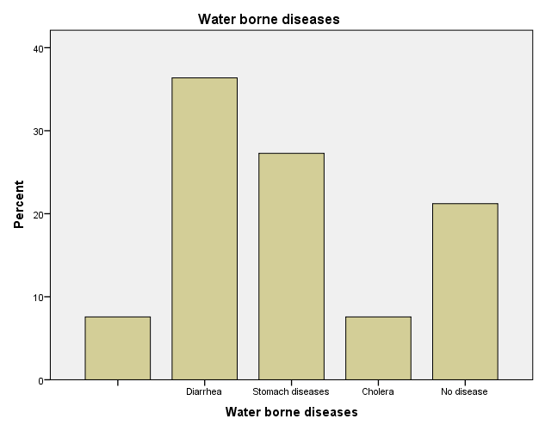
Figure 44: Water borne diseases

Source: Field data 2020
At least 35 percent of the respondents experienced diarrhea, where 28 percent got stomach disease. About 8 percent experienced cholera outbreak.
The study also revealed there were some minor conflicts in irrigation water especially during dry season where water is scarce. Some people violated irrigation time table and rules provided. Also some conflicts occurred in wells where there was long waiting queue and everyone wants to fetch first. The outcomes experienced was chaos at the source but conflicts usually solved by leaders where others solved by themselves.

Opportunities available for improving water supply, hygiene and sanitation
Marwa village has several opportunities useful for improving water supply. One of the opportunities is availability of river Pangani which is permanent river flow throughout the year. The river located about 6 km from the village, if introduce water supply in the village this will be the main source. Water from the river was tested and test results revealed that is safe for human consumption if treated because is contaminated. Second opportunity is underground water as water table is close to the surface ground. The study revealed that drilled wells have 10 to 18 meters depending on the location. It was discovered that the community abandoned one drilled well because of negative perception though it has got enough water to supply in the village. It was explained that one person got accident in well which caused her death therefore the whole community feared to use the well. It was explained that if identified water source improved, will supply water in the community. The community is ready to contribute to the project if get support. Community involvement and contribution will create sense of ownership, accountability and project sustainability.
The village government is ready to provide land for drilling community wells and enforce by-law to protect the source. Also the village government is ready to mobilize community contributions and establish water users association which will help on water project operation, management and sustainability as well.

Efforts, Strategies and Plans of improving Water Supply, Hygiene and Sanitation
There are several efforts made by the village government to improve water situation and hygiene and sanitation situation. The village requested support from KIHO to improve water situation in the village. The organization in collaboration with University of Dodoma and Uhio University conducted a research on water situation and tested water quality. They constructed three storage tanks whereby two tanks constructed at primary schools and one at the dispensary. It was noted that water quality test result recommended water from Pangani River fit for human consumption though need to be treated as it is contaminated. Furthermore World Vision Tanzania drilled water well in the village but after water quality being tested, was recommended not fit for human consumption hence a well abandoned. Nevertheless Roman Catholic Church also drilled a well in the village which abandoned after testing result shows water is not safe for human consumption.
The village government conducts regular inspection to the households to inspect hygiene and sanitation situation. It was revealed that for those identified lack toilets, they face penalty of Tsh.50,000/= Although the village government practiced by-law but it was observed there were weakness in enforcing hygiene and sanitation by-laws as number of people who haven’t toilets were high and nothing was going on upon them. The village health committee and health officer provided education to the people on the importance of using toilets and effects of using bushes as toilets. Also the health officer educated community on key issues to be considered on hygiene and sanitation to prevent outbreak diseases like cholera. However some people still face challenge on adhering to the instructions and knowledge provided by health officer and put the whole community in outbreak risk.

Focus Group discussion
In Focus Group discussion it was explained that lack of reliable source of water in the village caused the residents especially women and girls to be in hard situation of finding water. There was challenge with drilled water which is too salt therefore most of residents don’t prefer it. Also they added that not all family was in good position financially to buy 20 litters of water for Tsh.100. Furthermore majority of household located far from the drilled wells therefore the only option was using the river. Though majority of people drink water from the river without any treatment, but it was proved scientifically that water is contaminated. On hygiene and sanitation issues it was explained that more than 50 percent of the households in the village lack toilets. The village government and health officers provided education to the people but still problem persist. The village experienced cholera outbreak in 2018 caused by poor hygiene and sanitation. Also it was explained that the village experienced floods for consecutive three years which cause food insecurity and insufficient family income.
This village provided some recommendations for water source improvement and sustainability. They recommended to have water supply system in the village whereby the source can be either drilling or from Pangani river. It was explained that water supply services will minimize risks of fetching water from the river, long way walking on foot to fetch water and save time. Also was recommended that knowledge on water source protection, hygiene and sanitation is still important to the people for behavioral change. They add that, the village government should enforce established by-laws to ensure hygiene and sanitation issues are good in the village. However it was noted that more research especially on ground water is important for sustainable solution of water challenge. The researcher concludes that according to the situation observed in the village, people were in high need of water service. Their daily income activities affected by water challenge as have to spent more time especially women and girls on fetching water. The people’s lives were in high risks of being affected by wild animals at the main source, and outbreaks as well. In primary schools, academic performance was affected by water challenge especially during dry season.
Figure 45: Major problems raised in the village
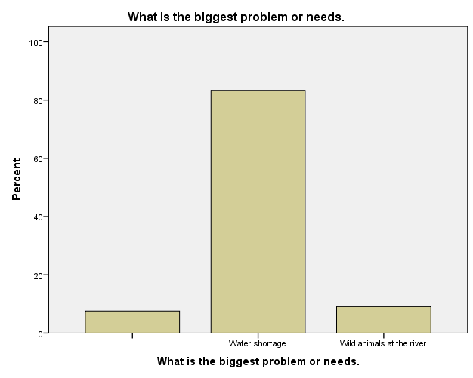

Source: Field data 2020
From the figure above about 80 percent of the respondents mentioned water as the major challenge in the village. However 5 percent who listed wild animals as challenges it was because of water challenge as the animal (hippopotamus and crocodile) were in river.

Gaps, weakness and strength identified
The finding revealed the gap exist in this community was poor community involvement to development activities. This caused the leaders to be reluctant to donors though have assets in the community. Village leaders observed to be week on community organization and finding solution to the challenge even those which were within their capacity to solve. The issue of hygiene and sanitation was within village government capacity to control. If the village could apply by-laws effectively, there could no household without toilet. Leaders need to be reminded on their roles and responsibility. Ward level also need to conduct regular monitoring to this village especially on issues of hygiene and sanitation.

Project Sustainability
If water project will be materialized in this village the following things should be adhered for sustainability purpose;
- The community should be involved at each stage and must contribute to the project’s costs
- People must be trained on project operation and management for sustainability purpose.
- There must be by-laws established for water users to control defaulters
- Technology is important to be applied to the project for the purpose of minimizing operation costs

Emuguri village
In this village all logistics were prepared by village executive officer in collaboration of village chairman. The village leaders and community representatives were informed to meet at Emuguri primary school for interview and discussion. The team found leaders assembled at primary school at 9.30 am where introduction of the exercise provided. The leaders were given chance to ask some questions for if not clear and team made elaborations. After exercise purpose being explained, village sub leaders led enumerators to their area of jurisdiction for households’ interview. The community was aware about the exercise as their leaders informed them before. In schools also teachers had information about visiting of enumerators therefore they found pupils prepared for interview though it was weekend. After data collection exercise being completed, the team met at the school to finalize the exercise and share with leaders briefing report on what found. This village was among challenging village as its households were very scattered hence enumerators suffered to accomplish tusk.
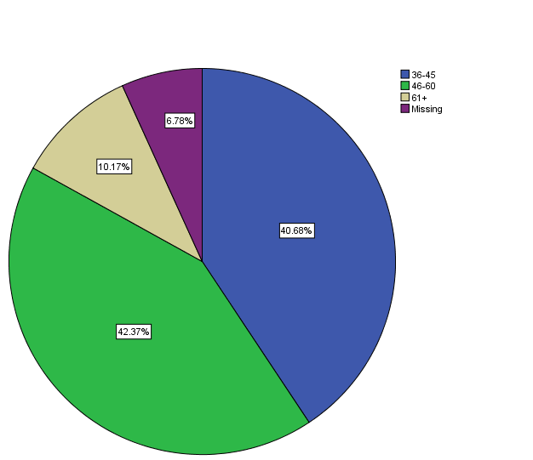
Emuguri village is a new village established in 2019. Formally this village was a sub village of Njoro village. It has got four sub villages which are Emuguri A, Emuguri B, Endevesi, and Nasuri. The village lack health facility as people depend on near village dispensary. However Emuguri village has got two primary schools which are Emuguri and Endevesi primary school. The people in this village depend on livestock keeping as 90 percent of the residents were pastoralists though doing agriculture. About 42 percent of the respondent’s age ranged between 46 to 60 years old see figure No.6 The village located in barren area which receives little rainfall per annum. Due to this weather condition, agriculture activities in this village remain probability.
Figure 46: Emuguri Respondent’s age

Source: Field data 2020
Respondent’s age determine manpower in the community. Emuguri village has got high number of manpower as the figure above illustrate.
The number of family members at household level was high as 60 percent of the respondents got married with several children, see figure No.7
Figure 47: Marital status
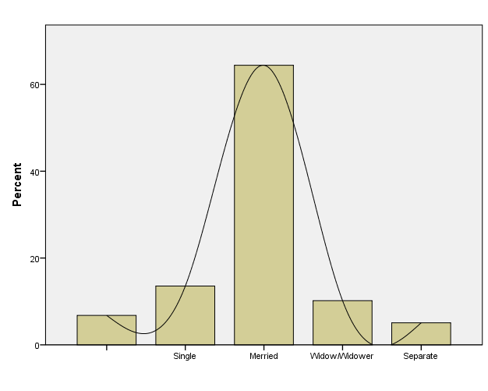

Source: Field source 2020

Water Supply, Sanitation and Hygiene challenges
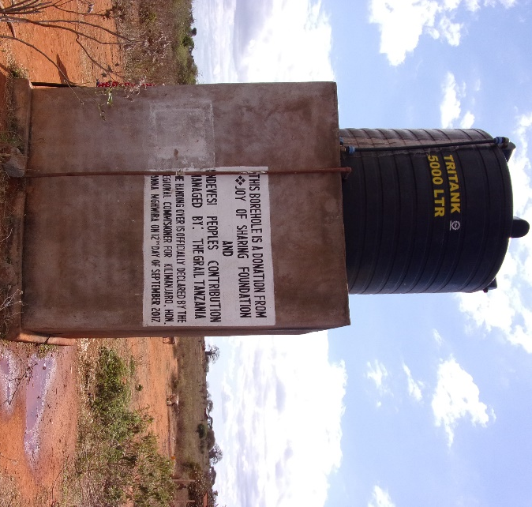
Emuguri village is characterized by semi-arid climate vegetation and the water source depend underground water. There was no either river which cross in the village or spring. The village got support of drilled two wells from ISF organization and Roman Catholic Church. It was huge efforts done by leaders and the village government as people was suffering from water challenge. However one well found function though faced technical problems which rise operation costs and the other was not function. The community got water from water points established by the organization. It was explained that the village government established water committee which is responsible on water management and infrastructure maintenance. For the purpose of operation and sustainability, the water committee introduced water charges whereby each 20 litters charged Tsh.100. Among the major problem raised in this village was water problem as figure No.49 illustrate.
Figure 48: Water Sources

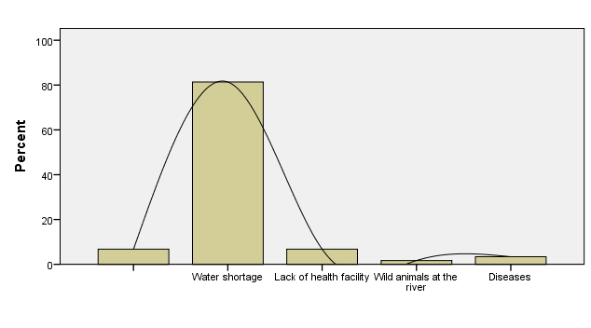
Figure 49: Emuguri Community’s problems.

Source: Field data 2020
About 81 percent of the respondents mentioned water as the big problem in the village. Although the village had water project but doesn’t fulfill community need due to challenges facing the project. However 6 percent of the respondent listed lack of health facility as the problem.
The researcher revealed that when the well is not function, people had to walk on foot more than 10 km go and return to the nearest village to fetch water. For those who had good financial liquidity had to buy water in the village for Tsh.1000 per 20 litter jug. Those selling water during water challenge, they fetch from near village (Njoro village) using motorbike or animals (donkeys) see figure No.9 water costs. The village lack electricity therefore water pump use diesel which explained to cause high operation costs compared to the income earned for the project. However the study revealed weakness on water management hence there was no person who controls number of customers at the source. The committee left people to be free on fetching and pay money. This system brought a major challenge on operation due to cheating done by some customers. Nonetheless the income earned seemed to be insufficient to cover operation costs because of this weakness. Though water pump and infrastructures seemed need repair to smoothen waters services.
The water point placed at the village center therefore majority of people who lived out of the village center had to walk for about 4 km to access water. The village failed to extend water infrastructures to the rest sub village because of insufficient fund. Although the village got water services, it explained that water is not sufficient therefore people had to spend much time at the source waiting water. Water pump capacity became down which failed to sustain community’s need due to depreciation. In sub village named Endeves got support of drilled well from Roman Catholic Church. This water managed by water committee formed by the community under facilitation of the church. Water in this sub village serves community and school as well.

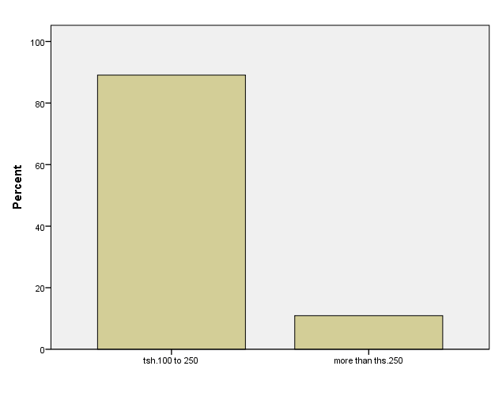
Figure 50: Water costs

Source: Field data 2020
In institutions, water is challenge as in Emuguri primary school there was no water sources. The source used was 240 minutes from the school which causes pupils to fail access water. The parents gave 3 litters of water to their children mainly for school activities in order to avoid pupils fetching water during class sessions. However as human settlement is too scatted, some pupils walk long distance to the school with 3 litters of water gallons. The same water is used for drinking in school and for other activities. At Endeves primary school they depends water source from well drilled by Roman Catholic Church which located about 1-1.5 km from the school. The residents in Endeves sub village depend on the well for water service whereby during dry season, water became scarce. As the school and community depend on the same source of water, people had to spent hours waiting water at the source during dry season. The school needs up to 500 litters of water a day to sustain activities.
Hygiene and sanitation issues in this community revealed as the challenge as 22 Percent of the respondents lack toilets. This implies that majority of people in community lack toilets therefore they use bushes instead. These practices had exposed the residents into an outbreak risk. The children suffered from skin infections, UTI and others, as the result of shortage of water at households. The schools had female and male toilets though lack special room for girls changing during menstruation. Teachers in both primary schools had emergence pads for girls bought by their teacher own money. The pads normally provided to a girl who experienced menstruation period in school.
About 92 of the respondents don’t treat drinking water though some of them had received hygiene and sanitation trainings. The trainings provided by ISF, Same District Council, and village leaders. The researcher observed dirty toilets and environment at household. It seemed as their normal life and some of them didn’t care about it. Insufficient water at school put toilets environment to be dirty and exposed pupils to infections see table No.3 diseases. Emuguri primary school has got 166 pupils and Endeves primary got 201 pupils. Having this population without sufficient water is real a big challenge. The schools lack income generating project which might assist in water purchasing or storage tanks construction. It was noted that there were minor conflicts at water source especially during dry season where water become scarce. However emerged conflicts solved by themselves and there was no big outcome from the conflicts.
Table 33: Diseases
Diseases |  | Frequency |  | Percent |  | Cumulative Percent
Cholera | 4 |  | 6.8 |  | 6.8
Diarrhea | 3 |  | 5.1 |  | 11.9
Stomach diseases | 6 |  | 10.2 |  | 22.0
No disease | 5 |  | 8.5 |  | 30.5
Skin infections | 41 |  | 69.5 |  | 100.0
Total | 59 |  | 100.0
Source: Field data 2020
The table above illustrates common diseases in Emuguri village. Water challenge affected bathe rate to children and adults hence suffered from skin infections.

Opportunities available for improving water supply, hygiene and sanitation
Availability of development partners like NGOs and Churches is an opportunity to this community as to government doesn’t had capacity to expand services in each area. Also passionate village leaders who are committed to community development activities also noted as an opportunity in this village. Emuguri community is aggressive to water services hence majority are pastoralists. This implies that if get support, the community is ready to contribute for the project. The village has got arable land useful for production if get irrigation water.

Efforts, Strategies and Plans of improving Water Supply, Hygiene and Sanitation
The leaders took initiative to consults development partners including churches to help the community on water challenge solving. The outcome of this effort was having wells donated by Roman Catholic Church. Also the village government organized community contribution to renovate water pump and improve water supply. The leaders had talk to the community through village meeting where the plan was approved by the meeting. However the village is planning to buy solar system to run water pump instead of diesel pump. It was explained that this plan if achieved will minimize operation cost while improving water supply. Nevertheless, the village is seeking donors to assist in extending water services to sub villages which lack water. The request sent to the government but was insufficient fund to implement the project.
In order to improve water supply system, the village recommended improving water sources by drilling other wells and extend water supply to sub villages and at schools. Planting trees and enforcement of environmental by-laws noted as another strategy to improve water sources and supply. Due to challenges experienced on water charges collection, the village was in plan to restructure water committee and assign new roles and responsibilities.
The researcher observed people suffering from water challenges where others walk long distance to find water in nearest sub village. Schools affected by water challenge and exposed pupils and teacher to an outbreak. Hygiene and sanitation situation also observed to be big challenge due to few households with toilets. Improving water supply system in this village will be useful to people’s life. However the community needs more hygiene and sanitation training to expand understanding.

Focus Group discussion
During Focus Group discussion the community raised water problem as the major challenge in the village. It was explained that people work for more than 4 hours to find water in nearest village when village well got break. However they added that, those affected direct with this problem were women and girls. This is because of gender imbalance as women face heavy load of domestic roles and responsibility and other income generating activities as well. Also hygiene and sanitation explained to have challenge due to inadequate knowledge among community members. People don’t treat drinking water and majority of households lack toilets. They said poor accountability of village government caused the problem to exist. They explained that the village government failed to manage water committee that’s why project was in worse situation due to poor maintenance. It was noted that although they pay money for water, but it happen management failed to buy fuel for water pump for the reason of insufficient fund. It was suggested that water committee must be restructured for project sustainability.
The findings and observations from this village proved water challenge and need of intervention. The community especially those without water service real suffered from water challenge. As the village had water project which is function, better way of improving is extension infrastructure by extending pipes to at least all sub villages. There should be recommended number of water points depending on the population.

Gaps, Weakness and Strength identified
The study revealed that poor community involvement to the project and poor communication were among of the gaps identified. The leaders were failed to organize community efforts to project sustainability. It was revealed that people were ready to contribute for project improvement but leaders didn’t take initiative to involve them. Lack of resources (material and non-materials resources) observed as gap hinder water improvement efforts. Also poor leaders’ accountability, lack of transparency identified as weakness in this village. There should be efforts from ward office to change this situation if project sustainability is expected. However community willingness toward development contribution, identified as among of the strength.

Project sustainability
There are several things to be considered in this village for project sustainability
- The village leaders should be educated on the importance of community involvement to the project.
- Water committee must be well trained on operation, management and financial management
- There must be by-laws established for water users to control defaulters
- Technology is important to be applied to the project for the purpose of minimizing operation costs
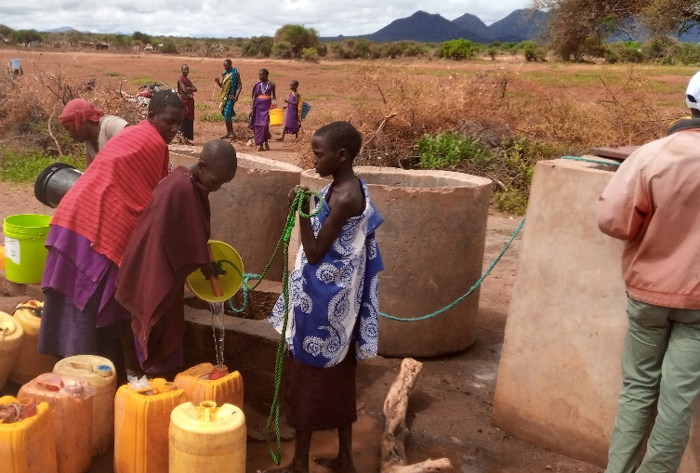
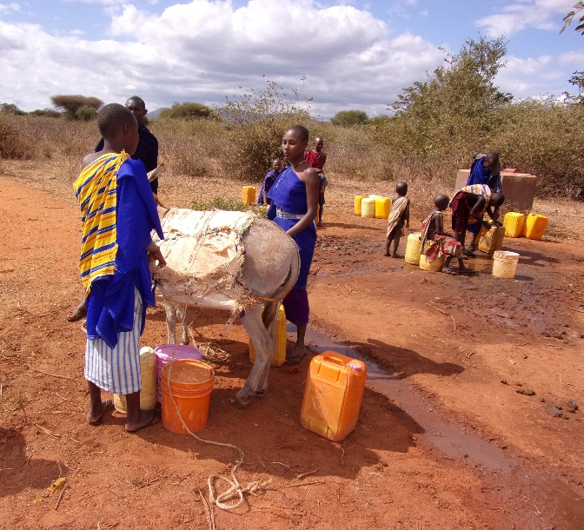 Figure 51: Water Point at Betel Sub Village

Figure 52: Water Point at Emuguri Village

Bangalala village
In Bangalala village about 49 percent of the respondents were adults whereby their age ranged between 46 to 60 years oil as table No.34 illustrate. About 94 percent of the respondents got married with several numbers of family members. It was explained that majority of youth transferred to towns for job seek.
Table 34: Bangalala respondent’s age (n=52)
Age range |  | N | Percent | Cumulative Percent
 | Below 18 years | 1 | 1.9 | 1.9
 | 19 to 35 years | 3 | 5.7 | 7.7
 | 36 to 45 years | 13 | 24.5 | 32.7
 | 46 to 60 years | 26 | 49.1 | 82.7
 | 61 and above years | 9 | 18.9 | 100.0
 | Total | 52 | 100.0
Source: Field data 2020
The Community Assessment team visited this village on 10 of July 2020. One of the challenges experienced in this village was poor organization which caused the exercise to start late. Leaders came late whereby activities started around 11 am. As usually team leader made an introduction to the village leaders and explained activities planned to be accomplished. Thereafter sub-village leaders led enumerators to their area of jurisdiction for households’ interview. The enumerators interviewed 52 households, one primary school, one secondary school and health facility existed in this village.
The village located about 31 km from district headquarters Same. Major economic activities of this village are agriculture and livestock keeping. Bangalala village has got one primary school named Mghungani primary school and one secondary school called Bangalala secondary school. Also the village had one dispensary which provides health services to the people. The residents of this village depended on agriculture as main source of income and livestock keeping. They practiced irrigation system whereby water came from the mountain area. The irrigation type applied here was traditional system with traditional canals.

Water Supply, Sanitation and Hygiene challenges
Bangalala village is among several villages in the districts suffering from water challenge. The village has two rivers where one was permanent and the other was seasonal river flow water during rainy season. The source of the main river located in Vudee village in upland area which flown to Bangalala village and other villages. People in this village use the river for domestic and irrigation as well. However the village got water project from ISF (Non-Governmental Organization) support where 21 water points installed. Poor project management, lack of regular maintenance led the infrastructure to be in worse situation and left 14 points not function. It was explained that poor financial management cause fund collection to be insufficient to the extent that can’t cover operation costs. This situation led water infrastructure to be in worse situation with several parts of water leakages. After village water committee proved failure and water became a major challenge, people refused to pay for water. The researcher proved water was free, no any management mechanism set at water points. Nevertheless there was no tape at some water points where people bend pipe to close water flowing. Figure No.10 show’s needs (problems) rose in Bangalala village.
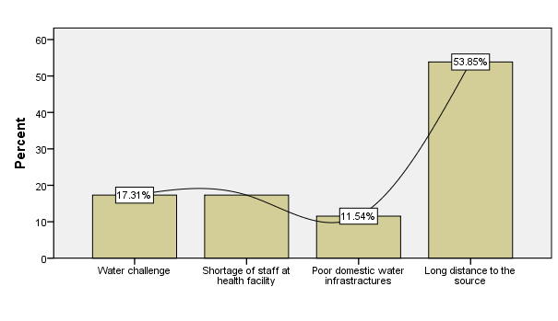
Figure 53: Bangalala major problems

Source: Field data 2020
Broken of water points which caused people to have long distance to the function water source seemed to be a major challenge in this village compared to other challenges listed. The problem covered 54 percent of the respondents followed by shortage of staff at health facility and water challenge. It noted that at least each household experienced water challenge especially during dry season due to poor water infrastructure. The study revealed that about 65 percent of the respondents walked more than 1000 meters where 21 percent walked 500-1000 meters to find water.
In institutions it was revealed that scarcity of water was a major challenge though Bangalala secondary school has got storage tank with capacity of 10,000 litters donated by World vision Tanzania. The school receive free of charge water from the village main tank which serves the school water needs especially during rainy season when water is sufficient. The water in school normally chlorinated therefore was safe to drink. During dry season, the school experienced water shortage and storage tank remains empty. The students had to find water from the river located about 2 km from the school. The school fixes hand washes facility with soap therefore all students’ access hand washing service. Mghungani primary school faced with water challenge as the school lack storage water tank. The pupils had to carry drinking water from home. Hand washing facility had to be filled water by pupils every morning and once water decrease. The school toilets lack infrastructure with people with disability and facility with girls who are in menstrual period. However schools had emergency pads bought by teachers to serve girls facing menstrual situation while in school.
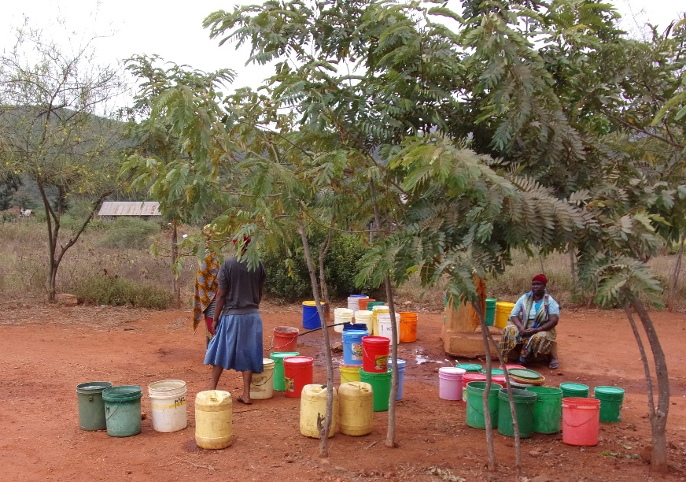
The village dispensary accessed water from tape located in the health facility compound. Water was free no any payment for water service. The dispensary has got two plastic water tanks with capacity of 2000 litters each, used for water storage. During dry season, the health facility experience water challenge as water volume decrease at the source. It was explained that there was periods where the dispensary bought water for the facility operation especially during dry season.
Figure 54: Tape in the Health Facilities at bangalala
On hygiene and sanitation the village experienced challenges of water borne diseases due to contaminated water. Diseases like diarrhea, Typhoid, UTI experienced in the village and cost people’s life. It was observed people fetched dirty water from irrigation canal for family consumption. It was real dirty water with mad color. However it was explained that before use, they had to store for a while to allow separation of mad and water. Thereafter they took clean water and dump mad. Family activities like washing clothes, cleaning toilets etc affected by water challenge. In schools there was hand washing facility which serve students to clean their hands after toilet. Figure No.11 illustrates most common diseases in Bangalala village. Among the common diseases listed, U.T.I ranked 58 percent due to poor hygiene and sanitation.
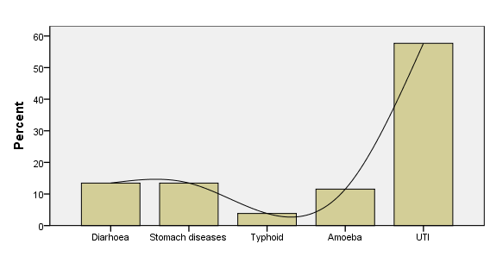
Figure 55: Common diseases in Bangalala village.

Source: Field data 2020

Opportunities available for improving water supply, hygiene and sanitation
Bangalala village got water from the mountain from sources which are permanent source of water. Although water become scarce during dry season but is available at least twice a week. Existing of reliable water source identified as an opportunity to this village. Also domestic infrastructures supported by ISF organization noted as an opportunity though need improvement. The village is rich of stones and sands therefore in case of infrastructure construction these stand as an opportunity. The community which has knowledge and willing to support water project also identified as an opportunity to this village.

Efforts, Strategies and Plans of improving Water Supply, Hygiene and Sanitation
The village government took efforts on improving water and hygiene situation. Leaders in collaboration with health committee conducted regular inspection at household level to ensure issues of hygiene. Also leaders in collaboration with health officer normally educate community on hygiene and sanitation good practices. The village government was planning to fix water meter to each water point for the purpose of controlling water and revenue. However insufficient fund caused the plan to fail. Implementation of hygiene and sanitation by-laws explained as efforts taken by village leaders to control poor hygiene and sanitation situation.

Focus Group Discussion
Focus group discussion involved 18 people of whom 6 were female and 12 male. It was explained that the village face water challenge though during dry season situation became more serious. It noted that the village gets water from river which comes from upland area (Vudee village). Water flew throughout the year and used for domestic and irrigation as well. During dry season, water volume in the river decrease while their demands remain constant. It is in this time where residents in this village experience hard time in accessing water. They had to walk on foot to the river about 2 to 3 km depending on people’s location. The village has water catchment for livestock but during dry season all catchment lack water therefore livestock shared water with human at the source. Furthermore some people use to wash clothes and take bathe at the source. In upland are where the river pass, people conducted agriculture activities near the river. All those activities contributed to water contamination and cause water borne diseases like diarrhea etc.
Although the village had got water project support from ISF, but poor management system, lack of infrastructure maintenance caused the project to be in poor condition. They added that formally they had to pay tsh.100 per 20 litter jerry cane but that system collapsed after water committee failed to collect money and repair infrastructures. I revealed that if there is technical problem from current infrastructure, people had to raise fund mainly to solved emerged problem. The village hygiene and sanitation situation explained as the challenge because of poor by-laws enforcement and water challenge as well. Some households lack toilets but leaders didn’t take any effort even though there was penal of ths.50,000/=. People knowledge on hygiene and sanitation issues was very low as only 2 percent of FGD members got trainings. They said the government normally creates awareness to people when there is outbreak like cholera but for normal hygiene and sanitation people were ignorant.
The respondents explained some efforts the leaders took on improving water situation. It was explained that if the village government want to repair damaged part, had to collect contribution from each household. The amount to be contributed by household normally depends on maintenance costs raised. For those who went contrary to instruction, they face penalty and fine according to the village by-laws. It was revealed that people were willing to contribute if the contribution brought positive outcome to their life.

Gaps, Weakness and Strength identified.
The gap identified on leader’s capability to organize community to contribute to project sustainability. Also gap identified on resources utilization for development activities. Though village has got human and material resources like sand, stones, water but leaders and other staff in the village failed to utilize the resources even for simple project improvement. This determines incompetent and lack of knowledge among village leaders.

Project Sustainability
Project sustainability in this village will depend on the following factors;
- Community involvement. The community should be involved from project identification, preparation, implementation and evaluation. The people must contribute to the project costs to create sense of ownership
- Committed water committee. The village should establish water committee which must be well trained on water management and operation. The committee should be responsible on collecting money from the project and conduct regular maintenance of water infrastructures. However the committee should be monitored for the purpose of controlling poor performance and fund disbursement.
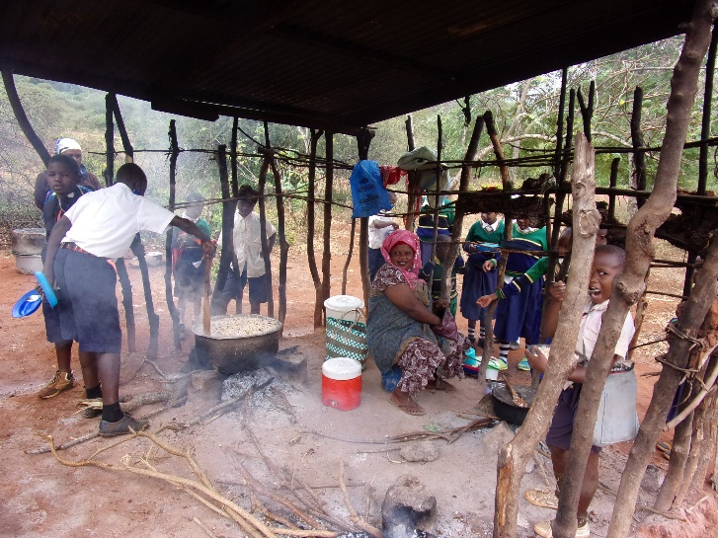
Figure 56: Kitchen Status at Bangalala Primary School

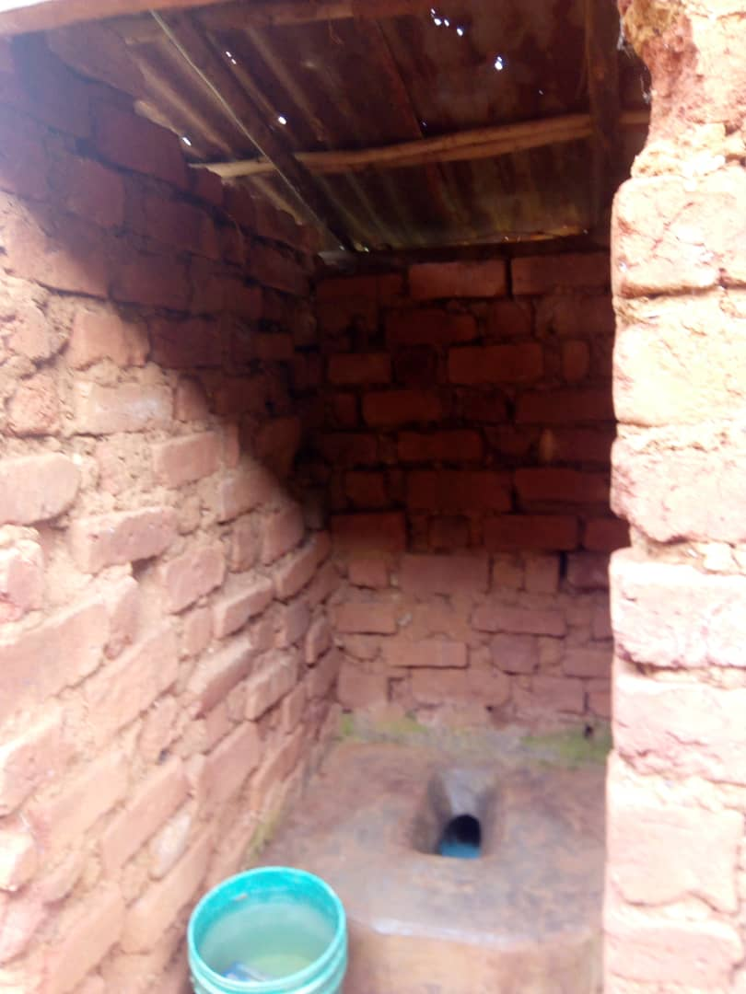
Figure 57: Toilet Status at Bangalala Primary School

Mabilioni village
This was the first village for the CA exercise where it was took place on 06 of July 2020. CA team leader made communication with village executive officer who organized logistics in the village. The team met at ward office for induction thereafter went to Mabilioni village whereby introduction was made as well. The village leaders and community representatives found assembled at village conference hall. Then the village chairman opened the meeting and introduced meeting members. Also the team leader led an introduction of CA team members and explained the purpose of the exercise. The CA team members were assigned households to visit and interviewed which guided by sub village leaders. Some of the enumerators visited schools (primary and secondary school) where others visited Mabilioni dispensary.
In this village about 50 percent of the respondent’s age ranged between 46 to 60 years old as table No.5 illustrates. The high percentage of matured age determines water consumption at the household as 62 percent of the respondents were married.
Table 35: Mabilioni village respondent’s age
Age range |  | Frequency | Percent | Cumulative Percent
 | 19 to 35 years | 5 | 9.6 | 9.8
 | 36 to 45 years | 15 | 28.8 | 39.2
 | 46 to 60 years | 25 | 50 | 88.2
 | 61 and abover years | 6 | 11.5 | 100.0
Total |  | 51 | 100.0
Source: Field data 2020
Mabilioni village has got 7 sub village which are Gunge, Kidundai, Jitoeni A, Jitoeni B, Mabilioni A, Mabilioni B and Chanika. Major economic activities of this village were agriculture and livestock. They major crops cultivated were maize, lablab and vegetables. However some people engaged on fishing activities as the village located along river Pangani.

Water Supply, Sanitation and Hygiene challenges
Water problem mentioned as the major problem in the village. Though other problem identified as figure No.12 illustrate, but water caused major challenge to the people of Mabilioni village. The resident of this water depend water from river Pangani. The river located about 4km from the village and there were no water infrastructures in the village. The people had to walk on foot more than 1000 meters to the river daily to access water for domestic. The same source used for irrigation agriculture and shared with animals. Due to long distance to the source, some people fetched water from irrigation canals to shorten long walking distance. Available water is contaminated as the source shared with animals where majority of the people wash clothes over there and took bathe. It was explained that the source was very dangerous due to existence of animals’ like hippopotamus and crocodile. Last year four people were killed by hippopotamus when fetching water at the source.
Institutions also use the same water from river Pangani for daily activities. Mabilioni village had two schools, a primary and secondary school. The students miss at least 2 hours daily because of fetching water from the river. Water challenge in schools brought conflicts between parents and teachers as they don’t like their children to get close to the river due to hippopotamus and crocodiles risk. The schools had hand washing facility though water remained to be a big challenge. The students had to go to school with water in gel canes for hand washing and drinking. However water is not clean and safe for drinking though students used because there was no alternative.
Among of the major problems raised in this village were lacks of water supply system, lack of health facility, water borne diseases like typhoid, amoeba, diarrhea, cholera etc. Other diseases listed include malaria and UTI. Lack of dispensary explained as a major challenge face the community on health sector. It was noted that people had to walk more than 10km to access health services at nearest ward Hedaru. Formally the village had a private dispensary owned by Roman Catholic Church but it was closed by government following failure to meet government standards.
Figure 58: Mabilioni Major problems
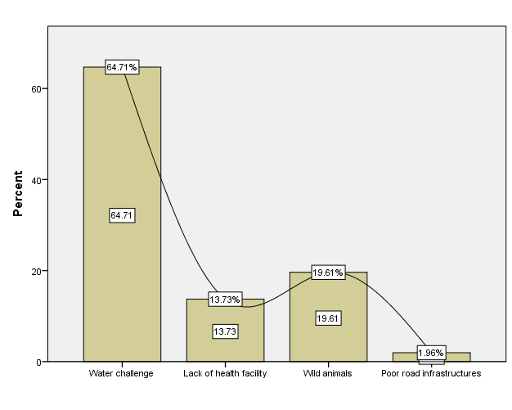
Source: Field data 2020
The situation of hygiene and sanitation in Mabilioni village was not in good condition because of water challenge and community’s behaviors. Water contamination which fueled by people’s behaviors for example takes bathe and washes clothes at the source, bodies of dead animals at the source etc. Nevertheless some people lack toilets therefore use farms, bushes and those who were close to the river use bushes near to the river. In the village some people use galleys as toilets, so if it rain all contamination get into the source which makes water to be unsafe if drink without treatment. Washing hands and cleaning toilets affected by shortage of water and this put people into more risk of outbreak. The same risk face students in primary and secondary school. Though 30 percent of the respondents got training on hygiene and sanitation, but its application seemed questionable to the majority of the community members.
Due to poor hygiene and sanitation the village diseases like diarrhea, typhoid, and other water borne diseases are very common in the village as table No.36 and figure No.48 illustrates.
Table 36: Water borne diseases
Water borne diseases |  | Frequency | Percent | Cumulative Percent
 | Diarrhea | 13 | 25.5 | 25.5
 | Cholera | 3 | 5.9 | 31.4
 | Stomach pain | 29 | 56.9 | 88.2
 | Typhoid | 2 | 3.9 | 92.2
 | Amoeba | 4 | 7.8 | 100.0
 | Total | 51 | 100.0
Source: Field data 2020
Figure 59: Mabilioni water borne diseases
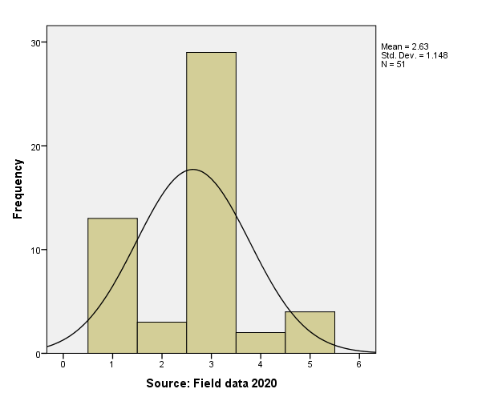
People had to work more than 10 km to find health services. Though health officers talk to patients regularly on the cause of the disease and its mitigation measures, but Mabilioni residents didn’t care about that. The reasons behind observed as prolonged behaviors of not treating drinking water for an assumption that if water get stored for a period of time is safe to drink. Furthermore lack of toilets to some households and using bushes as toilet alternative, accelerated outbreaks in the village.
    - Opportunities available for improving water supply, hygiene and sanitation
The finding revealed some opportunities available in the village which might be useful in improving water supply system. The river Pangani observed as sustainable water source opportunity. The river is permanent flown throughout the year. It used for domestic and agriculture purposes through water is contaminated. If the village water to improve water supply system, this will be the only water source to use. However people who are willing to take part into the project by contribution are another opportunity in this village. Available resources like sand and stones are opportunities in improving water services. The construction resources available will minimize project costs especially on transportation.

Efforts, Strategies and Plans of improving Water Supply, Hygiene and Sanitation.
Water project need financial resources which was beyond village government to cover. Nevertheless leaders seek supports from Non-Government Organization and other development partners without success. On hygiene and sanitation leaders in collaboration with health officers provided education on how to keep environment clean, ways to prevent outbreaks, simple technology of washing facility. Also by-laws enforcement was among efforts taken by leaders to ensure issues of hygiene and sanitation settled. Those without toilets faced penalty of tsh. 50, 000 and banned washing clothes at the source. Agriculture activities near to the water source also banned any activities should consider 60 meters from the water source. For pregnant women were given mosquitos net to prevent from malaria.

Focus Group Discussion
People explained water challenge as the major problem in the village. Other problems listed as lack of health facility, poor road infrastructures, wild animal’s crocs, and hippopotamus. During the discussion it was explained that people had to fetch water from the river which located about 4 km from the village. “Though we don’t pay for water, but it’s really challenge to walk on foot long distance with bucket on head daily,” said by one participant. They said accessing water from the river is very risk especially during night hours due to hippopotamus. The animal killed 4 peoples in the village who went to the river during night hours. However it was experienced hippopotamus in the village in night. The village experienced waterborne diseases like diarrhea and cholera as the result of consuming contaminated water from the river without treatment.
Lack of health facility in the village explained as the major cause of outbreak spreading as people get treatment late. The dispensary located in near ward Hedaru located about 7 km from the village.

Gaps, Weakness and Strength identified
There was gap in hygiene and sanitation knowledge provision to the community which speed up poor sanitation behaviors. By-laws enforcement on hygiene issues also identified as gap. Some people lack toilets and don’t have any efforts of having toilet because of leaders reluctant on by-law enforcement. Supportive policy and guidelines was among strength identified.

Project’s Sustainability
Project sustainability in this village will depend on the following factors;
- Community involvement. The community should be involved from project identification, preparation, implementation and evaluation. The people must contribute to the project costs to create sense of ownership
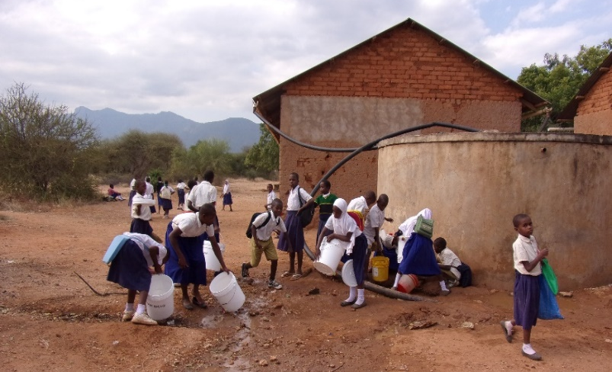
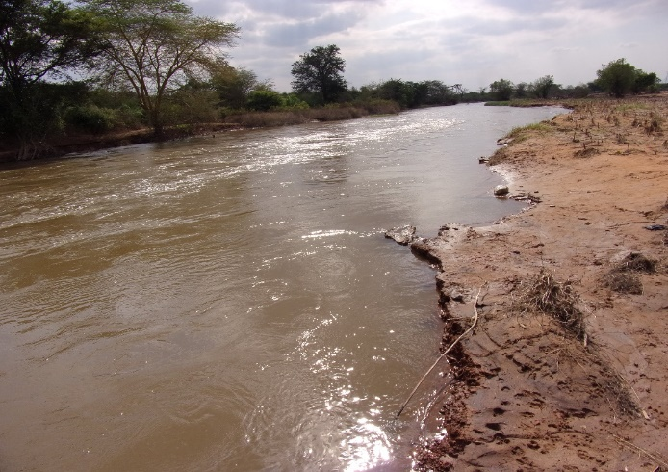
- Committed water committee. The village should establish water committee which must be well trained on water management and operation. The committee should be responsible on collecting money from the project and conduct regular maintenance of water infrastructures. However the committee should be monitored for the purpose of controlling poor performance and fund disbursement.
Figure 60: Water Source at Mabilioni Figure 61: Mabilion Primary School Water Point

8.0. Selection of priority villages in the district
The seven villages investigated were selected jointly by the manager for rural water supply and sanitation Authority Engineer Alphonce Mlay and the Rotarians–they were apparently those with high need, with no projects in process, and which are not yet supported by any other funder or NGO. All of the villages presented to us are suffering significant to severe water scarcity, although not all villages are in the same position. It was recommended that Rotarians and the Same District Engineer select villages based on several factors: strong community leadership, water need, community willingness to be involved in all stages of project development and implementation, the status of the community’s existing water and sanitation committees or other sanitation-based organization, the social cohesiveness of the community, and the willingness of the community members to do much of the work themselves to assure these becomes the community’s projects and system to own, maintain and keep sustained. The RC Same and Ruwasa discussed and provided the priority list. We recommend that the priority in allocating resources be the distant rural villages. Depending on the cooperating NGO, project manager, community development person, and design choices, we recommend that three villages and or more than three, be selected for the first TRF global grant application as the idea of scale up model which guarantee completion of multiple projects at once. Based on the experience execution of huge global grants by Rotary club of same and ETI, these projects are manageable and can be completed in a reasonable time.
For the next round of villages the next global grants can be applied for using similar or improved methods. If achievable, consider overlapping the project development and funding: as implementation for the first project is started, the next project’s funding and planning commences; and as implementation is enfolding up the next global grants application are submitted, with the confidence that the prior methods and timeline were successful improved. Villages and Priority Sequence. The Rotary Club of Same and the manager for the rural water supply and sanitation Authority agree, and this assessment team supports, working on the following villages in the priority order shown in the table below. The reasons are partially illustrated in the table below, but also reference can be made to the sections with gaps and general findings and recommendations at each village investigated.

8.1. Table of priority villages determined by rural water supply and sanitation authority and Rotary club of Same
Village and Ward | Present Springs  & Boreholes | New Sources | Distribution System improvements | Reasons
- Mabilioni village | Pangani River  Water holes available | Pangani River& Underground water | Borehole and or pumping surface water from Pangani River, filtration and treatment  Solar power, wind mill is currently potent. Electricity is available  , electricity | The Pangani river is only the main available water source in the village. Four (4) people are reported to killed by hippos during water collection from the River
- Emuguri village | No any spring water source  Two wells are available powered by solar and fuel generator | Underground water is the only available source in the village | Improvement of the available well, Purchase of new or rehabilitation of the fuel generator to operate the second well. Installation of filtration and water treatment systems | The village has two well but only one is operating effectively powered by solar. Due to cattle population is inadequate
- Marwa village | Pangani River  Water holes available  Ground surface water available  Rain harvest water | Pangani River & Underground water  Rain water harvest water | Borehole and or pumping surface water from Pangani River, filtration and treatment  Solar power, wind mill is currently potent. Electricity is available  , electricity | They are only available water sources
- Menumu Village | The local springs are available above the village. No borehole available | The Kiririgwi water source is suggested that can serve the three villages of Vudee, Menamu and Bangalala | Need for improvement of the local available water piping and proposed construction of an improved water source in the village | The village lack any improved water system. Population obtain water from the surface spring water which is not safe and clean
- Vudee Village | The local springs are available above the village. No borehole available | The Kiririgwi water source is suggested that can serve the three villages of Vudee, Menamu and Bangalala | Need for improvement of the local available water piping and proposed construction of an improved water source, piping, filtration and treatment in the village | The village lacks any improved water system. Population obtain water from the surface spring water which is completely unsafe and un clean for human uses
- Bangalala village | The local springs are available above the village. No borehole available | The Kiririgwi water source is suggested that can serve the three villages of Vudee, Menamu and Bangalala  The current water source may also be improved with an adequate storage tank and filtration | Improve the current water source, replacement of the main pipe from source to the storage tank which was reduced from 3” to 1.5”  The water is share with animals and irrigation | The population is very big with a couple of social institutions including school, churches and health facility
- Kwizu Village | The local springs are available above the village. No borehole available | The Nzoroko water source is suggested that can serve the village of Kwizu and neighbors | Need for improvement of the local available water piping and proposed construction of an improved water source and piping in the village | The village lacks any improved water system. Population obtain water from the surface spring water which is not clean and safe

General comments from the above table
It is fact that the situation the situation is worse at the villages of Mabilioni, Emuguri and Marwa. Although reports from Marwa village and the District commissioner’s office informed that, Marwa village is already surveyed several times on water situation by the local organization called KiHO which is partnering with the staff and students from the Ohio State University in USA who implemented the survey during their internship to conduct and initial health assessment in the village. The goal of the assessment was to provide baseline data on health indicators prior to the arrival of clean, safe and accessible in the village, and so that it could be compared with data collected after water is introduced.
Likewise, based on the villages located on the highland which are Vudee, Menamu and the nearby Bangalala village which is located at a bit lower plain land, the Kiririgwi water source is significant to serve those multiple villages of as the source is located at higher elevation of all the three villages and is highly productive. Information from the village officer (VEO) during interview is that the survey for Kiririgwi water source is already conducted by several partners including technicians from Rural and urban water supply and sanitation authority (RUWASA) and the layout is available at the village office and the designated authority.
- Success/Achievement
Out of six villages in plan, seven villages out of six in the original plan were visited and data collection was successfully done. The pretesting village was very successful and a potential lesson to determine effective assessment. Knowledge and experience, the team has gained potential experience in the use of mWater surveyor tool since deployment of the questionnaires and during assessment. The community assessment, the Global Grant’s Community Assessment Results forms were effectively filled at all social institutions in the villages. With limited resources, the team was able to do beyond the original plan.

Conclusion
The team found a very high scarcity of water in all villages visited. This results in diarrhea and water borne diseases, skin rushes, many hours every day for women and girls to find and haul water, a loss of income from growing crops, raising animals and milk production, villagers being forced to move from their homes for pastures and increased domestic disputes. Despite two rainy seasons in the locality there is little rainwater harvesting only a few wealthy homes and public buildings and what exists is of poor quality. There is some open elimination, especially while livestock keepers traveling on foot or while herding animals, but most homes have simple pit latrines with no pit covers. Some toilets have concrete slabs, but some are simply holes in the ground. Most toilets are in very primitive forms with mud floors supported by wooden logs. Most of buildings in the villages are constructed of sticks and mud, which does not weather well especially in cold and hot seasons. The Rotary Club of Same and ETI the cooperating partner are working closely with the manager for the rural water supply and sanitation authority (Ruwasa) to improve the situation, but they need assistance and international partner support to enable households to improve their situations.

Prepare by

Giliard E. Mkumbwa
Assessment team leader

