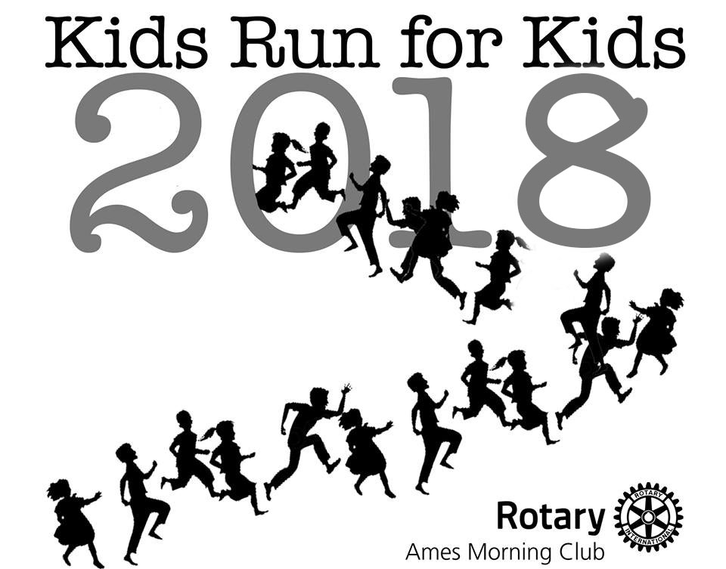
Send entry form and signed waiver to:
Ames Morning Rotary
PO Box 2432
Ames, IA 50010

Check payable to:
Rotary Club of Ames Foundation
(Note: This is a 501(c)(3) organization)
(Put Kids Run for Kids or KRK on memo line)

Registration

PLEASE PRINT IN CAPITAL LETTERS

Child Participant (age 12 or under on April 28, 2018)

Name:____________________ ____________________________ Age on April 28, 2018:______
(First) (Last—for filing)
Email:______________________________________ Phone: _____________________ Zip Code: __________
Emergency Phone: _______________________

Circle distance to run: 1K / 2K / 3K / 4K Circle T-shirt Youth Size: Y-XS Y-S Y-M Y-L
Child entry fee before April 12, 2018: $20.00 _______

Child entry fee on or after April 12, 2018: $25.00 _______
(T-Shirt Not guaranteed if received on or after April 12, 2018)

Runner Waiver
(MUST BE SIGNED)
In consideration of your accepting this entry to participate in “Kids Run for Kids,” I, the below signed, intending to be legally bound, for myself, my heirs, my executors and administrators, waive and release any and all rights and claims for damages I may have against this event, and sponsors and their representatives, successors, and assigns, for any and all injuries suffered by me in said event. I attest that I will participate in this event as a run, that I am physically fit and sufficiently trained for the completion of this event. Furthermore, I hereby grant full permission to use my name and likeness, as well as any photographs and any record of this event in which I may appear for any legitimate purpose, including advertising and promotion.

_____________________________________________________ ___________________________________
Signature (parent or guardian) Date

