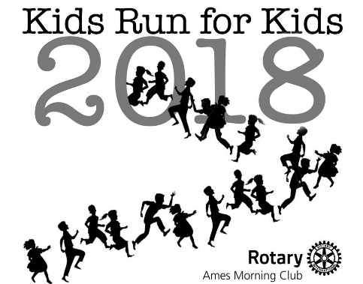 | FAMILY Registration (Maximum of 5 Runners)  Child is age 12 or under on 4/28/18; Adult is age 13 or over on 4/28/18  Registration fee is $50.00 before 4/12/18;  $60.00 on or after 4/12/18  Registration must be received before 4/12/18 to guarantee a T-shirt  Make check payable: Rotary Club of Ames Foundation;  put KRK on memo line  Mail to: Ames AM Rotary, P.O. Box 2432, Ames, IA 50010

Last Name: ________________________________ (used for filing) PLEASE PRINT IN CAPITAL LETTERS

E-Mail: ________________________________ Phone: ________________________ Zip Code: __________

Emergency Phone: ____________________________
Child 1: _________________ _____________________ Age: _____ 1K 2K 3K 4K Shirt Size: Y-XS Y-S Y-M Y-L
(First) (Last) (on 4/28/18) (circle distance and shirt size)
Child 2: _________________ _____________________ Age: _____ 1K 2K 3K 4K Shirt Size: Y-XS Y-S Y-M Y-L
(First) (Last) (on 4/28/18) (circle distance and shirt size)
Child 3: _________________ _____________________ Age: _____ 1K 2K 3K 4K Shirt Size: Y-XS Y-S Y-M Y-L
(First) (Last) (on 4/28/18) (circle distance and shirt size)
Child 4: _________________ _____________________ Age: _____ 1K 2K 3K 4K Shirt Size: Y-XS Y-S Y-M Y-L
(First) (Last} (on 4/28/18) (circle distance and shirt size)

Adult 1: _________________ _____________________ 1K 2K 3K 4K Shirt Size: A-S A-M A-L A-XL A-XXL
(First) (Last) (circle distance and shirt size)
Adult 2: _________________ _____________________ 1K 2K 3K 4K Shirt Size: A-S A-M A-L A-XL A-XXL
(First) (Last) (circle distance and shirt size)
Adult 3: _________________ _____________________ 1K 2K 3K 4K Shirt Size: A-S A-M A-L A-XL A-XXL
(First) (Last) (circle distance and shirt size)
Runner Waiver (MUST BE SIGNED) Date: __________________
In consideration of your accepting this entry to participate in “Kids Run for Kids,” I, the below signed, intending to be legally bound, for myself, my heirs, my executors and administrators, waive and release any and all rights and claims for damages I may have against this event, and sponsors and their representatives, successors, and assigns, for any and all injuries suffered by me in said event. I attest that I will participate in this event as a run, that I am physically fit and sufficiently trained for the completion of this event. Furthermore, I hereby grant full permission to use my name and likeness, as well as any photographs and any record of this event in which I may appear for any legitimate purpose, including advertising and promotion.

____________________________________
Signature (parent/guardian) for Children
____________________________________
Signature Adult 2

____________________________________
Signature Adult 1
____________________________________
Signature Adult 3

