Polio Eradication Update
For The Week Ending 6/17/23
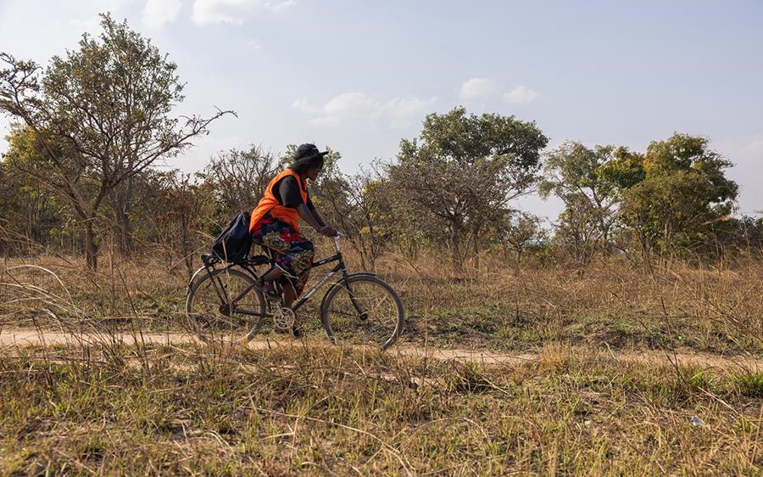
Rotary’s World-wide 2022-23 Rotary Year Polio Fundraising Goal Is
$150 Million – Including the Gates Foundation $2 to $1 Match

Rotary’s Goal is Global Polio Eradication!
A Win Against Polio is a Win For Global Health!
Advocate, Donate & Educate to END POLIO NOW & FOREVER!
20,000,000 Children Saved from the Paralysis of Polio Since 1988
Wild Polio cases reported in the past week:
Pakistan 0, Afghanistan 0

Total paralysis cases | Year-to-date 2023 | Total  2022 | Total  2021 | Total  2020 | Total  2019
Globally | 5 | 30 | 6 | 140 | 176
- in endemic countries: | 5 | 22 | 5 | 140 | 176
- in post-endemic countries: | 0 | 8 | 1 | 0 | 0

2023 Wild Polio Cases Afghanistan - 4, Pakistan - 1
2023 Vaccine Derived Polio Cases – 114 in 12 Countries
2022 Wild Polio Cases - Pakistan 20, Afghanistan 2, Mozambique 8
2022 Vaccine Derived Polio Cases – 909 in 25 Countries

Terry Ziegler, bigzlumber@aol.com

