Adding a Speaker to Club Runner
In adding Speaker information, try to add a bit about the speaker, their topic, and/or their organization. As our members gets used to seeing this additional information, it can influence whether they attend a meeting and whether they invite potential new members to hear the programs. Good programs typically drive club meeting attendance so let’s give them a lot to consider. 😊

- Login to Club Runner
Select “Member Area”
*************************************************************************
- Scroll down to Website Manager
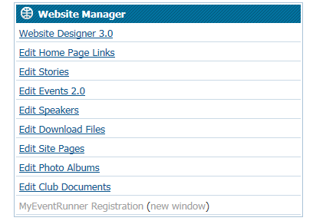
Select “Edit Speakers”
*********************************************************************

- Select “Add New Speaker”
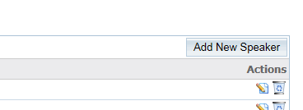

- Enter Speaker data and Save
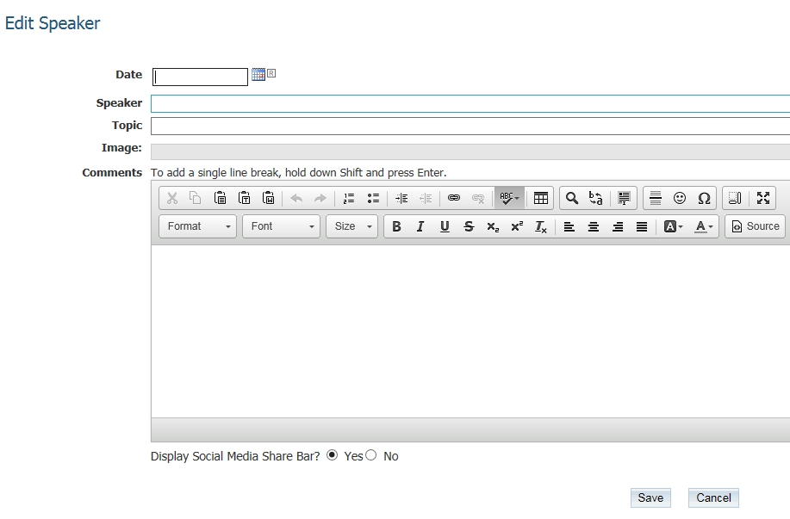

You can take a screen shot of the speaker, or an image of a picture that depicts their topic or organization and add it to “Image”.

Sometimes the speaker or the speaker solicitor will send bio or background information, website address. This can be added in “Comments”.

COMPLETED EXAMPLE
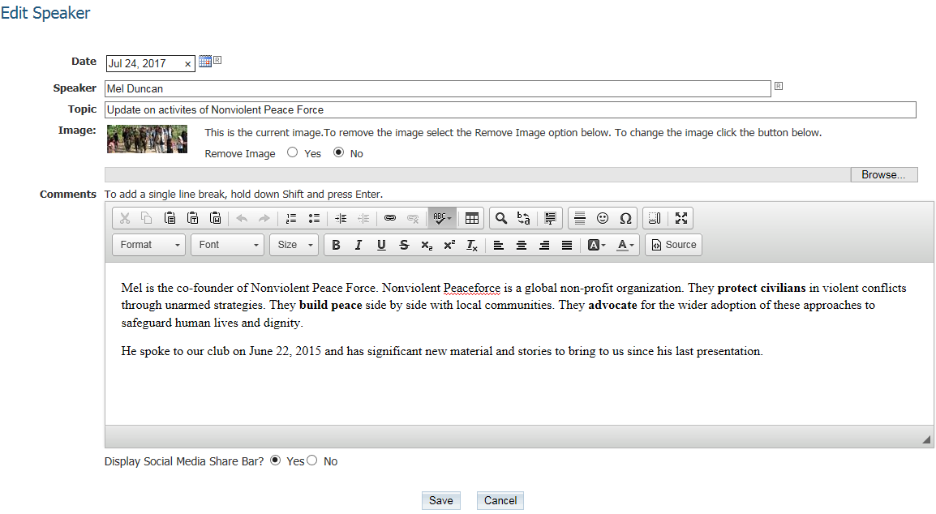

How it will appear from the website.

