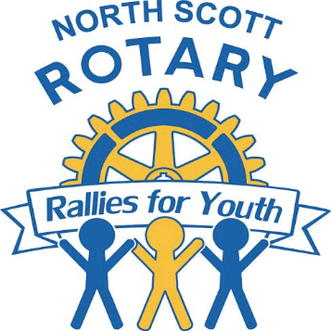
North Scott Rotary Rallies for Youth
Annual Dinner and Auction
Friday, November 16, 2018
The Rogalski Center, St. Ambrose University
518 W. Locust Street, Davenport, IA 52803

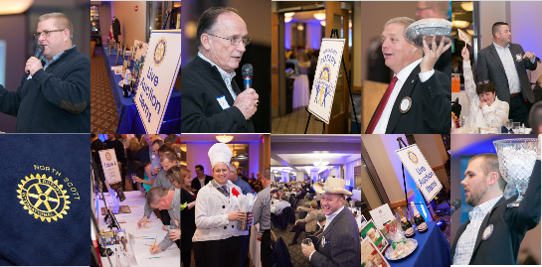
Last year our North Scott Rotary Rallies for Youth campaign was the largest in club history, and raised over $82,000 net to be used in funding over 20 Quad City grant recipients and local scholarships. Another milestone was our record breaking attendance of 400 people! The 2018 Annual Dinner and Auction will be held at the Rogalski Center, on the Campus of St. Ambrose University on November 16, 2018.
The evening will consist of:
- Social hour/cocktail hour
- Dinner
- Hosted Beer, Wine and Soft Drinks
- Live and Silent Auction
- FUN!

We are offering your organization opportunities to be promoted at our North Scott Rotary Rallies for Youth event. Our event consists of a live and silent auction. All donated items are mentioned in the program and are visible to all guests during the event. Some of the items that have been big hits over the last few years are; gift baskets, services, experiences not available in a store, and many others. We welcome any item or donation to this event.

Your donation and/or sponsorship to the North Scott Rotary Rallies for Youth event would be greatly appreciated and will help us continue to support local organizations that apply for our bi-annual Community Needs Grants.

I would be happy to pick up your donation and answer any questions you may have. You can contact me at 563-282-2533. To learn more about our North Scott Rotary Club, please visit our website at www.northscottrotary.org.

Thank you for supporting North Scott Rotary Rallies for Youth!

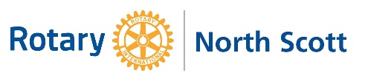
Sincerely,

Pat Olsen

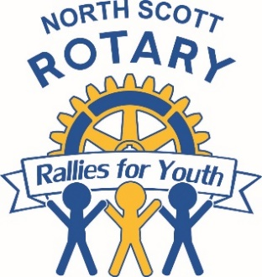
Item Donation Form

Auction Item (how would you like it listed in the program)

___________________________________________________________________________________________

_________________________________________________________________________________________________________________________________________________

Item Description (Please be specific, contents or details that will be helpful to know)

___________________________________________________________________________________________

___________________________________________________________________________________________

___________________________________________________________________________________________

___________________________________________________________________________________________

Donated By: __________________________________________________________________________

Procured By: ________________________________________________________________________

Item Value: _________________________________________

Are there any other items that go with this item? YES NO

If yes, what other item(s):______________________________________________________________

SPONSORSHIP ORDER FORM

