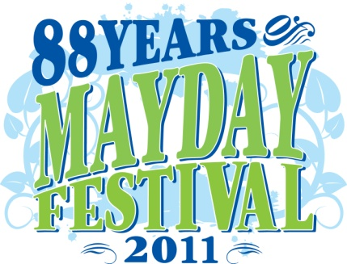2 2011 Port Coquitlam
Ro Rotary May Day Parade
“Celebrate Our Community”
Parade Entry Closing Date: | Tuesday April 12th, 2011
Parade Date: | Saturday May 7th, 2011

Name of Company or Group: _______________________________________________________________
Name of Contact Person: _______________________________________________________________
Address: ________________________________________________________________________________
Number Street City Postal Code
Contact info: (e-mail)___________________________________ (phone)________________ (alt phone)___________________
Your entry is considered to be ...
COMMERCIAL - $50 ASSOCIATION -N/C MUNICIPAL-N/C

Note: Commercial Applications require a $50 registration fee.
Cheques should be made payable to The Rotary Club of Port Coquitlam Centennial, 1283 Steeple Drive, Coquitlam, B.C. V3E 1K4.
Please select one of the following categories:
FLOAT (If you would like to be judged, complete the Judging Application Form at www.rotarymayday.ca.
Float Dimensions: (length) (width) (height)
Description: _________________________________________________________________________________
Total Length of the entry including vehicles and persons walking: ______________________________________
Number of Adults: _______ Number of Children: _______ Does your entry have music? Yes _____ No ______
Do you have a vehicle (limit of two) accompanying the float? Yes ___ No ___
Please Describe the vehicle(s) below:

Note: Evidence of vehicle insurance must be available for inspection on the day of Parade.
ANTIQUE VEHICLE (This category is not judged.)
Year _________ Model ________________________________________ Number of Vehicles _______________
Do you wish to carry a VIP in the Parade? Yes ____ No ___
Note: Evidence of vehicle insurance must be available for inspection on the day of Parade.

WALKING GROUP (If you would like to be judged, complete the Judging Application Form at www.rotarymayday.ca.
Number of Adults: ______ Number of Children: ______ Does your entry have music? Yes __ No __
Do you have a vehicle (limit of two) accompanying you? Yes ____ No _____
Please Describe the Vehicle(s) Below:

Note: Evidence of vehicle insurance must be available for inspection on day of Parade. 50% of the vehicle’s surface must be decorated.
BAND (If you would like to be judged, complete the Judging Application Format at www.rotarymayday.ca.
Type of Band: ______________________________________________________________________
(pipe, marching or novelty, etc)
# of Adults: ____ # of Children: ____ Is a Color Party accompanying your band? Yes ____No ____
If so, please describe them below:

MARCHING UNIT (If you would like to be judged, complete the Judging Application Form at www.rotarymayday.ca.
Type of Entry: Drill Team __ Color Party ___ Number of Adults: ____ Number of Children: ____
Does your entry have music? Yes ___ No ___
Do you wish to accompany a band? Yes ___ No ___ If so, what band: __________________________
EQUESTRIAN Total Number of Horses: _____ Total Number of Riders: _____
DECORATED VEHICLE (If you would like to be judged, complete the Judging Application Form at www.rotarymayday.ca.
Type of vehicle: __________________________ Does your entry have music? Yes ___ No ___
If you wish to enter more than two vehicles, there is a $75 charge for each additional vehicle.
Please Describe Additional Vehicle(s):
Note: Evidence of vehicle insurance must be available for inspection on day of Parade.
50% of the vehicle’s surface must be decorated.
Please sign - Indemnity Agreement
The undersigned agrees to indemnify, hold harmless and defend any action against the May Day Task Force, the Rotary Club of Port of Coquitlam Centennial including its members, and the Corporation of the City of Port Coquitlam from and against all liabilities whatsoever arising out of its participation in the Rotary May Day Parade.
Signature: ______________________________ Date: ___________________________________
Parade line up number and assembly information will be e-mailed to all applicants.

Your application form may be completed and submitted online, or emailed to register@rotarymayday.ca
or delivered prior to the deadline, to The Rotary Club of Port Coquitlam Centennial, 1283 Steeple Drive, Coquitlam BC, V3E 1K4. Or you can fax it to 604-941-5429.For questions regarding the Rotary May Day Parade please visit www.rotarymayday.ca, or e-mail Barrie Seaton at barrie@barrieseaton.com or call 604-945-6627


