Deer Park Rotary
Wave Petunia Basket Sale $25!
Saturday May 8th
10 am to 2 pm @ Double Eagle Pawn Parking Lot
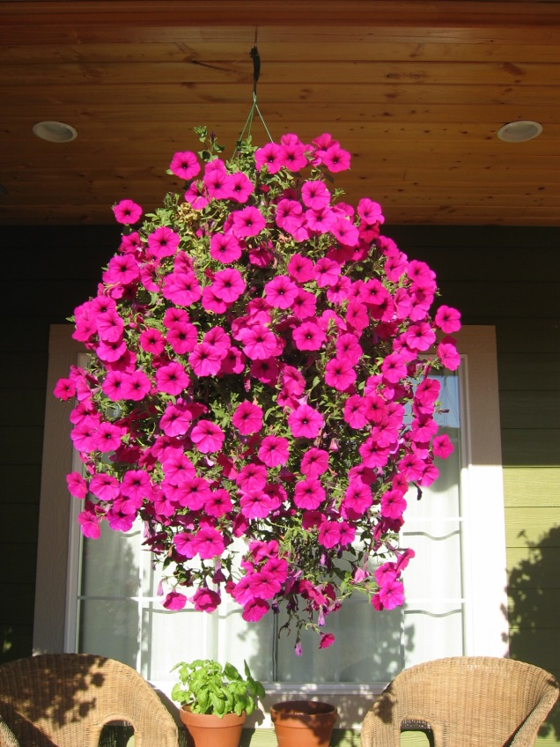

Deer Park Rotary sells Wave Petunia Hanging Baskets as an annual fundraiser to support the club's many youth projects. The plants are grown locally. All are in 12-inch plastic hanging pots. Wave petunias are known for their easy care, season long bloom and vibrant colors. We have many colors to choose from!

