Deer Park Rotary
Annual Flower Sale
Deer Park Rotary sells Wave Petunias as an annual fundraiser to support the club's many youth projects. The plants are grown locally. Plants are usually ready in mid-May depending on weather. All are in 12-inch plastic hanging pots.
Wave petunias are known for their easy care, season long bloom and vibrant colors.
Variety # of Baskets Variety # of Baskets
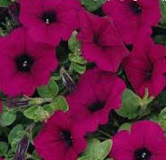
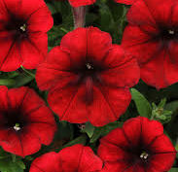
++ Red Velour Purple
____ as 1st Choice ____ as 1st Choice

____ as 2nd Choice ____ as 2ndChoice
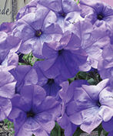
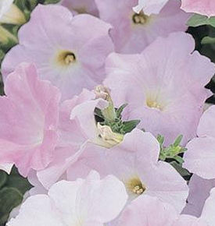
Lilac Evening Scentsation
____ as 1st Choice ____ as 1st Choice

____ as 2nd Choice ____ as 2ndChoice
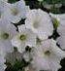
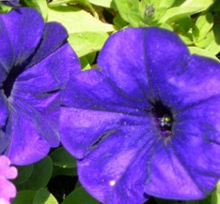
Blue White
____ as 1st Choice ____ as 1st Choice

____ as 2nd Choice ____ as 2ndChoice
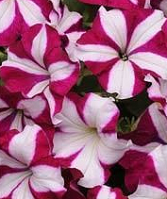
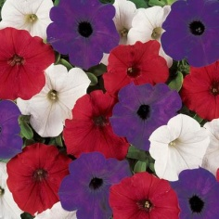
Red White & Blue Burgundy Star
____ as 1st Choice ____ as 1st Choice

____ as 2nd Choice ____ as 2ndChoice
*Limited quantity of Yellow petunias available on request and while they last* _____________________________________________________________________
TOTAL # OF BASKETS: ______ @ $25.00 = $__________ Cash___ Check____
Please make checks payable to Deer Park Rotary; PO Box 1234; Deer Park, WA 99006
Name: ________________________________________ Phone:_________________
Address: ______________________________City:________________ Zip:________
Member of Rotary Club of: ____________________________________ (if applicable)
Email:__________________________ Pick Up Date: May 8, 2021; from 10am-2pm
Sold by: _______________________ Pick-up Location: 811 S. Main Street, Deer Park

