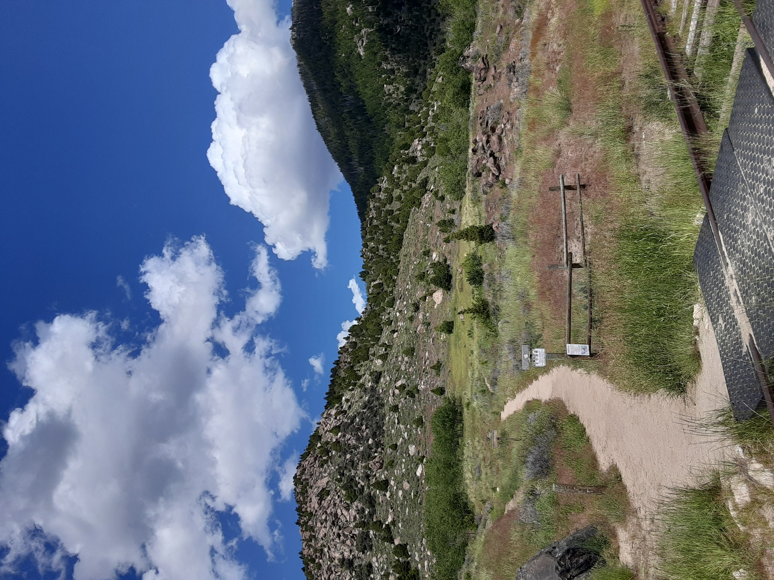  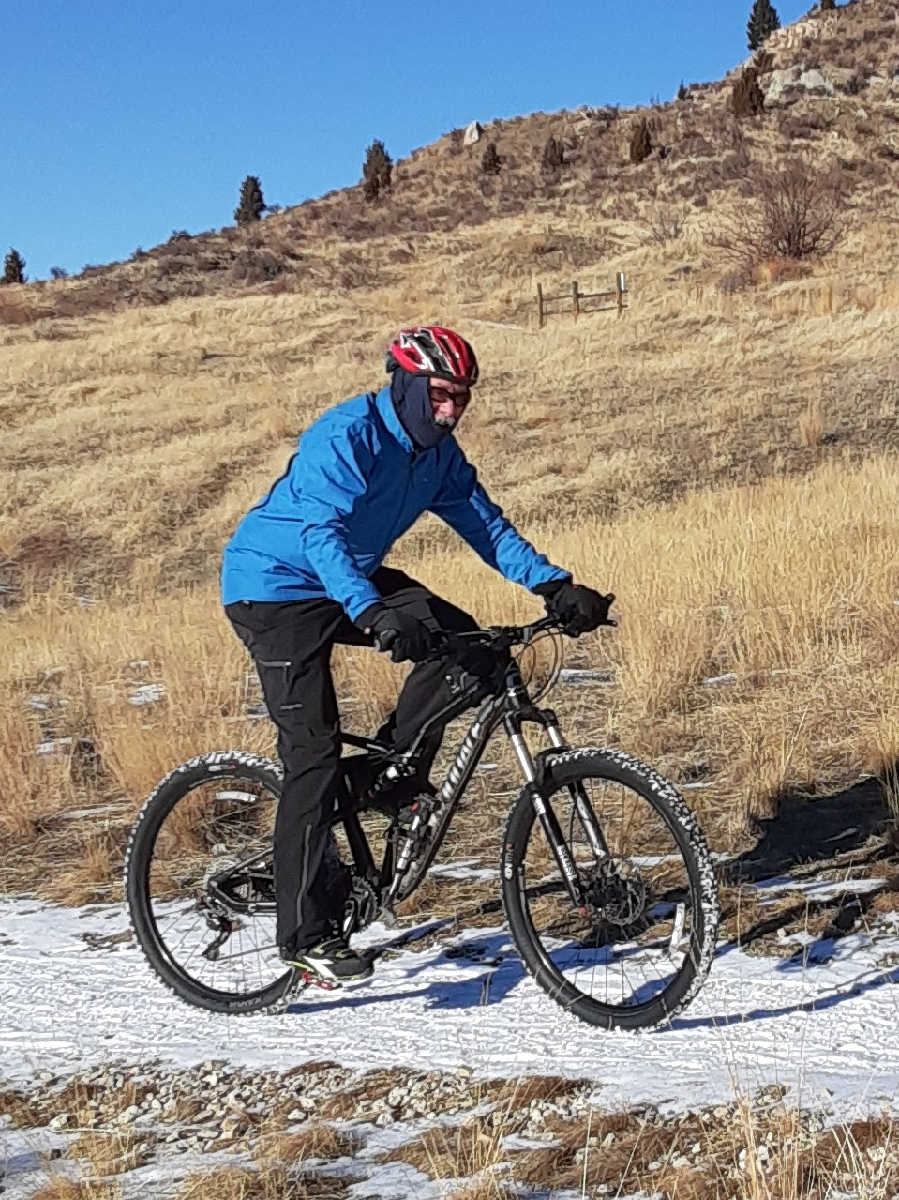  - June 25, 2022  PACE RACE TRAIL CHALLENGE  Personal Challenge Race  Divisions for mountain bikers, trail runners, and hikers. Participants will submit an estimate of time to complete the course, follow the Maud S loop trail (+/-4 miles, 1000 ft elev) to the finish, and winners will be determined by closeness to their initial time estimate. The closest top three times in all three divisions will win gift card prizes. Proceeds from the race will go to the Action Inc. Homeless Youth programs in Butte, and to maintenance of the Maud S trails.  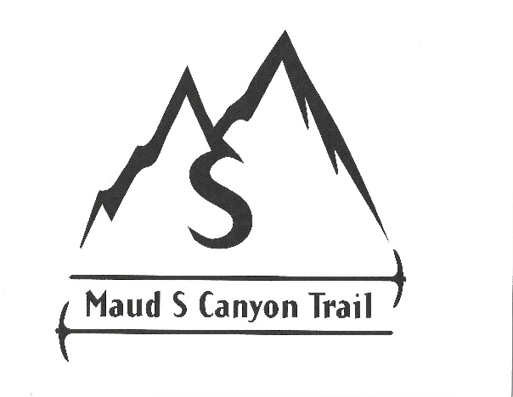  Race will start and end at the trailhead parking lot, just off Saddle Rock Road near the Continental Drive I-90 entrance. Mountain bikers will start first at individual lagged times, followed by trail runners, and lastly by hikers. Participant parking will be available at Continental Drive parking lots, with shuttle service provided to the trailhead. All participants will receive race shirts and number bibs. Registration fee is $35 per person. Further details will be provided to the participants after their online registration prior to June 16, 2022. | Maud S Canyon Trails  ____  Test your time estimate against the challenge of the Maud S trails.  ____  Separate individual starts for bikers, runners, and hikers.  ____  Proceeds go to help Homeless Youth programs in Butte.  ____  Register on-line before June 16th.  East Ridge Foundation  Rotary Club of Butte  Street Address  Butte, MT 59701  Telephone  Web Address  Register by 6/16/22

