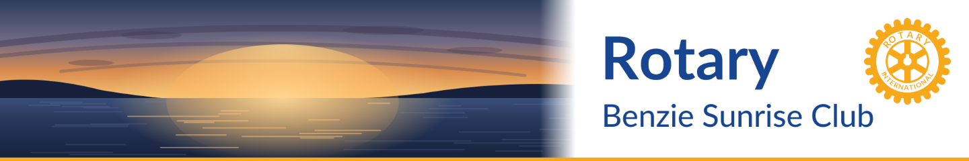

BENZIE SUNRISE ROTARY
Three Ways Your Giving Is Multiplied
Every dollar you give goes further through these powerful giving channels

1 | Benzie Sunrise Rotary Foundation  Local giving with lasting community impact
GRANTS FUND  ■ Quarterly grants to community nonprofits & Benzie  Central Schools  ■ Ideal for annual donations or memorial/tribute gifts  ■ Designate as one of your IRA Required Minimum  Distribution (RMD) recipients  ■ For IRA RMD donations, the EIN is 26-1470780 |  | ENDOWMENT  ■ Held by GTRCF — Club receives 4% annually  ■ Grows over time to increase future grant awards  ■ Ideal for estate gifts and larger donations  ■ For IRA RMD donations, the EIN is 38-3056434, designate  the BSR Endowment

2 | 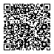  GTRCF Rotary Match  Double your personal charitable giving — up to $250
■ Donate to any regional nonprofit and receive an additional match up to $250 from the Rotary Charities Endowment Fund
at GTRCF
■ The Benzie Sunrise Rotary Foundation qualifies as a match recipient
■ The $250 match may be split across more than one regional nonprofit
■ Limit: one $250 match per member per year
► Deadline: Return the GTRCF Match Form to John Ester by May 15 and/or November 15.

3 | Rotary International Foundation (TRF)  Fund local and global projects through District Match Grants
HOW IT WORKS  ■ Donations must be received by June 30  ■ Club giving to TRF Annual Fund must average  $100/member to qualify for a District Match Grant  ■ District Match Grant unlocks both local and  international grant opportunities  ■ For IRA RMD donations, the EIN is 36-3245072, find  your Rotary ID from the member area of club website |  | PAST GRANT PROJECTS  ■ Back the Track $20,000  ■ Imagination Library $5,460  ■ Northwest Food Coalition $7,000  ■ Benzie Food Partners $5,000  ■ Frankfort Garden Theater $7,500  ■ BACN Capital Campaign $7,500  ■ Wheels of Hope, Nigeria $1,000+/yr  ■ Malawi Bicycle Project $1,000

Questions? Contact your club president, treasurer or foundation president.
Together, we make a difference — locally and globally.

