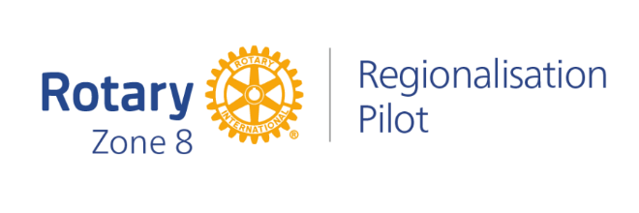

September update notes key points:

1. **Clubs and members are at the core of the new model.** As club members you will still decide when, where and how you meet and the best way of running your club. You will still have the same leadership roles and run the projects and programmes you are passionate about.

What will change is the network of support around you.

1. **Regional Council Elections** – voting opens on Tuesday 117 October and closes on Tuesday 31 October. Votes are submitted by the Club President – [please ensure the President’s email address in the RI database (via ClubRunner) is correct.

If your president can vote in this time you need to email [zone8elections@rotary.org](mailto:zone8elections@rotary.org) to let them know which Club Officer will be voting.

Presidents and Secretaries received an email on 3 October with instructions re voting which are now also on the pilot website - [Regional Council candidates — Creating tomorrow | Rotary (creatingtomorrowrotary.org)](https://creatingtomorrowrotary.org/regional-council-candidates)

1. **Rotary Community Groups (RCG)** – a new way of grouping Rotary and Rotaract Clubs designed to encourage / foster great collaboration among clubs. RCGs will be based on what clubs have in common eg. Geographyu7, type of club or common feature.
2. **Rotary Community Groups** – Club Preferences Form – To be completed by 29 October 2023 this form is currently with clubs, this is a survey to say how you want to be grouped. Once all information is submitted the Regionalisation team and District Leaders (myself, DG Ian and DGN Christine) will use the information to determine the best groupings for clubs.
3. **Rotary Community Leaders (RCLs)** – Once RCGs are formed they will meet to discuss their vision, what leadership and support they need and how and when they will meet.

Each Rotary Community Group will elect their RCL from within members of their group of clubs. Only clubs within a sprcific RCGT wil vote to elect their own leader.

1. **Rotary Specialists** – will be selected to provide consultancy type support to clubs
2. **Membership update** – the Membership Regionalisation Team is already in place and providing support to establish new clubs and assist clubs to attract and retain members.
3. **Transformation of District Duties and Functions** – a key part of the pilot is to have the Regional Council provide governance and operational support at a zone wide level. As such, starting in 2024 some duties and functions currently done by Districts and District Leaders will gradually be transferred to the Regional Council the first being Membership and Public Image

For more information go to the Regionalisation Pilot website [Creating tomorrow | Rotary (creatingtomorrowrotary.org)](https://creatingtomorrowrotary.org/)