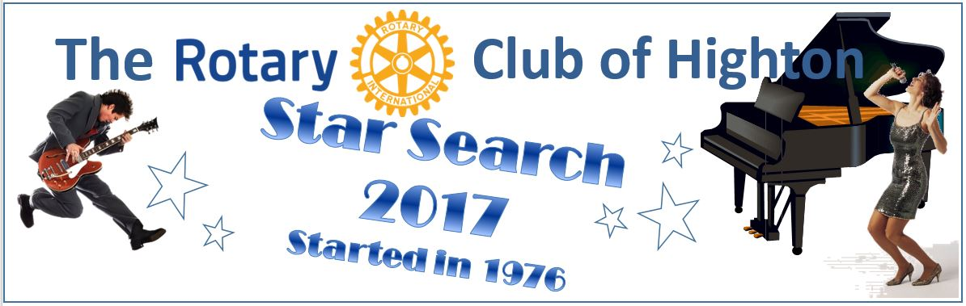
Highton Rotary has been hosting this event since 1976 and relies on the generous support of local businesses and organisations to provide financial and in kind prizes for our winners.
Highton Rotary Star Search is open to vocal or instrumental entries from Geelong and the surrounding Rotary District. Entries can be solo or group (up to 5 members) in either vocal or instrumental sections. Entrants perform for an audition, where finalists are chosen to play at a Final Performance in front of a large audience with professional judges, sound and lighting. All Finalists are awarded prizes with generous prize amounts for section winners.
Successful finalists will experience performing in a public setting with the chance of joining past winners including Missy Higgins, Amy Lehpamer and Caleb Vines.
PRIZES are made up of cash and in kind value.
Categories are – Vocal Solo and Vocal Group, Instrumental Solo and Group

- First in each category $1000
- Second in each category $500
- Third in each category $300
- All other Grand Final acts receive $100
- The overall winner will receive a total of $1300, made up of First Category $1000 plus the Overall Winner's Prize of $300
- Two Encouragement Awards - $250 (1. non-placed Vocalist and 2. non-placed Instrumental or Group)
Important Dates

Vocal Auditions – Wednesday 26th April at St Luke’s Church, Highton
Instrumental Auditions - Wednesday 3rd May at St Luke’s Church, Highton
There is a $5.00 fee per entry to cover costs, payable at the audition.
Finals Performance - Saturday 27th May at Sacred Heart McAuley Hall

