Tell us about You
First Name
Last Name
Address
Is this the same address as the nature strip ? Yes No
Phone |  |  | Alt Phone
Email
- How did you hear about this project (e.g. Rotary, friend etc.)

- Are you able to assist with the works on your strip? (if No please explain your circumstances)

- Are you the owner of the house? If no, you will need to speak with the owner, gain their permission and have them co-sign the Agreement.

Tell us a little about the Nature Strip
Size Length (cm) Width(cm) Not sure
A street tree on site? Yes /No Deciduous? Yes/ No/ Not sure
Soil type | Sandy Clay Loam Not sure
Current status Grass Gravel Concrete Other
Gradient | Level Gentle slope Steep Not sure
Is it a corner block? Yes No
If you are able, please do a simple drawing of your verge over the page.

Alternatively, either attach photo/s of your nature strip to your email or copy paste into this document.

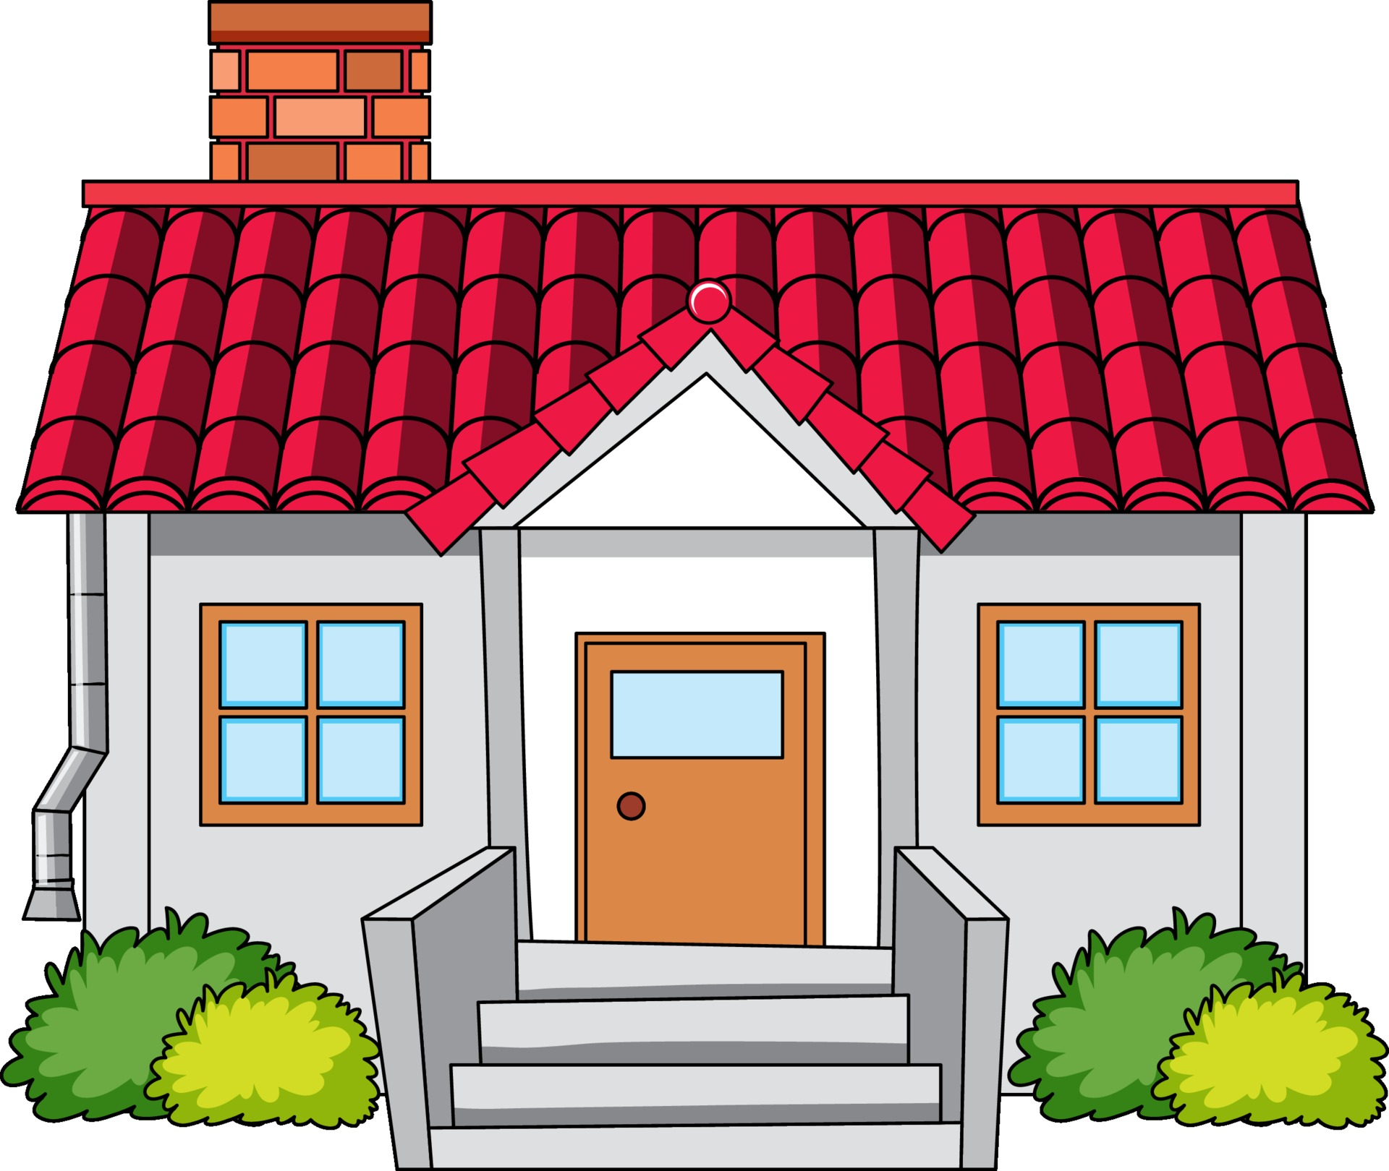

Please show the location of any of these features that are relevant to your nature strip.
- Where is north?
- Your driveway
- Location of street tree – estimate of height. If you know the species please write this.
- Fire hydrant
- Traffic lights
- Manhole/ footpath etc
PLEASE NOTE: CLOSING DATE FOR EOI SUBMISSION IS 16 MARCH 2026.
Please email to naturestrips26@gmail.com

Other Information?

