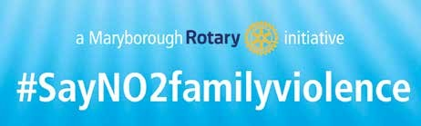

A program to raise awareness of the problems associated with Family violence in our community

24 Hour Help Lines:
1800RESPECT or 1800 737 732
MensLine Australia: 1300 789 978
In an emergency call: 000

Maryborough
Counselling & Support:
Maryborough District Community Services: 5461 0400
Maryborough Psychology & Health Clinic: 0417 441 700
Maryborough Police: 5460 3330

Rotarian Garry Higgins PHF PP Family Violence Coordinator
0418 473 669 pvb1@westnet.com.au

CONTENTS  ROTARY INTERNATIONAL |  | 2
THE ROTARY CLUB OF MARYBOROUGH VICTORIA |  | 2
MARYBOROUGH ROTARY #SayNO2familyviolence |  | 3
Maryborough Rotary’s Intervention |  | 4
Some of the initiatives |  | 5
 | Reflections on SAFE project | 7
 | Importance of community | 8
TESTIMONIALS | Victoria Police | 9
 | Maryborough Harness Racing Club | 10
 | Salvation Amy - Maryborough Corps | 11
 | Tru Foods | 12
 | The Maryborough District Advertiser | 13
 | National Bank Australia | 14
 | Maryborough & District Health Service | 15
 | Maryborough Education Centre | 16

ROTARY INTERNATIONAL is an international service organisation whose purpose is to bring together business and professional leaders to exchange ideas and information in order to provide humanitarian services, encourage high ethical standards in all vocations, and help build goodwill and peace in the world. It is a secular organisation with a network of approximately 34,000 clubs and over 1.2 million members worldwide.

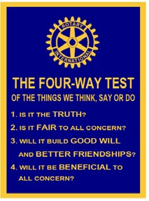

THE ROTARY CLUB OF MARYBOROUGH VICTORIA (Maryborough Rotary) was estab- lished in 1952 and is part of the International Rotary network. Service to the community is one of the core values of Rotary. Rotarians believe their diverse viewpoint and approach to challenges, gives them distinct advantages in obtaining credible and worthwhile results for the communities they serve. Their multidisciplinary perspective to problem solving provides the leadership and expertise to deal with social issues and effect outcomes for positive, sustainable change.
Maryborough Rotary is led by its President along with a nine person Executive. The club is supported by a membership of 48.
The organisation’s business plan has a number of flagship projects currently in train. These include: Aqua Box (water purification for disaster areas)
Lift program (leadership instruction for young leaders)
Project Uplift (a Pacific Nation resources project for the disadvantaged)
This program is an initiative of
Maryborough Rotary that commenced in 2014.
The aim of the program is to raise awareness of the problems associated with Family violence in our community.
#SayNO2familyviolence

There is a growing focus by Maryborough Rotary to contribute to the wellbeing and safety of
its community as reflected in their 2012-15 vision statement:

‘We would like to be a place where all citizens have community pride and positive self-image; where people are fully employed, there is no vandalism or teenage suicide and little crime; where people are better educated with more local students in the top 10 percent of the state; where gambling has decreased and people have better incomes; where there are no child protection issues or unwanted pregnancies, and where we are regarded as an innovative community, no longer at the bottom of the socio-economic scale.’

MARYBOROUGH is located in Victoria’s Central Goldfields district (estimated population
12,500). Its closest regional cities are Bendigo to the North East and Ballarat to the South East. The smaller communities of Bealiba, Carisbrook, Dunolly, Majorca, Talbot and Bowen- vale-Timor make up the outlying districts.
Maryborough is the main business centre. It is famous for its heritage architecture and takes pride in its sporting facilities, agricultural industries and a developing tourism sector. However, despite improving infrastructure and social improvements, it has one of the state’s highest unemployment rates of 11 percent which is around twice the state average of 6.7 per cent while the socio-economic indexes which look at disadvantage, economic resources, education and occupation, have consistently rated Maryborough among the lowest in the state.

FAMILY VIOLENCE WITHIN THE REGION data from Victoria Police Family Incident Reports (2013-14) indicates that the Central Goldfields district is among the state’s leading catchments for family violence offenses and is second highest for officially reported incidents.
Given there was sufficient anecdotal information from agencies dealing with family violence that these offenses may be significantly under reported, has presented an alarming window into the social degeneration occurring within the district.
MARYBOROUGH ROTARY’S INTERVENTION in 2013, was prompted by increasing reports of family violence in the region, Maryborough Rotary was moved into action, based on the premise that remedying the issue was the responsibility of everyone in the communi- ty who could help.
Among its first tasks was to link and consult with government and non-government agencies, to become informed about the issues and determine what Maryborough Rotary could do.
It found a significant barrier to successfully tackling family violence was reluctance, and
often fear within the community to openly discuss the issue.
The broad cross section of rationale for ‘silence’ as anecdotally collated included:
● Not wanting to make the situation worse.
● A ‘what happens in the family, stays in the family’ attitude.
● ‘It’s none of my business’ response.
● Concerns about stigmatising the town socially and economically.
● Despair in the system: ‘it will come to nothing, just more grief for me’.

There was sufficient information to indicate that for some people, talking about the issue was regarded as taboo. Others, although recognising that family violence was unacceptable and wanted it dealt with, nonetheless preferred the issue not to be overly exposed within their district.
These revelations provided a call to action by Maryborough Rotary. The organisation strongly believed that the lack of open conversation was a key causal factor for the problem remaining prevalent and largely untreated.
As Maryborough Rotary is an organisation which believes in leading by example, one of its first steps was to make a public statement in the form of a White Ribbon oath, pledging to take a stand against family violence and to become strong advocates for its eradication.
That experience seeded the motivation to put words into action.
We decided that the campaign needed to focus on safety and providing a safe environment. We developed what we have named the ‘SAFE model’. SAFE stands for:
Support (via information, education and delivery of specified projects);

Advice (provision of expert advice, especially regarding marketing communications);
Facilitation (bridging stakeholders and assisting comprehension of strategy and priorities);
Early intervention (encouraging a proactive, collaborative community-based response).

The SAFE project aims to prevent or reduce the prevalence of family violence by mitigating its consequences through a number of initiatives, aimed to increase understanding of family violence, promote non-violent relationships and encourage conversation about the issue.
Some of the initiatives
Vocational Scholarship awards:
Because of Maryborough’s geographical location, a lot of its middle and senior managers fly in and out, leaving only the locals on the weekend. We thought we would try and improve Maryborough’s social capital by providing vocational scholarships to some of the local people, to learn about best practice and successful strategies undertaken in overseas communities, with the view to these skills then feeding back into and enriching and resourc- ing the community. We created the Vocational Scholarship awards, which grant scholar- ships to people who work with and address family violence.
Our first scholarship was awarded to a young woman who is a physical education teacher. She did a course in San Diego on positive behaviour and language. It was about teach- ers modeling to students a positive way of communicating rather than a negative way of communicating. As one aspect of the severe disadvantage that is present in many areas of Maryborough, a lot of our local kids are from backgrounds where they only hear negative language. The impact at the local school was amazing; the children’s use of language has changed significantly and there has been healthier engagement by not only students but a more positive attitude among the teachers.
The second was awarded to the head of the local childcare centre head to study world’s best practice in ‘wraparound services’ in child care services at Pen Green in the United King- dom. Wraparound services provide intensive, individualized care management process for children with serious or complex needs. The wraparound plan typically includes formal ser- vices, together with community services and interpersonal support and assistance provided by friends and other people drawn from the family’s social networks
The third was awarded to a leading Senior Constable. He completed the Graduate Certifica- tion in Social Science (Male Family Violence) which looked at working with men involved in family violence and men’s behavioural change.
Wallet cards and posters
We created wallet cards, posters, bumper stickers, business placards to distribute around
Maryborough with messages and information about family violence.

Bystander intervention training:
We recently ran a bystander intervention training day. The program was facilitated by Loddon Mallee Women’s Health and was aimed at the major employers within the town. Over 30 CEOs, HR managers and key staff attended the day. The purpose of the program was to embed knowledge and responses to family violence in the workplace.
Local media:
We have engaged with the local press. The local newspaper, The Maryborough District Advertiser runs a banner along the bottom of the paper once a week in a double issue which says ‘Say No To Family Violence’ at the bottom of a page. They have also been supportive of running relevant articles.
Football and netball community:
We engage with the local football and netball club in several different ways, including an initiative where we devote one round of the local football season to the issue of family violence. On Sunday 17 August 2014, we held the ‘#sayno2familyviolence football round’. This involved the players wearing white armbands, educational information was distributed to players and supporters and a perpetual shield was presented by a female Rotarian to the winning team. This received extensive coverage within the local media.
It will now become an annual event as part of the football/netball league’s community round. We have also done a couple of talks about family violence, what it means and how prevalent it is, at the football netball club.
Elephant in the Room:
The Elephant in the Room is a colourful fibreglass elephant that was created by a group of women survivors of family violence. The aim of the Elephant in the Room, as the name suggests, is to encourage people to talk about the often hidden issue of family violence. One side of the elephant is black and white and the other side is colourful. The Elephant in the Room is hosted at various venues. Discussion is generated by the elephant, with both women and men, about their family violence experience.
Maryborough Harness Racing Club:
Maryborough has the most number of meetings outside of metropolitan Melbourne. On
19 October this year, Maryborough Rotary sponsored the whole card. That event goes into
3600 TABs throughout Australia, with approximately 10 million viewers. We think this is the demographic that need to hear this message. We have the support from the local club and they are working with Harness Racing Victoria.
RACV Energy Breakthrough:
The 2015 Energy Breakthrough saw every vehicle on the track with a logo under the vehicle number. There was also a 4.3M banner on a raised footpath over the track.

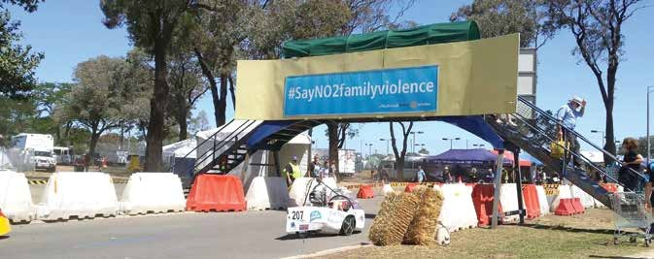
RACV Energy Breakthrough 2015

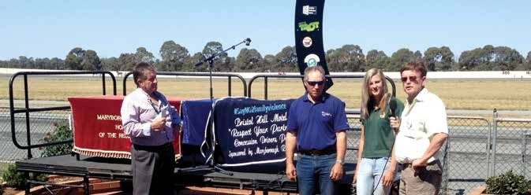
Les Chapman, Secretary/Manager, Maryborough Harness Racing Club with Mr John Newbury - Trainer, Ms Simone Innes - Driver and Mr Bob Butterfield - Bristol Hill Motor Inn
/ Peppa’s Restaurant

Reflections on SAFE project:
The SAFE project has been really useful in that it creates an environment where people feel comfortable to talk about family violence. It creates dialogue and the issue becomes forefront of the community’s mind. This assists with identifying and responding to issues of family violence and, hopefully, reducing incidents of family violence.
It has worked well because it has come from the bottom up, rather than the top down. We have had community engagement and a community response and things have started to change. However, there have also been the right leaders within the community.
It is ultimately about personality. A project like this needs champions, driving it from with- in the community.
Importantly, it is not someone imposing a project and then moving onto the next job. With a project like this it is about engaging the community. The people at the top shouldn’t be do- ing everything for those at the bottom. It is important that the community take ownership, and have a belief in positive change. The community has the ability to solve its own prob- lems, but it does need some assistance, whether that be finance, resources or knowledge. The outcomes of the SAFE project have been wide-ranging:
there has been a raised awareness of the issue in community;
we’ve influenced local government and services’ decision making;
Go Goldfields is intending to establish a Family Violence project in shire with a
dedicated worker;
reporting of family violence, both primary and third party, has increased; a collaboration table has been introduced; which is a management system composed of service providers, service users and community representatives to
manage community focused services offered by our local government.
an increase in recidivism. There are several theories as to why this is so. We believe
that the campaign has given renewed confidence to those suffering family violence to report repeat incidences. There is some discussion that the reporting by victims is leading to retribution from abusive partners.

Importance of community:
The local community has seen a willingness of support for the campaign by displaying framed posters of the initiative, collections tins, selling and using bumper stickers, wallet cards and other promotional materials.
Businesses display large window stickers and Maryborough Bus Lines have fully endorsed the program with stickers on all their buses.
The Maryborough branch of NAB has set up a large display just inside their front entrance of
posters, promotional materials and hand outs.

If we consider the world of 20 years ago, there was a lot more active strength in community organizations. Today, a lot of those community institutions have less power and fewer members
We can leverage the power of community networks and community groups, of which Rotary is a classic example. Part of it is having sufficient funding, but it should be money allocated for local community to make decisions about. A network like Rotary is so well set up it encompasses a worldwide audience. As a result of our campaign there are 15 or 20 other Rotary clubs that have shown support in rolling out a similar project.
Government should acknowledge the value of community and its capacity to change the lives of individuals, and should resource community organisations accordingly.

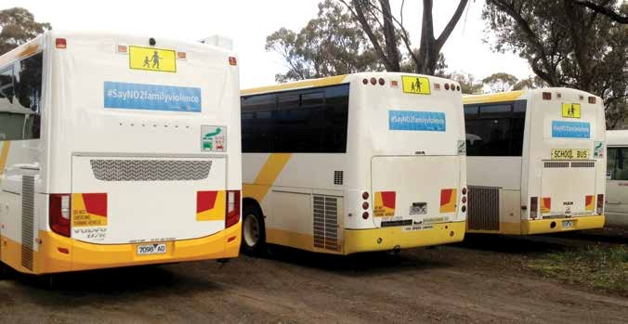

Maryborough Bus Lines
TESTIMONIALS

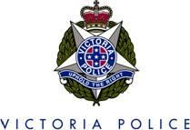

Central Goldfields/Loddon PSA Western Region - Division 5
55-61 Clarendon Street, Maryborough 3465.
Ph: (03) 5460-3301

16 December 2015

Re: Maryborough Rotary Club #SayNO2familyviolence initiative.

To whom it may concern,

I am the Local Area Commander for the Central Goldfields/Loddon Police Service Area and have been in this position since September 2014. Upon commencing in my position, I became aware of the Maryborough Rotary Club #SayNO2familyviolence initiative and the profile this campaign has within the community.

Family violence needs to be eradicated in our communities and at previous work locations, I have partnered with external agencies to address family violence issues but this is the first time I have encountered a non-government or service agency that has been so active in raising the awareness of family violence.

Some of the proactive initiatives I have observed include the following;

• Family violence Program wallet cards
• S.A.F.E. program banner working for a SAFE community.
• Speak up initiatives.
• Sponsorship of local football matches highlighting the need to address family violence.
• Campaigning against family violence in conjunction with Maryborough
Harness Club highlighting the issue across Australia by sponsoring the televised event.

The passion of Maryborough Rotary Club to highlight and work towards eradicating family violence within the community is one of the most important and original initiatives I have encountered during my policing career.

To continue their ground breaking work, I encourage any support that can be provided is given as I am confident actions groups like Maryborough Rotary in addressing family violence provides for a safer and more vibrant community.

Yours sincerely,

Paul GARDINER Inspector
Maryborough Harness Racing Club

#SAYNO2FAMILYVIOLENCE.

On Monday 19th October The Maryborough Harness Racing Club was pleased to join with the Maryborough Rotary Club in advancing the theme of preventing family violence. We were partic- ularly interested having read news paper reports of the campaign over the past 10 – 12 months. We would have been foolish to believe that our industry was free from this scourge on our society and took the project on from two angles. One was that we could get the conversation started within our Industry and secondly we had, through the media outlets and TAB”s and Licensed clubs throughout Australia , New Zealand and Asia the capacity to spread the word. On the day the day the Rotary Club came to the fore with creative race names such as “Bristol Hill Motel Respect Your Partner Pace and Bob Osborne Safe Family Pace these were designed to make peo- ple think about the issue. In addition the Rotary Club were able to find sponsors who provided Inscribed rugs for the winners of each of the races on the day. The eight rugs all carried the theme in bold lettering #SAYNO2FAMILYVIOLENCE. The enthusiasm shown by the local Rotary club and the eagerness of sponsors to get on board was very encouraging. Coverage of the race meeting from all sources was amazing with on course Television coverage on the day, major newspaper coverage and extensive cover through social media. Surprisingly, not that it should have been and probably more satisfying to our club, and Maryborough Rotary was the fact that on the day sever- al of our participants and patrons made positive comments about the campaign and went on to say how the issue of family violence had impacted their lives. Whilst we regret that people have been effected the important issue here is that they were prepared to start a conversation with someone outside their family about it. We are eagerly awaiting the new year to engage with the Rotary Club again to assist with a follow up race meeting to build on the good work already done.

Les Chapman

Les Chapman, Secretary/Manager
Maryborough Harness Racing Club
MARYBOROUGH CORPS WITH ST. ARNAUD & AVOCA AUSTRALIA SOUTHERN TERRITORY

December 16, 2015

To Whom It May Concern:

On behalf of The Salvation Army Maryborough, I would like to endorse the ‘Say No to Family Violence’ Campaign that is run by Maryborough Rotary. Their innovative work has brought the issue of family violence out of the shadows and into the light which is helping to shape a culture within our community of not tolerating violence against women. We are seeing real community transformation take place as a result.

One of the real strengths of what Maryborough Rotary is doing in relation to family violence is working with various community agencies and clubs to spread the message. This has helped to create a community dialogue around the issue which is a major issue within our shire. It is through this dialogue that people are becoming more and more aware that violence of any sort is never okay.

The campaign that Maryborough Rotary has developed has the potential to have a real positive affect nationwide and we would like to commend the value of their work to you.

If you would like any more information please call me on either 5461 2789 or 0417
836 220.

Yours sincerely,

Andrew Walker (Capt.)
Corps Officer Maryborough

Northern Victoria Division
27 Wills Street, Maryborough, Victoria, 3465
PO Box 152, Maryborough, Victoria, 3465
Telephone 03 5461 2789 Fax 03 5460 5020

16 December 2015

To Whom It May Concern,

www.truefoods.com.au

The #SayN02familyviolence Program is a successful and worthy initiative of the Maryborough Rotary that commenced back in 2014. The key objective of this program is to raise awareness of the problems associated with Family Violence in the Maryborough Community and sees the Rotary Members partnering with the community to safely raise awareness and help those in need.

Garry Higgins is the Membership Director of Maryborough Rotary and has done a magnificent job promoting the program and raising awareness across the Shire. True Foods is a major employer of the Maryborough community who has benefited greatly from the
#SayN02familyviolence Program and we can't thank Garry and his team enough for this
very worthwhile cause.

We employ 280 employees. This program has enabled us to raise awareness in a safe manner and to help those in need during very emotional and frightening limes. The program offers a useful tool kit which has been used on numerous occasions successfully here at True Foods.

We support any measures in assisting Maryborough Rotary in further promoting
#SayN02familyviolence.

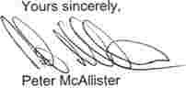General Manager

12

True Foods Ply Ltd ACJN J 100 193 2•e 1 O'Halloran Drive :PO Box 173) Mlr'lbO<ough Voe 3465 tel: (03) 5459 0000 fax: (03) 5459 0099
MARYBOAOUGH REOION.ALNEWSPAPERS PTY. LTD
(�,corpocated in VICIOria)
Tradi'lgas •••

94 Nlj)ief Street, Ma,ybc<ough, Vlctotla 3465, PO Box 306
Telephone (03) 5461-3866; FAX; (03) 5461-4407
Emd: Editortel: �ma,yaddy.cx,m III Ad'Nls: �ngOma,yaddycom au
Admlnisttatlon: edmlnOma,yaddy.com.111
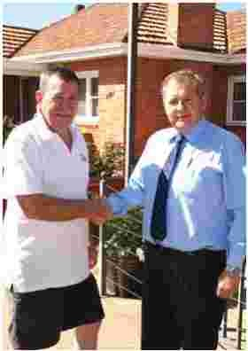ABN 56006204584

Maryborough Rotary Club
POBox50
Maryborough, Vic 3465

December 15, 2015

Dear Garry,
Rotarian Garry Higgins with Mr Michael Rossi - Managing Director, The Maryborough District Advertiser

I thought it timely that I should write to you and express our sincere appreciation for the work you and the Maryborough Rotary Club has done for the "say No 2 Family Violence" campaign.

Not only have you highlighted family violence, but you have also encouraged people who know about, or are effected by family violence, to speak up or seek assistance.

One can only imagine the pain and suffering that must be experienced in a violent relationship. It's an ugly part of society that must be exposed to give those effected an opportunity to seek help.

The Aduertiser is proud to be involved with this campaign and thanks you for the work you have done in spearheading its important message.

I know that your work on exposing family violence, in itself; is far more important to you than any recognition you may gain from it, however it is good to know your efforts have not gone unrecorded and that merit has its reward.
My wife and staff, join with me to again express our appreciation for Rotary's "Say No 2
Family Violence" campaign and wish you every success in the future.

Yours sincerely,

Michael Rossi
General Manager

13
National Bank Australia

To whom it may concern,

I would like to take this opportunity and say congratulations and thank you to Maryborough
Rotary on their Safe #saynotofamilyviolence initiative for my home town Maryborough.
In 2016 The NAB will be looking to strengthen their relationship with Maryborough Rotary and is looking forward to seeing the #saynotofamilyviolence achieving their long term goal of changing attitudes and behaviours toward offending, condoning, tolerating and ignoring family violence in the community.

Adam Balzan
National Bank Manager Maryborough Branch

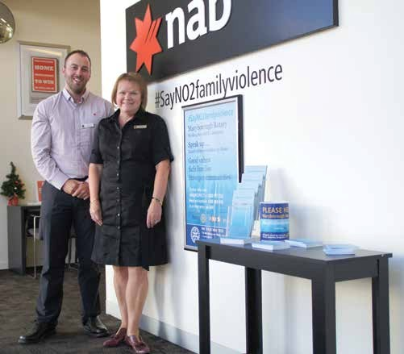

Mr Adam Balzan - Manager, Maryborough Branch, NAB and Linda Rogers Customer Advisor

-why MDHS participated

MDHS has over 430 staff and is the largest employer in the region. Over 400 of these staff are female. Over 1/10th of the shires female population is associated to the health service. The reality for our health service given the statistics on family violence is that a significant number of our staff may at some stage have been affected by family violence. We have par- ticipated to tell our staff that no family violence is acceptable and we are here to help them. Having such a community presence we believe we can also provide leverage to the message associated with the #Saynotofamilyviolence campaign.

- how is it progressing

The CEO of MDHS has written via internal memorandum to all staff outlining the commit- ment of the health service to this campaign. This memorandum also offered all staff access to support both via internal and external mechanisms as required. We are building a culture that the MDHS family is one that supports each other and this is reaffirmed through this campaign. Wallet Cards associated with the campaign are positioned in prominent positions throughout the health service is have been well received. MDHS has committed to the in- stallation of a three metre sign at the Maryborough Campus which will be fully visible from Tuaggra St. This will be installed by end of December.

- the outcome/effect on the community from the campaign

A number and community members of staff have acknowledge the campaign and the ter- rific linkage between the health service and such a campaign. The public and highly visible demonstartion by the health service advocating the #Sayno2familyviolence campaign can only build support and acknowledgement.

Tara Cramer Executive Assistant to CEO

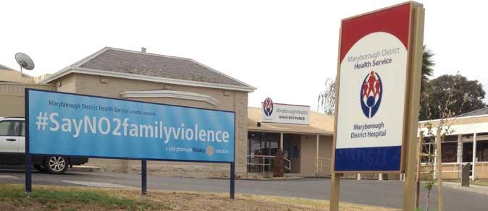
Installed sign at MDHS
15

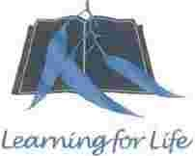

19•• January 2016

To whom it may concern

Maryborough Education Centre

Centro Pnnclpal - Mr David Sutton
PO Box 171
Maryborough VIC 3465
(102·192 Balaclava Road)

Telephone: 03 5461 7900
Facsrmtle: 03 5461 3508
Email: mary1>01oug1J.ec@edum11n,»c.go.Y.11u

Maryborough Education Centre is proud to support Maryborough Rotary Club's #SayN02familyviolencc initiative. Family violence is a highly sensitive and complex issue that takes courage, creativity and persistence to address.

A key strength of Maryborough Rotary's program Is its organic nature. #SayN02familyviolence is an entirely community grown and led initiative. established 10 raise awareness about the confronting Issue that is family violence. Maryborough Rotary Is to be congratulated for its insight and courage in beginning the community conversation about a topic that for too long has rematned hidden.

The research Is clear: in order to address family violence and specifically violence against women; men's attitudes to women must change. This is a national problem that stems from gender inequality. The courage that Maryborough Rotary has shown in recognising this and pulling In place a local response Is to be commended. Violence against women is preventable, but it is only achievable if we all work together and this is what Maryborough Rotary has been able to do. 11 has courageously named the problem and then through a range of creative strategies it has raised awareness and promoted an honest community conversation about the need for family violence to stop.

Maryborough Education Centre's work, to teach our young people about the importance of gender equality, has been beautifully supported by Maryborough Rotary's #SayNo2familyviolence initiative.

Yours sincerely

David Sutton
Principal

#SayNO2familyviolence

